**DAY 26**

**GET PIZZA WITHOUT LOGIN**

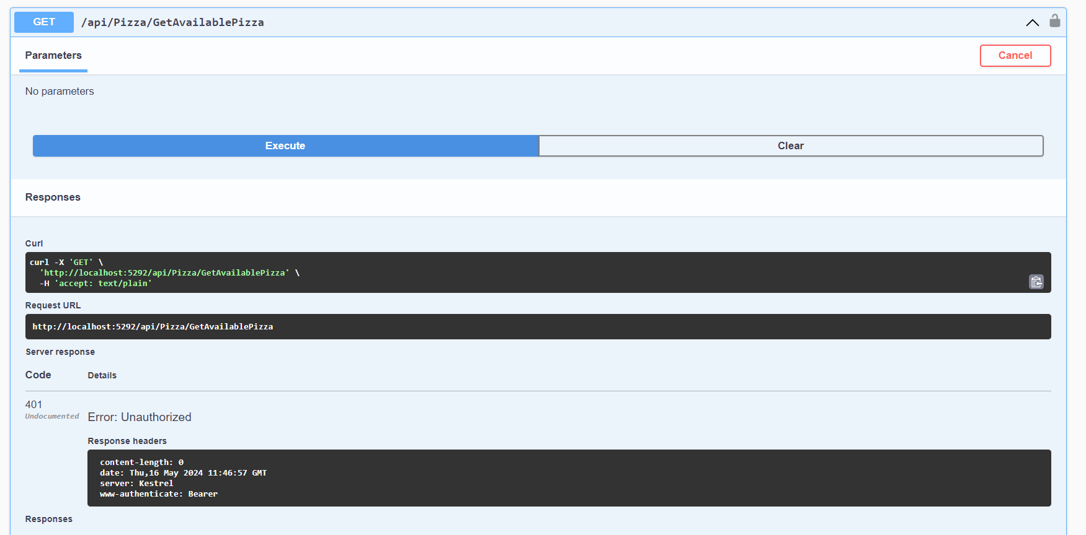

**LOGIN**

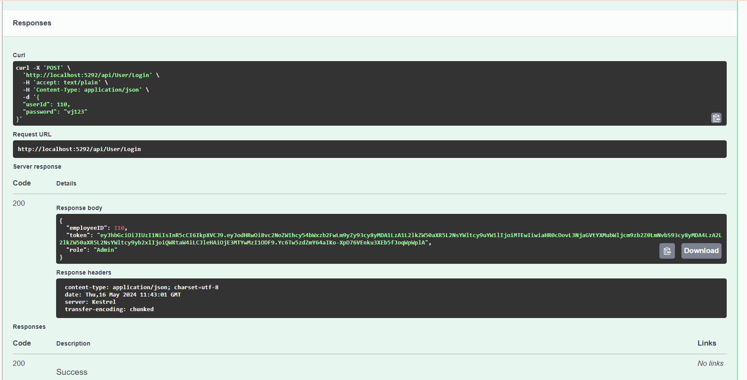

**AUTHORIZE**

**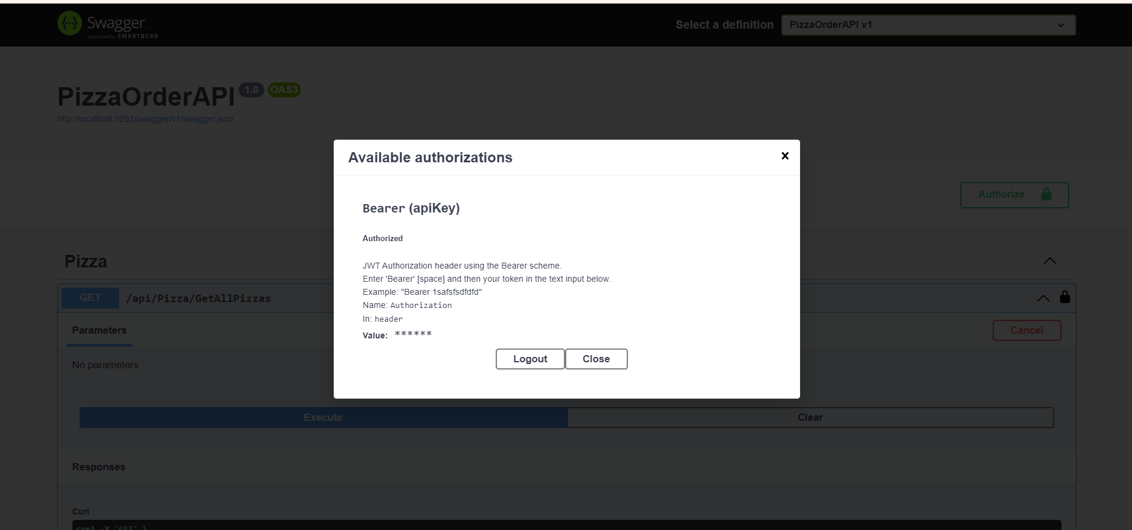  
GET ALL PIZZA AFTER LOGIN AND AUTHORIZE**

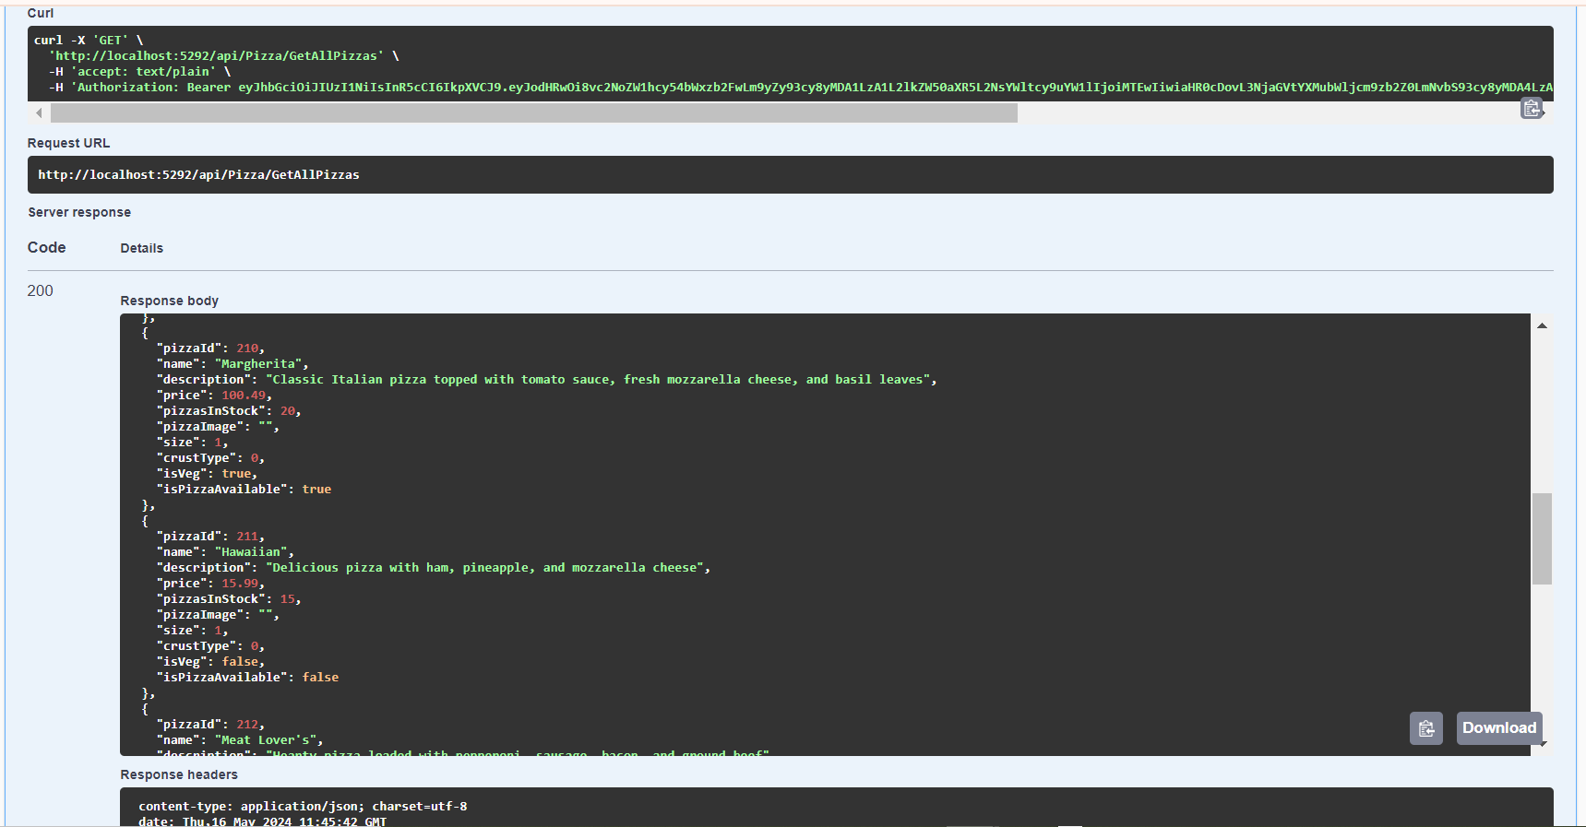

**GET AVAILABLE PIZA AFTER LOGIN AND AUTHORIZE**

