**DAY 11 ( BL AND DAL UNIT TESTING CODE COVERAGE)**

**Unit testing**

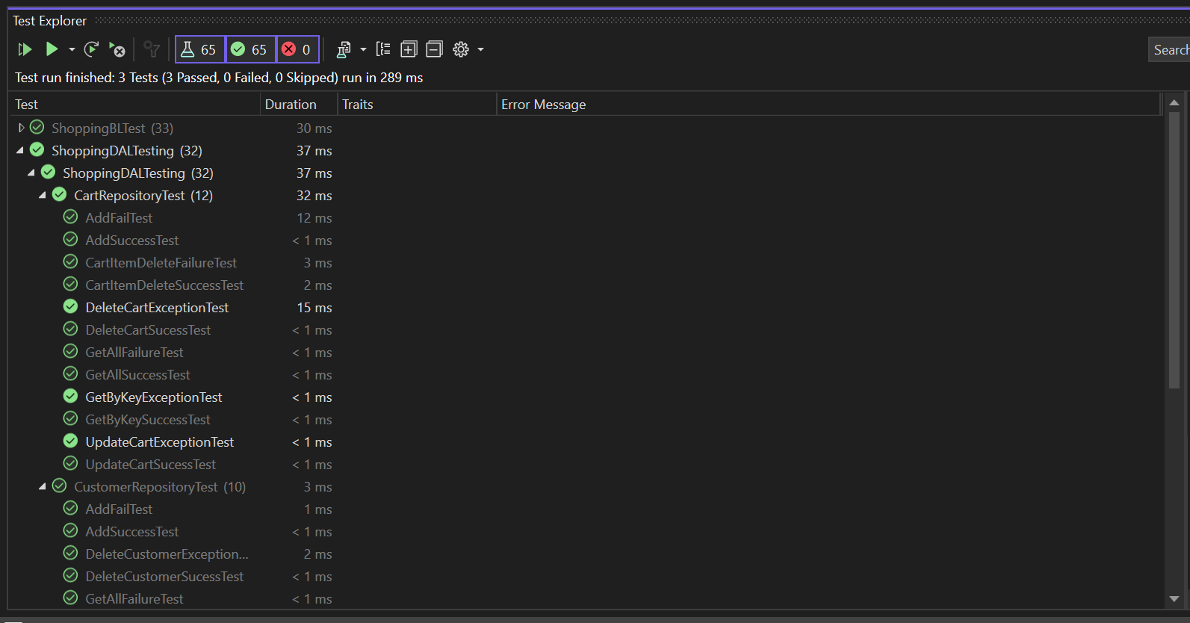

**BL CODE COVERAGE**



**DAL CODE COVERAGE**

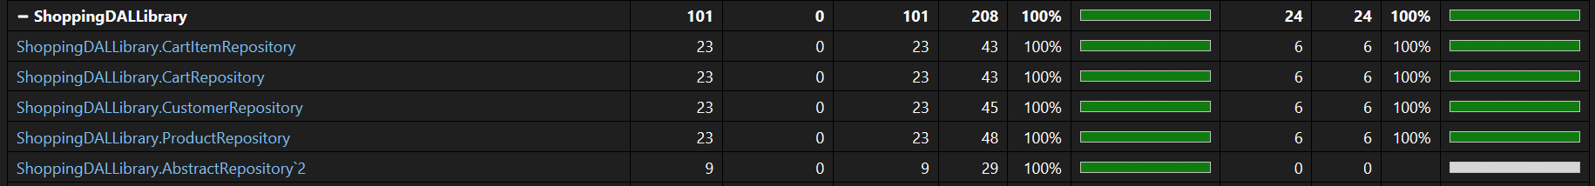

**OVERALL CODE COVERAGE**