**DAY 17**

JOIN AND SUB QUERIES TASKS

use Pubs

1. Print the storeid and number of orders for the store

**Query :**

select st.stor_id 'Store ID', sum(qty) from stores st

join sales s on st.stor_id=s.stor_id

group by st.stor_id

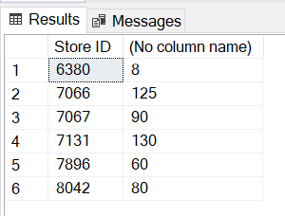

1. print the numebr of orders for every title

**Query :**

select t.title 'Title',count(s.ord_num) from titles t

join sales s on s.title_id=t.title_id

group by t.title

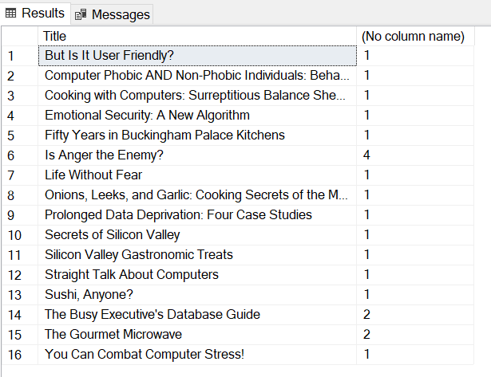

1. print the publisher name and book name

**Query :**

select p.pub_name 'Publisher Name', t.title 'Book Name' from publishers p

join titles t on p.pub_id=t.pub_id

order by 1

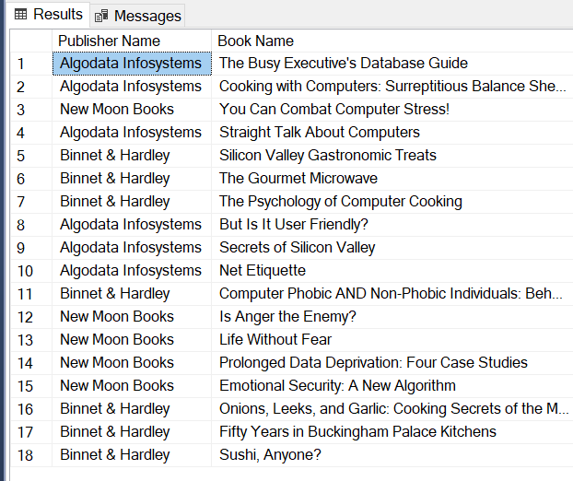

1. Print the author full name for all the authors

**Query :**

select concat(a.au_fname,a.au_lname) "Author's Full Name" from authors a;

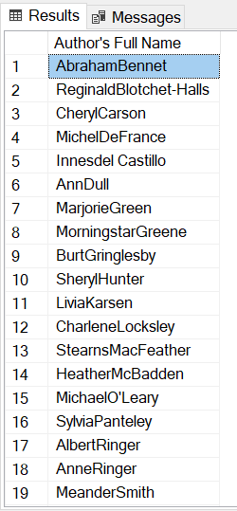

1. Print the price or every book with tax (price+price*12.36/100)

**Query :**

select title 'Book',(price+price*12.36/100) 'Price With Tax' from titles

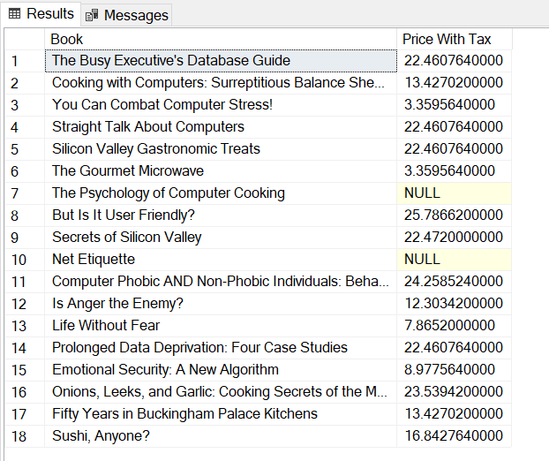

1. Print the author name, title name

**Query :**

select concat(a.au_fname,au_lname) 'Author Name',t.title 'Title Name' from titles t

join titleauthor ta on t.title_id=ta.title_id

join authors a on ta.au_id =a.au_id

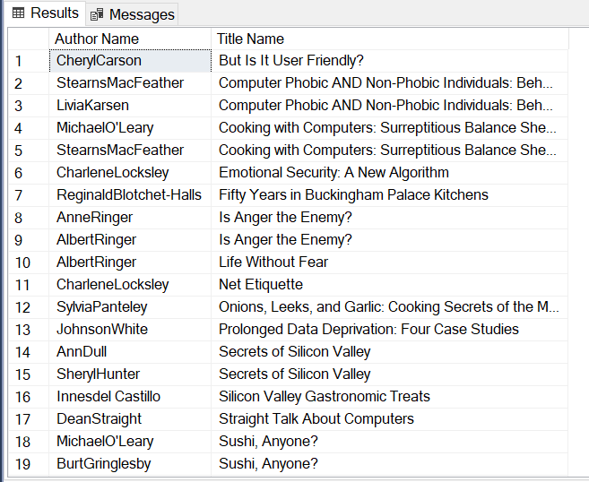

1. print the author name, title name and the publisher name

**Query :**

select concat(a.au_fname,au_lname) 'Author Name',t.title 'Title Name' , p.pub_name 'Publisher Name'

from titles t

join titleauthor ta on t.title_id=ta.title_id

join authors a on ta.au_id =a.au_id

join publishers p on p.pub_id=t.pub_id

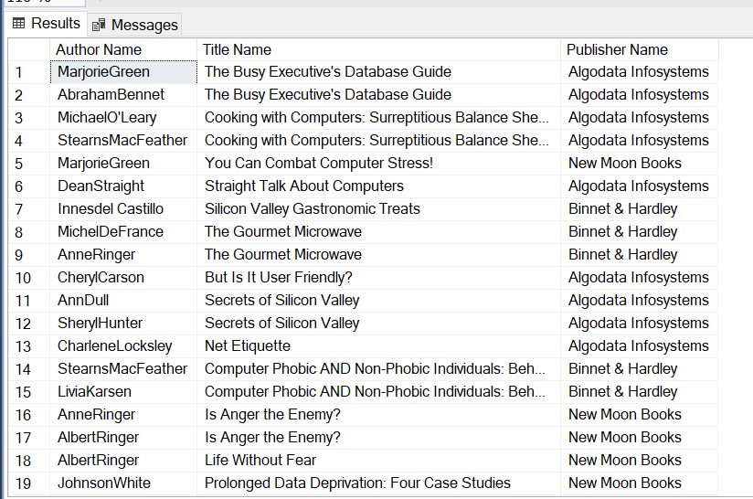

1. Print the average price of books pulished by every publicher

**Query :**

select pub_id 'Publisher ID' ,avg(price) 'Average Price'

from titles group by pub_id

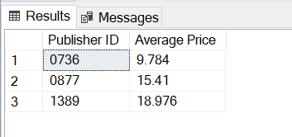

1. print the books published by 'Marjorie'

**Query :**

select t.title 'Books' from titles t

where t.pub_id=

(select pub_id from publishers where pub_name='Marjorie')



1. Print the order numbers of books published by 'New Moon Books'

**Query :**

select ord_num from sales where title_id in

(select title_id from titles where pub_id=

(select pub_id from publishers where pub_name='New Moon Books'))

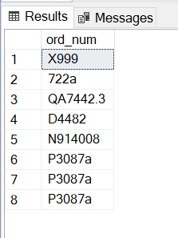

1. Print the number of orders for every publisher

**Query :**

select p.pub_name 'Publisher ID',count(s.qty)'Number of orders'

from publishers p

join titles t on p.pub_id=t.pub_id

join sales s on s.title_id=t.title_id

group by p.pub_name

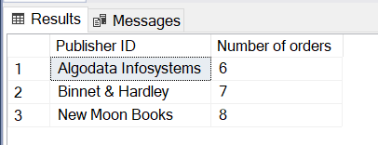

1. print the order number , book name, quantity, price and the total price for all orders

**Query :**

select s.ord_num 'Order Number' ,

t.title 'Book Name',

s.qty 'Quantity',

t.price 'Price',

(t.price * s.qty) 'Total Price'

from sales s join titles t on t.title_id = s.title_id

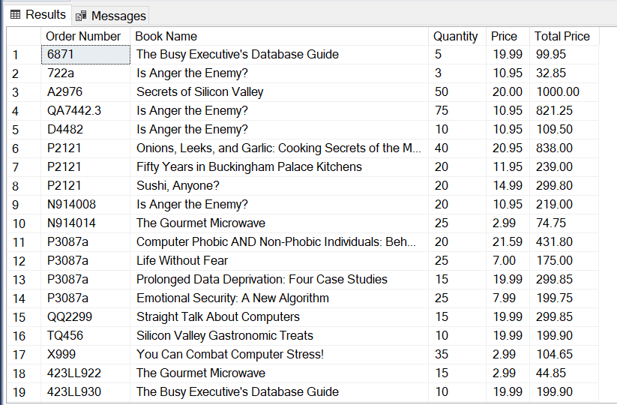

1. print he total order quantity fro every book

**Query :**

select t.title 'Book',sum(s.qty) 'Total Order Quantity'

from titles t

join sales s on s.title_id=t.title_id

group by t.title

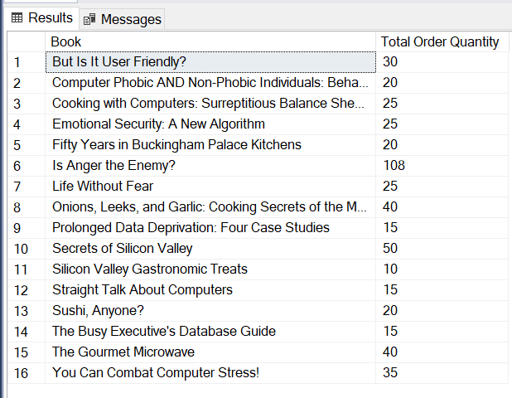

1. print the total ordervalue for every book

**Query :**

select t.title 'Book',sum(s.qty * t.price) 'Total Order value'

from titles t

join sales s on s.title_id=t.title_id

group by t.title

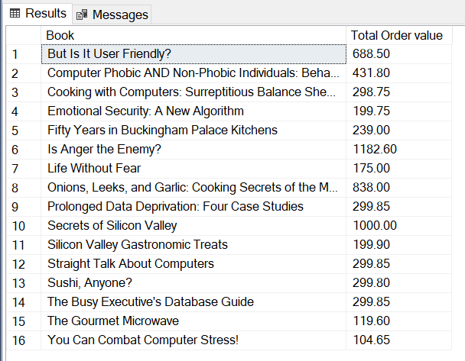

1. print the orders that are for the books published by the publisher for which 'Paolo' works for

**Query :**

select title_id 'Title ID', ord_num 'Order Number' from sales where title_id in

(select title_id from titles where pub_id=

(select pub_id from employee where fname='Paolo'))

