**DAY 22**

Main Login Page

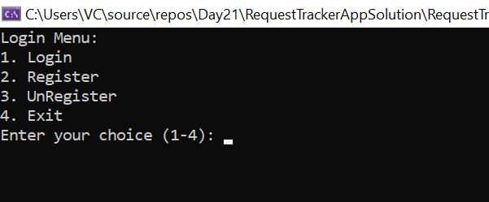

**USER**

User Login

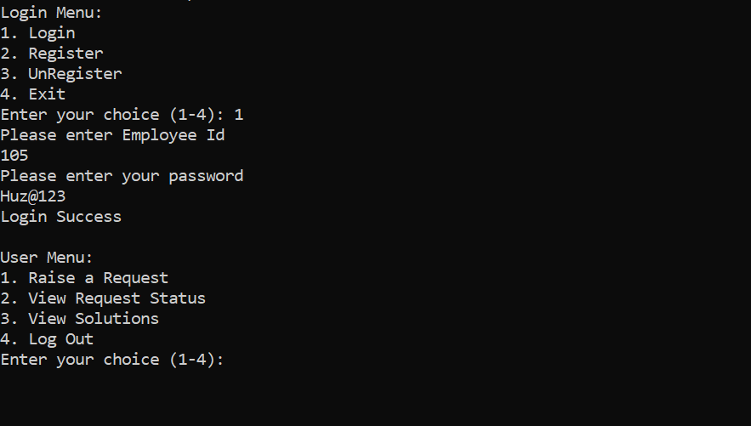

1. Raise a Request

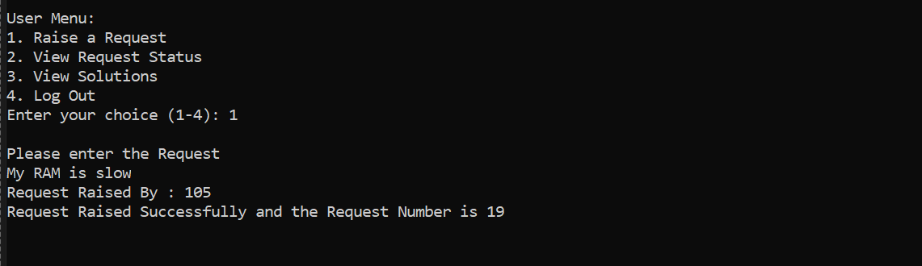

1. View Request Status

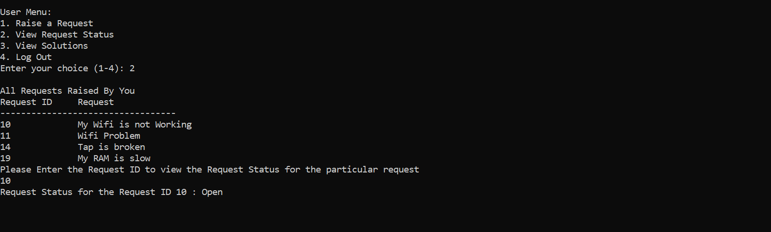

1. View Request Solution

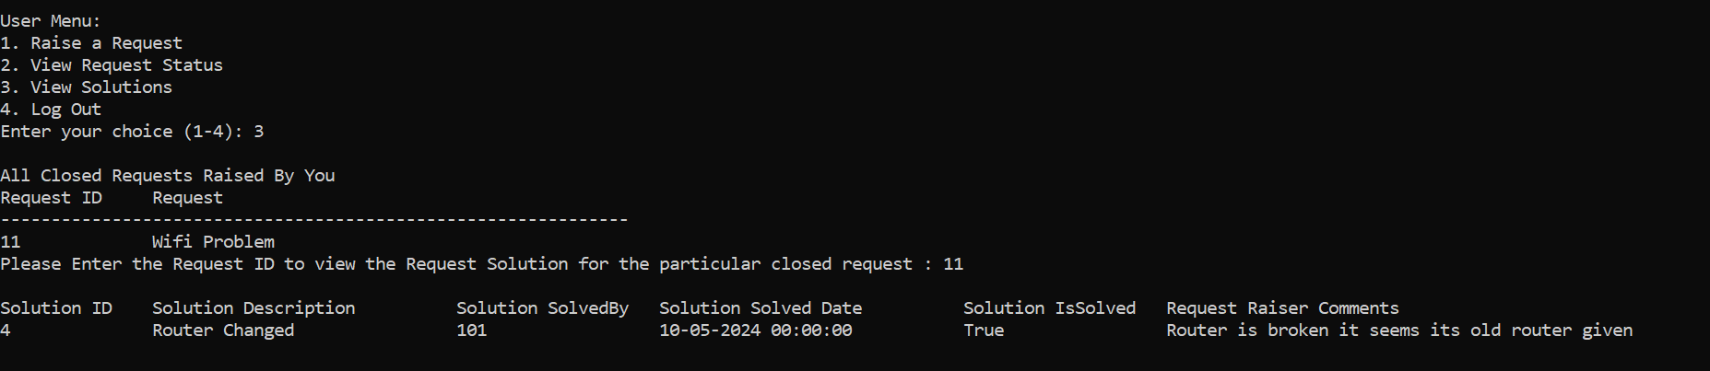

3a) Give Feedback to the Solution

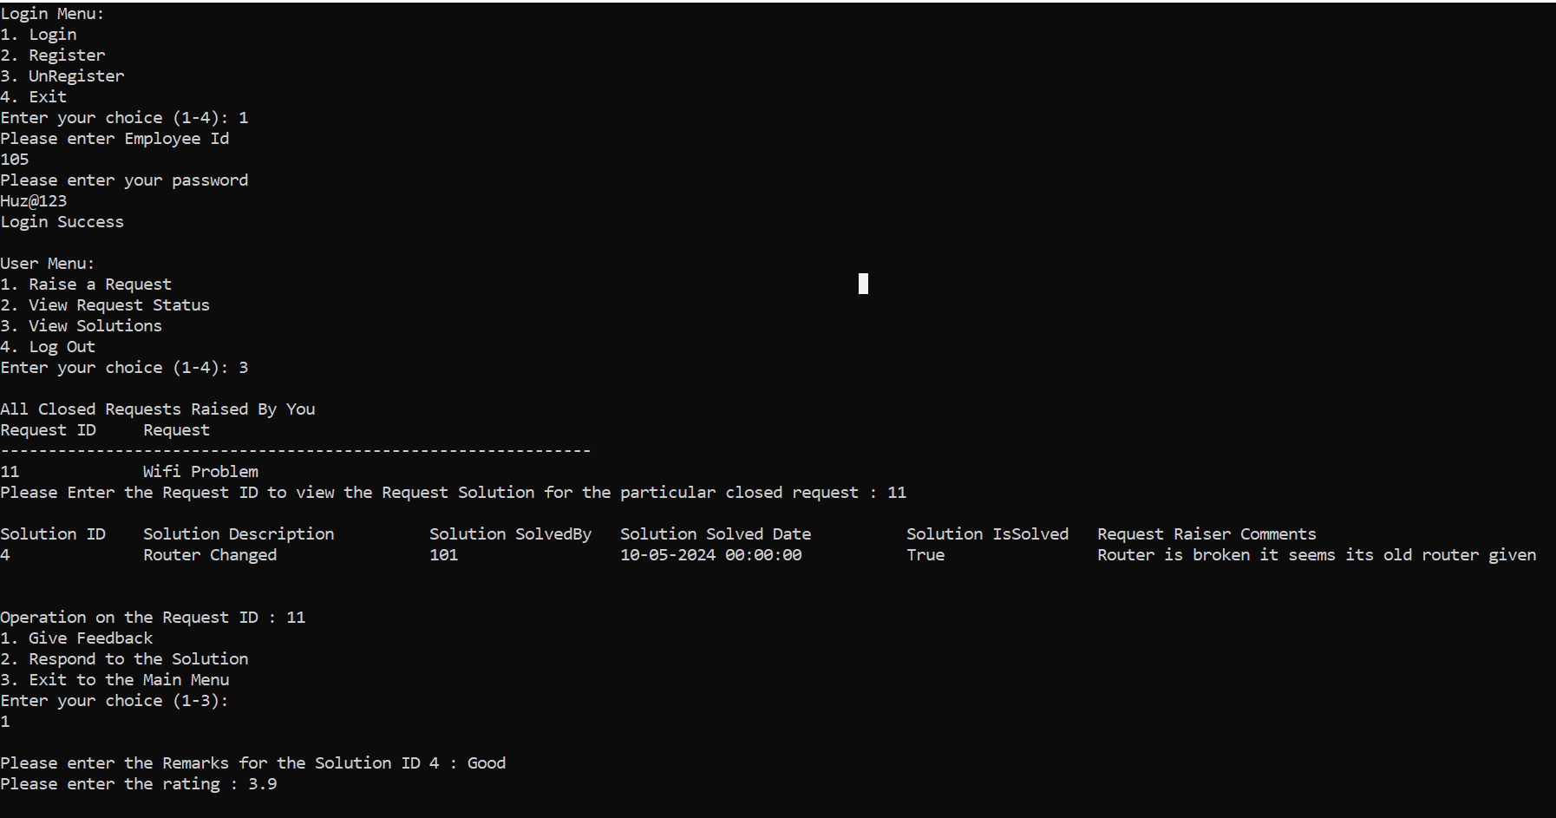

3b) Respond to Given Solution (Raise a comment)

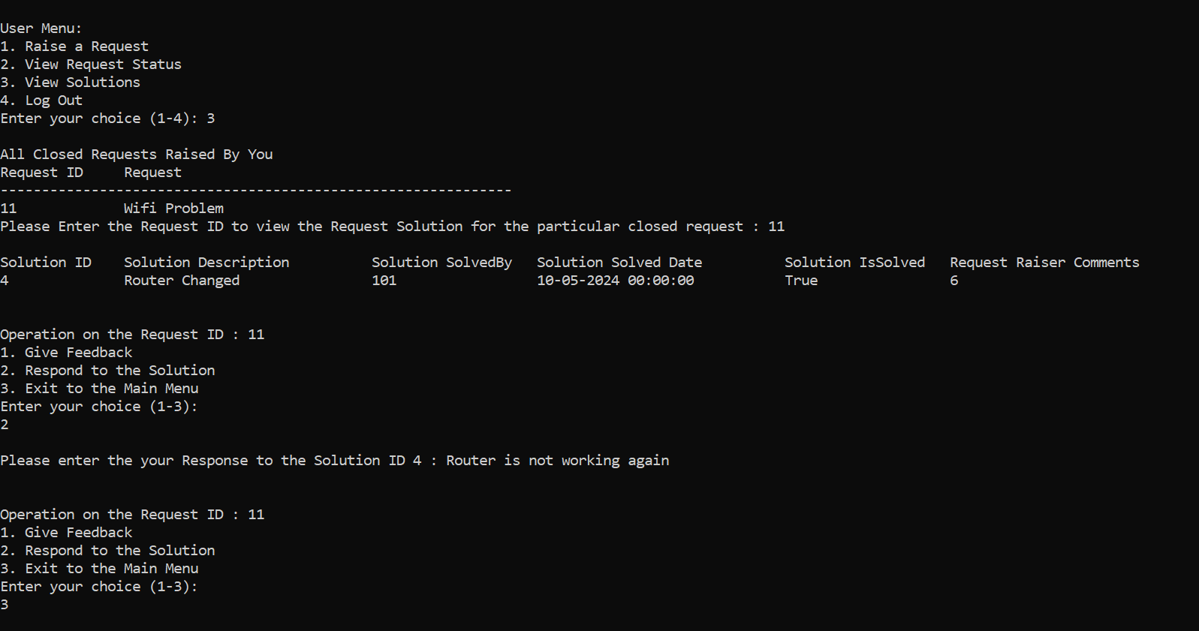

1. Logout User

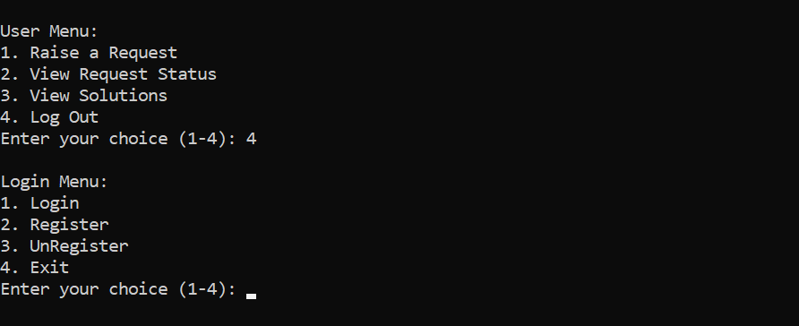

**ADMIN**

1. Admin Raise Request

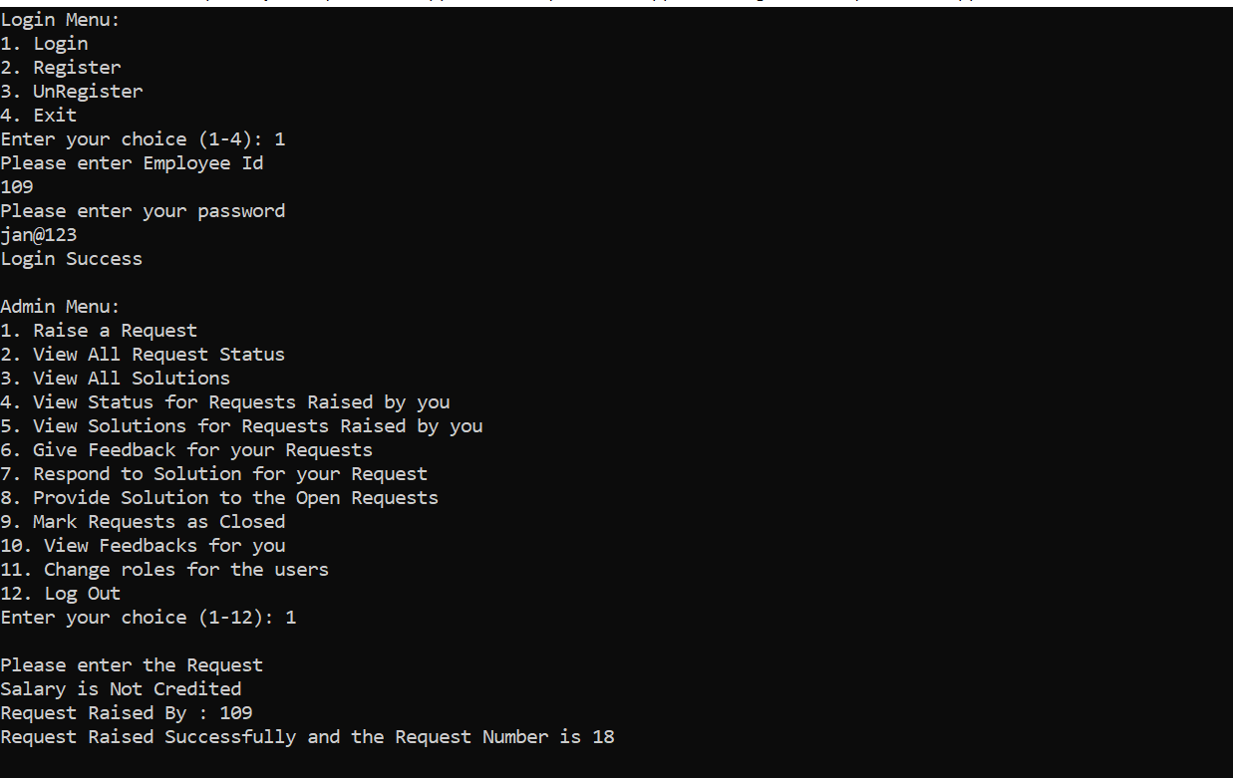

1. Admin View All Request and its Status

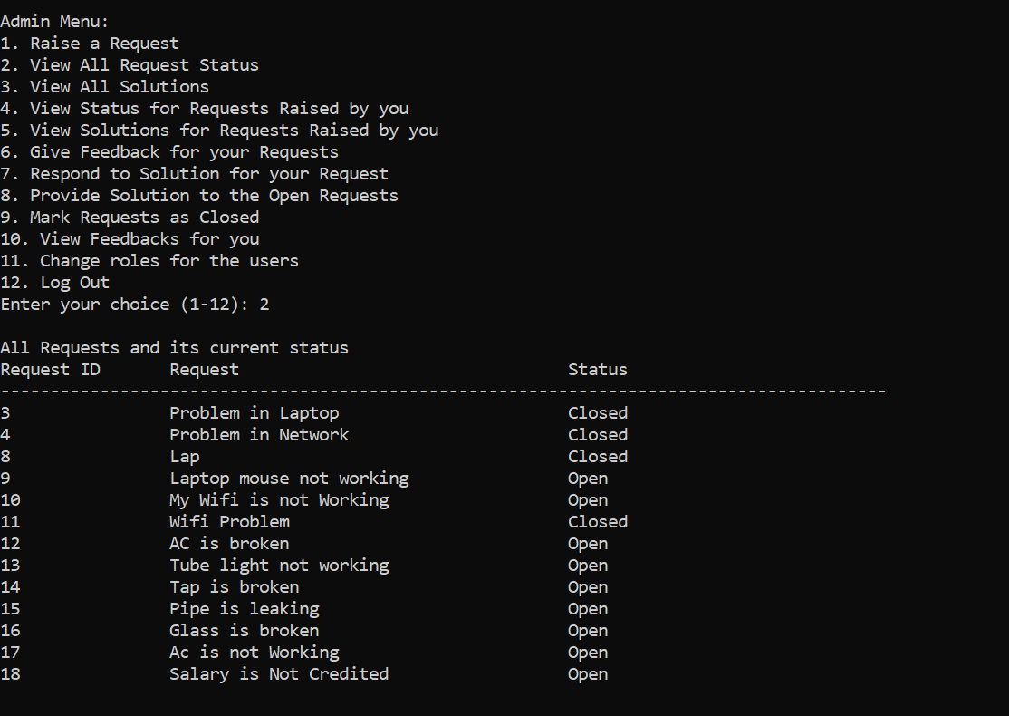

1. Admin View All solutions

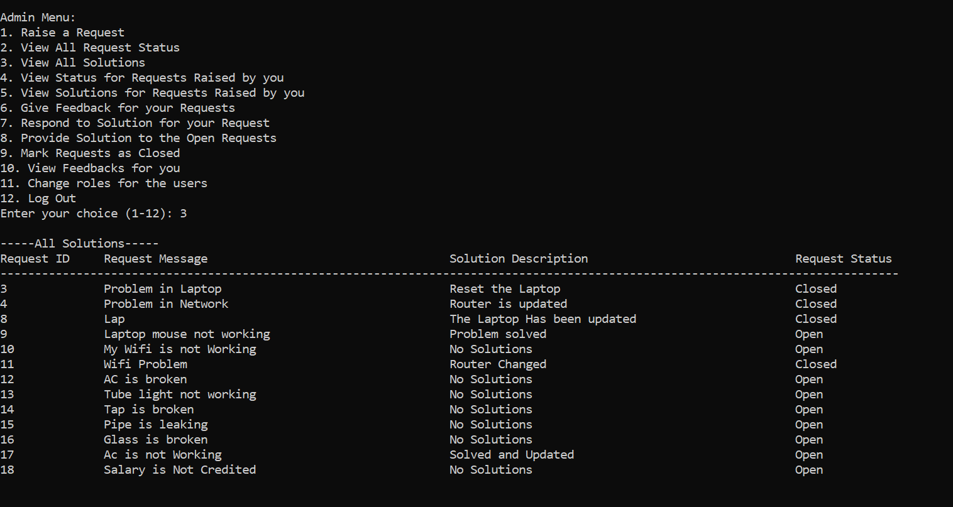

1. Admin Request Status For His Requests

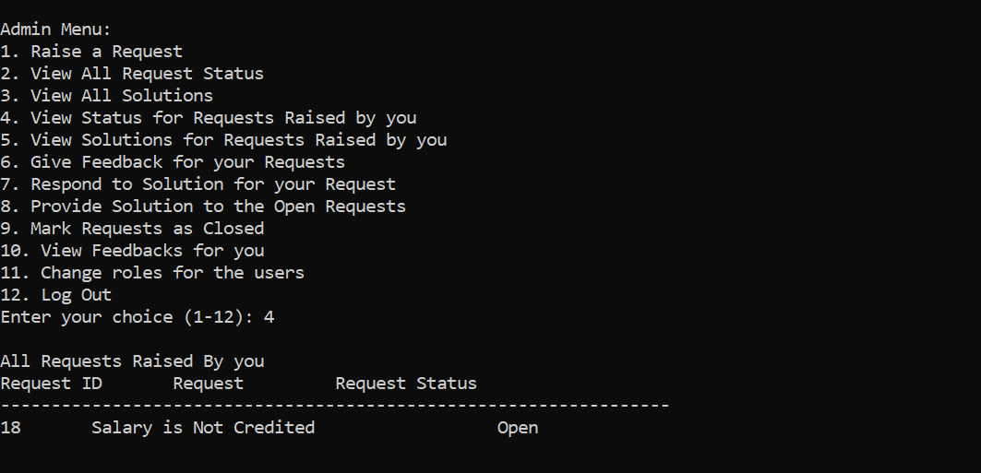

1. Admin Solution View For His Solution

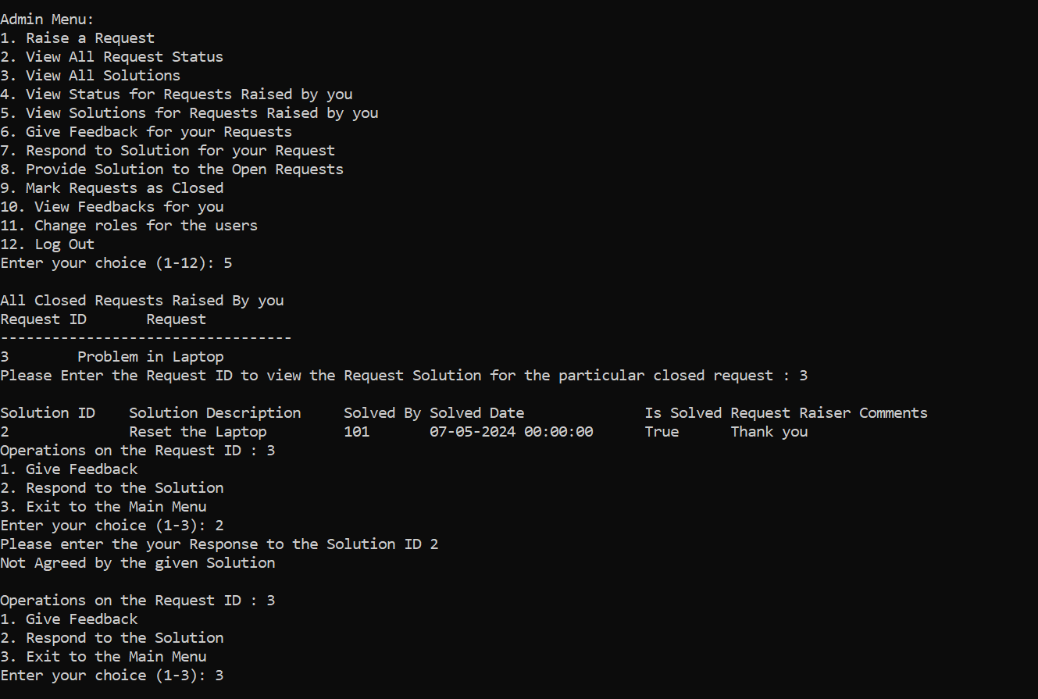

1. Admin Giving Feedbacks for his Request Solutions

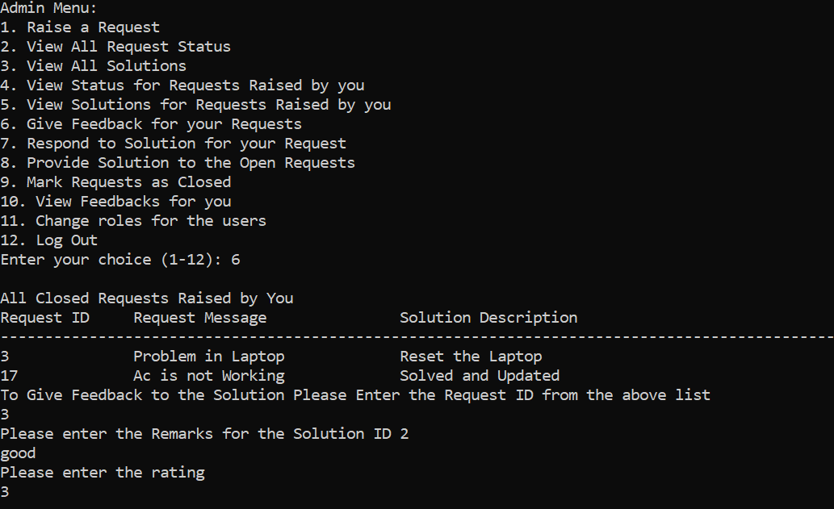

1. Admin Respond to his Requests

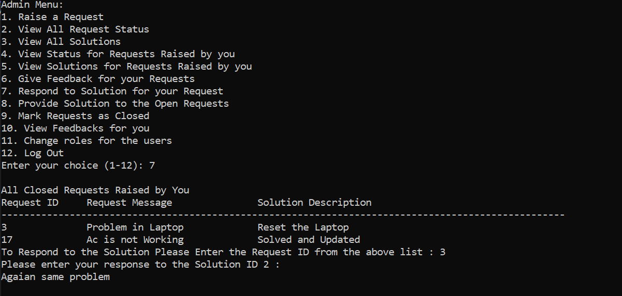

1. Admin Provide Solution To Open Requests

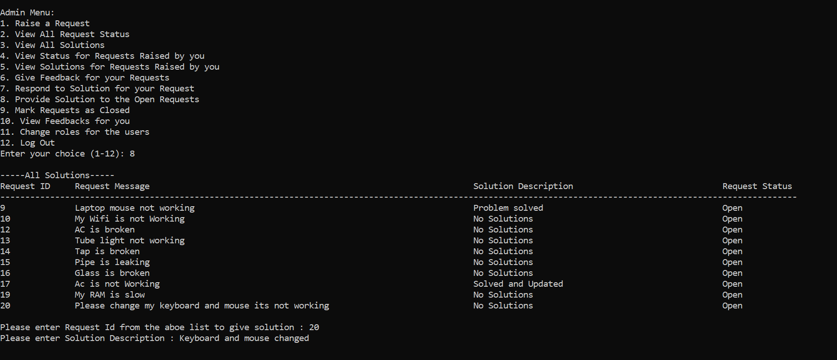

1. Admin Closed the Open Requests

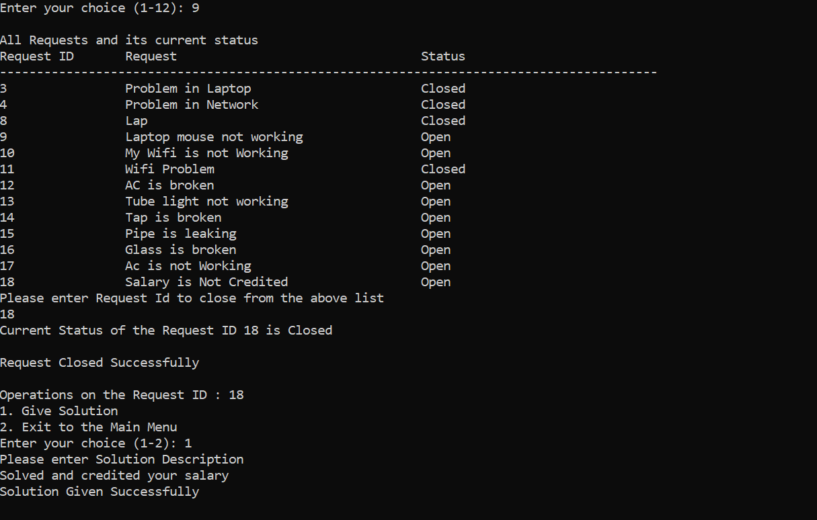

1. Admin View Feedbacks for him

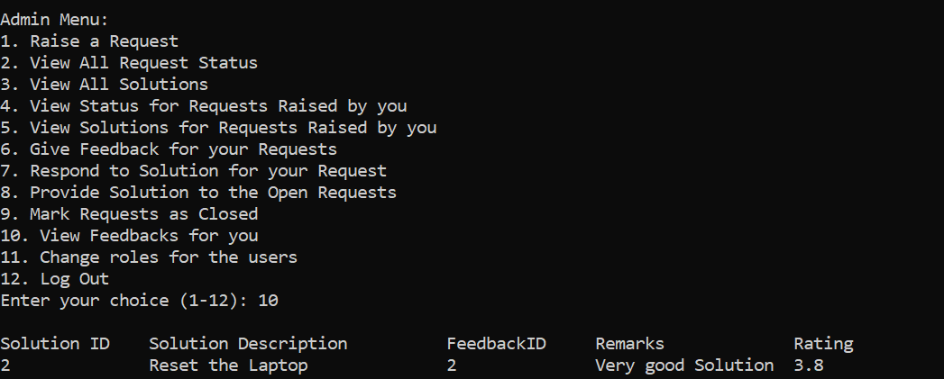

1. Admin Changes Role for the Employee

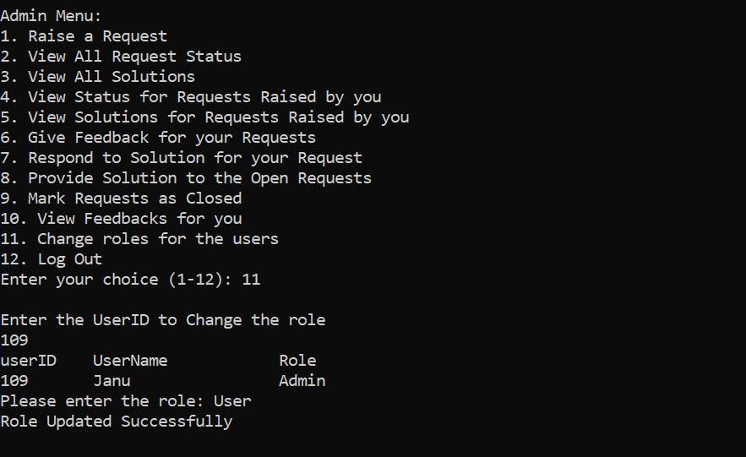

1. Admin Logout

