**DAY 27**

**SWAGGER API**

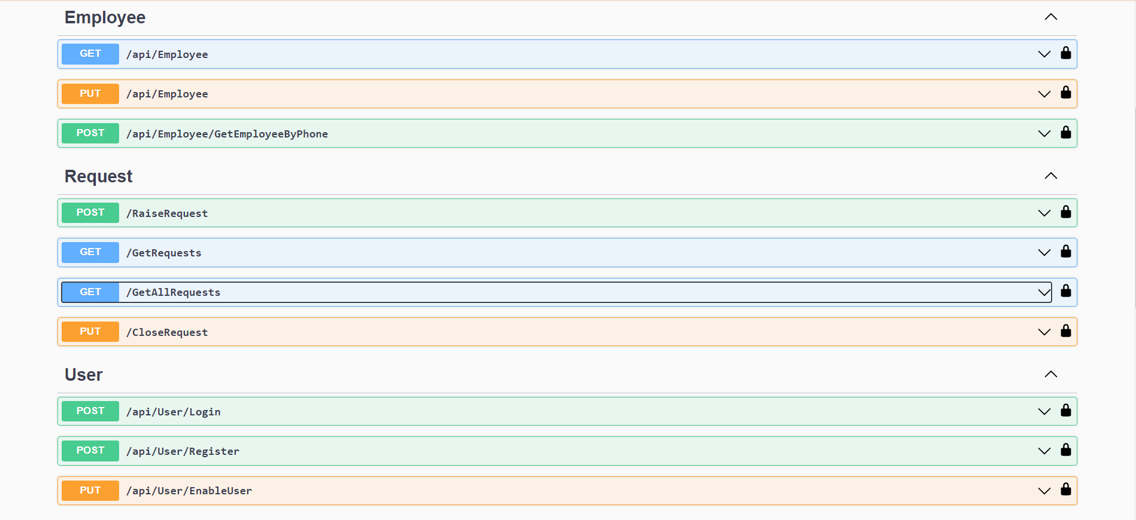

**GET ALL REQUESTS UNATHORIZED FOR USERS**

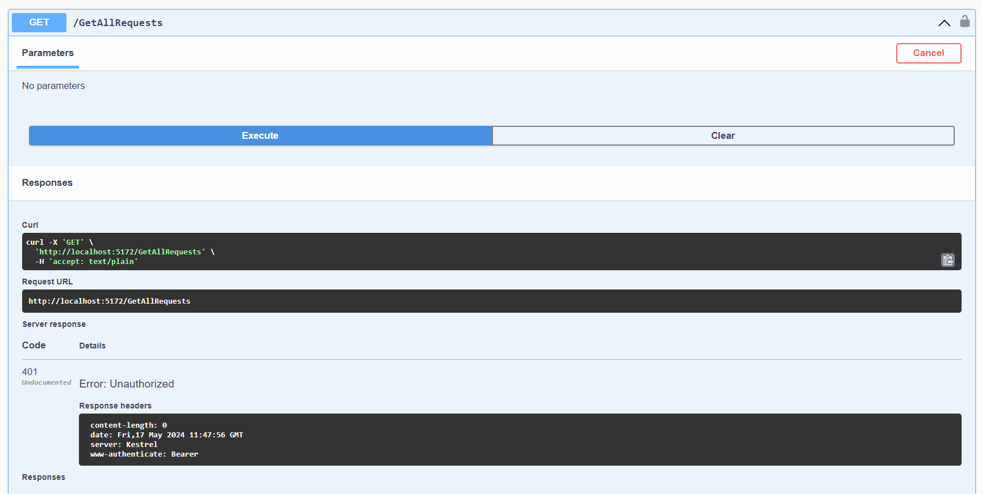

**LOGIN ADMIN TOKEN**

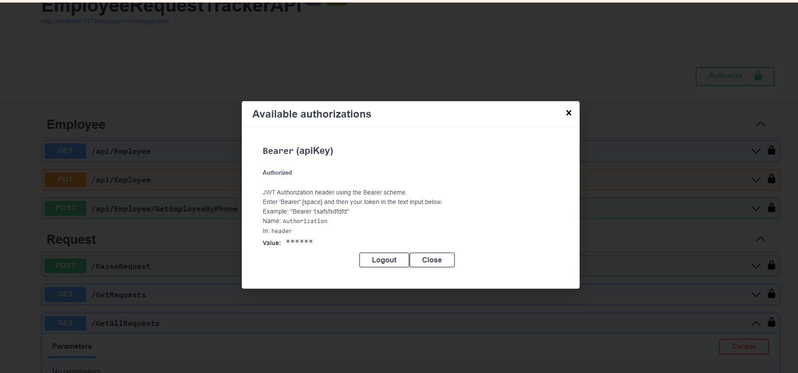

**GET ALL REQUESTS FOR ADMIN**

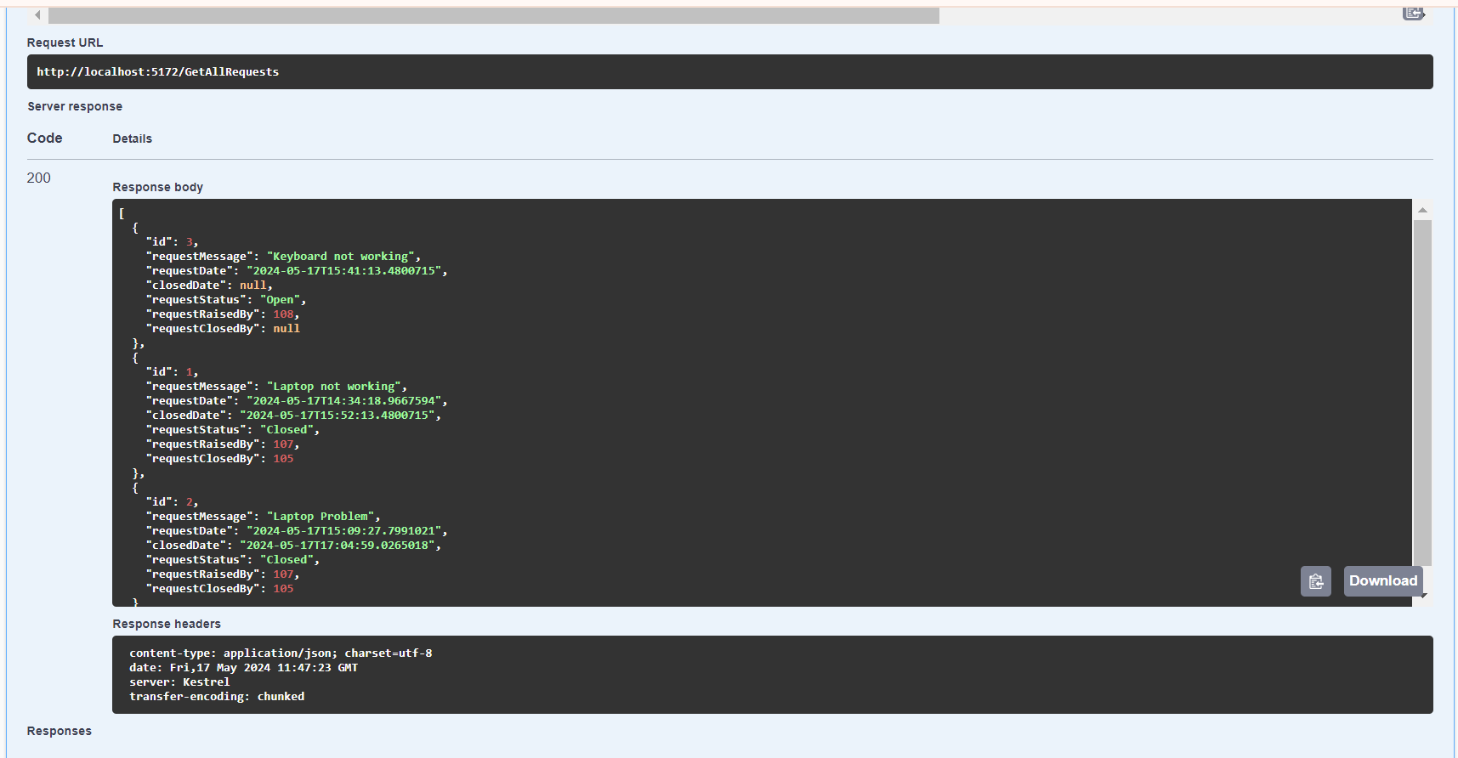

**GET REQUEST FOR THE PARTICULAR USER (BELOW IMAGE FOR REQUESTS BY EMPLOYEE 107)**

