***DAY – 5 (15/04/2024)***

***COW AND BULLS CODE LOCAL CODE OUTPUT***

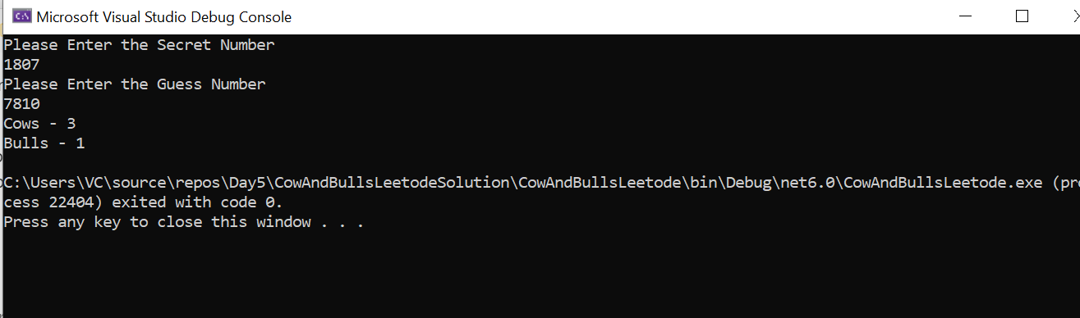

***COW AND BULLS PROBLEM LEETCODE OUTPUT***

