Bee Guardian 2.0: A Smart Beehive Health Monitoring System Using Embedded Multimodal Technology
A project submitted in partial fulfilment of the requirements for the degree of
Bachelor of Science in Computer Science

Department of Computer Science
Namal University Mianwali
23/09/2026

Project Registration
Project ID (for office use)
Type of project |  |  | Continuing
Nature of project |  |  | Development and Research
Area of specialisation |  |  | Artificial Intelligence, Machine Learning, Computer Vision Embedded Systems / IoT, Mobile Computing
Project Group Members
Sr. # | Reg. # | Student Name | CGPA | Email ID | Phone # | Signature
(i) | NUM-BSCS-2023-07 | Huzaira Sultan | 3.19 | bscs23f07@namal.edu.pk | 03206905656 | Huzaira Sultan
(ii) | NUM-BSCS-2023-26 | Aiman Malik | 2.6 | bscs23f26@namal.edu.pk | 03013106254 | Aiman Malik
Declaration: FYP group members have cleared all prerequisite courses for FYP-I as per their degree requirements.

Plagiarism Free Certificate
This is to certify that, I am Huzaira Sultan D/o Sultan Muhammad, group member of FYP under registration no NUM-BSCS-2023-07 at Computer Science Department, Namal University. I declare that my FYP proposal is checked by my supervisor and the similarity index is *% that is less than 20%, an acceptable limit by HEC. Report is attached herewith as Appendix A.
Date:09/23/2026
Name of Group Member 1: Huzaira Sultan Signature: Huzaira
Name of Group Member 2: Aiman Malik Signature: Aiman
Name of Supervisor: Dr. Shafiq-ur-Rehman Signature: Dr. Shafiq-ur-Rehman

Project Abstract
Honeybee colonies are essential for agriculture and for nature, but for small-scale beekeepers there is simply no convenient way of monitoring the health of their colonies. It is not until the colony has suffered a considerable loss that problems like diseases, pests or stress are noticed. Earlier work by the project team produced two separate modules: a mobile application that filters the buzzing sounds of bees from background noise to assess colony condition, and an image-based module that detects bees and classifies visible health issues such as mites and damaged wings from photographs. This project integrates these two modules into a single pipeline and extends the system with an automatic hive unit that captures sound, images and environmental data using an attached camera, microphone and sensors. The hive unit sends this data through a microcontroller to a server, where the integrated models process it to generate an overall health score. The beekeeper then sees this score, along with clear alerts, in a mobile app. The aim is to have a simple and inexpensive system that can help beekeepers identify problems early on, while also creating a beneficial database of honeybee health data for future use.

1. Introduction
The beekeeping industry benefits farming and nature not only through the honey it produces, but also because bees pollinate many of the fruit, vegetable and oilseed crops grown in Pakistan. This is why keeping bees healthy is not only the beekeeper's responsibility; a healthy colony is important for the food supply as well. Despite this, hive monitoring in Pakistan is still mainly manual, requiring the beekeeper to open the hive and inspect the frames one by one. This process takes time, disturbs the bees, and requires experience that many small-scale and part-time beekeepers lack. As a result, problems such as mite infestation, a missing queen, or early brood disease are often only noticed once the colony is already in serious trouble.
This problem has already been partly addressed in earlier work. A prototype mobile application was developed to record hive sound with a standard mobile phone, apply a custom signal-processing and machine-learning pipeline to separate bee buzzing from wind and traffic noise, and give an early indication of colony condition based on that sound; the results of this work have been published in a scientific journal [1]. Separately, an image-based module was also developed and tested to detect bees in photographs and classify visible health issues such as mites and damaged wings. This proposal builds on both of these completed and working modules, integrating them into a single pipeline and extending the system with an automatic hive unit. Because the automatic hive unit introduces new hardware and continuous data-capture conditions that differ from the original phone-based data collection, both modules will also be retrained and fine-tuned on data gathered from the new hardware, rather than being used unchanged.
Sound is a good indicator of behavioural changes, such as a missing queen or a colony preparing to swarm, while the existing image module can catch issues that need to be seen, such as mites or damaged wings. Bringing these two modules together, and adding sensor-based monitoring, including entrance traffic, allows hive conditions to also be tracked over time.
Bee Guardian 2.0 is proposed as this extended system. It uses four types of evidence: sound, visual observations of bees, entrance traffic, and readings from in-hive sensors. The project has three major components. First, integrating the existing sound-based and image-based health detection modules into a single combined pipeline. Second, a hive monitoring unit with a camera, a microphone and basic sensors that automatically gathers data and uploads it to a server through an on-hive microcontroller. Third, a combining layer that fuses the sound, image, sensor and traffic outputs into one easy-to-read health score, keeps a health history for each hive, and sends alerts through the mobile app.
The system is designed to operate fully automatically. A camera and microphone are attached alongside environmental sensors on the hive unit, so that sound, images and sensor readings are captured without any manual input from the beekeeper. This data is sent through an on-hive microcontroller to a server, where the integrated models process it and generate a health score. The result and any alerts are then delivered directly to the mobile app. The success of the project will be judged by the accuracy of the models on test data, the reliability of the hive unit, and by running the complete system on at least one real hive; the results will be presented in the final dissertation.

2. Related Work
Automated monitoring of beehives is a well-studied field of research. A recent survey on machine learning and computer vision techniques used for beehive monitoring gives a broad overview of the types of sensors, datasets and models used so far [2]. The survey broadly categorizes the work into three types: sound-based monitoring, image/video-based inspection and sensor-based hive tracking, and notes that the three are rarely combined into a single working system.

2.1 Sound-Based Monitoring of Colony State
Sound-based sensing is popular because it does not disturb the bees and requires only low-cost hardware. Initial studies demonstrated that hive sound recorded from a distance carries a good amount of useful information [3]. Kulyukin et al. classified beehive sound using deep learning and more traditional machine learning algorithms, with the deep learning methods performing better when operating on spectrogram images of the sound [4]. Ruvinga et al. focused on detecting a missing queen, showing that this produces a clear change in the sound of the colony [5], while Zgank used deep neural networks to classify activity in an IoT farm system [6]. More recently, Sad et al. demonstrated that such sound classifiers can be scaled down enough to run on low-power hive devices [7]. This work supports the sound classification module already developed and published by the project team, which forms one of the two modules integrated in this project.

2.2 Image-Based Inspection and Pest Detection
For aspects that cannot be detected through sound, computer vision provides a complementary means of detection. To estimate mite infestation level without inspecting all the bees manually, Bjerge et al. developed a camera system at the hive entrance to guide the bees through illuminated tunnels which was then used to build a deep learning model [8]. Voudiotis et al. introduced a camera and detection model into the hive, with the aim of early detection of mites. They discovered that a detection model can be executed on a server or on the camera depending on the network [9]. In a similar fashion, Mrozek et al. worked on low-power hive devices, which are not necessarily connected to the internet all the time [10]. In addition to pest detection, Alves et al. showed that visual assessment of hive structure can be automated through deep learning as well, achieving the task of comb classification [11].

2.3 Gap Addressed by the Proposed Work
This related work highlights a few important directions that this project builds on. First, sound and image methods each capture different types of problems, so combining the two, as this project does, gives a more complete picture of colony health than either method alone. Second, while several existing systems use hive-mounted hardware, this project focuses on selecting low-cost, readily available components so that the resulting hive unit stays affordable for local beekeepers. Third, most existing datasets were collected in Europe and North America; by collecting and labelling local data during field testing, this project contributes a dataset that better reflects hives, bee types and climate conditions in Pakistan. Bee Guardian 2.0 brings these directions together by integrating sound, image and sensor data into a single system built around an affordable hive unit.

3. Project Rationale
Motivation for this project comes from the gap between the value of honeybee colonies and the simplicity of the tools available to manage them. When a colony is losing its queen, or is accumulating a large mite infestation, it typically exhibits measurable changes in sound and appearance weeks before this becomes apparent. An automated system is particularly valuable during this early window, as requeening, mite treatment, or feeding at that stage is inexpensive and effective; however, if corrective action is not taken in time, it may be too late.
The problem is important for three reasons. Colony loss affects large-scale keepers far less than small-scale keepers, because a hive is a significant source of income for small-scale keepers, and beekeeping is one of the few micro-enterprises available to rural women in Pakistan. From an ecological perspective, this reduction in pollinators leads to reduced crop yields and biodiversity, and is directly linked to several of the UN Sustainable Development Goals (SDGs), such as SDG 2, SDG 13 and SDG 15. From a machine learning perspective, this is a genuine multi-modality application: the data modalities are highly distinct, unhealthy examples are limited, and the system must be deployed on low-power, noisy, outdoor hardware.
From the project team's perspective, this project builds upon and integrates two previously developed and tested components of earlier work. Earlier phases demonstrated the ability to reliably detect bee buzzing in background noise and to classify visible health issues from bee images. Integrating these into a single multimodal system, and extending it with an automatic hive unit, requires capabilities in deep learning for sound and images, as well as hardware and sensors, backend design, and mobile application development, along with the discipline of testing a system in the field instead of on a pristine data-set. These are the skills the team is working towards developing in this project.

3.1 Aims and Objectives
This project aims to integrate the existing sound-based and image-based health-detection modules into a single automatic system that also incorporates hive sensor data, and to deliver clear health results and alerts to the beekeeper through a mobile application. Specific objectives are:
- Integrate the existing sound-based and image-based health detection modules into a single combined pipeline and build a hive monitoring unit (camera, microphone, temperature/humidity sensor, weight sensor, entrance traffic sensor) that automatically collects data and sends it to a server through an on-hive microcontroller.
- Design a fusion model that combines the sound, image, sensor and traffic outputs into one overall health score, delivered through a mobile app with alerts.
- Evaluate the complete system on real hive deployment and submit the results as a research paper.

3.2 Scope of the Project
Bee Guardian 2.0's scope is defined by the effort and testing that two students can carry out in one academic year. The following are included:
- Integration of the existing sound-based and image-based health-detection modules into a single pipeline.
- A working hive unit (camera, microphone, temperature and humidity sensor, weight sensor, entrance traffic sensor) attached to a standard hive, sending data automatically to a server through an on-hive microcontroller.
- A cloud-hosted back-end with a unified health-scoring (fusion) service and an alert service.
- An Android application that displays the health score, hive history and alerts.
- A labelled dataset collected from local apiaries, along with an evaluation report of the integrated system.
- Project documentation: requirements document, design notes, user guide, final report, and a research paper submission.
The following are not within the scope of this project and are mentioned here so that success can be judged on what was actually delivered:
- Laboratory-confirmed diagnosis of specific diseases; the system provides an indicative health assessment to encourage inspection, not a clinical diagnosis.
- Any physical action automatically performed in the hive, e.g. robotic treatment or mite removal.
- A nationwide data centre or multi-region rollout; the back-end is designed to scale but will only be built and tested at pilot scale.
- Manual (phone-only) submission; the system is built around the automatic hive-unit pipeline.
- An iOS version of the app and/or commercial production of the hive unit.

3.3 Success Criterion
The project will be judged to be a success if the following can be demonstrated and reported, with evidence, in the final dissertation:
- The hive monitoring unit (camera, microphone and sensors) is built and operates reliably on a live hive, automatically collecting and sending data to the server through the on-hive microcontroller.
- The mobile app correctly receives the combined health score and alerts from the server and displays them to the beekeeper.
- The complete system is evaluated on real data and a live hive, and the results are compiled and submitted as a research paper.

3.4 Proposed Methodology and Architecture
The project is developed in a step-wise manner. The three parts (module integration, hive unit, app) are developed, tested individually, then assembled in steps. This is appropriate, since the sound and image modules already exist in a tested form and can serve as the foundation for the integrated system, and also since the model-building process tends to be better served by short iteration cycles.

3.4.1 System Architecture
The system consists of five layers. The capture layer captures raw data from the hive unit. The edge layer is on the hive hardware and performs simple cleaning operations like cropping images and removing background noise to ensure that only useful information is passed on. The communication layer transmits sensor data and media files to the back-end via the on-hive microcontroller over normal wireless channels. The intelligence layer contains the sound classifier, the image detector and classifier, a sensor-analysis model, a bee-traffic analysis model, and the fusion model that combines all four into a health score. The mobile app is the presentation layer, and displays dashboards, hive history, and provides alerts.
Table 1 presents the types of data collected by the system and the corresponding indicators of hive health.
Table 1. Data captured by Bee Guardian 2.0 and what it indicates.
Data Type | Captured by | What it tells us
Sound (buzz) | A microphone inside the hive, or a phone recording | Queenlessness, swarming, stress or colony agitation
Bee images | A camera facing a frame inside the hive, or a phone camera | Mites, damaged wings, pests, bee population size
Temperature & humidity | A temperature/humidity sensor placed among the frames | Brood condition and situations that favour disease
Hive weight | A weight sensor under the hive | Honey flow, honey stores, sudden loss of bees
Bee traffic (entrance) | An infrared break-beam sensor at the hive entrance | Colony activity level and abnormal entrance traffic patterns

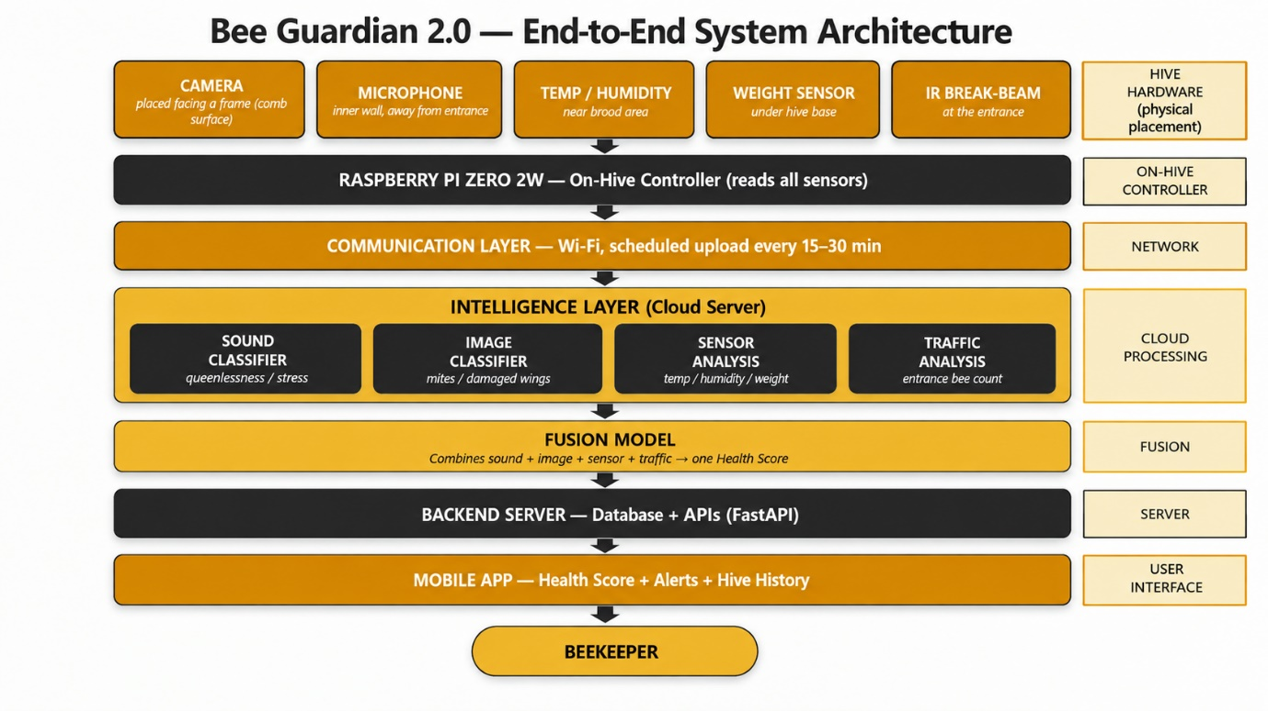
Figure 1. System Architecture of Bee Guardian 2.0.

3.4.2 Development Phases
Phase 1, Requirements and data foundation. Beekeepers' needs are collected and documented in a requirements document. The existing sound and image datasets from earlier work are reviewed and consolidated to support integration.
Phase 2, Module integration. The existing sound and image classification modules are integrated into a single pipeline, with a shared data format and consistent output labels so that their results can be combined later.
Phase 3, Hive unit development. The hive unit is put together and its software is written for scheduled capture (e.g. every 15-30 minutes), basic on-device clean-up and sending data. Power use, enclosure design and protection from hive humidity are also dealt with in this phase.
Phase 4, Combining results and backend. The individual data sources generate their own health estimates, which are fused by a learned model into a single estimate of health, along with a degree of confidence.
Phase 5, App development and integration. The mobile app is designed with a single interface that displays the health score, hive history, sensor readings and alerts, along with push notifications.
Phase 6, Field deployment and evaluation. The entire system is placed in at least one active hive, operated for a given period and compared to the success criteria stated in Section 3.3. Issues picked up in the field are used for a final round of improvement.

4. Individual Tasks
This project is done in a team of two students. The one-year effort is distributed fairly, as the core activities (planning, data collection, system integration, field testing and final report) are carried out together, with one member responsible for the model building and development work of each part.
Table 2. Task allocation and tentative schedule.
Team Member | Activity | Tentative Duration
Both Members | Requirement gathering, study of related work and system design | Week 1 - 4
Both Members | Collecting and labelling the audio and image dataset | Week 5 - 12
Aiman Malik(Audio & Hardware) | Integrating the existing sound-based health detection module into the combined pipeline | Week 13 - 18
Huzaira Sultan (Vision & Backend) | Integrating the existing image-based health detection module into the combined pipeline | Week 13 - 20
Aiman Malik (Audio & Hardware) | Building the hive sensor unit and connecting it to the server | Week 19 - 26
Huzaira Sultan (Vision & Backend) | Building the backend server, database and alert system | Week 21 - 27
Both Members | Combining audio, image and sensor results into one health score | Week 27 - 32
Huzaira Sultan (App) | Building the mobile app (automatic hive-unit mode) | Week 28 - 34
Both Members | Testing the full system on a real hive and fixing issues | Week 33 - 38
Both Members | Final testing, documentation and report writing | Week 39 - 40

5. Tools and Technologies
Table 3 provides the tools and technologies chosen for each layer of the system and how they are used in Bee Guardian 2.0. The selected components are open source and low cost to keep the system affordable for the intended users.
Table 3. Tools and technologies proposed for the project.
Layer | Tool / Technology | Purpose in Bee Guardian 2.0
Hive hardware | Low-cost embedded camera and controller board | Captures images and audio at the hive and does basic pre-processing
Sensors | Temperature/humidity sensor, microphone, weight sensor, infrared entrance-traffic sensor | Reads hive temperature, humidity, sound, weight and entrance bee traffic
Connectivity | Wi-Fi / mobile network, standard messaging protocol | Sends sensor readings and media files to the server
AI - audio | Python, TensorFlow / Keras, CNN on sound spectrograms | Buzz extraction, noise removal and acoustic health classification
AI - vision | PyTorch, YOLO-based detector, OpenCV | Bee detection, counting and visual disease / pest classification
Fusion | Weighted classifier combining all model outputs | Combines audio, image and sensor evidence into one health score
Backend | Python (FastAPI), database, push-notification service | APIs, hive database, user accounts and alerts
Mobile app | Flutter (Android), on-device lightweight model | Automatic hive dashboard, health score display and alerts
Deployment | Docker, cloud server | Hosting of the inference server and database
Support tools | Git/GitHub, Google Colab, data-labelling tool | Version control, model training and dataset labelling

6. Gantt Chart
The activities for Section 4 are related to a 10-month schedule as shown in Table 4. Data collection is done concurrently with early integration work since the availability of data is the main risk to the project. The audio and vision integration tracks are carried out simultaneously by both members, then the fusion stage follows, followed by the backend, app and integration stage, which are done serially.
Table 4. Gantt chart of project activities; columns 1 to 10 denote project months and shaded cells indicate active periods.
Task | 1 | 2 | 3 | 4 | 5 | 6 | 7 | 8 | 9 | 10
Literature review & requirement analysis
Dataset collection and annotation (audio + image)
Integration of existing sound-based module
Embedded hive node design and assembly
Testing of integrated sound module
Integration and testing of existing image module
Multimodal fusion engine
Backend server, database and alert engine
Mobile application development (automatic mode)
System integration and edge optimisation
Field deployment and testing on live hives
Evaluation, documentation and final defence

7. References
[1] M. A. Khan, B. H. Khan, S. ur Rehman Khan, A. Raza, A. Raza, and S. A. Chaudhry, “Spectrogram-based deep learning models for acoustic identification of honey bees in complex environmental noises,” Machine Learning with Applications, vol. 23, art. 100807, 2026.
[2] Š. Bilík, T. Zemčík, L. Kratochvíla, D. Řičánek, M. Richter, S. Zambanini, and K. Horák, “Machine learning and computer vision techniques in continuous beehive monitoring applications: A survey,” Computers and Electronics in Agriculture, vol. 217, art. 108560, 2024.
[3] A. Qandour, I. Ahmad, D. Habibi, and M. Leppard, “Remote beehive monitoring using acoustic signals,” Acoustics Australia, vol. 42, no. 3, 2014.
[4] V. Kulyukin, S. Mukherjee, and P. Amlathe, “Toward audio beehive monitoring: Deep learning vs. standard machine learning in classifying beehive audio samples,” Applied Sciences, vol. 8, no. 9, art. 1573, 2018.
[5] S. Ruvinga, G. Hunter, O. Duran, and J.-C. Nebel, “Identifying queenlessness in honeybee hives from audio signals using machine learning,” Electronics, vol. 12, no. 7, art. 1627, 2023.
[6] A. Zgank, “IoT-based bee swarm activity acoustic classification using deep neural networks,” Sensors, vol. 21, no. 3, art. 676, 2021.
[7] C. Sad, D. Kampelopoulos, I. Sofianidis, D. Kanelis, S. Nikolaidis, C. Tananaki, and K. Siozios, “Deep edge IoT for acoustic detection of queenless beehives,” Electronics, vol. 14, no. 15, art. 2959, 2025.
[8] K. Bjerge, C. E. Frigaard, P. H. Mikkelsen, T. H. Nielsen, M. Misbih, and P. Kryger, “A computer vision system to monitor the infestation level of Varroa destructor in a honeybee colony,” Computers and Electronics in Agriculture, vol. 164, art. 104898, 2019.
[9] G. Voudiotis, A. Moraiti, and S. Kontogiannis, “Deep learning beehive monitoring system for early detection of the Varroa mite,” Signals, vol. 3, no. 3, pp. 506-523, 2022.
[10] D. Mrozek, R. Gorny, A. Wachowicz, and B. Małysiak-Mrozek, “Edge-based detection of varroosis in beehives with IoT devices with embedded and TPU-accelerated machine learning,” Applied Sciences, vol. 11, no. 22, art. 11078, 2021.
[11] T. S. Alves, M. A. Pinto, P. Ventura, C. J. Neves, D. G. Biron, A. C. Junior, P. L. De Paula Filho, and P. J. Rodrigues, “Automatic detection and classification of honey bee comb cells using deep learning,” Computers and Electronics in Agriculture, vol. 170, art. 105244, 2020.

Appendix A
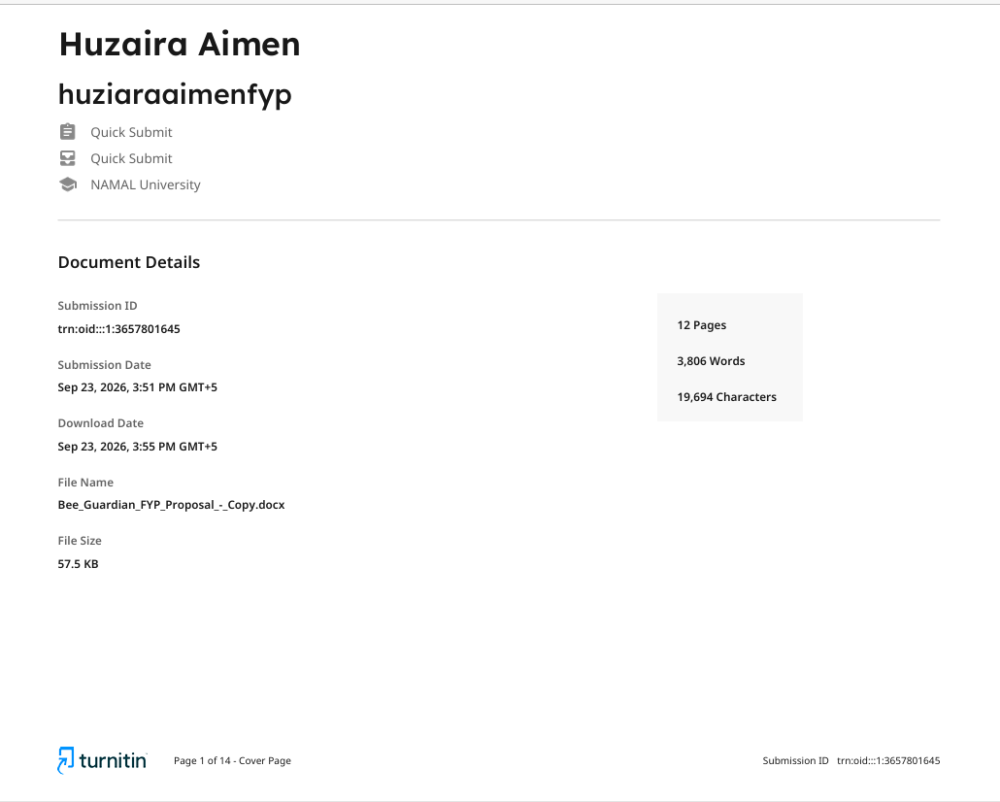
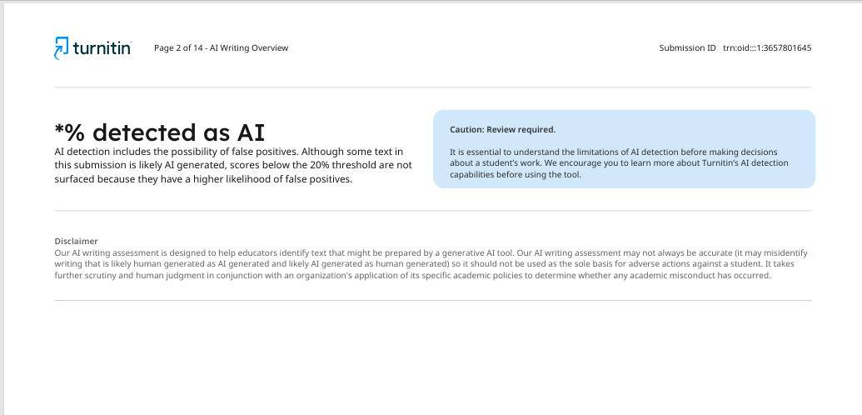
Fig3: Turnitin Report

