**COMPUTER ORGANIZATION AND ASSEMBLY LANGUAGE - LAB**

**ASSIGNMENT#01**

**SUBMITTED BY:** HUZEFA SAIFUDDIN

**SUBMITTED TO:** SIR KASHAN HUSSAIN

**DATE:** 3rd SEPTEMBER,2023

**EXERCISE:**

SOURCE CODE:

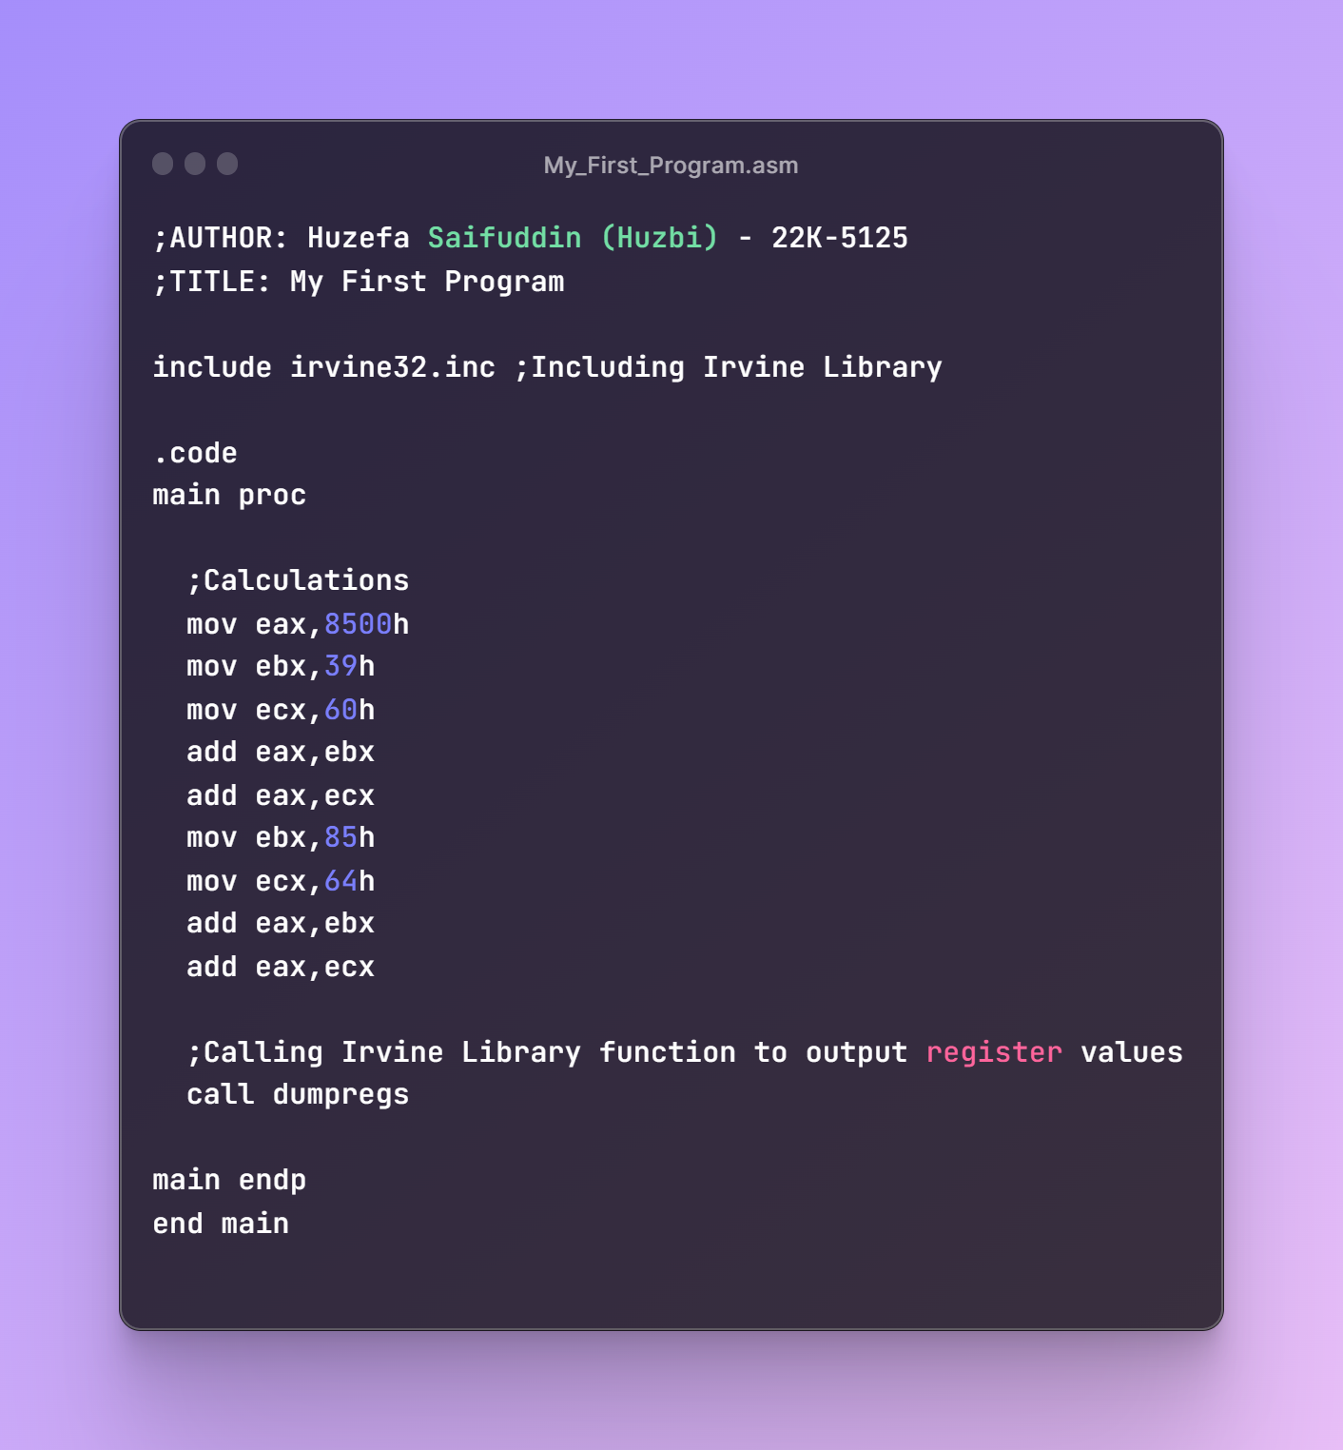

RESULT:

