

COAL – Lab: Project Report

Typing Game: Become a Typing Master

|  |  |
| --- | --- |
| Name | Student ID# |
| Huzefa Saifuddin | 22K-5125 |
| Muhammad Suhaib Qazi | 22K-5073 |
| Areeb-ur-Rehman | 22K-6003 |

Contents

Typing Game Report 3

Introduction 3

Features 3

Code Examples 3

Accuracy and Mistakes Tracking 4

Video Demo 4

Conclusion 4

References 5

# Typing Game Report

## Introduction

The Typing Game is a fun and challenging program written in Assembly language using the Irvine32 library. It presents the user with a series of strings that fall from the top of the screen, and the user must type these strings before they hit the bottom of the screen. The game has multiple levels, each of which is faster than the last. The number of strings and their size can be adjusted before the start of the program. The game also keeps track of the user's accuracy and mistakes after each level

## Features

* The game starts with a block at the bottom of the screen.
* The user must type the strings as they fall from the top of the screen.
* If a string is correctly typed, it will disappear.
* If a string is not correctly typed, it will turn red and the user will be restricted from typing the next character until the incorrect string is typed correctly.
* After completing a level, the game displays the number of mistakes and the user's accuracy.

## Code Examples

Here are some key parts of the code:

* BetterRandomRange PROC l: SDWORD, h: SDWORD: This procedure generates a random number between l and h.
* RandomString PROC uses esi ecx n: DWORD`: This procedure generates a random string of length n.
* set_speed PROC: This procedure sets the speed of the game according to the level.
* init_string PROC: This procedure initializes all the strings with random strings.
* user_input PROC: This procedure handles the user's input and updates the game state accordingly.

## Accuracy and Mistakes Tracking

The game keeps track of the user's accuracy and mistakes by comparing the user's input with the current string. If the user's input is correct, the correct count is incremented. If the user's input is not correct, the mistake count is incremented. This information is then used to calculate the user's accuracy and mistakes.

## Video Demo

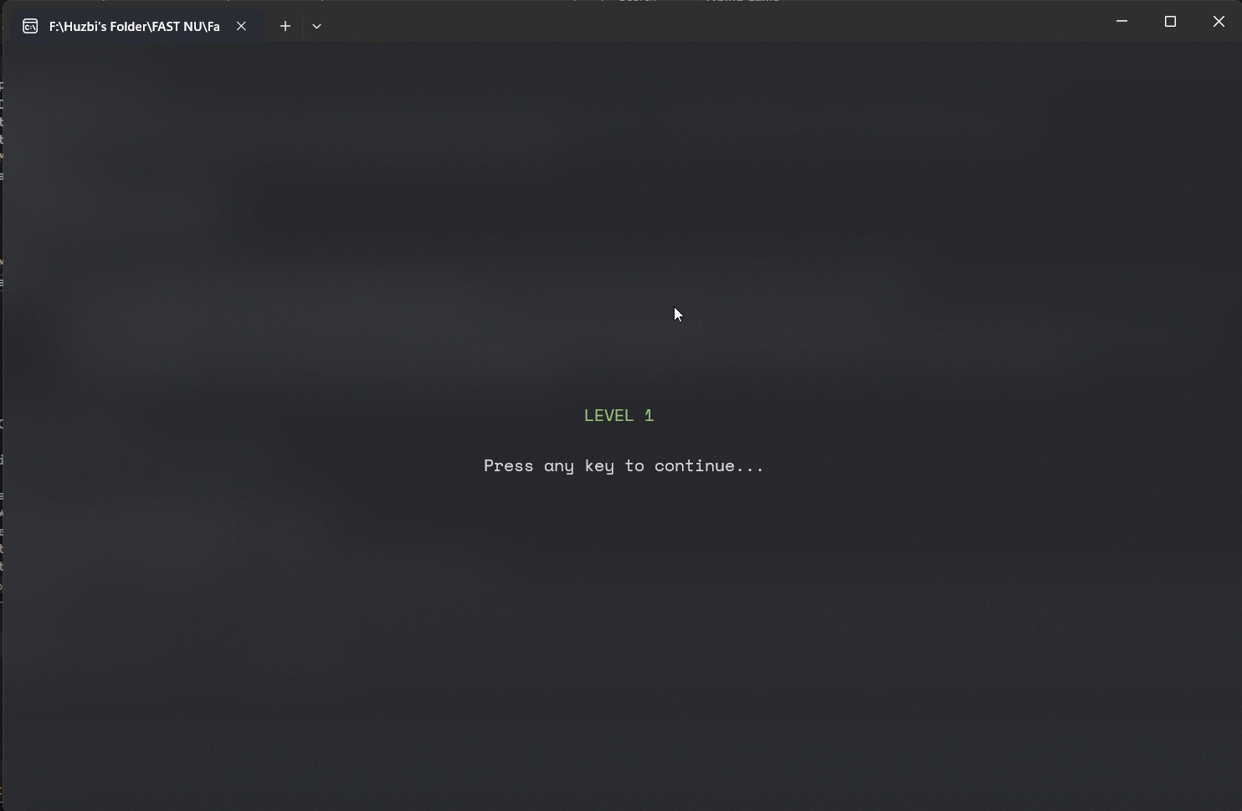  
Screenshot of the Game start.

You can find the video demo [here](https://file.garden/ZMu15i0EPHK4dj3e/Videos/Game_Demo.mp4).

## Conclusion

This typing game is a fun and challenging way to improve your typing skills. It is a great tool for both beginners and experienced typists.

## References

1. <http://www.nlpir.org/wordpress/wp-content/uploads/2019/03/Assembly.Language.For_.x86.Processors.Kip_.R..Irvine..6ed.Prentice.Hall_.2011www.xuexi111.com_.pdf>
2. <https://medium.com/@be.content23/a-comprehensive-guide-to-managing-game-logic-and-events-a3d60f1b9cb5>
3. <https://www.youtube.com/watch?v=dPvbgnbLTAM>