1. In the below elements which of them are values or an expression? eg:- values can be integer or string and expressions will be mathematical operators.

*

'hello'

-87.8

-

/

6

Answer: Value : ‘hello’, -87.8, 6

Expression: *, - , /, +

2. What is the difference between string and variable?

Answer: Variable is used to store the information, while string is a text usually enclosed with “”.

3. Describe three different data types.

Answer: String, Integer, Float, Complex number,

4. What is an expression made up of? What do all expressions do?

 An expression is an instruction that combines values and operators and always evaluates down to a single value. Expressions are representations of value.

5. This assignment statements, like spam = 10. What is the difference between an expression and a statement?

Answer: **An expression usually represent a code that can be evaluated to a value,**and is made up of variables, operators, while statement is just like a command that a python interpreter executes like print.

6. After running the following code, what does the variable bacon contain?

bacon = 22

bacon + 1

Answer: It gives 23 as a final answer.

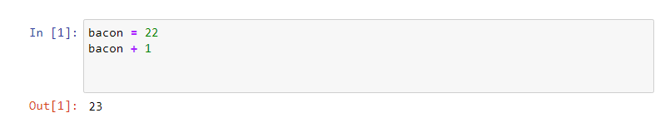

7. What should the values of the following two terms be?

'spam' + 'spamspam'

'spam' * 3

Answer: output is same in both the conditions

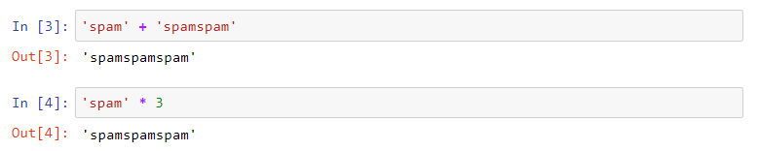

8. Why is eggs a valid variable name while 100 is invalid?

Answer: Because we can’t give an integer name to a variable

9. What three functions can be used to get the integer, floating-point number, or string version of a value?

Answer: str(), int(), float()

10. Why does this expression cause an error? How can you fix it?

'I have eaten ' + 99 + ' burritos.'

Answer: Because 99 is an integer we it cannot be concatenated with springs. To concatenate we should have to do typecasting.