**Point Of Care Device for Measurement and Analysis of Vital Parameters**

1Huzefa Essaji, 2Parth Bhalerao, 3Vivek Kaushik, 4Chandrakant Mohadikar, 5Mridula Korde *Department of Electronics and Communication Engineering, Shri Ramdeobaba College of Engineering and Management*, Nagpur, *Maharashtra, India. Email Id: 1*[*essajihf@rknec.edu*](mailto:essajihf@rknec.edu)*,* [*2bhaleraopv@rknec.edu*](mailto:2bhaleraopv@rknec.edu)*, 3*[*kaushikv_1@rknec.edu*](mailto:kaushikv_1@rknec.edu)*, 4*[*mohadikarcm@rknec.edu*](mailto:mohadikarcm@rknec.edu)*, 5*[*kordems@rknec.edu*](mailto:kordems@rknec.edu)*.*

***Abstract:*** This research aims in proposing a solution towards making of a portable device, which is capable of measuring vital parameters of human body such as Body Temperature, ECG & PPG and further calculating other parameters like Heart Rate and Blood Pressure via implementing of several algorithms in a non-invasive way. Additionally, this study focuses on how the desired system can be designed in as low form factor as possible. This research discusses and demonstrates and the prototype of the mentioned idea and its performance analysis. Lastly, the paper throws light on future recommendations and how the system can be improved further as well as the results.

**Keywords:** ECG, Health Care, PPG, Signal Processing, Machine Learning, Body Temperature, STM-32, practo-service.

**Introduction**

As we know, whenever a patient goes to a doctor, with slightly irregular symptoms, the most common advice that is being given to him/her is to perform all vital related tests like ECG, blood test, PPG, Heart Rate, along with other parameters like body temperature, throat infection, eye checkup, as per the patient symptoms and requirements. It is necessary to get these tests done for the obvious reasons of early diagnosis of any disease.

As per a survey done in 2019, statistics show that over 25% to 50% deaths worldwide are caused by cardio vascular diseases (CVD). Estimated 17.9 million people died due to CVD in year 2019. In many of such cases, either the disease was late diagnosed or was not even diagnosed till the death of patient.

However, this was the survey done before the Covid-19 pandemic and the cases of CVD have tremendously increased during and after pandemic. This provides a necessity of such devices in market and we must establish a complete end to end system right from collecting data from patients to consultation with doctor.

To provide a solution to this, we have designed a device with a low form factor and high portability providing functionalities like ECG monitoring, Heart Rate calculation and Body Temperature measurement.

Many a times, people in rural areas do not have these facilities and they tend to migrate from rural areas to urban areas at several multi-specialty hospitals, to get these tests done but only few of them manage to afford these expensive facilities.

The Point of care Device will be able to deliver clinical outcome at minimum cost as compared to standard medical test procedures. Also, it will be very safe and simple to use by the patients. This is a non-invasive type of device which will not cause any pain or discomfort to the patient and hence more acceptable. Once the proof of concept is established on a limited set of human beings, this will lay the ground for a clinical trial on a larger set of human beings. This will also be a requirement by the regulatory body.

An Accredited Social Health Activist is a community of health worker employed by the Ministry of Health and Family Welfare as a part of India’s National Rural Health Mission.

These health workers are called as ASHA Workers. This Point of care device will be very helpful and handy to these ASHA workers to carry out health related survey in rural areas of India.

**Related Work**

In research done in 2010, by Xin Guo from Hebei University of technology, proposed a portable ECG Monitoring System, which majorly gave a theoretical explanation of how the required system can be developed using an 8051-Microcontroller variant. However, this proposed system is concerned only with transfer of ECG data and its display.

Another study, carried by Tang Lili & Huang Wei, developed a portable ECG System, which uses an MSP control unit, which is an Arduino Like board. The major concern of this study was how ECG data can be acquired via sensors and how various data transfer interface like UART & SPI can be established and developing an Android based UI for display, along with Wi-Fi facility for wireless communication.

Similarly in 2020 a research, carried out by Muharrem Çelebi of Kartepe Vocational and Technical Anatolian High School, proposed a system in which AD8232 ECG sensor is interfaced with Arduino Nano and a LCD along with SPI communication interface and shows results of ECG samples at various frequency.

In 2020 a study was carried by the people of Department of Electronics and Telecommunication Engineering of Ramiah Institute of Technology, Bangalore India, proposing a system in which Raspberry Pi was interfaced with AD8232 ECG sensor and the final system was portable, however the additional thing which was done by this study was that it did not only develop a monitoring system, but also did an analysis of couple of machine learning algorithms, which paper suggests should be dumped into raspberry pi to establish a complete end to end system.

A similar attempt was observed in a study, carried out by people of Department of Electrical and Electronics Engineering, Chittagong University, which developed a complete end to end ecosystem for portable ECG monitoring and alarming system. However, they used several hardware components like Raspberry pi-3, ECG sensor AD8232, Arduino nano, etc. This makes the whole system very bulky and further optimization must be done.

Many research papers are published, which have carried out a detailed survey regarding analysis of several machine learning techniques on ECG signal. One such survey published in 2015, carried out by Shweta H. Jambukia and her associates of department of Information Technology, shows a detailed comparison of nearly 50 to 60 algorithms, carried out by other individuals along with accuracy and precision.

Many of such papers exist, which state analysis on several machine learning algorithms for ECG based signals, one such paper which was published in 2021, by Zeeshan Ahmad and his associates of Toronto University, provides discussion of CNN based algorithm into several classes named as N, S, V, F, Q respectively, each class providing its own meaning and different set of conclusions regarding heartbeat.

Lastly, a study was carried out by Sarvesh Kumar & Shahanaz Ayub from Department of Electronics and Communication Engineering of Bundelkhand Institute of Engineering & Technology, which majorly discusses a non-invasive way by which Blood Pressure can be estimated using ECG and PPG data.

It can be observed that, many attempts have been made in order to develop a portable system efficient enough to monitor and provide analysis of ECG signals of the patient. However, many of such studies do not discuss several points like providing a rough analysis on the ECG signal acquired and only are concerned with monitoring. Some provide only monitoring while some provide only a rough analysis of ECG signals implementing several ML algorithms.

Also, several points like whether any noise is occurred in procuring ECG signal, when the system was developed and which kind of filters must be implemented to better the results.

Methodology

Our proposed system or method can be divided into two parts for understanding purpose.

Part-1: Prototype phase

In this phase, we have developed a portable black box, which is able to perform two basic tasks, one is indicating the temperature of the body and second is acquiring a 3-lead ECG and displaying it on a screen as well as calculating heart rate from it.

During development of the prototype, we have majorly used the following components:

* ESP32
* TP4056
* AD8232 (ECG Sensor)
* MLX-90614 (Temperature Sensor)
* TFT Screen (Display Screen)
* USB Module
* Battery and Push Buttons

ESP32 is communicating with temperature sensor via I2C protocol. Similarly, ESP32 is communicating with TFT Screen via SPI protocol. TP4056 is used as a power regulating IC, which is connected to a battery as a power source for complete system as well as USB Module. Push Buttons are used to give external interrupts. Three push buttons are used out of which, one is the power button to turn the device ON/OFF. The other two act as buttons for selecting options one is for temperature while other is for selecting ECG and heart rate measurement. The block diagram in figure-1 shows the basic block diagram of the proposed system.

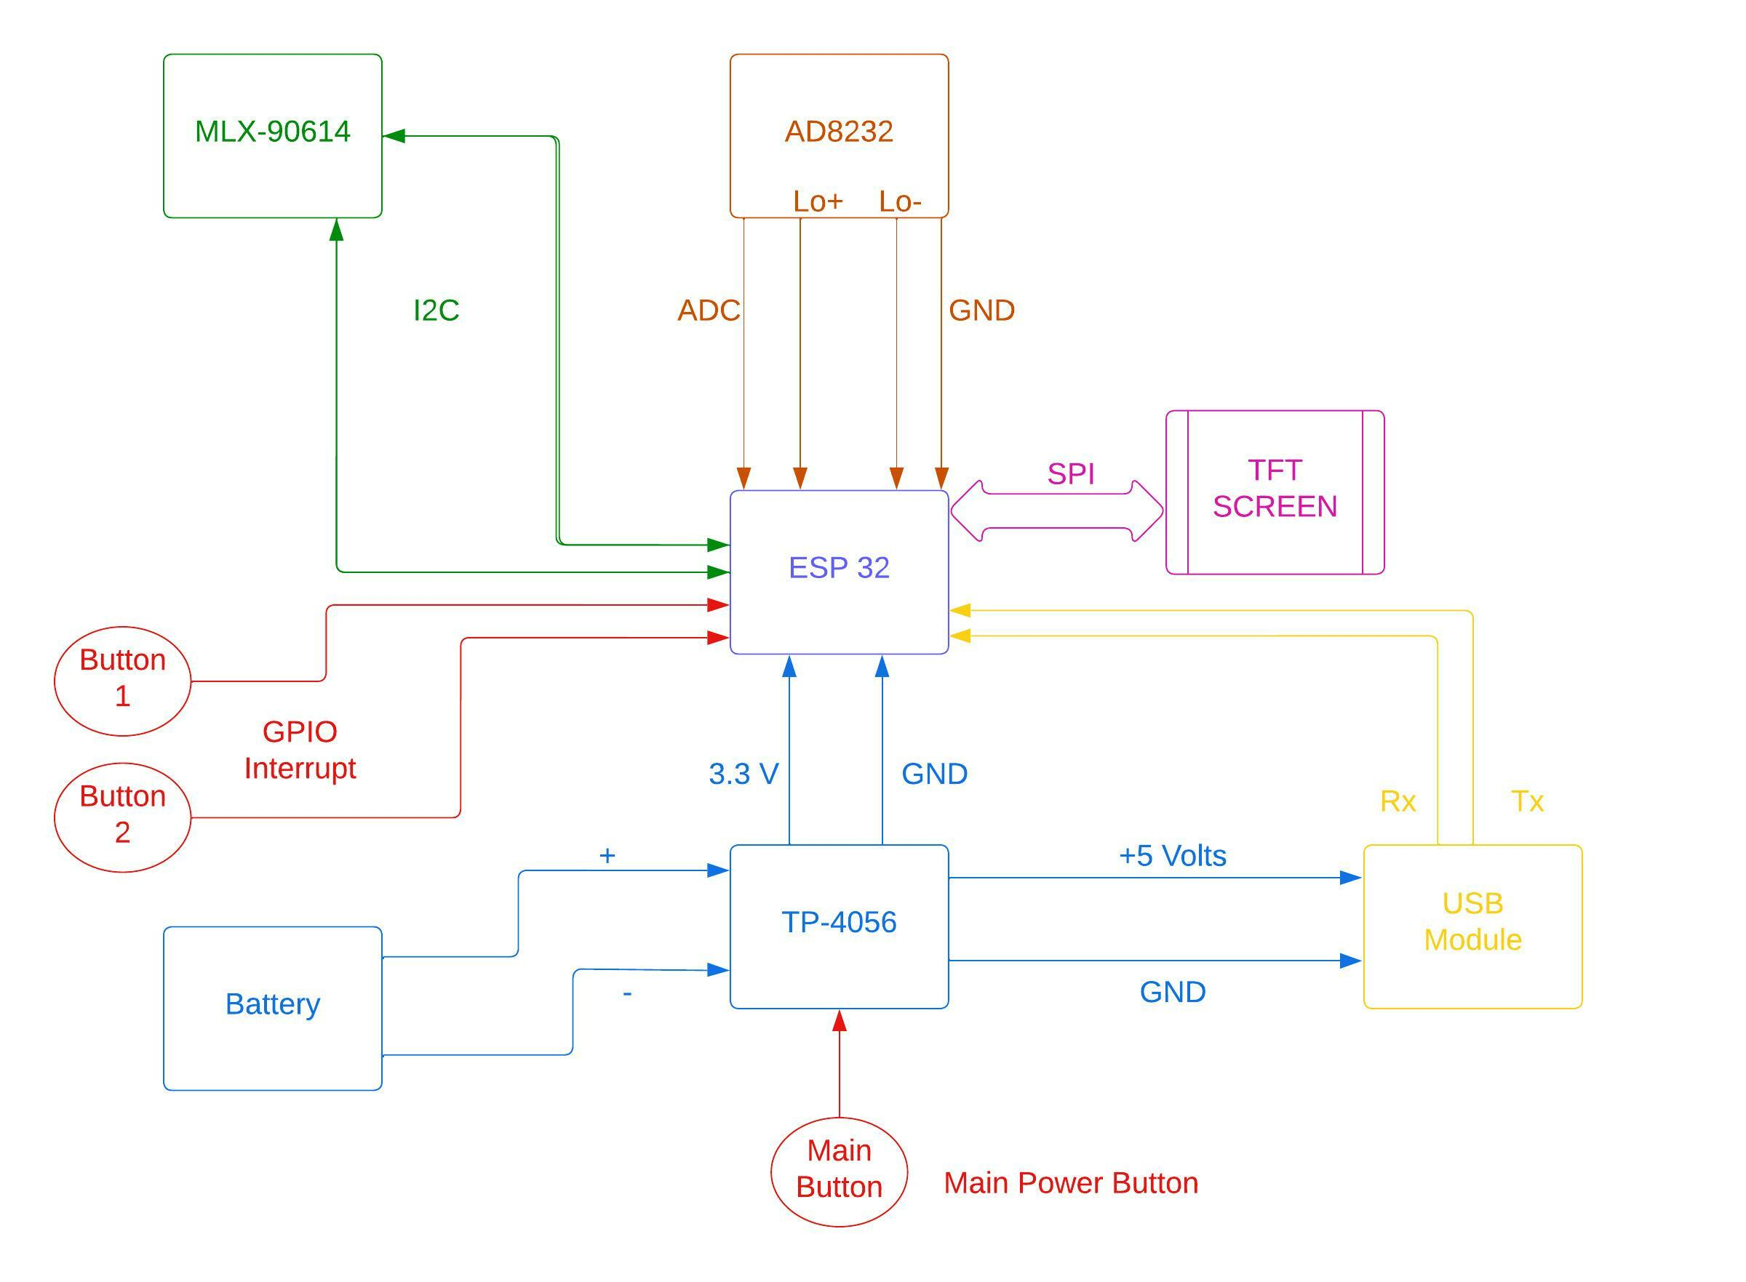

**FIGURE-1**

*Part-2: Product Phase*

The prototype developed in part-1 is sufficient enough to acquire ECG data and to display it. However, the system is not capable enough so that machine learning algorithms can be deployed in it. Also, in order to take this prototype to product stage and to put this for clinical trials or to sell to regular consumer, we need to improve the hardware and improve the credibility of the results. Also, the end product should have optimum power consumption. So, we must be able to deploy the machine learning model into our hardware for faster execution and edge computing. Similarly, we need to use medically graded sensors to improve accuracy and results.

Following components are used as a part of product phase:

* STM32-F303RET6 (Microcontroller)
* MAX14745 (Power Management IC)
* MAX86178 Sensor (ECG & PPG Sensor with Analog Front End)
* MLX90614 Sensor (Temperature Sensor)
* HC08 (Bluetooth Module)

MAX86178 is a clinical grade ECG & PPG sensor suitable for our product phase with analog front end. STM32 module will communicate with this ECG sensor via SPI protocol.

MLX90614 is the temperature sensor used, which will communicate with STM32 via I2C protocol. Also, the Power Management IC will communicate with STM32 via I2C protocol.

STM32 is capable enough such that machine learning algorithms and models can be deployed easily for faster execution analysis and edge computing. Bluetooth module is used to communicate and transfer data between our system and other device like smartphones. The block diagram in figure-2 shows the basic block diagram of the proposed system.

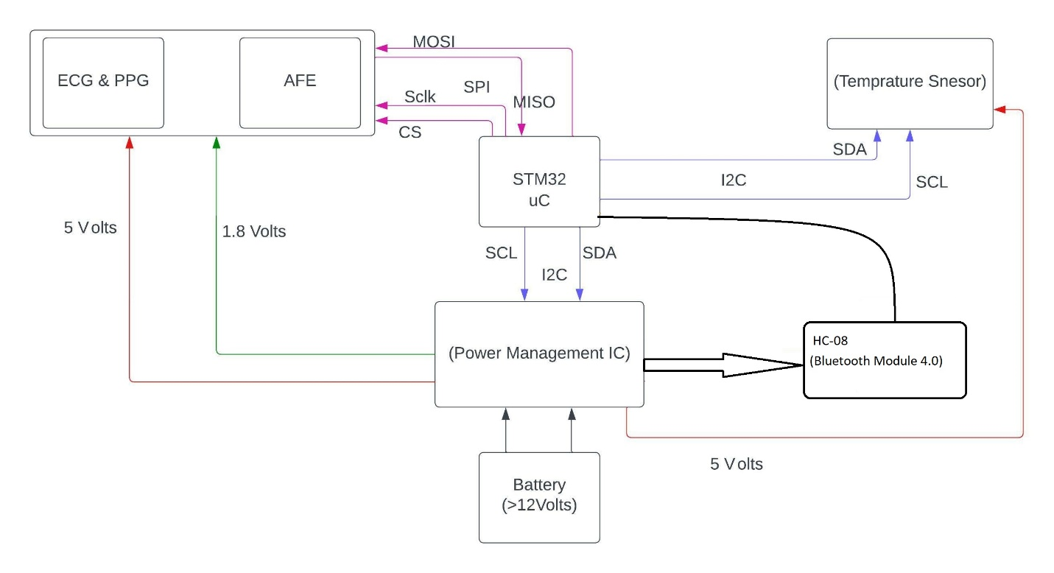

**FIGURE-2**

To further expand our application, we can also create a web-app or mobile app and push the data to our server. Further, we can keep a past and present record of patient as well as provide analysis to patient and establish a practo service and connect patients to doctor.

**Discussion & Results**

The figure-3 shows the prototype device developed. The device is completely operational with proper established firmware.

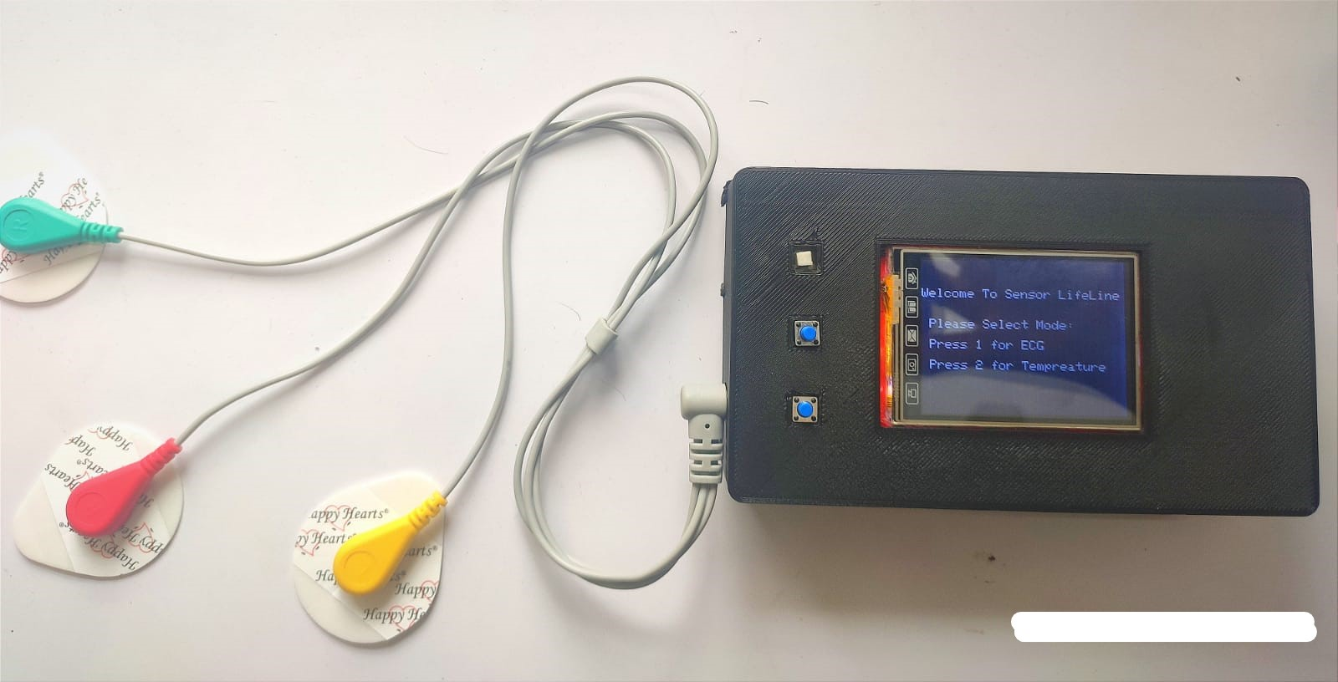

**FIGURE-3**

The figure-4 given below shows how the ECG waveform is displayed on our screen. It can be observed that obtained waveform consists of noise and needs further filtering. Similarly, figure-5 shows, how the data pushed from device is pushed to online web-server & web-app and waveforms can be observed along with calculated heart rate.

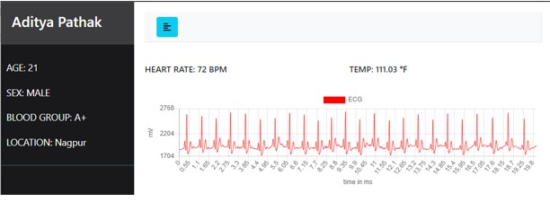

**FIGURE-4**

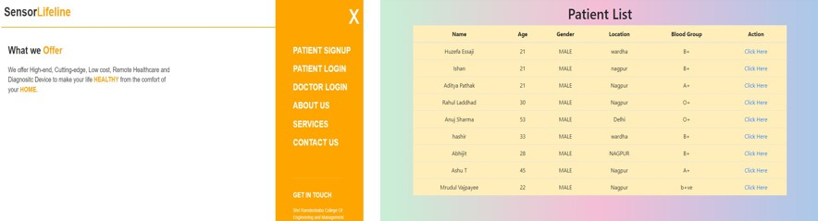

**FIGURE-5**

The algorithm used to calculate heart rate from ECG can be explained as follows:

***Step-1***

Record the ECG wave for specific duration of time.

***Step-2***

Get the value of maximum and minimum values that the waveform reached and calculate the difference between maximum and minimum values and obtain a threshold value.

***Step-3***

Analyze the complete waveform and count the number of times the QRS complex crossed the calculated threshold value.

***Step-4***

Consider the ECG wave is recorded for t-seconds and the count obtained from *Step-3* is denoted by *k*.

Hence Heart rate in BPM can be calculated as: (k*60)/t

It has been observed that the above algorithm for calculating heart rate has more than 90% accuracy. However, it has been observed that algorithm produce errors in case if the patient is not steady or still during recording of ECG. In such cases, the R-peak tends to rise abnormally and this leads to fluctuations in calculations of threshold value, further producing errors in heart rate. Hence, work has to be done on accuracy and improvement of heart rate calculation.

It can be observed from figure-4 that the acquired ECG wave is very noisy in nature and hence, filters must be applied on it in order to improve the quality of ECG wave obtained as this would be very necessary from clinical point of view.

Several filters, particularly equipped for ECG noise filtering such as: Diagnostic, Ambulatory & Patient monitoring, ST segment, Muscle & ESU noise filters. However, out of these mentioned filters, Ambulatory & Patient monitoring would be most suitable in this scenario which has a frequency range of 0.67 to 40Hz acting as a band pass filter which is most suitable for mild filtering for noisy environment, principally to detect the heart rate. Hence, further work is required in designing such ambulatory filters.

When hardware was upgraded in later stage, where in MAX86178 clinical grade sensor was used a better waveform, shown in figure-6, was obtained as the sensor itself has a second order FIR filter.

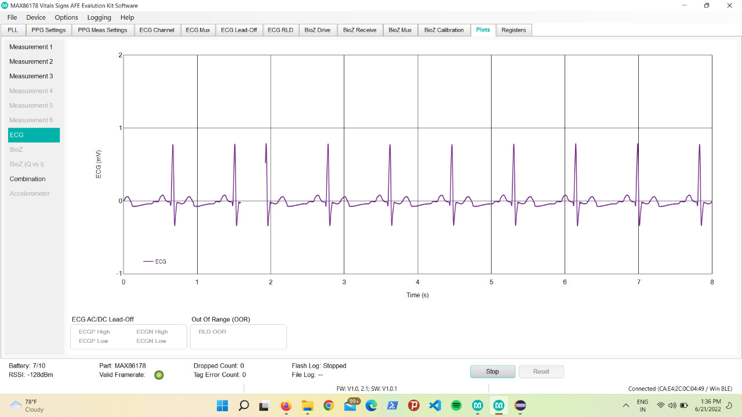

**FIGURE-6**

It can be clearly observed that the waveform obtained from the sensor is better than the one obtained previously as seen in figure-4. Further work is needed on setting appropriate filter configurations to enhance quality of wave acquired.

**Conclusion**

It was observed that results were significantly improved when hardware was upgraded from phase-1 to phase-2. However, further improvement is required on improving the filter configurations for better results. Secondly, the algorithm regarding heart rate calculation must be modified further in order to provide more accurate results. The current prototype, is very handy and easy to use. Further improvement can lead to reducing the form factor of device even lower and handy. This device is very beneficial for ASHA workers to go into rural area and collecting data from people. Such devices, providing monitoring functions and analysis of results, can help in early diagnosis of many diseases. Especially after Covid-19 pandemic need for such devices is extremely high and such devices have got a lot of potential for improvement and huge demand in market. Finally, patient record and history can be easily maintained.

With the proposed device a person doesn’t require to visit hospital and can eventually test for the required parameters using wearable medical device at home. Wearable medical device can provide regular records of these tests to doctors. The complete system is user friendly and easy to use. With the advances in this wearable medical device, we can help many patients by saving their time and money, along with connecting them with doctors remotely.

**Future Work**

The idea and prototype mentioned above has room of improvement in several areas. Further study and work is needed to acquire PPG waveform from MAX86178 and perform its analysis as well. Also, further work is required on calculating Blood pressure from ECG & PPG data in a non-invasive way. Similarly, further work is required to find and train the best suitable model for ECG & PPG analysis and further deploy this model in STM32 for edge computing and faster analysis.

Along with this, several features can be added to this existing device such as, interfacing an additional camera module for taking images of retina and ear canal. Such a handy device would be easy for doctors to remotely monitor their patients by observing images of pupil or ear canal or any type of skin infections. As a result of this, a complete end to end ecosystem can be established for remote patient consultation and practo service. Further patient history could be linked to patients Aadhar card or Health card.

**References**

* Portable ECG Monitoring System with USB Host Interface (2010 IEEE-EMB), 2010 3rd International Conference on Biomedical Engineering and Informatics.
* Portable ECG Device for Remote Monitoring and Detection of Onset of Arrhythmia (IEEE 2020), 2020 IEEE International Conference on Electronics, Computing and Communication Technologies (CONECCT).
* A Survey : Classification of ECG Signals using Machine Learning Techniques (IEEE 2015), 2015 International Conference on Advances in Computer Engineering and Applications.
* Application of Machine Learning on ECG Signal Classification Using Morphological Features (IEEE 2020), 2020 IEEE Region 10 Symposium (TENSYMP).
* Estimation Of Blood Pressure by using Electrocardiogram(ECG) and Photo-plethysmogram(PPG) (IEEE 2015), 2015 Fifth International Conference on Communication Systems and Network Technologies.
* ECG Heartbeat Classification Using Multimodal Fusion (IEEE 2021), IEEE Access, 9, 100615–100626.
* Jourand, P., De Clercq, H., Corthout, R., & Puers, R. (2009). Textile integrated breathing and ECG monitoring system. Procedia Chemistry, 1(1), 722-725. Weiler, D. T., Villajuan, S. O., Edkins, L., Cleary, S., & Saleem, J. J. (2017, September).
* Wearable heart rate monitor technology accuracy in research: a comparative study between PPG and ECG technology. In Proceedings of the Human Factors and Ergonomics Society Annual Meeting (Vol. 61, No. 1, pp. 1292-1296).
* Chan, M., Estève, D., Fourniols, J. Y., Escriba, C., & Campo, E. (2012). Smart wearable systems: Current status and future challenges.
* Chung, H. U., Rwei, A. Y., Hourlier-Fargette, A., Xu, S., Lee, K., Dunne, E. C., ... & Rogers, J. A. (2020). Skin interfaced biosensors for advanced wireless physiological monitoring in neonatal and pediatric intensive-care units.