* **Idea Introduction :**
* **Block Diagram :**

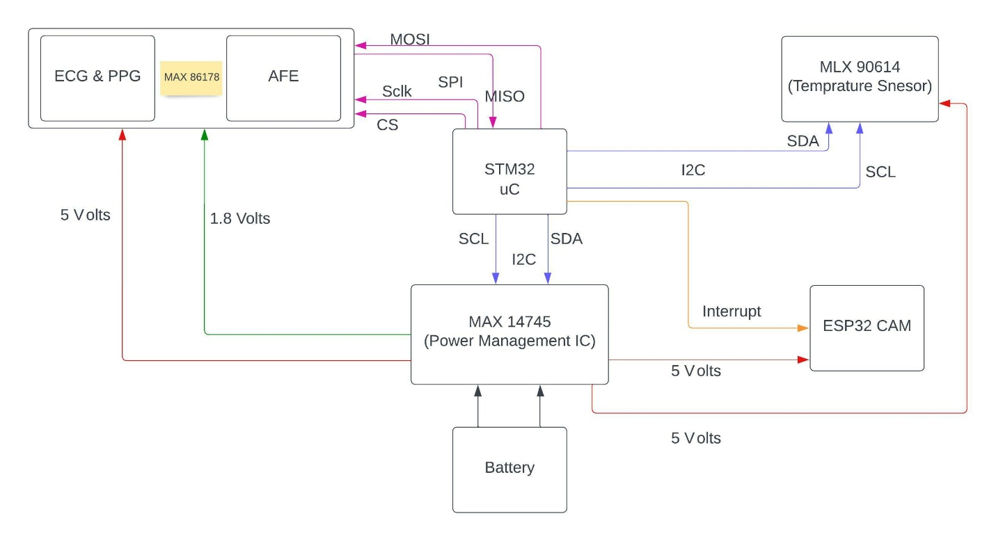

* **Hardware Details :**
* **Process Flow Chart :**

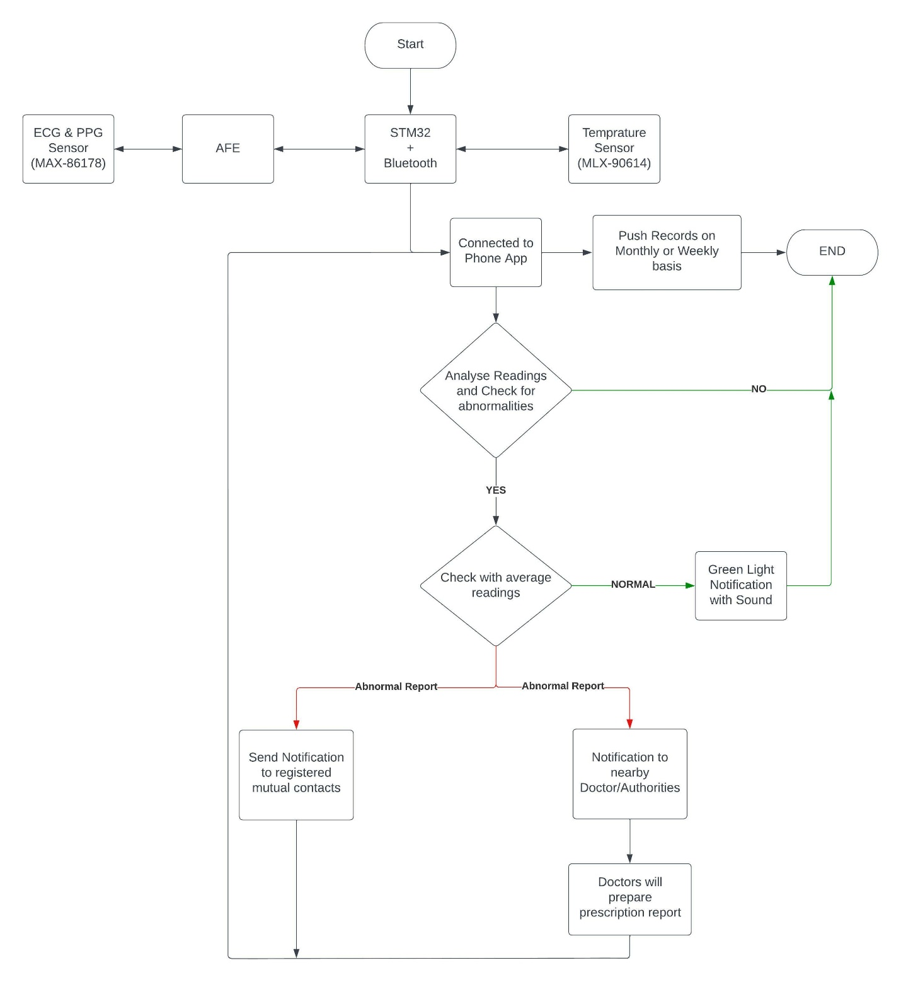

* **Any other additional details :**

* **Approximate Bill of Material :**
* **Authorization Letter from the Institute :**

**Authorization letter for participation in “The Inventors Challenge 2022”**

**To whom so ever it may concern**

Subject: Authorization of Participants for “The Inventors Challenge 2022” jointly organized by All India Council for Technical Education (AICTE), Arm Education and ST Microelectronics.

I hereby certify/authorize that the below listed faculty and students are enrolled in our institution Shri Ramdeobaba College of Engineering and Management Nagpur Maharashtra.

|  |  |  |  |
| --- | --- | --- | --- |
| Name of the Faculty | Designation | E-mail | Department |
| 1. Dr Deepak Khushlani | Associate Professor | khushalanidg@rknec.edu | E&C |

|  |  |  |  |  |
| --- | --- | --- | --- | --- |
| Students’ Name | Degree | Current Year/Semester | E-mail | Department |
| 1. Huzefa Essaji, | BE | 7TH Sem | essajihf@rknec.edu | E&C |
| 2.Chandrakant Mohadikar, | BE | 7TH Sem | mohadikarcm@rknec.edu | E&C |
| 3. Vivek Kaushik, | BE | 7TH Sem | kaushikv_1@rknec.edu | E&C |
| 4. Parth Bhalerao | BE | 7TH Sem | bhaleraopv@rknec.edu | E&C |

***Name of the idea:***

Development of Point of Care Device for measurement and analysis of vital parameters.

***Abstract of the Idea:***

HoD EC Name : Dr. Dipak .J. Dahigaonkar

HoD EC Signature:

Institute Seal

Date: