Software Requirements and Design Document
for
SmartKiryana
Prepared by Burhan Ahmed, Ali Akbar and Huzaifa Ali
FAST NUCES ISLAMABAD
30/04/2026

Contents
1. Introduction 1
1.1 Purpose 1
1.2 Product Scope 1
1.3 Title 1
1.4 Objectives 1
1.5 Problem Statement 2
2. Overall Description 2
2.1 Product Perspective 2
2.2 Product Functions 3
2.3 List of Use Cases 3
2.4 Extended Use Cases 4
2.5 Use Case Diagram 34
3. Other Nonfunctional Requirements 35
3.1 Performance Requirements 35
3.2 Safety Requirements 35
3.3 Security Requirements 35
3.4 Software Quality Attributes 35
3.5 Business Rules 35
3.6 Operating Environment 35
3.7 User Interfaces 36
4. Domain Model 37
5. System Sequence Diagram 38
6. Sequence Diagram 68
7. Class Diagram 83
7.1 Version 1: 83
7.2 Version 2: 84
8. High-level Architecture 85
8.1 Package Diagram 85
8.2 Deployment Diagram 86
8.3 Component Diagram 87
9. Work Division Table 87

Introduction

Purpose
The purpose of this Software Requirements Specification (SRS) document is to outline the functional and non-functional requirements for the SmartKiryana System (Version 1.0). The primary objective of the SmartKiryana System is to provide a digitized and automated solution for the operations of small- to medium-sized grocery (kiryana) stores.

This document is intended for developers, project stakeholders, instructors, and users of the system. The SRS specifies how the system is expected to behave, as well as its limitations and features. This SRS encompasses the entire function of the SmartKiryana system, including inventory management, billing, employee management, and analytics.

Product Scope
The goal of SmartKiryana is to develop a digital retail management system to eliminate the need for traditional manual processes in local grocery stores, improve overall efficiency within grocery stores, reduce human error, and give shop owners access to data-driven information.

A few of the general goals of this system are to improve Operational Efficiency; decrease lost revenue through inefficient inventory management; improve Customer Service by reducing the time required to bill customers; and lastly, increase the ability of shop owners to make data-driven business decisions through reporting and analytics.

Title
SmartKiryana: A Digital POS and Retail Management System for Local Grocery Stores

Objectives
The main objectives of SmartKiryana are:
- To automate billing and sales transactions
- To maintain accurate and real-time inventory records
- To manage employee accounts and track performance
- To generate sales reports and analytics dashboards
- To reduce human errors in calculations and record-keeping
- To provide insights for better business decisions
- To support integration with payment services

Problem Statement
In Pakistan, small and medium-sized Kiryana stores primarily use handwritten registers and basic tools to manage inventories, sales, and employee records, because they do not have access to a more sophisticated system. These manual systems are inefficient, mistake prone, lack analytics, and result in problems like incorrect billing, mismanagement of stock, a lack of transparency, and difficulty in monitoring employee performance.

Moreover, due to the absence of a centralized system, it is challenging to generate reports, monitor sales trends, and make informed business decisions; therefore, Kiryana Shop owners incur significant financial loss, overstock/understock their stores, and are much less effective in business operations.

SmartKiryana provides kiryana Shop Owners with a comprehensive digital solution that automates the core business processes, provides accurate information, and enables the shop owner to manage their business in a more data driven manner and use of this type of system is becoming increasingly feasible due to the availability of affordable computer technology and the increased use of digital solutions in retail settings.

Overall Description

Product Perspective
SmartKiryana is an independent platform that has been designed to replace the traditional methods used to manage and run your local grocery retail business. Unlike other solutions which have been developed as part of an existing family of solutions, SmartKiryana can be extended into larger retailer systems at some point in the future.

The SmartKiryana platform works with various external entities including:
- Payment processing services that are necessary for payments
- Regulatory agencies that require compliance and reports around sales and operations
- Database services for information storage and retrieval

Internally the SmartKiryana platform contains several modules:
- Inventory Management
- Invoice Management
- Employee Management
- Reporting and Analytics
When used together, the modules provide a comprehensive and complete solution to all of the aspects of managing your grocery store's operations.

Product Functions
SmartKiryana provides the following major functions:
- Manage employee accounts (add, update, remove employees)
- Manage inventory (add products, update stock, categorize items)
- Generate and manage customer bills
- Process item returns
- Track and analyse sales data
- Generate monthly reports
- Set and monitor sales targets
- View sales dashboard and analytics
- Track employee performance
- Receive stock alerts for low inventory
- Access bill history

List of Use Cases
Use Case ID | Use Case Name
UC01 | Manage Employee Accounts
UC02 | Manage Inventory
UC03 | Receive Stock Alerts
UC04 | Filter Sales Data
UC05 | Set Monthly Sales Targets
UC06 | Review Employee Performance
UC07 | View Sales Dashboard
UC08 | Generate Monthly Reports
UC09 | Manage Billing
UC10 | Process Item Return
UC11 | Generate Customer Bill
UC12 | View Inventory Availability
UC13 | Access Bill History
UC14 | Track Personal Performance
UC15 | Manage Product Categories

Extended Use Cases
UC01
Use Case Section | Comment
Use Case Name* | Manage Employee Accounts
Scope | SmartKiryana
Level | User Goal
Primary Actor* | Admin
Stakeholders and Interests | - Admin: Wants to Apply CRUD Operation to Employee for contained access and up-to-date information  - Employee: Want to get registered or change current info
Preconditions | - Admin Should be Logged in the system
Success Guarantee (Post Conditions) | - The records are updated in the database  - A success message is displayed
Is Main Success Scenario* | UC01: Main Success Scenario
  Actor Action | System Responsibility
  Admins logs in the system and chooses the Manage Employees Option
   | The System Shows the current Employee List
  Admin chooses the desired CRUD operation and inputs any information required. | The system Validates the information entered
   | The System updates the employee Database.
   | A Success Message is shown to the admin
Extensions* | - The Employee details are incomplete  - Ask the user to enter complete Details  - The Employee already exists  - Ask the user to enter new Employee details  - Database not connected  - Reload the Manage Employee Module  - Contact IT Department
Special Requirements | - The Data entered should be stored securely and only accessible to admin  - System must respond to operations within 3 seconds.
Technology and Data Variations List | - The Employee may provide his CNIC Number or Passport for identification
Frequency of Occurrence | - Occasionally. Used when Data of Employee Change
Miscellaneous | - Are there any roles between the Employees?  - Could we integrate employee attendance modules in the future?  - Could the system include employee account deactivation instead of permanent deletion?

UC02
Use Case Section | Comment
Use Case Name* | Manage Inventory
Scope | SmartKiryana
Level | User Goal
Primary Actor* | Admin, Employee
Stakeholders and Interests | Admin: Wants the Inventory to be up-to date  Employees: Wants the Inventory to be up-to-date process sale smoothly
Preconditions | - The user must be successfully logged into the system.
Success Guarantee (Post Conditions) | - Inventory records are updated in the database according to the operation performed.  - The system displays a Success message
Main Success Scenario* | UC02: Main Success Scenario
  Actor Action | System Responsibility
  The user logs into the system and navigates to the Inventory Management module.
   | The system displays the list of inventory items along with available operations.
  The user selects one of the Available operations and enters the required information. | The system validates the entered information
   | The system updates the inventory records in the database according to the selected operation.
   | The system displays a success message confirming the operation.
Extensions* | - Invalid or Incomplete Data  - Ask the user to enter correct data.  - Duplicate Item Entry  - Notify the User the Item already Exists  - Database or System Error  - Ask the User to try again  - On persistent Issue contact the IT department
Special Requirements | - Only authorized users should be able to access inventory management functions.  - The interface should clearly display inventory information and provide simple navigation for operations.  - The system must ensure that inventory updates are atomic to prevent partial updates.
Technology and Data Variations List | - Item identifier entered by bar code laser scanner (if bar code is present) or keyboard.
Frequency of Occurrence | - Daily. Used Almost daily whenever new batches of items arrive
Miscellaneous | - Explore the bulk inventory import/export (e.g., CSV or Excel files) option  - Should employees have limited permissions compared to admins (e.g., cannot delete items)?

UC03
Use Case Section | Comment
Use Case Name* | Receive Stock Alerts
Scope | SmartKiryana.
Level | User Goal
Primary Actor* | Admin
Stakeholders and Interests | - Admin: Wants to be quickly informed about out-of-stock items so that necessary actions (such as restocking) can be taken.
Preconditions | - The admin must be successfully logged into the system.  - Inventory records must exist in the system.
Success Guarantee (Post Conditions) | - The admin is notified about all out-of-stock items.  - Alerts are cleared for the current login session after being displayed.
Main Success Scenario* | UC03: Main Success Scenario
  Actor Action | System Responsibility
  The admin logs into the system and proceeds to the Inventory Management module.
   | The system retrieves inventory records from the database and analyses inventory quantities for each item.
   | The system identifies items with few stock quantities and displays alerts for these items.
  The admin acknowledges the alerts. | The system clears up the alerts for the current login session.
Extensions* | - No Out-of-Stock Items  - The system shows no alert  - System Failure  - The user restarts the system and logs in again  - If the issue persists, contact the IT department
Special Requirements | - The system should generate stock alerts within 2 seconds after accessing the inventory module.  - Alerts must accurately reflect the latest inventory data from the database.  - Alerts should be clearly visible.
Technology and Data Variations List | - Alerts may be displayed as pop-up notifications, dashboard messages, or highlighted inventory items.
Frequency of Occurrence | - Medium – Occurs only when a registered Item is low on Inventory.
Miscellaneous | - Should the system support automatic email or SMS notifications for out-of-stock items?  - Should there be configurable stock thresholds?

UC04
Use Case Section | Comment
Use Case Name* | Filter Sales Data
Scope | SmartKiryana
Level | User Goal
Primary Actor* | Admin
Stakeholders and Interests | Admin: Wants quick filtered insights for decision making.  Sales Analyst: Needs precise data for analysis.
Preconditions | - Actor is logged into the system.  - Sales data exists in the database.
Success Guarantee (Post Conditions) | - The system displays filtered sales records based on the criteria.
Main Success Scenario* | UC04: Main Success Scenario
  Actor Action | System Responsibility
  Admin opens the sales data module. | System displays all available sales data.
  Admin selects filter criteria (date range, product category, store location).
   | System receives filter parameters.
  Admin applies the filter. | System processes the filtering request.
   | System displays the filtered sales data.
Extensions* | Invalid filter criteria entered  - System displays error message and requests correction.  No matching data found  - System displays message: No records found
Special Requirements | - Filtering results should be displayed within 2 seconds for good user experience.  - Data must be presented in sortable tables or charts
Technology and Data Variations List | - Filters may include date ranges, product categories, store locations, or employee IDs.  - Data can be displayed in table view or graphical analytics view.
Frequency of Occurrence | - High – Actors may perform this operation multiple times daily.
Miscellaneous | - Future versions may allow saving custom filter presets.

UC05
Use Case Section | Comment
Use Case Name* | Set Monthly Sales Targets
Scope | SmartKiryana
Level | User Goal
Primary Actor* | Admin
Stakeholders and Interests | Admin: Needs to define achievable sales goals.  Employees: Require clear performance targets.
Preconditions | - Admin is authenticated in the system.
Success Guarantee (Post Conditions) | - Monthly sales targets are stored successfully.
Main Success Scenario* | UC05: Main Success Scenario
  Actor Action | System Responsibility
  Admin opens the sales target module.
   | System displays target configuration interface.
  Admin selects employee. | System retrieves relevant employee information.
  Admin enters monthly sales targets. | System validates entered values.
  Admin confirms the targets. | System saves targets in the database.
   | System displays success message.
Extensions* | Invalid target value entered  - System prompts admin to correct the value.
Special Requirements | - Target values must be numerical and within predefined limits.  - Only authorized actors can set or modify targets.
Technology and Data Variations List | - Targets may be defined per employee, per department, or per store.  - Data may be entered manually or uploaded via CSV file.
Frequency of Occurrence | - Medium – Typically done once every month.
Miscellaneous | - Historical targets should remain stored for performance comparison.

UC06
Use Case Section | Comment
Use Case Name* | Review Employee Performance
Scope | SmartKiryana.
Level | User Goal
Primary Actor* | Admin
Stakeholders and Interests | Admin: Wants insight into employee productivity.  Organization: Needs performance monitoring.
Preconditions | - Employee sales data exists.
Success Guarantee (Post Conditions) | - Employee performance metrics are displayed.
Main Success Scenario* | UC06: Main Success Scenario
  Actor Action | System Responsibility
  Admin opens employee performance module.
   | System displays available employee list.
  Admin selects an employee | System retrieves performance data.
  Admin requests performance analysis. | System calculates performance metrics.
   | System displays performance charts and statistics.
Extensions* | Employee data unavailable  - System displays notification: No performance data available.
Special Requirements | - Performance metrics should include sales totals, target achievement %, and rankings.  - Graphical representation should be supported.
Technology and Data Variations List | - Performance may be viewed per employee or time.  - Data may be displayed in charts, tables, or dashboards.
Frequency of Occurrence | - Medium – Admin may review performance weekly or monthly.
Miscellaneous | - Future versions may include AI-based performance recommendations.

UC07
Use Case Section | Comment
Use Case Name* | View Sales Dashboard
Scope | SmartKiryana
Level | User Goal
Primary Actor* | Admin
Stakeholders and Interests | Admin: requires quick visualization of business performance.
Preconditions | - Admin is logged into the system.
Success Guarantee (Post Conditions) | - Dashboard with updated sales analytics is displayed.
Main Success Scenario* | UC07: Main Success Scenario
  Actor Action | System Responsibility
  Admin selects the dashboard option.
   | System loads dashboard interface.
  Admin requests dashboard analytics. | System retrieves sales analytics data.
   | System displays charts, graphs, etc.
Extensions* | Analytics data unavailable  - System displays messages indicating data retrieval failure.
Special Requirements | - Dashboard must refresh data automatically at regular intervals.  - Charts should be interactive and responsive
Technology and Data Variations List | - Dashboard may include bar charts, pie charts, line graphs, and KPI indicators.  - Data sources may include real-time sales transactions and stored analytics data.
Frequency of Occurrence | - Very High – Admin may access the dashboard several times daily.
Miscellaneous | - Users may customize dashboard widgets in future updates.

UC08
Use Case Section | Comment
Use Case Name* | Generate Monthly Reports
Scope | SmartKiryana
Level | User Goal
Primary Actor* | Admin
Stakeholders and Interests | Admin: requires summarized reports for evaluation and planning.
Preconditions | - Monthly sales data exists in the system.
Success Guarantee (Post Conditions) | - A monthly sales report is generated and displayed.
Main Success Scenario* | UC08: Main Success Scenario
  Actor Action | System Responsibility
  Admin opens the report generation module.
   | System displays report options.
  Admin selects the month and report format. | System validates input parameters.
  Admin requests report generation. | System processes sales data.
   | System generates monthly report.
   | System displays the generated report.
  Admin views or downloads report.
Extensions* | Data missing for selected month  - System displays message indicating insufficient data.
Special Requirements | - Reports must support export formats such as PDF and Excel.  - Reports should include sales summaries, charts, and performance indicators.
Technology and Data Variations List | - Reports may be generated for different months, stores, or product categories.  - Output formats may vary (PDF, Excel, or on-screen display).
Frequency of Occurrence | - Medium – Typically generated once per month.
Miscellaneous | - Reports may later be automatically emailed to management.

UC09
Use Case Section | Comment
Use Case Name* | Process Sale
Scope | SmartKiryana
Level | User Goal
Primary Actor* | Employee
Stakeholders and Interests | - Admin: Wants correct revenue recording and inventory deduction.  - Employee: Wants a fast, accurate billing process.
Preconditions | - Employee is logged into the system.  - Products are registered in the system.
Success Guarantee (Post Conditions) | - A complete and accurate bill is generated.  - Inventory is automatically updated to reflect items sold.  - Transaction is recorded in the system's bill history.
Is Main Success Scenario* | UC09: Main Success Scenario
  Actor Action | System Responsibility
  Employee starts a new billing session.
  Employee scans barcode, enters serial number, or manually searches for the item. (Repeated for each item) | System retrieves item details and adds item to the bill with a running total
  Employee reviews bill and adjusts quantities if needed. | System recalculates totals after each modification.
   | System presents final total with applicable taxes.
  Employee confirms the bill and proceeds to checkout. | System finalizes the bill and saves the transaction.
Extensions* | - Item not found by barcode or serial number:  - System displays an error message. Employee switches to manual search.  - Database not connected  - Reload the Inventory Module
Special Requirements | - System must respond to item addition within 2 seconds.  - Billing must maintain 99.9% calculation accuracy.
Technology and Data Variations List | - Items may be added via barcode scanner, keyboard serial number entry, or mouse-driven manual search.  - Receipts may be printed physically or saved as digital records.
Frequency of Occurrence | - Multiple times per hour during store operating hours.
Miscellaneous | - Could I include customer loyalty points for discount?
UC10
Use Case Section | Comment
Use Case Name* | Process Item Return
Scope | SmartKiryana
Level | User Goal
Primary Actor* | Employee
Stakeholders and Interests | Admin: Wants accurate inventory restoration and return records.  Employees: Wants a straightforward process to handle customer returns.
Preconditions | - Employee is logged into the system.  - The original transaction exists in the bill history.
Success Guarantee (Post Conditions) | - Returned items are restored to inventory.  - The return is recorded in the system's transaction history.  - Revenue records are adjusted accordingly.
Main Success Scenario* | UC10: Main Success Scenario
  Actor Action | System Responsibility
  Employee accesses the bill history and locates the original transaction.
   | System displays the original bill details including all purchased items.
  Employee selects the item to be returned and initiates the return. | System validates the return request.
  Employee confirms the return.
   | System processes the return, restores stock levels, records the return transaction, and updates revenue figures.
Extensions* | - Original transaction cannot be found:  - System notifies the Employee. Employee may attempt a manual search by date or amount.  - Database or System Error  - Ask the Employee to try again
Special Requirements | - Return processing must update inventory in real time.  - All return records must be auditable by Admin.
Technology and Data Variations List | - Return confirmation may be printed or recorded digitally.
Frequency of Occurrence | - Occasional. several times per day depending on customer activity.
Miscellaneous | - Can the admin approval be needed for high-value returns?

UC11
Use Case Section | Comment
Use Case Name* | Generate Customer Bill
Scope | SmartKiryana.
Level | User Goal
Primary Actor* | Employee
Stakeholders and Interests | - Employee: Wants to quickly generate an accurate bill for the customer.  - Admin: Wants all generated bills stored accurately for reporting.  - Government Regulators: Want tax-inclusive receipts for audit purposes
Preconditions | - A billing session is active with at least one item added.
Success Guarantee (Post Conditions) | - A formatted receipt is generated showing all items, quantities, prices, taxes, and total.  - The bill is stored in the bill history.  - Inventory is updated to reflect the completed sale.
Main Success Scenario* | UC11: Main Success Scenario
  Actor Action | System Responsibility
  Employee requests bill generation.
   | System calculates the subtotal, applies applicable taxes, and computes the final total.
   | System generates a formatted receipt.
  Employee selects the receipt delivery method (print or digital). | System outputs the receipt via the selected method.
   | System saves the bill on the transaction history and deducts sold items from inventory.
Extensions* | - Printer is unavailable:  - System notifies the Employee. Employee switches to digital receipt option.
Special Requirements | - Receipt generation must complete within 3 seconds.  - Receipt must be formatted clearly and include all legally required fields.
Technology and Data Variations List | - Receipts may be printed via a thermal printer or stored as a digital record in the system.
Frequency of Occurrence | - Every completed billing session, multiple times per hour.
Miscellaneous | - Can the system email or SMS the digital receipts to customers?

UC12
Use Case Section | Comment
Use Case Name* | View Inventory Availability
Scope | SmartKiryana
Level | User Goal
Primary Actor* | Admin, Employee
Stakeholders and Interests | Admin: Wants accurate, real-time visibility of stock levels to make restocking decisions.  Employee: Wants to quickly check item availability during customer inquiries.
Preconditions | - User is logged into the system with appropriate access rights.
Success Guarantee (Post Conditions) | - The actor views accurate, real-time stock levels for the requested products.  - Any understock or overstock alerts are clearly displayed.
Main Success Scenario* | UC12: Main Success Scenario
  Actor Action | System Responsibility
  Actor navigates to the Inventory Management module.
   | System loads and displays the full inventory list.
   | System highlights any items flagged as understocked or overstocked.
Extensions* | - Inventory data fails to load:  - System displays an error notification  - If the issue persist contact the IT department.
Special Requirements | - Inventory data must reflect real-time stock levels updated after every transaction.  - Stock alerts must be visually distinct (e.g., color-coded) for quick identification.
Technology and Data Variations List | - Inventory may be searched by product name, category name, or barcode number.
Frequency of Occurrence | - Multiple times, as needed by user during customer interactions.
Miscellaneous | - Should the system support automated purchase order generation when understock is detected?

UC13
Use Case Section | Comment
Use Case Name* | Access Bill History
Scope | SmartKiryana
Level | User Goal
Primary Actor* | Admin, Employee
Stakeholders and Interests | - Admin: Wants full access to all transaction records for auditing, reporting, and analytics.  - Employee: Wants to retrieve specific bills to process returns or resolve customer disputes.  - Government Regulators: Want access to auditable transaction records for tax verification.
Preconditions | - User is logged into the system.  - At least one completed billing transaction exists in the system.
Success Guarantee (Post Conditions) | - The actor successfully retrieves and views the required transaction records.  - All displayed bill details are accurate and complete.
Main Success Scenario* | UC13: Main Success Scenario
  Actor Action | System Responsibility
  User navigates to the Bill History module.
   | System loads and displays a list of completed bills.
  Actor applies filters (e.g., by date range etc.) to narrow results
   | System filters and displays the matching bill records.
  Actor selects a specific bill to view its full details.
   | System displays the complete bill including all items, quantities, prices, tax breakdown, and total.
Extensions* | - Bill history fails to load:  - System displays an error notification.  - User contacts IT Support.
Special Requirements | - Bill history must be retrievable within 3 seconds for any date range.  - All records must be read-only to preserve audit integrity.
Technology and Data Variations List | - Admin may export bill history as a report (e.g. PDF etc).
Frequency of Occurrence | - Several times daily by Admin for reporting and by Employees when processing returns.
Miscellaneous | - Can I apply long-term archiving strategy for historical bills?

UC14
Use Case Section | Comment
Use Case Name* | Track Personal Performance
Scope | SmartKiryana
Level | User Goal
Primary Actor* | Employee
Stakeholders and Interests | Employee: Wants to monitor their sales performance and progress toward targets to improve productivity.
Preconditions | - The employee must be successfully logged into the system.  - The employee’s sales records must exist in the database.
Success Guarantee (Post Conditions) | - The employee is shown a summary report of their personal performance.
Main Success Scenario* | UC14: Main Success Scenario
  Actor Action | System Responsibility
  The employee logs into the system and navigates to the Personal Performance section.
   | The system retrieves the employee’s sales records from the database and calculates relevant performance metrics.
   | The system generates a performance summary report and displays it to the employee.
Extensions* | - No Sales Data Available  - The system displays a message indicating that no performance data is available.  - System Failure  - Ask the user to restart the system and try again.  - If the issue persists, contact the IT department.
Special Requirements | - The system should generate the performance report in 3 seconds.  - Employees should only be able to view their own performance data.  - The performance report should be clearly presented using readable summaries or charts.
Technology and Data Variations List | - The performance report may be displayed as a table, graphical chart, or downloadable report.
Frequency of Occurrence | - Occasionally – Used When the employee wants to see their performance only
Miscellaneous | - Should employees receive automatic notifications when they reach sales milestones?  - Should historical performance reports (e.g., previous months) also be available?

UC15
Use Case Section | Comment
Use Case Name* | Manage Product Categories
Scope | SmartKiryana
Level | User Goal
Primary Actor* | Admin, Employee
Stakeholders and Interests | - Admin: Wants to manage and organize product categories efficiently to maintain a structured inventory.  - Employee: Wants easy access to well-organized product categories to correctly assign products during inventory or sales operations.
Preconditions | - The user must be logged into the system.
Success Guarantee (Post Conditions) | - The product category records are updated according to the performed operation.  - The updated list of product categories is displayed to the user.  - A success message is displayed.
Main Success Scenario* | UC15: Main Success Scenario
  Actor Action | System Responsibility
  The user logs into the system and chooses the Product Category Management option.
   | The system retrieves and displays the current list of product categories and available operations.
  The user selects a category operation and enters the required Data. | The system validates the requested Operation and data entered.
   | The system updates the category records in the database.
   | The system displays a success message and an updated list of product categories.
Extensions* | - Invalid Category Data  - The system generates an alert that the entered data is invalid  - Duplicate Category Name  - The system generates an error that the category already exists.
Special Requirements | - Only authorized users should be able to modify category records.  - The category list should be clearly displayed and easy to navigate.  - Category data must remain synchronized with the product inventory system.
Technology and Data Variations List | - The Categories may be based on the same company (Barcode) or would be according to the nature of product(manual)
Frequency of Occurrence | - Medium – Typically used once per week.
Miscellaneous | - Should categories support icons or images for easier identification?  - Should employees have restricted permissions compared to admins (e.g., employees cannot delete categories)?

Use Case Diagram

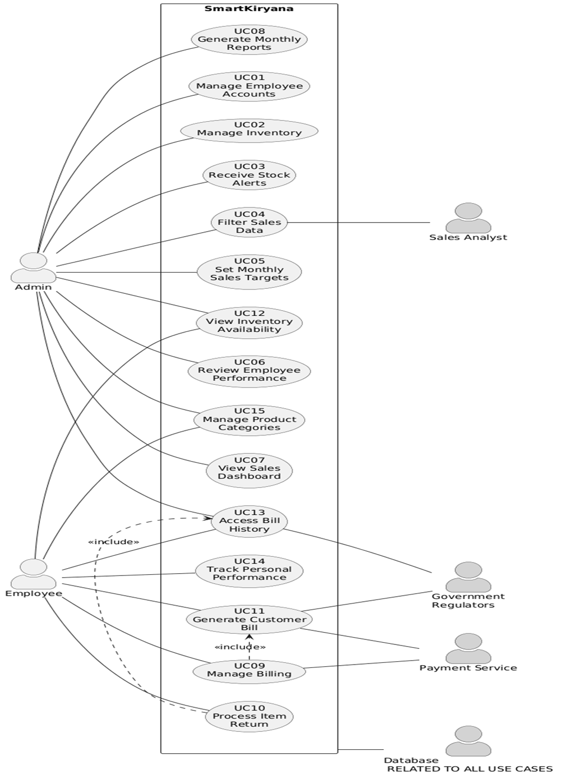

Other Nonfunctional Requirements

Performance Requirements
<If there are performance requirements for the product under various circumstances, state them here and explain their rationale, to help the developers understand the intent and make suitable design choices. Specify the timing relationships for real time systems. Make such requirements as specific as possible. You may need to state performance requirements for individual functional requirements or features.>

Safety Requirements
<Specify those requirements that are concerned with possible loss, damage, or harm that could result from the use of the product. Define any safeguards or actions that must be taken, as well as actions that must be prevented. Refer to any external policies or regulations that state safety issues that affect the product’s design or use. Define any safety certifications that must be satisfied.>

Security Requirements
<Specify any requirements regarding security or privacy issues surrounding use of the product or protection of the data used or created by the product. Define any user identity authentication requirements. Refer to any external policies or regulations containing security issues that affect the product. Define any security or privacy certifications that must be satisfied.>

Software Quality Attributes
<Specify any additional quality characteristics for the product that will be important to either the customers or the developers. Some to consider are: adaptability, availability, correctness, flexibility, interoperability, maintainability, portability, reliability, reusability, robustness, testability, and usability. Write these to be specific, quantitative, and verifiable when possible. At the least, clarify the relative preferences for various attributes, such as ease of use over ease of learning.>

Business Rules
<List any operating principles about the product, such as which individuals or roles can perform which functions under specific circumstances. These are not functional requirements in themselves, but they may imply certain functional requirements to enforce the rules.>

Operating Environment
<Describe the environment in which the software will operate, including the hardware platform, operating system and versions, and any other software components or applications with which it must peacefully coexist.>

User Interfaces
<Describe the logical characteristics of each interface between the software product and the users. This may include sample screen images, any GUI standards or product family style guides that are to be followed, screen layout constraints, standard buttons and functions (e.g., help) that will appear on every screen, keyboard shortcuts, error message display standards, and so on. Define the software components for which a user interface is needed. Details of the user interface design should be documented in a separate user interface specification.>

Domain Model

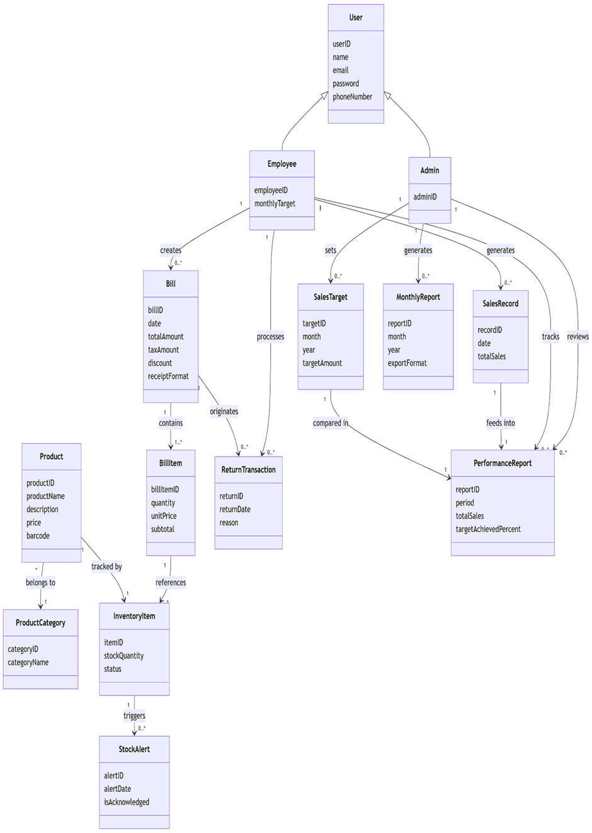

System Sequence Diagram

UC01 Main Success Scenario SSD
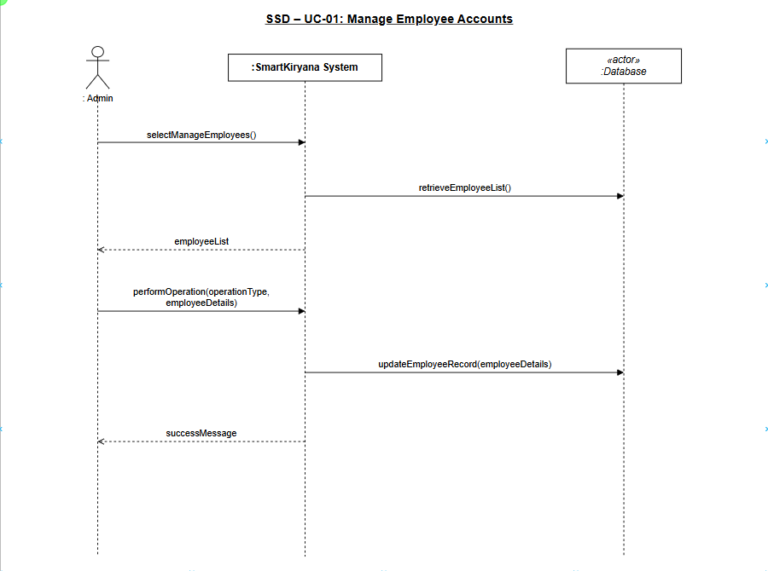

UC02 Main Success Scenario SSD
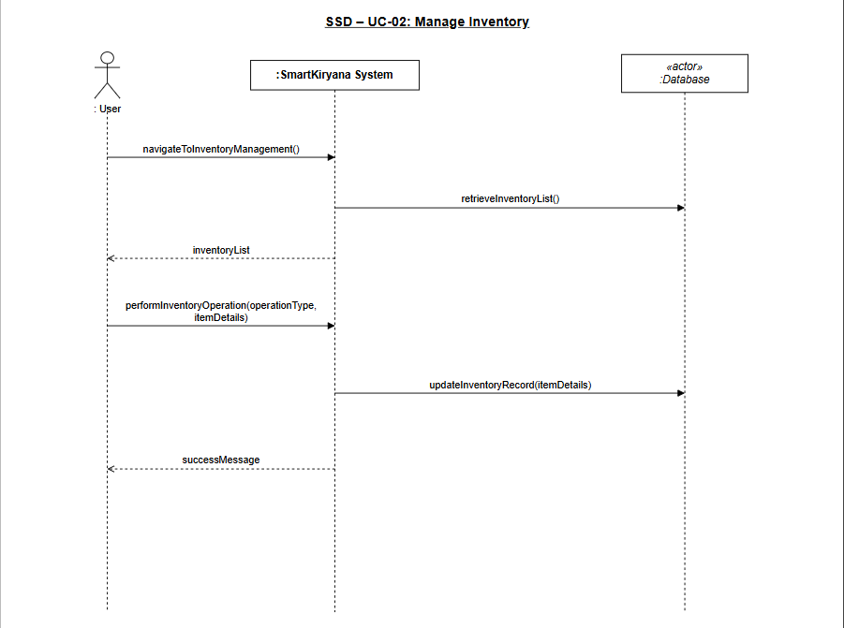

UC03 Main Success Scenario SSD
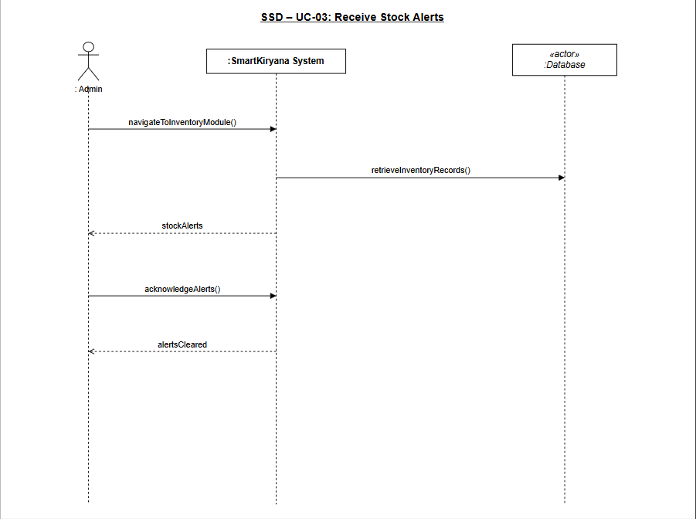

UC04 Main Success Scenario SSD
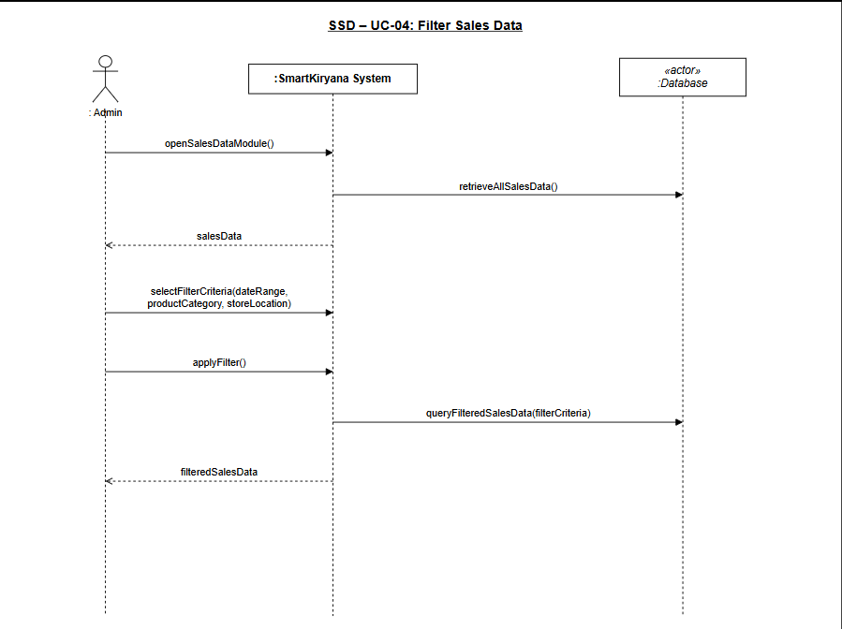

UC05 Main Success Scenario SSD
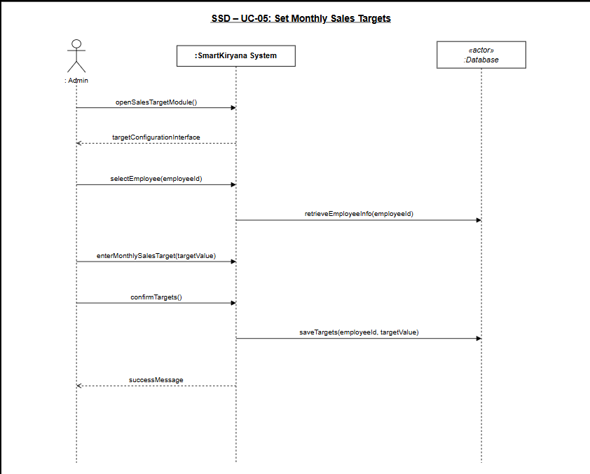

UC06 Main Success Scenario SSD
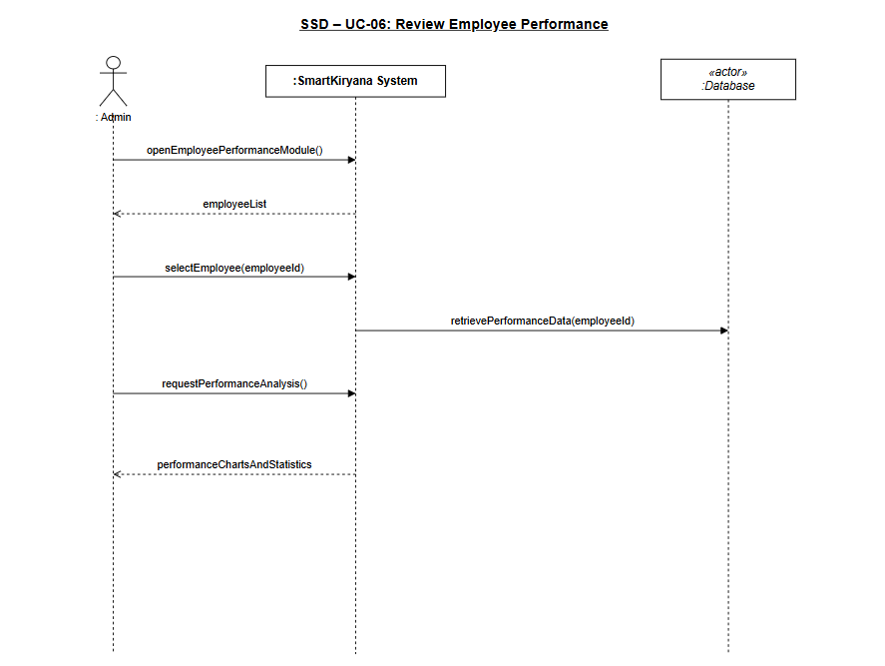

UC07 Main Success Scenario SSD
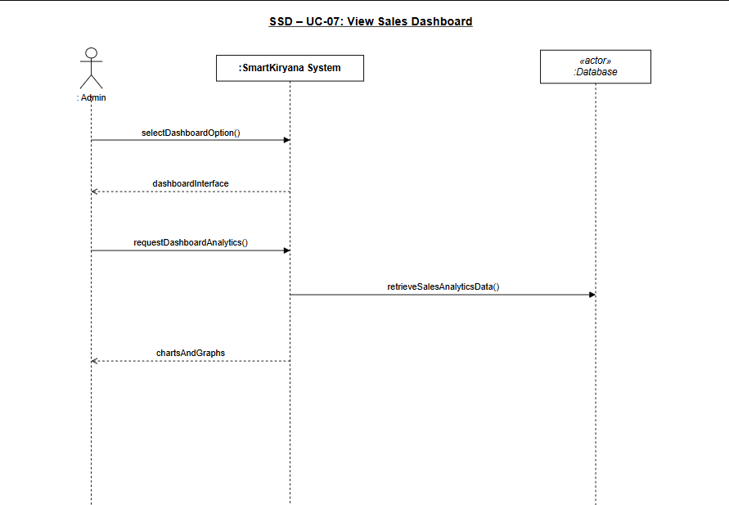

UC08 Main Success Scenario SSD
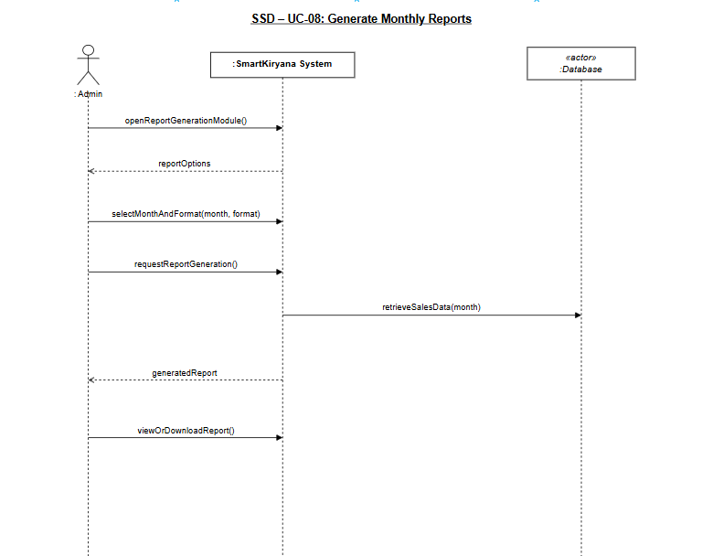

UC09 Main Success Scenario SSD
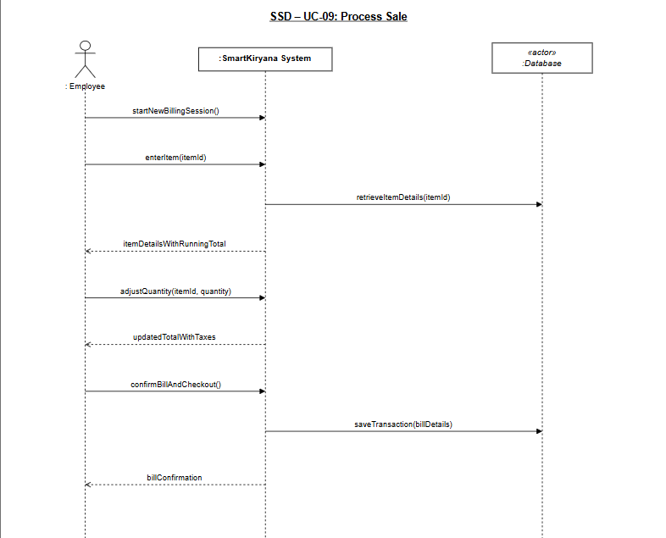

UC10 Main Success Scenario SSD
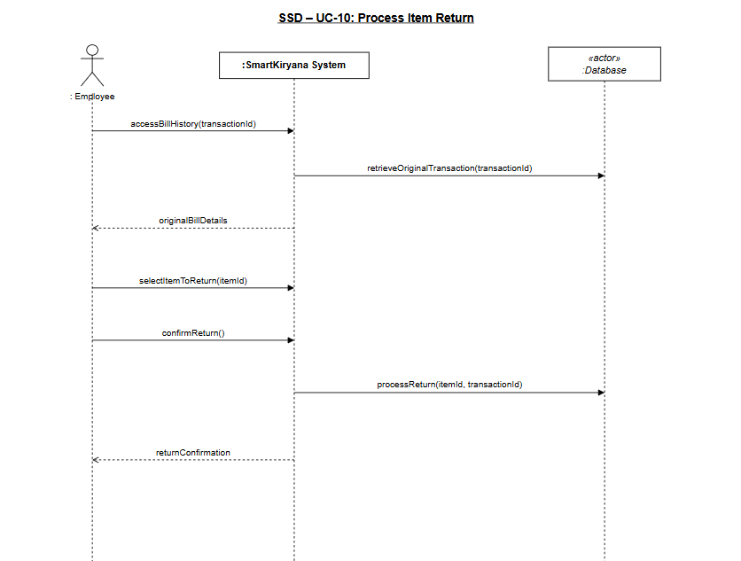

UC11 Main Success Scenario SSD
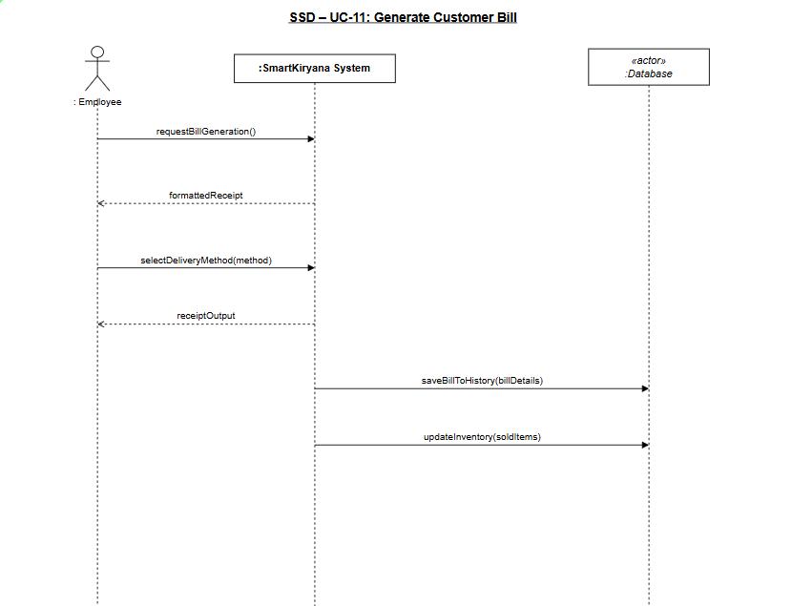

UC12 Main Success Scenario SSD
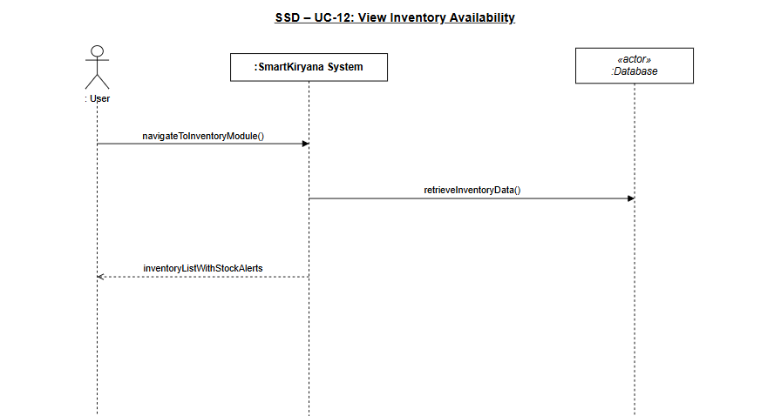

UC13 Main Success Scenario SSD
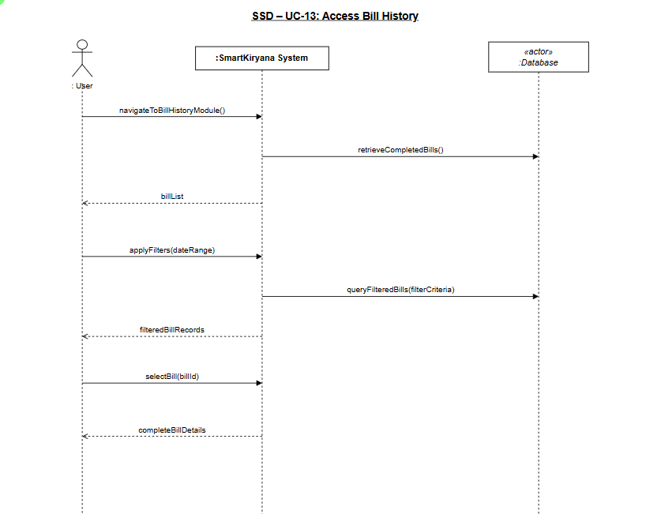

UC14 Main Success Scenario SSD
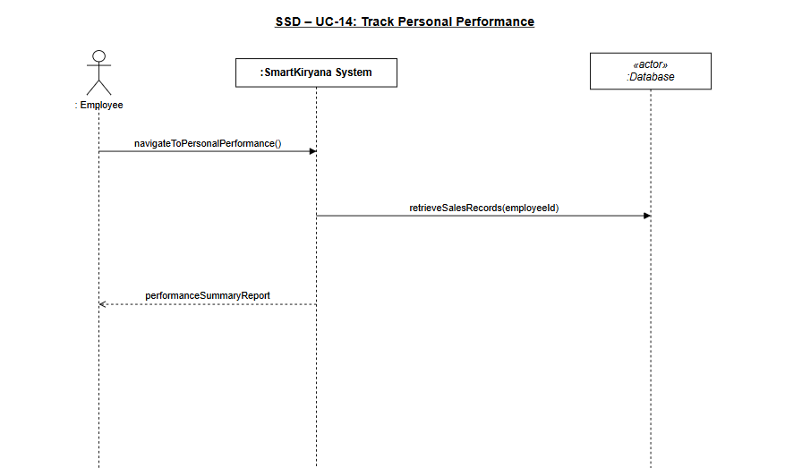

UC15 Main Success Scenario SSD
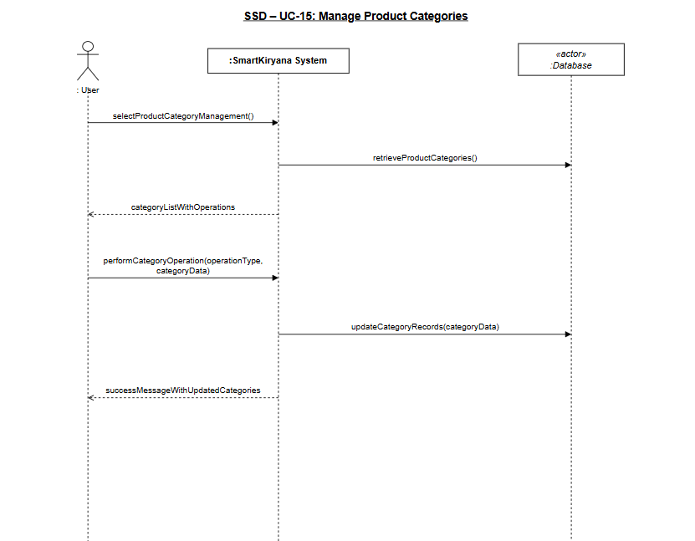

UC01 Alternate Scenario SSD
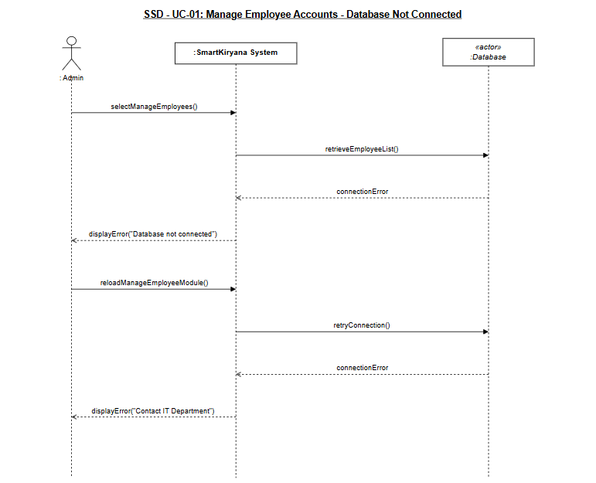

UC02 Alternate Scenario SSD
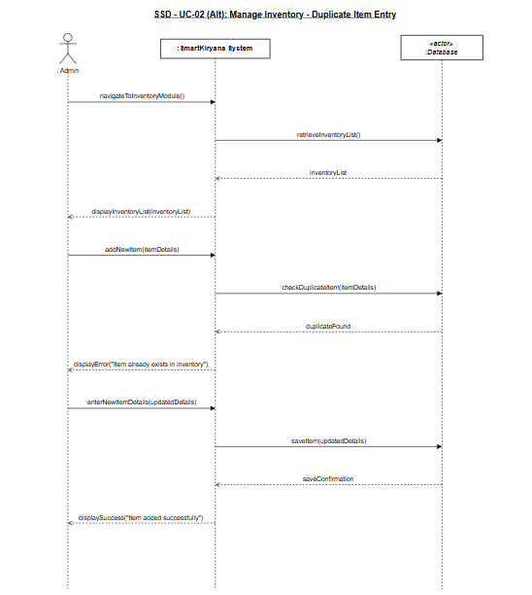

UC03 Alternate Scenario SSD
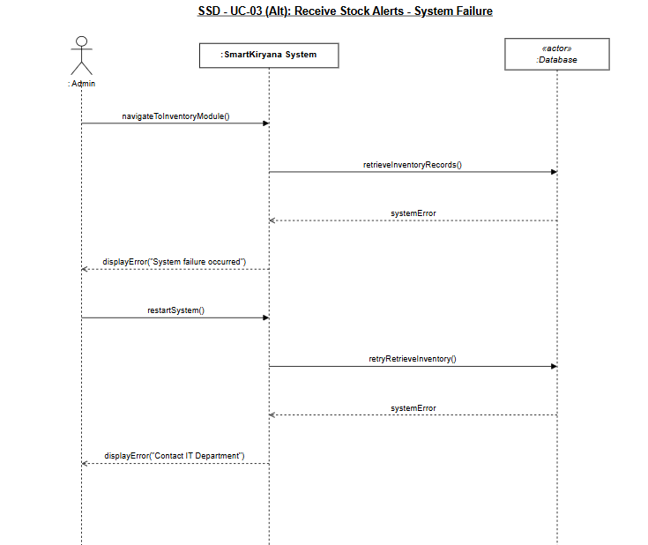

UC04 Alternate Scenario SSD
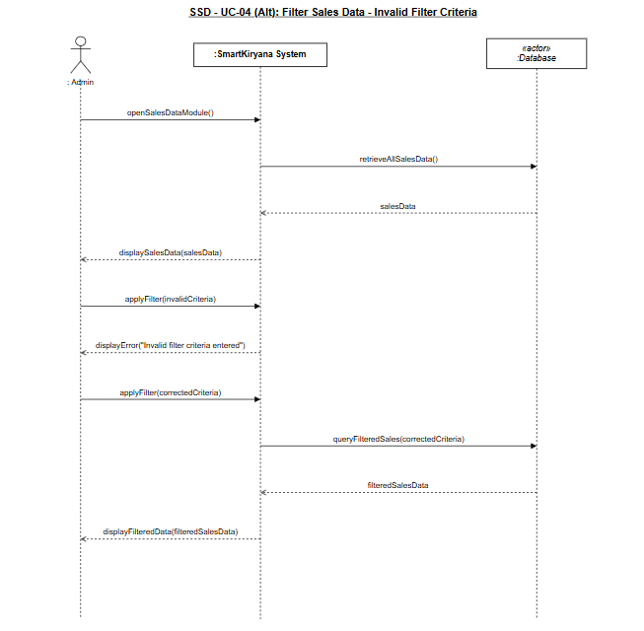

UC05 Alternate Scenario SSD
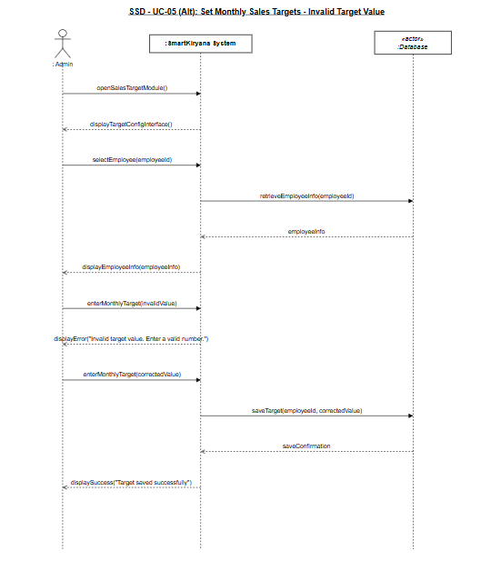

UC06 Alternate Scenario SSD
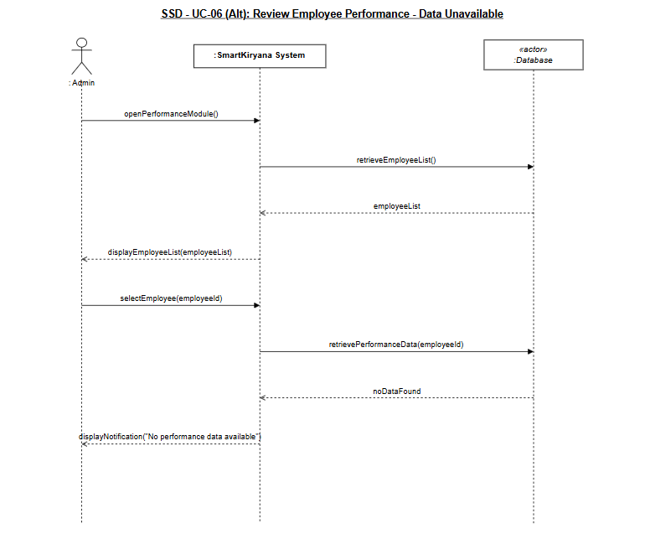

UC07 Alternate Scenario SSD
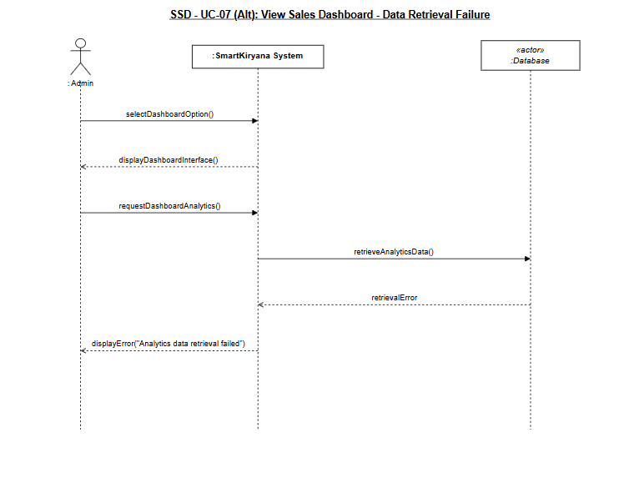

UC08 Alternate Scenario SSD
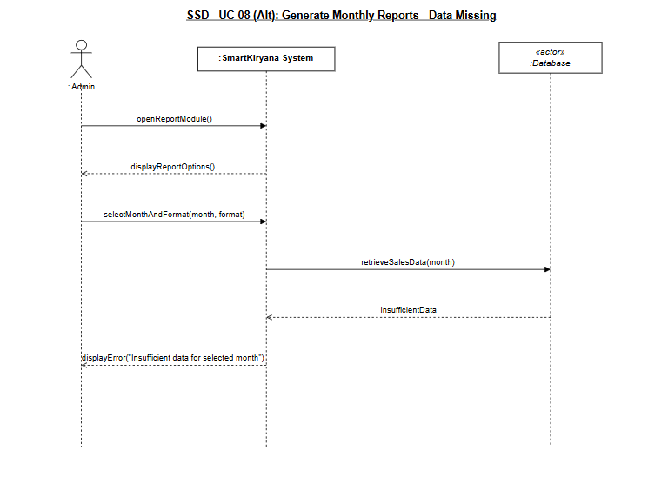

UC09 Alternate Scenario SSD
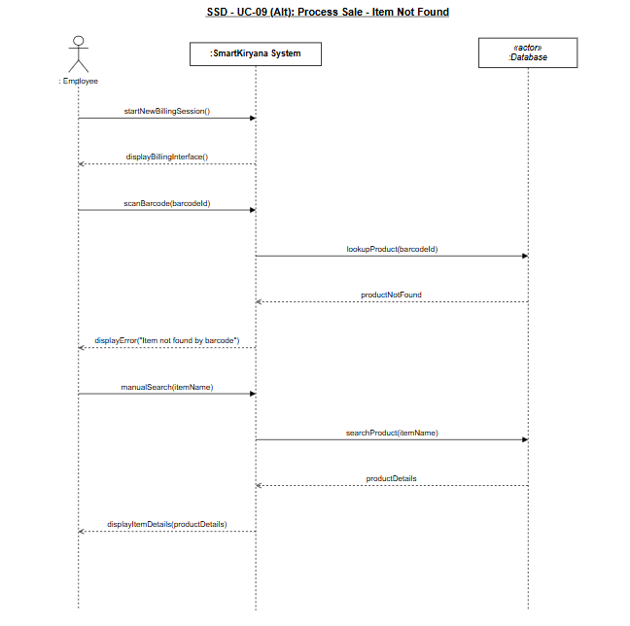

UC10 Alternate Scenario SSD
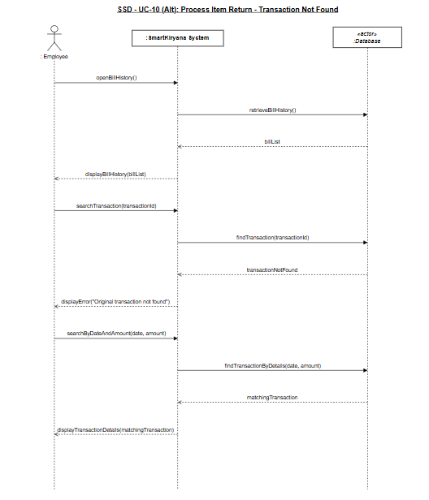

UC11 Alternate Scenario SSD
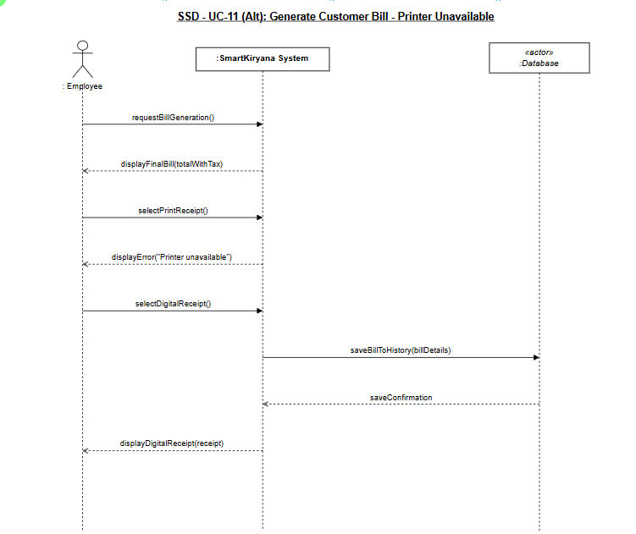

UC12 Alternate Scenario SSD
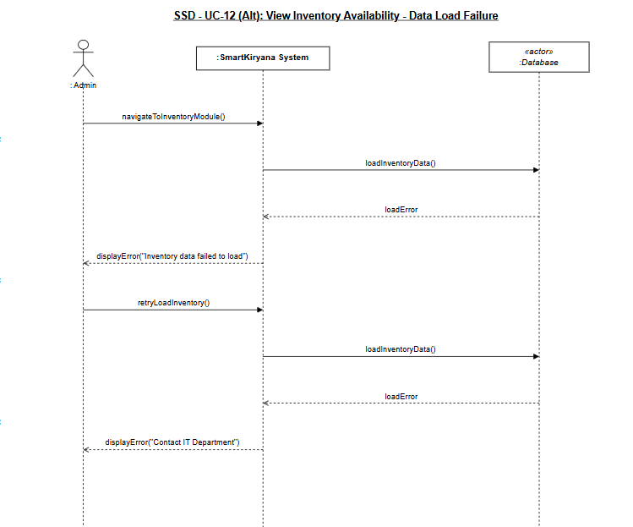

UC13 Alternate Scenario SSD
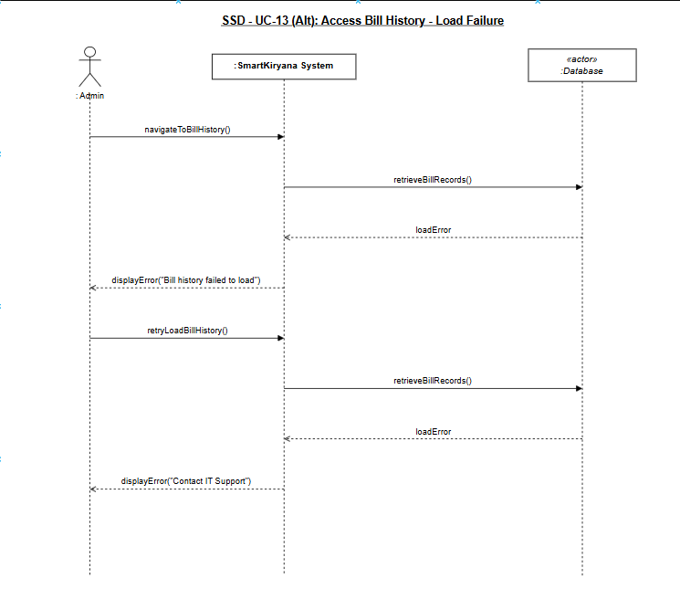

UC14 Alternate Scenario SSD
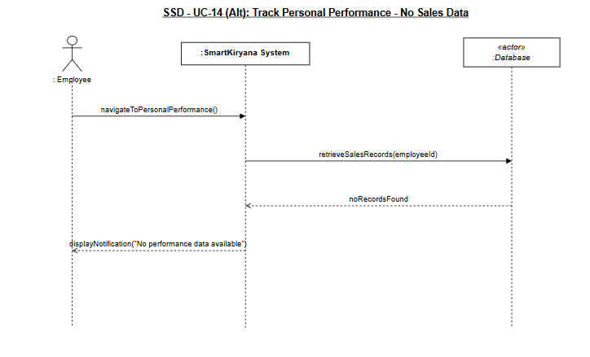

UC15 Alternate Scenario SSD
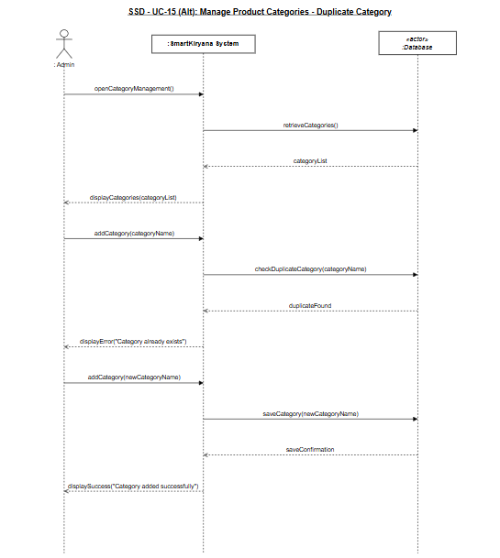

Sequence Diagram
UC01 SD

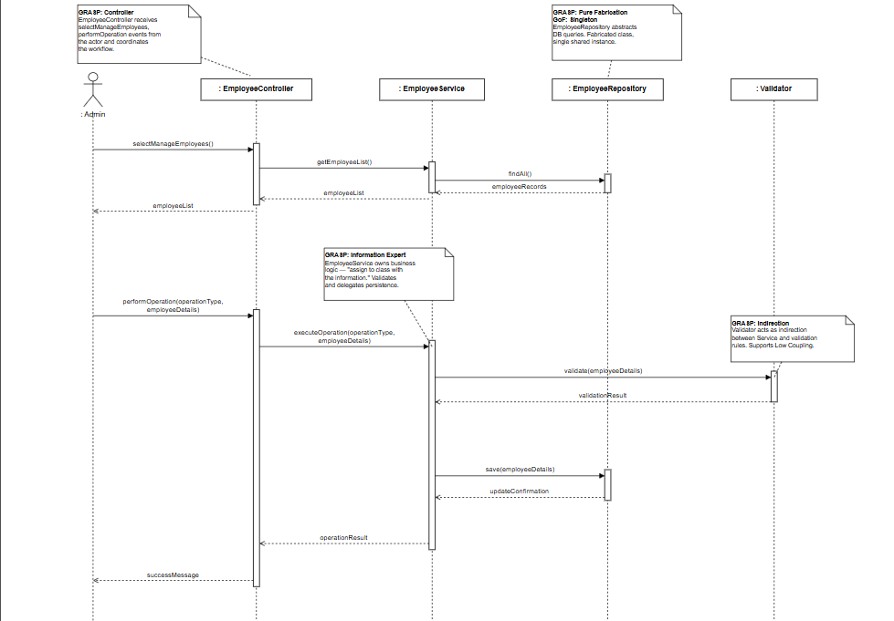

UC02 SD

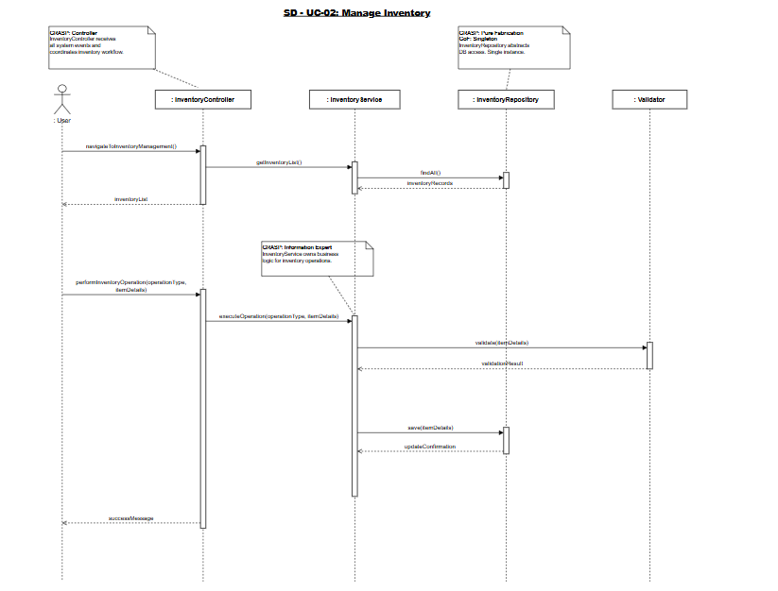

UC03 SD

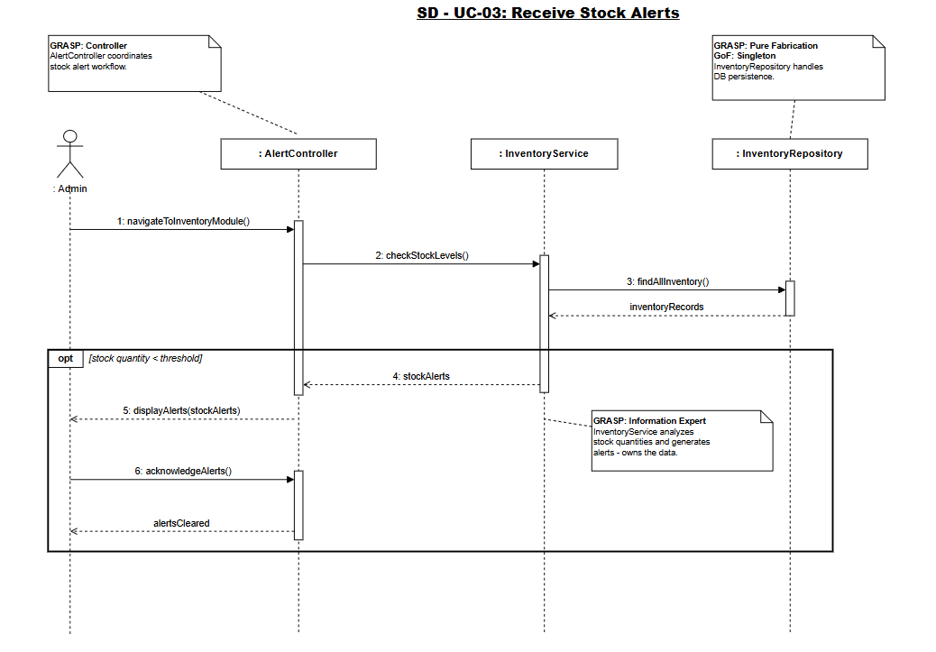

UC04 SD

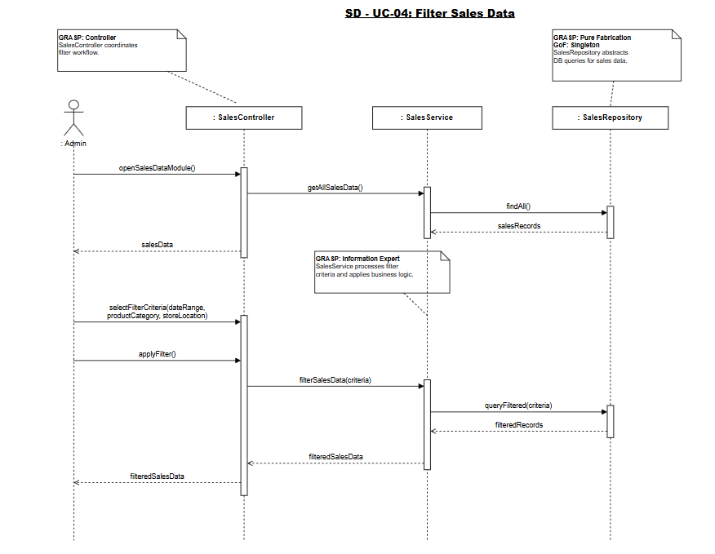

UC05 SD

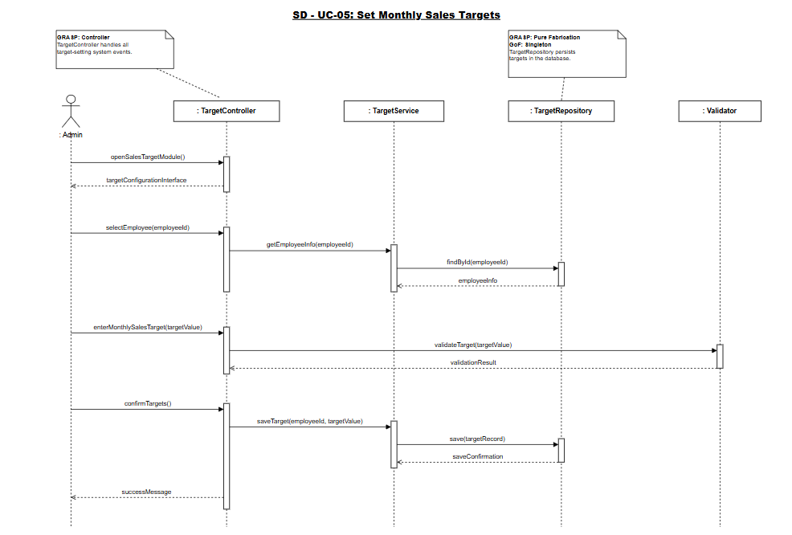

UC06 SD

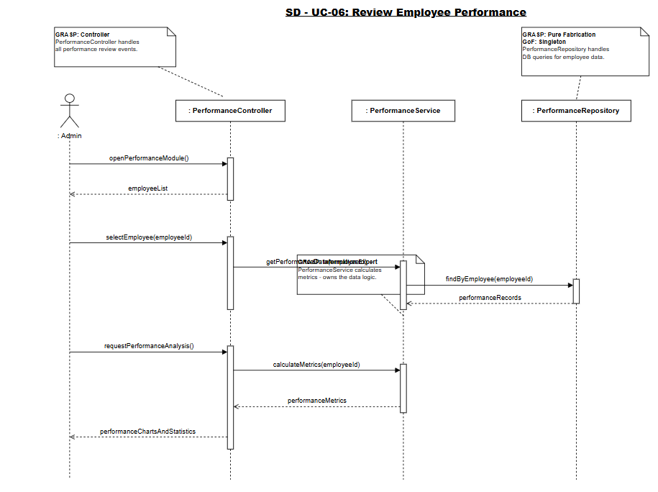

UC07 SD

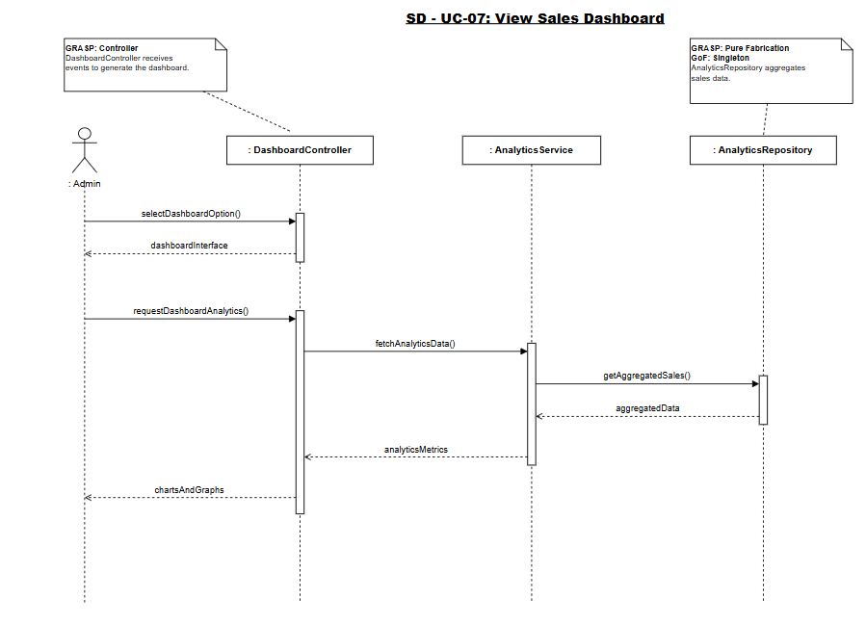

UC08 SD

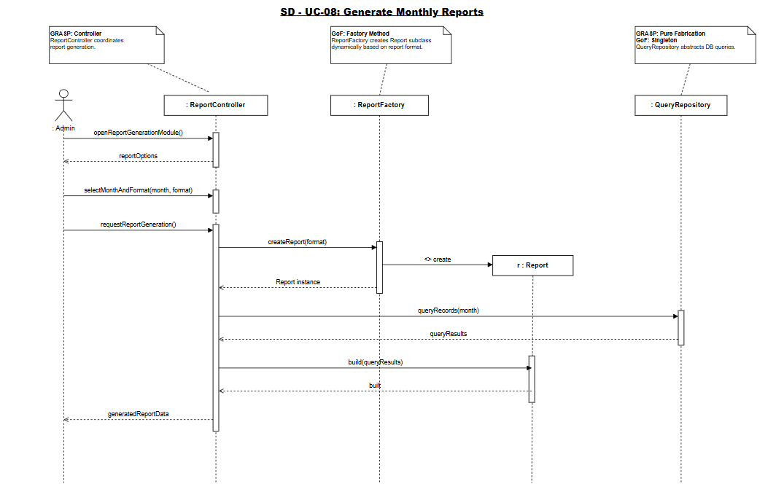

UC09 SD

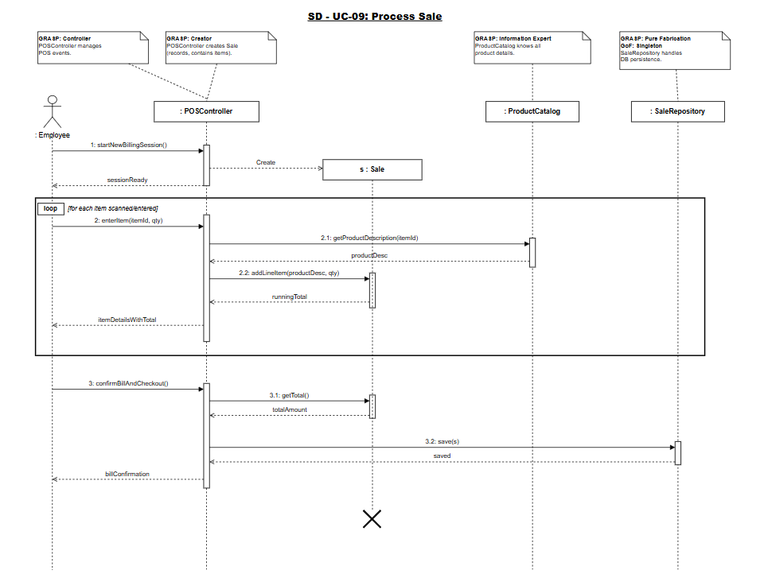

UC10 SD

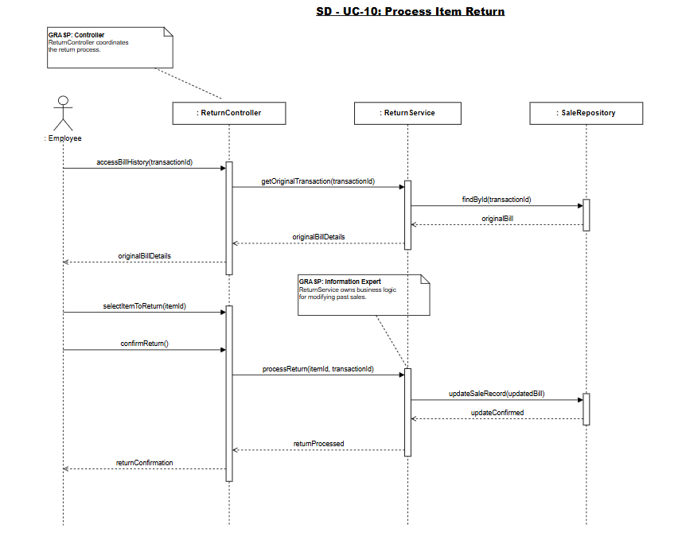

UC11 SD

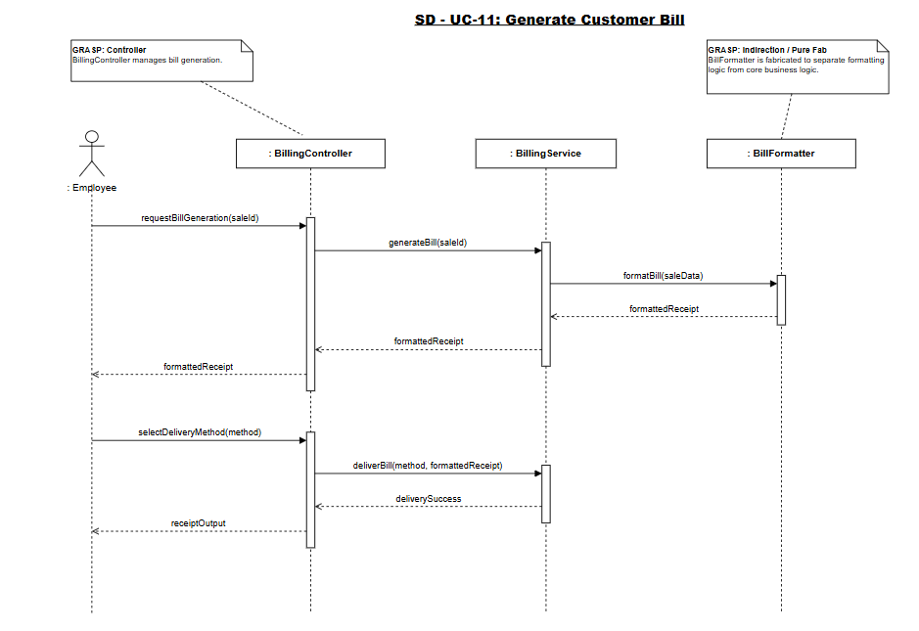

UC12 SD

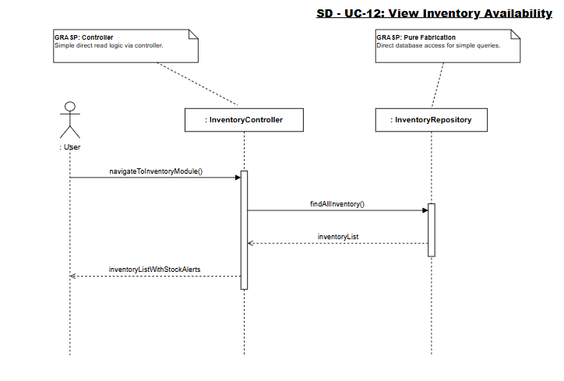

UC13 SD

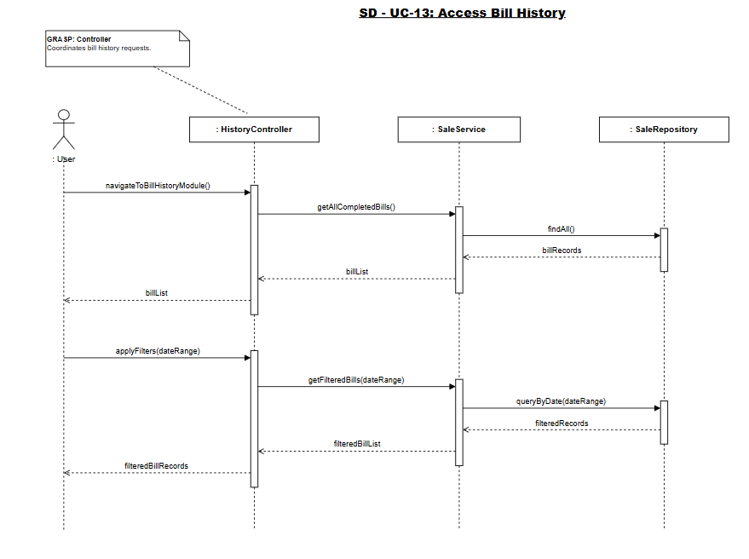

UC14 SD

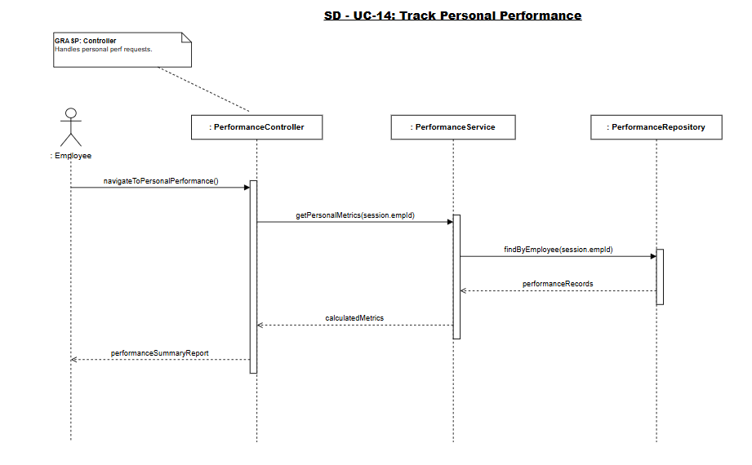

UC15 SD

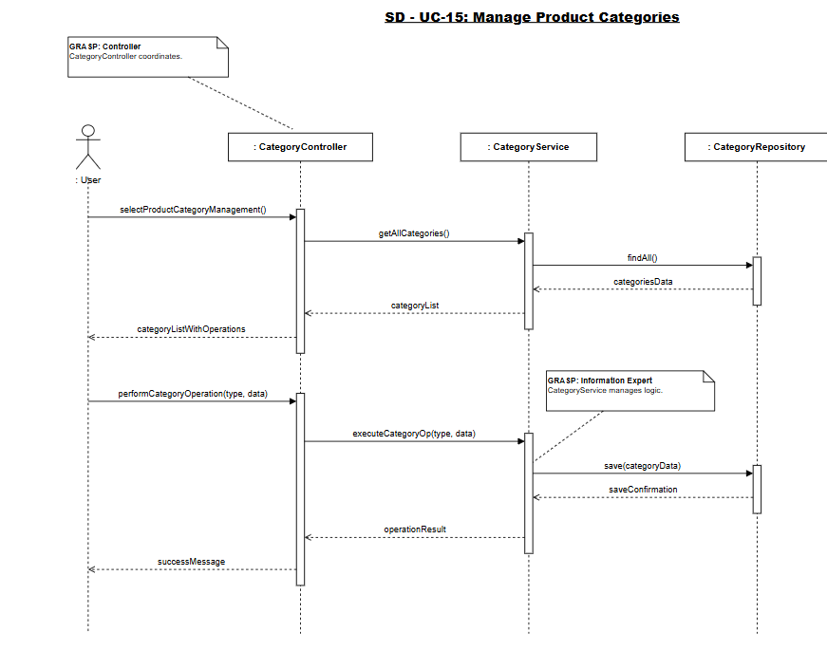

Class Diagram

Version 1:
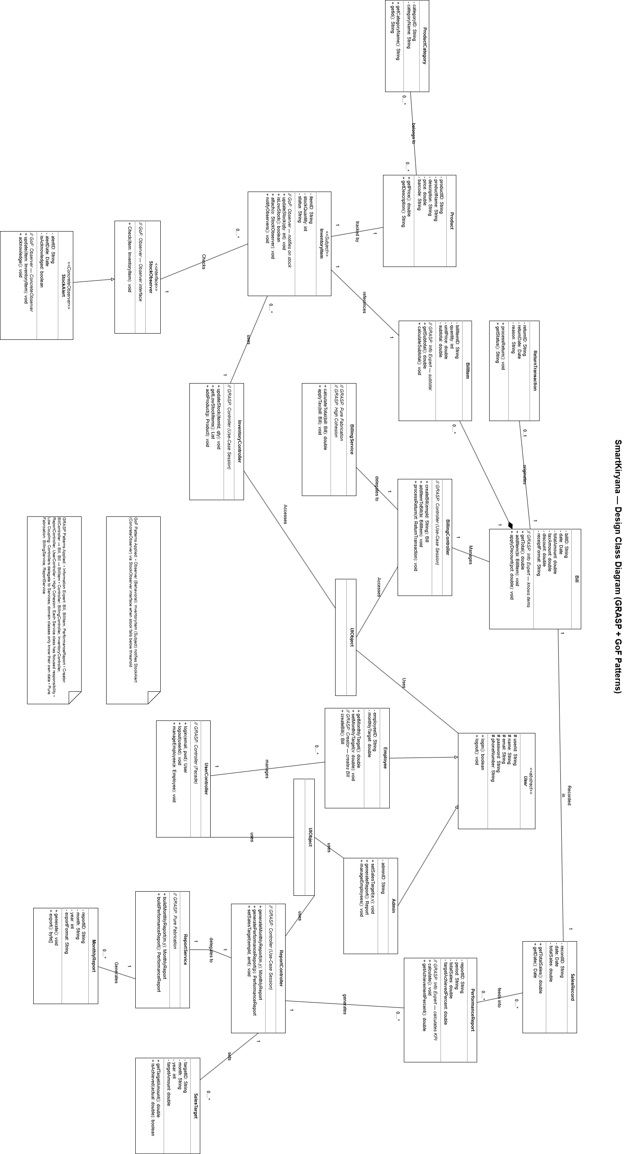

Version 2:
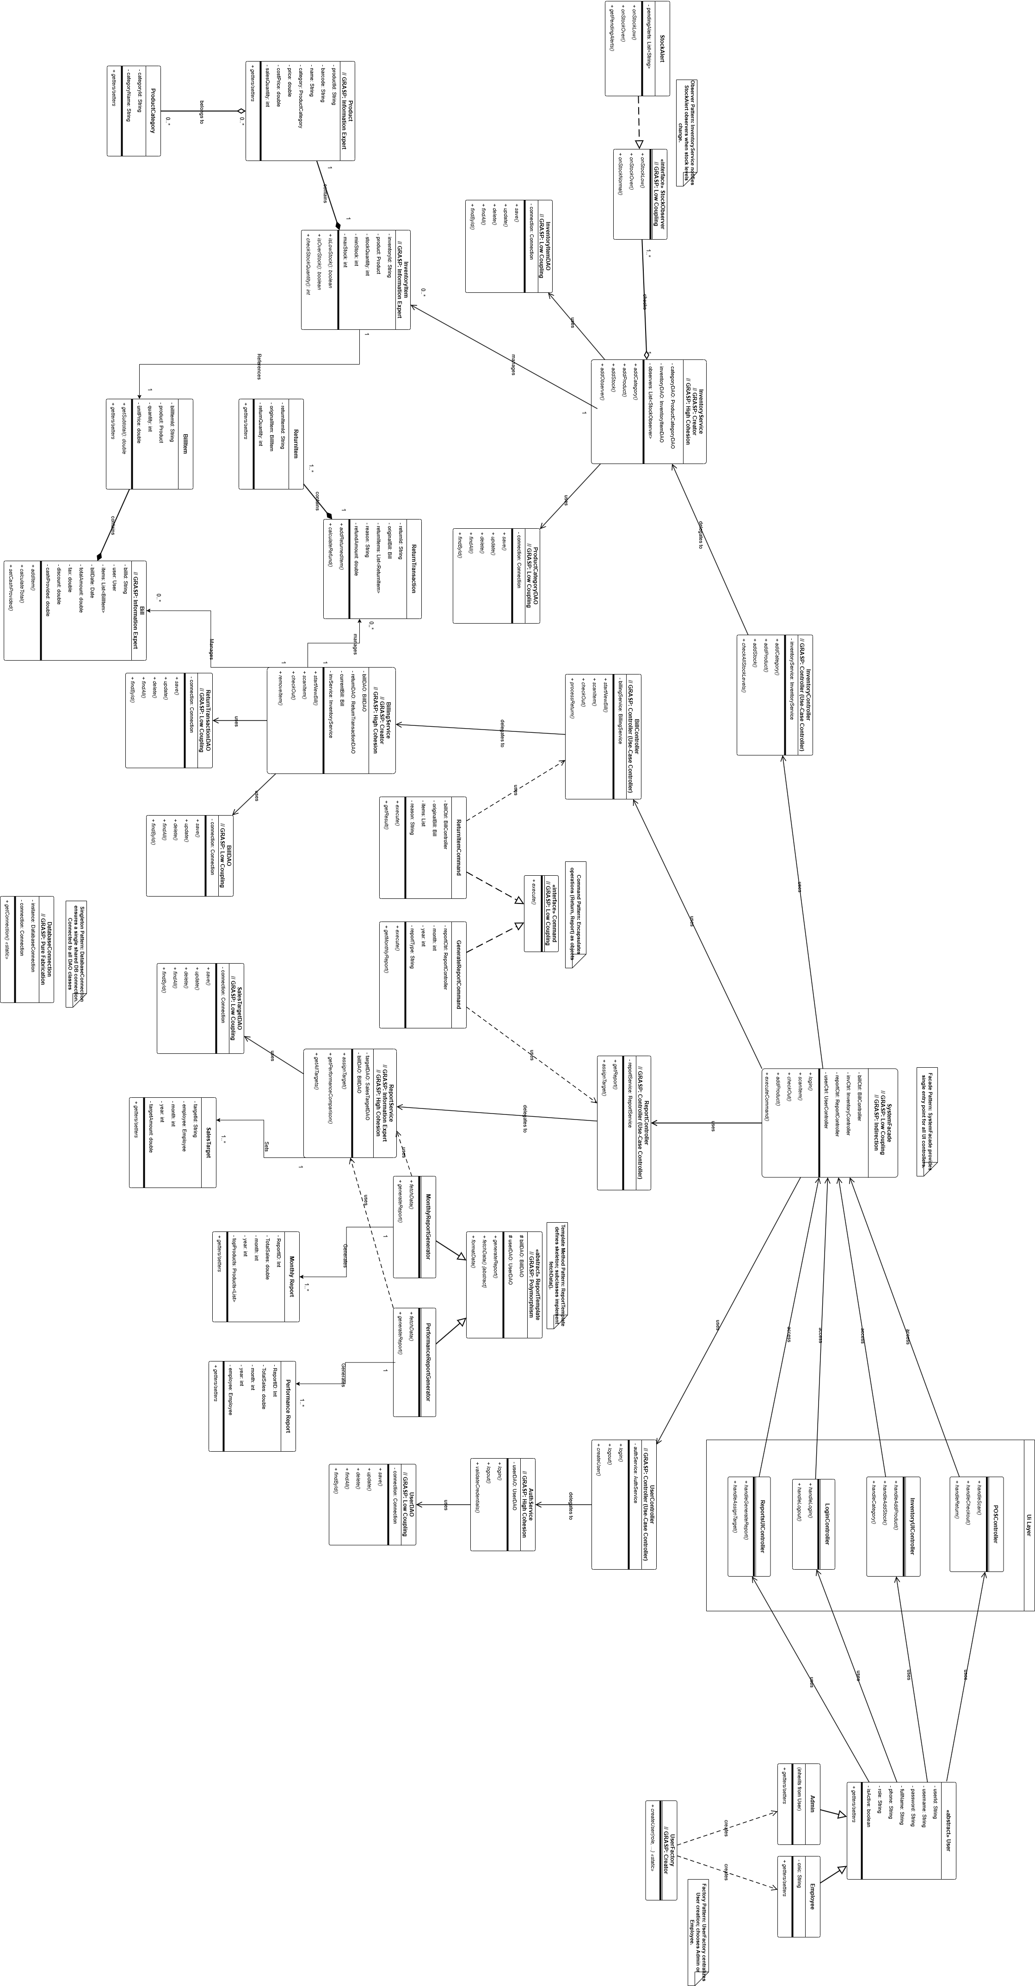

High-level Architecture

Package Diagram
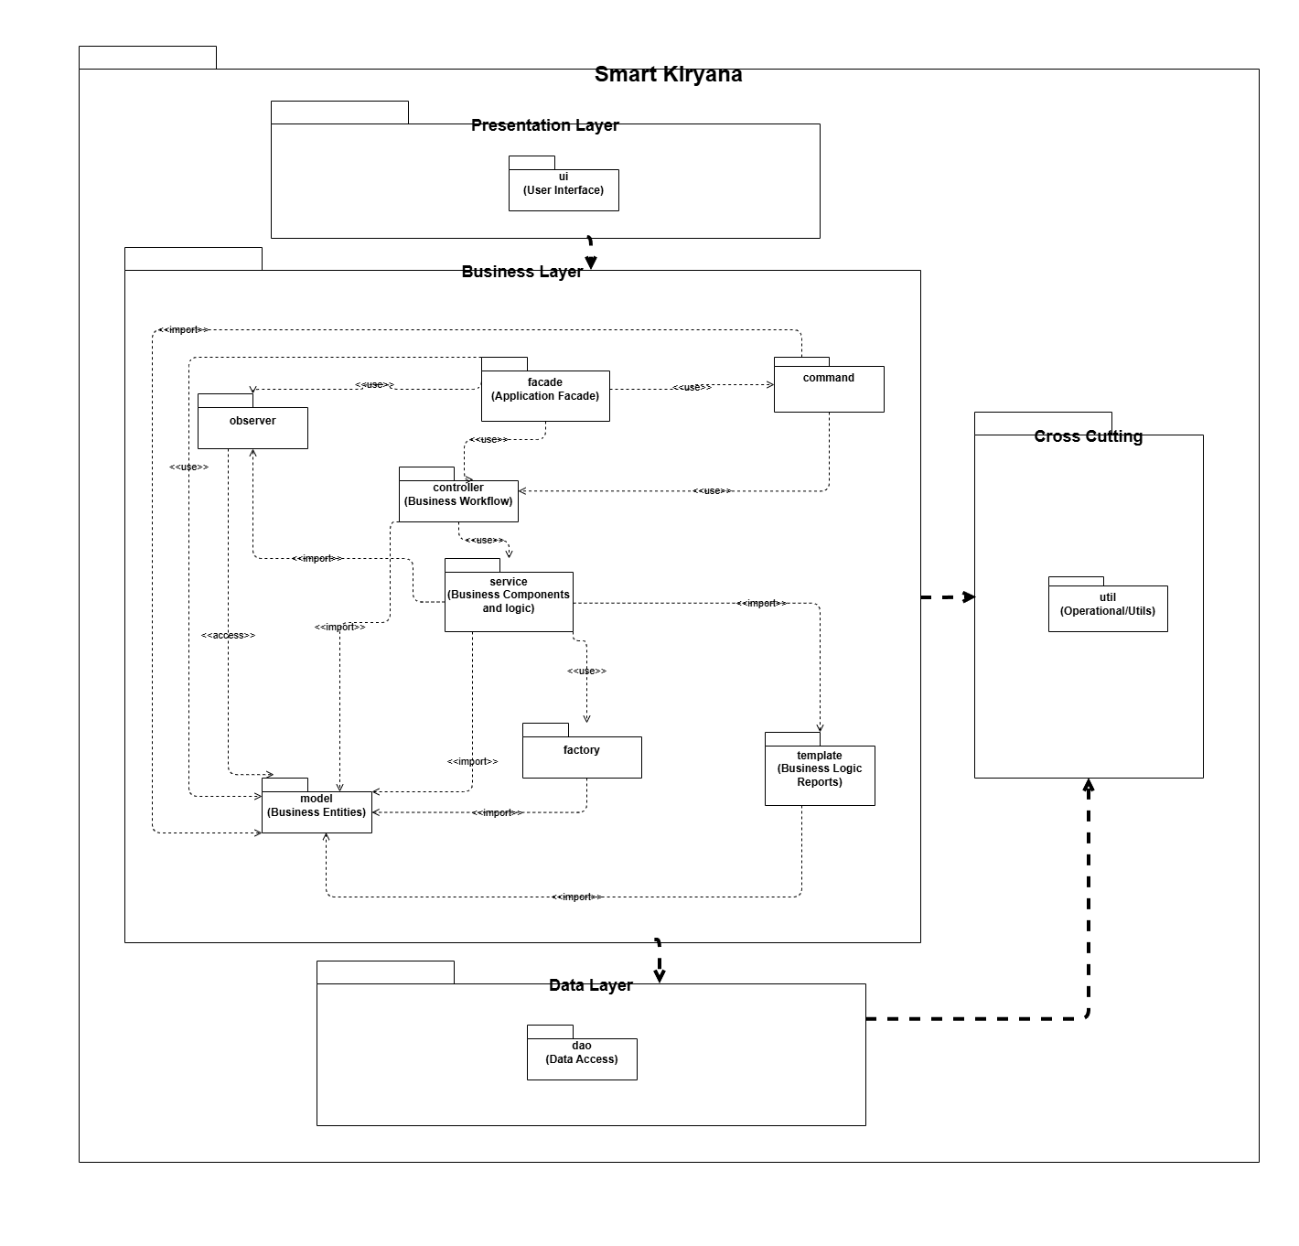

Deployment Diagram
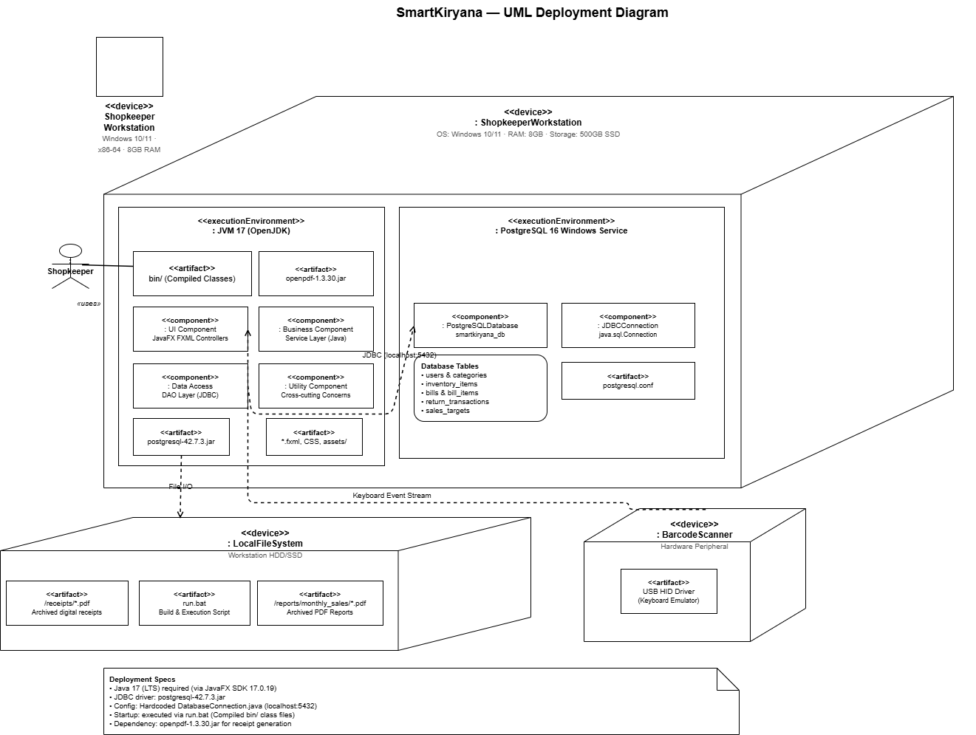

Component Diagram
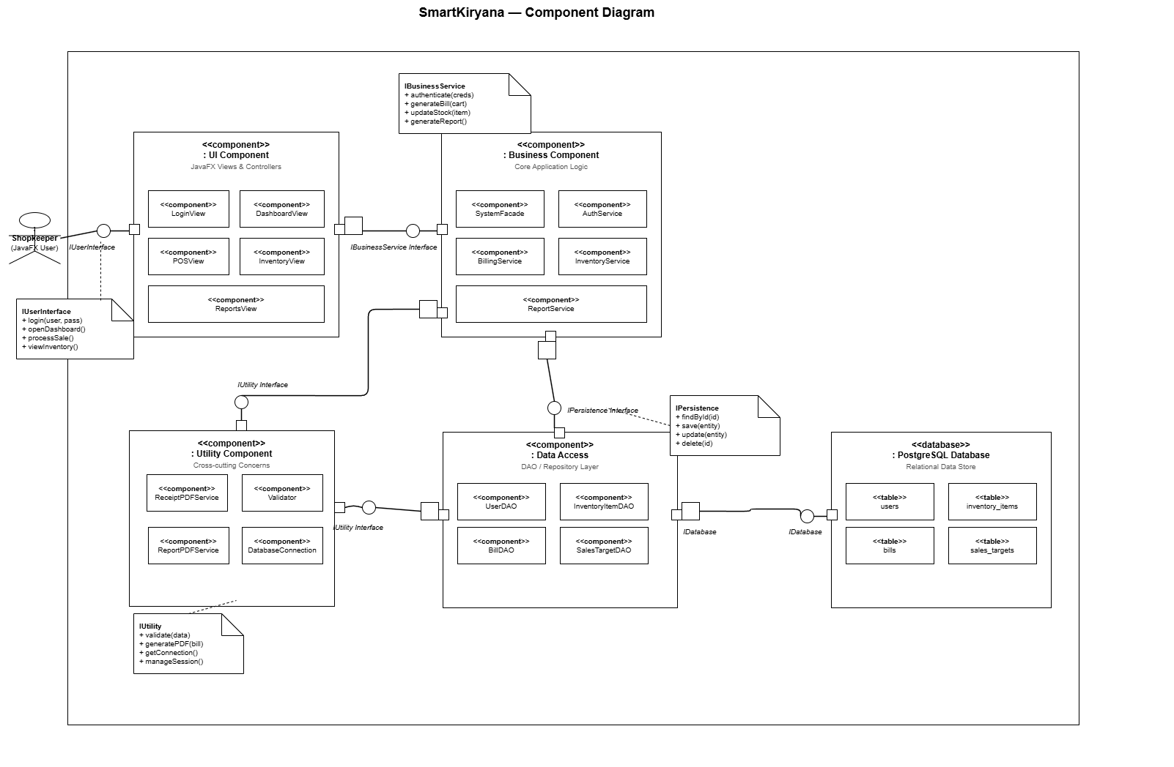

Work Division Table

