Deliverable 3

Course Instructor
Ms. Laiba Imran
Submitted By
Burhan Ahmed | 24I-3030
Ali Akbar | 24I-3079
Huzaifa Ali | 24I-3114

Date
March 17, 2026
Spring 2026


Department of Computer Science
FAST – National University of Computer & Emerging Sciences

UC01 Main Success Scenario SSD
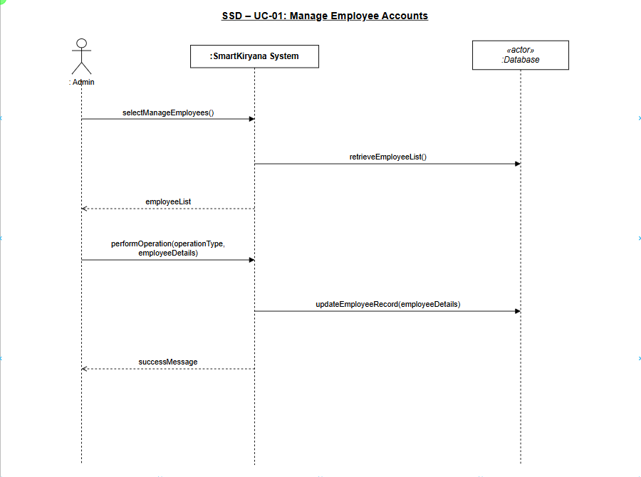

UC02 Main Success Scenario SSD
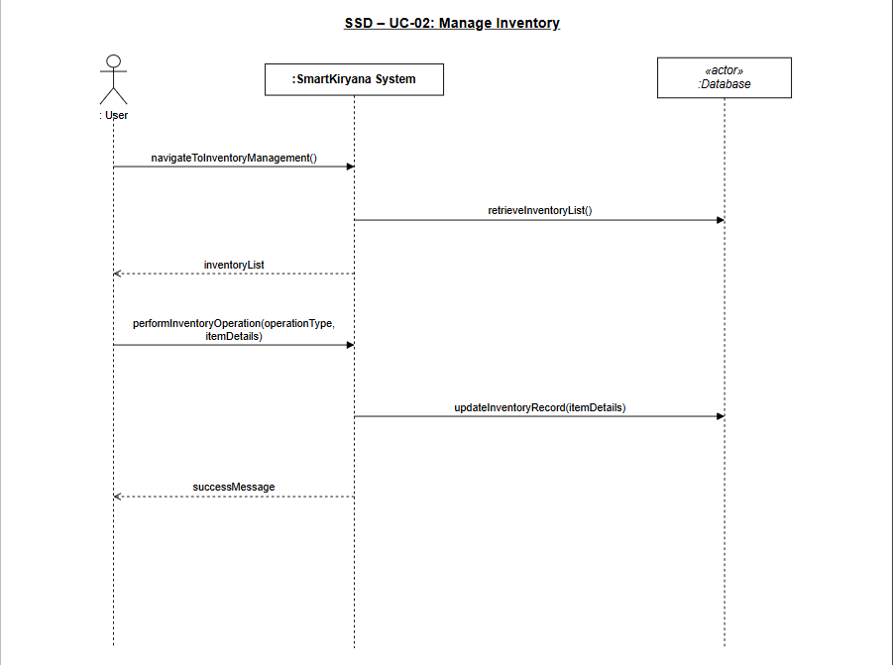

UC03 Main Success Scenario SSD
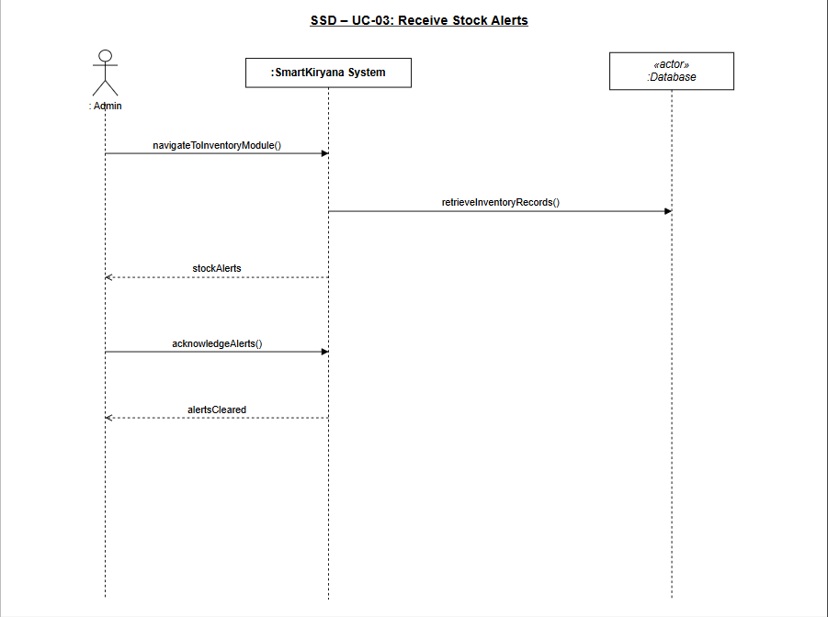

UC04 Main Success Scenario SSD
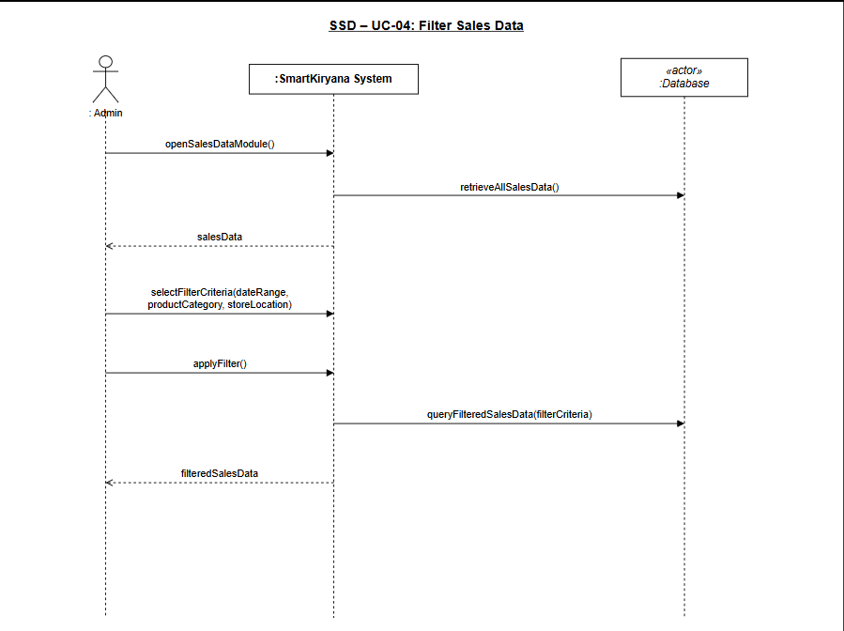

UC05 Main Success Scenario SSD
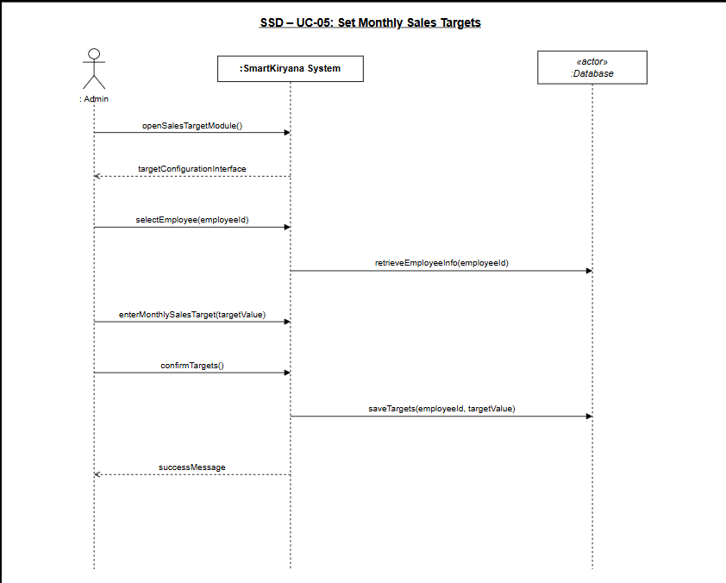

UC06 Main Success Scenario SSD
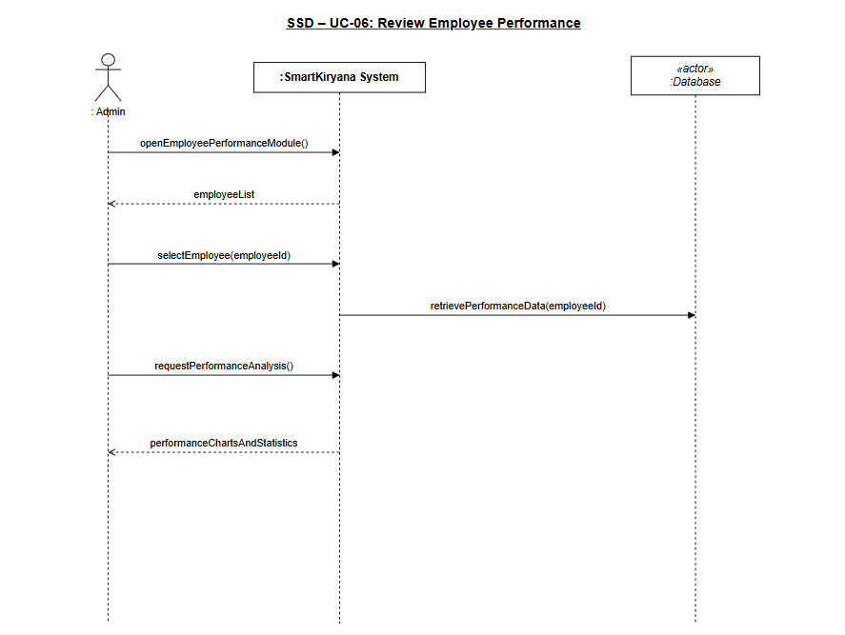

UC07 Main Success Scenario SSD
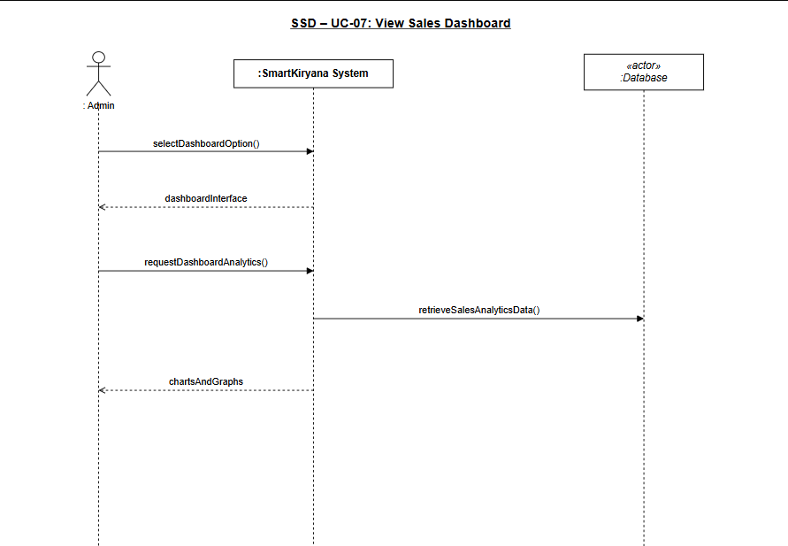

UC08 Main Success Scenario SSD
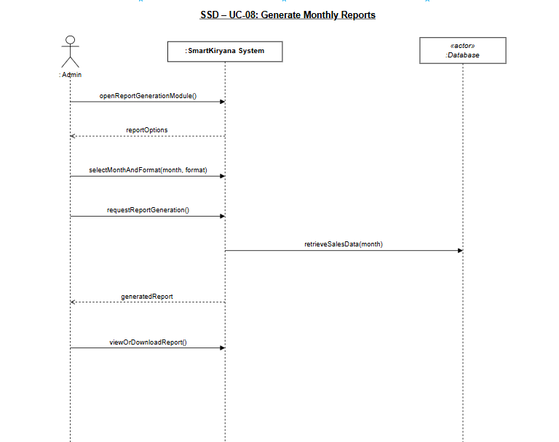

UC09 Main Success Scenario SSD
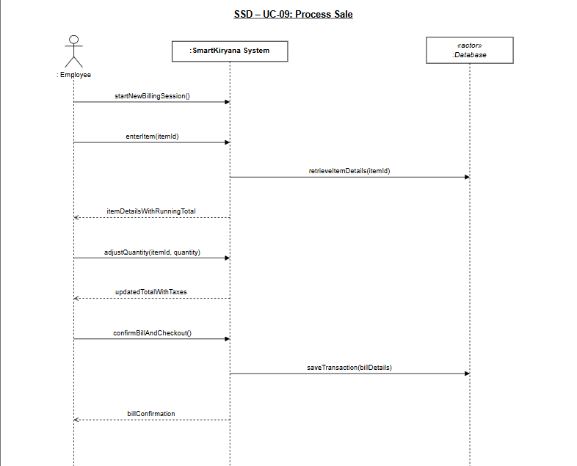

UC10 Main Success Scenario SSD
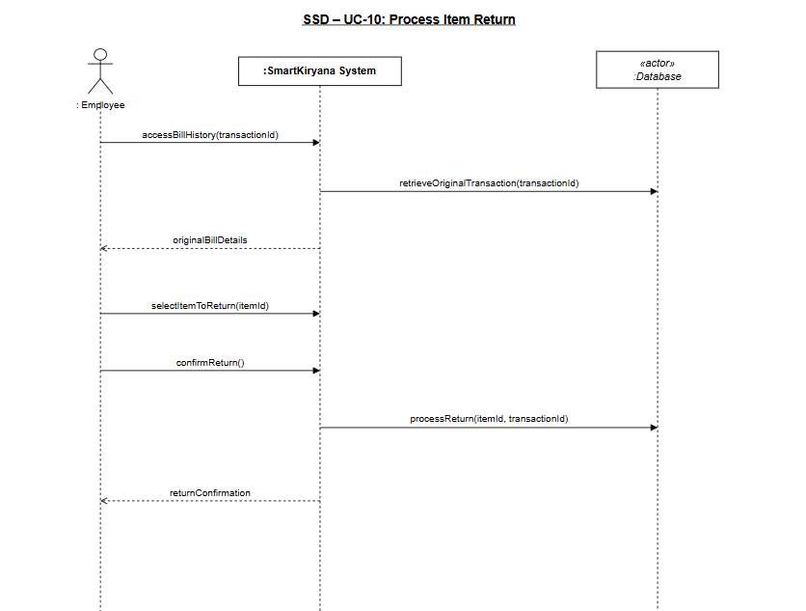

UC11 Main Success Scenario SSD
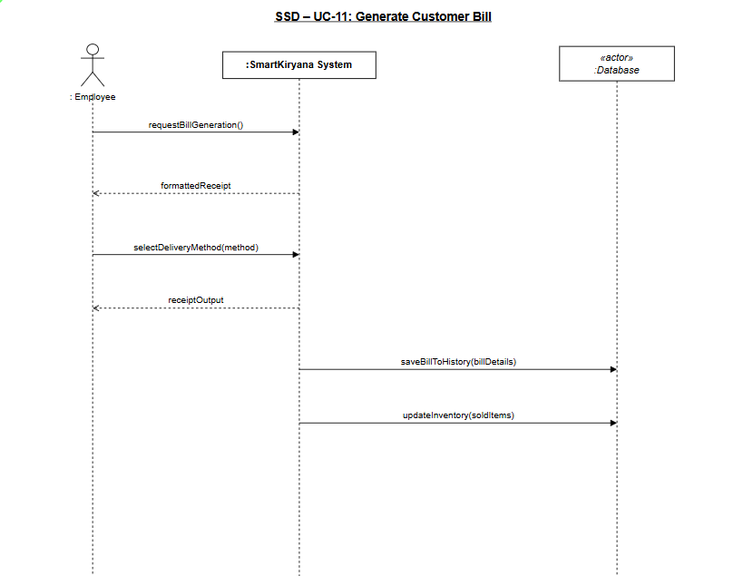

UC12 Main Success Scenario SSD
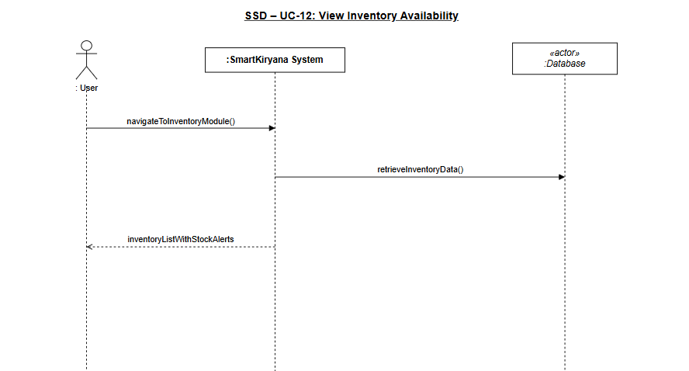

UC13 Main Success Scenario SSD
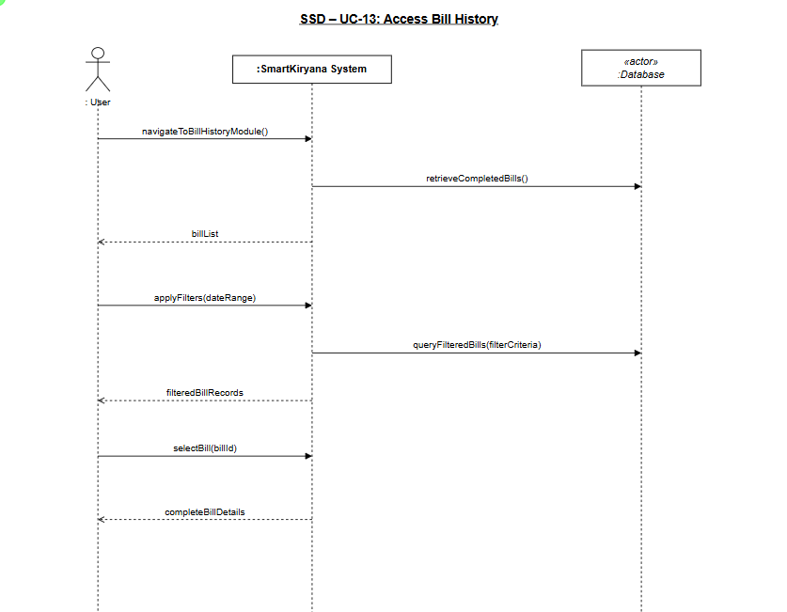

UC14 Main Success Scenario SSD
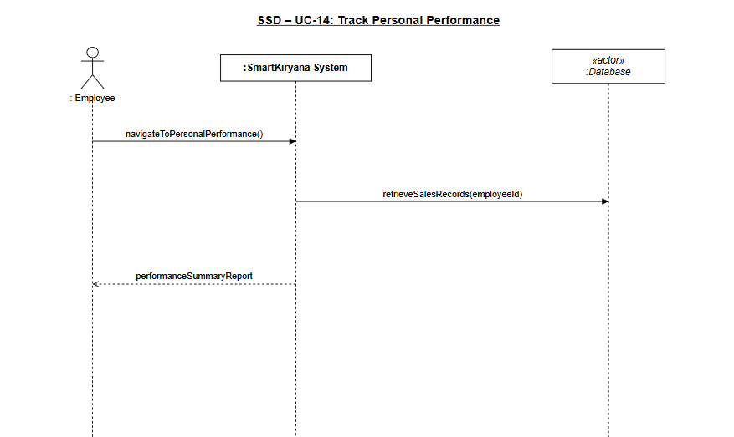

UC15 Main Success Scenario SSD
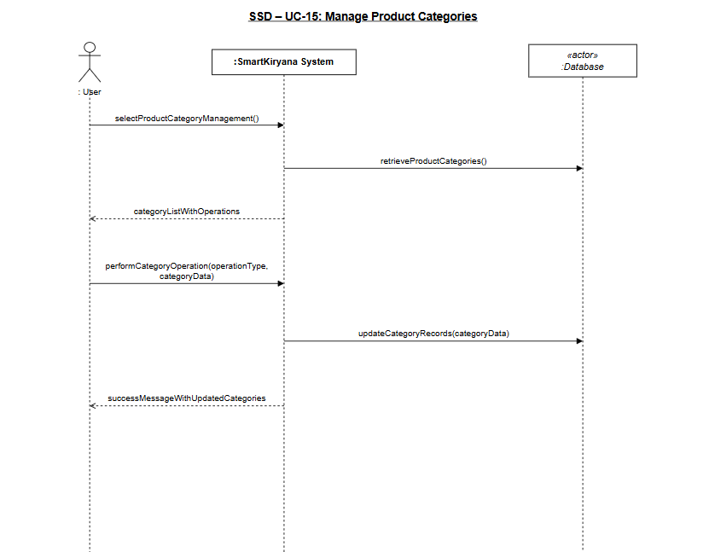

UC01 Alternate Scenario SSD
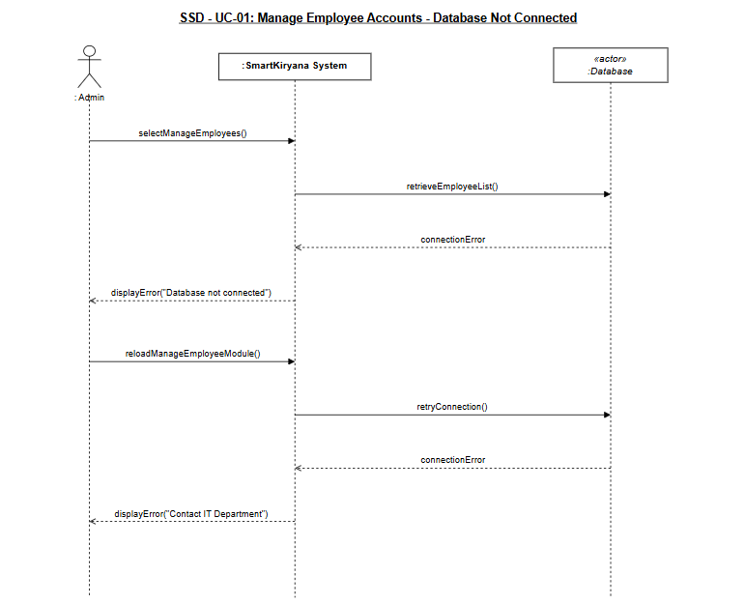

UC02 Alternate Scenario SSD
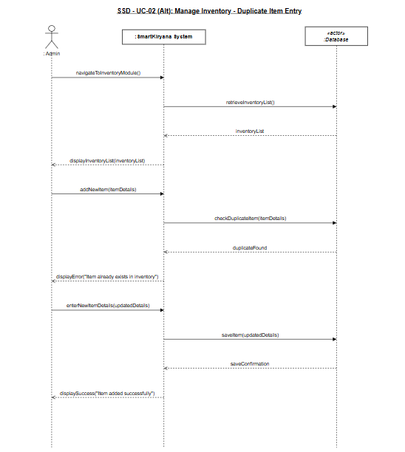

UC03 Alternate Scenario SSD
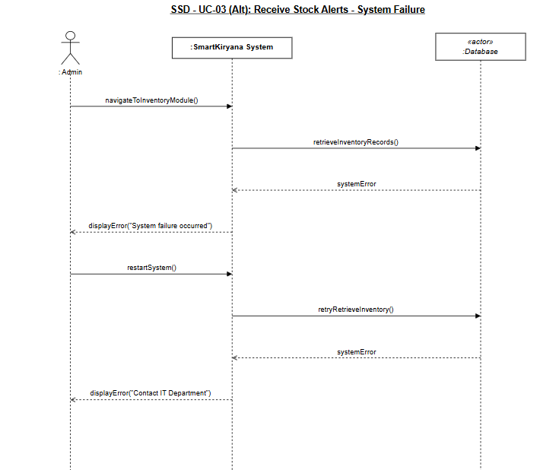

UC04 Alternate Scenario SSD
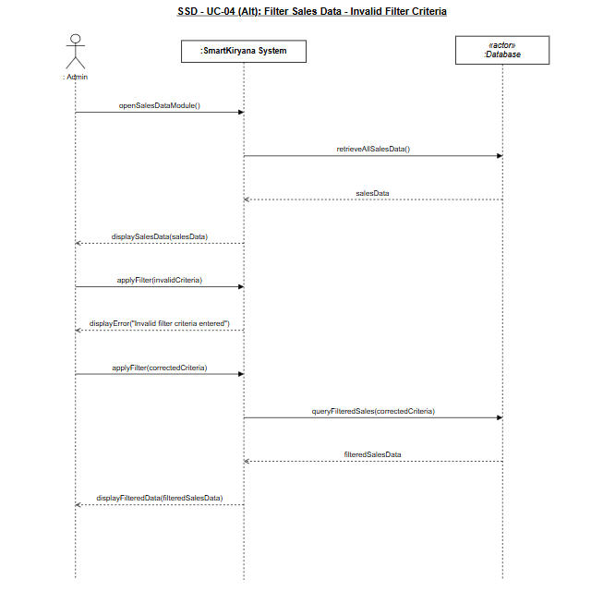

UC05 Alternate Scenario SSD
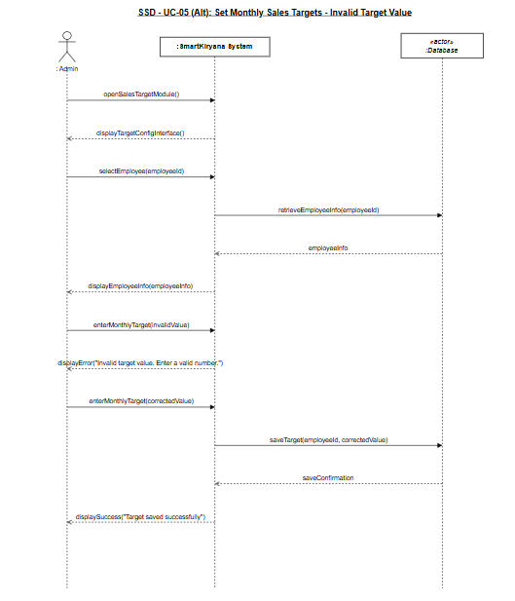

UC06 Alternate Scenario SSD
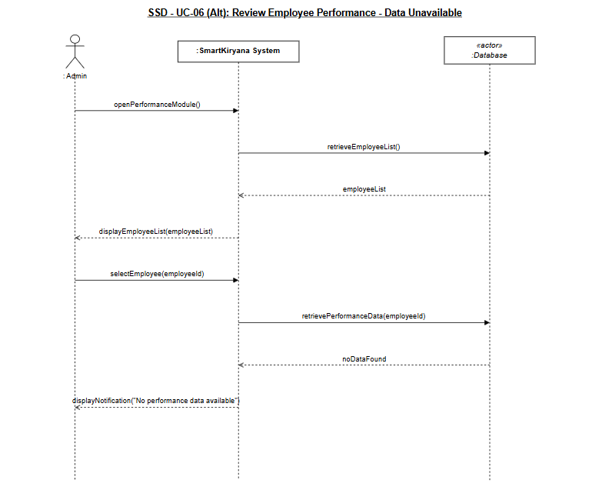

UC07 Alternate Scenario SSD
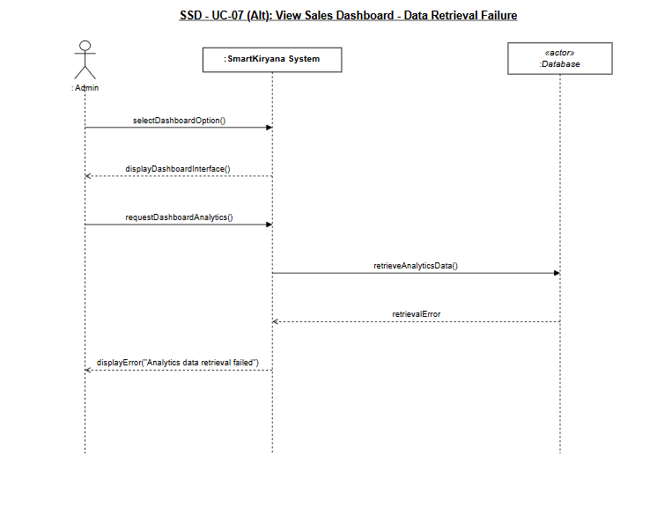

UC08 Alternate Scenario SSD
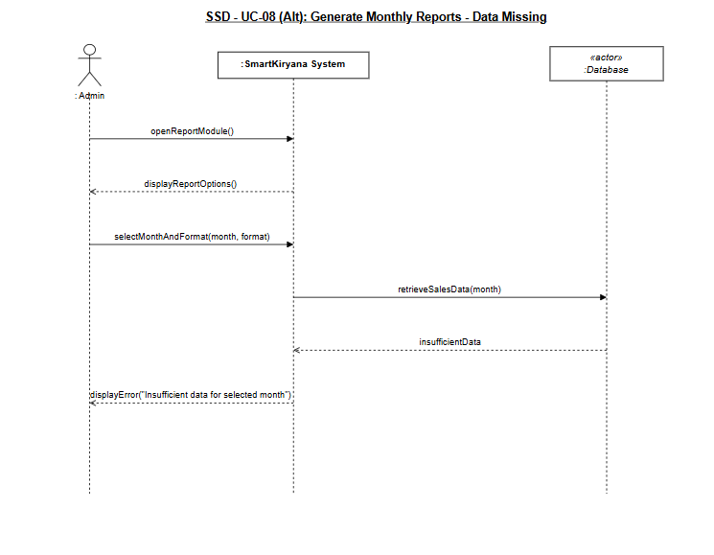

UC09 Alternate Scenario SSD
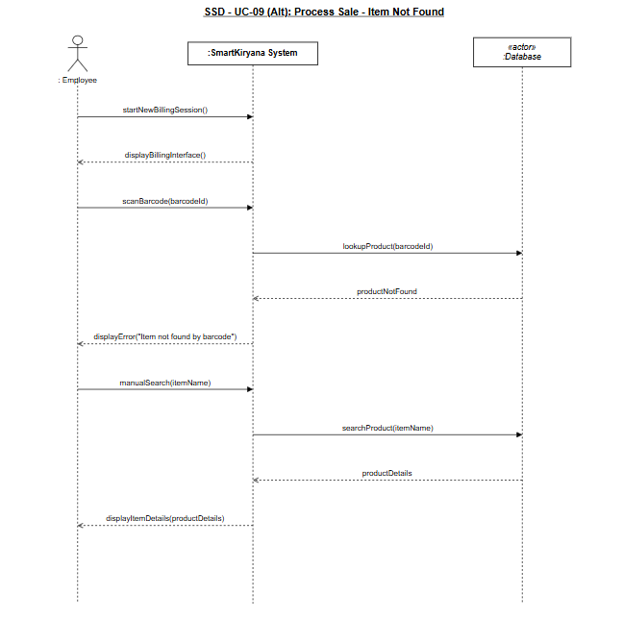

UC10 Alternate Scenario SSD
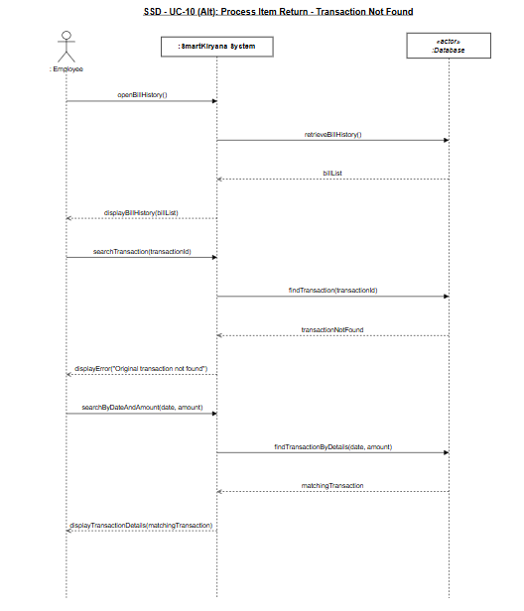

UC11 Alternate Scenario SSD
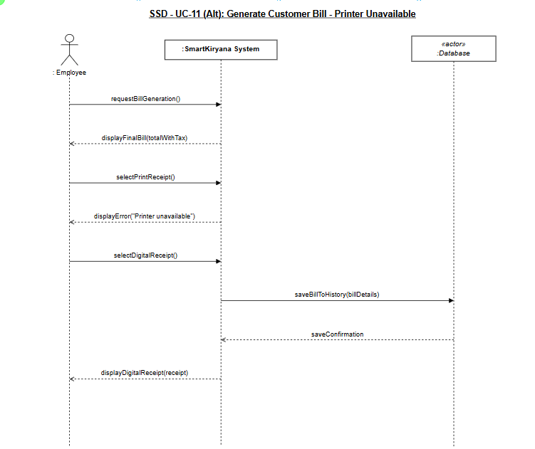

UC12 Alternate Scenario SSD
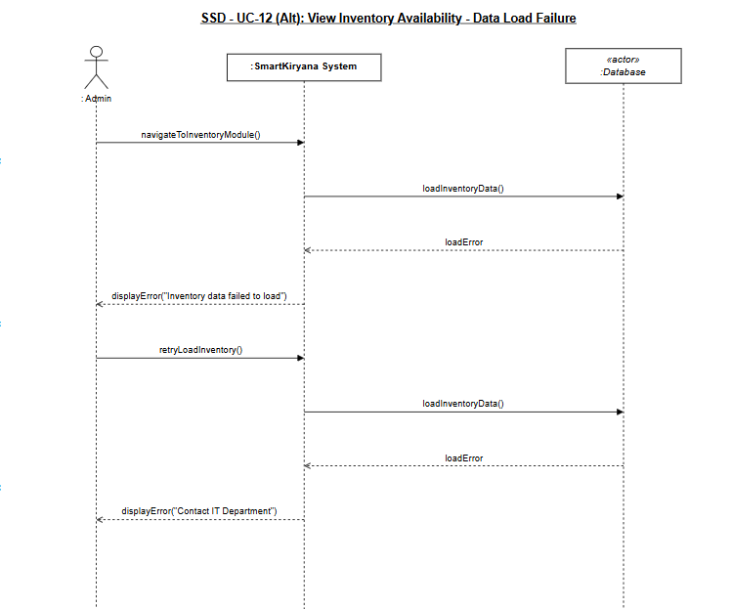

UC13 Alternate Scenario SSD
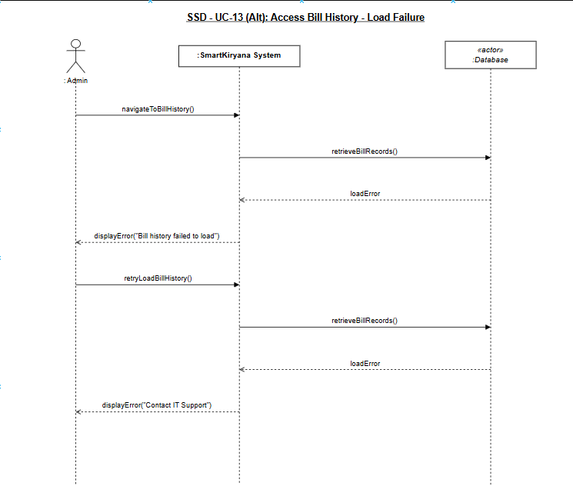

UC14 Alternate Scenario SSD
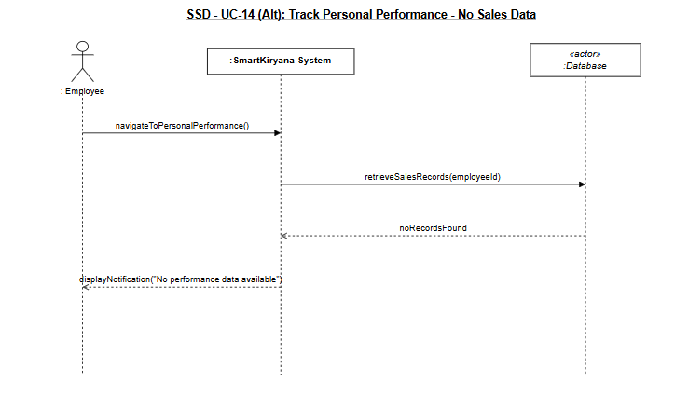

UC15 Alternate Scenario SSD
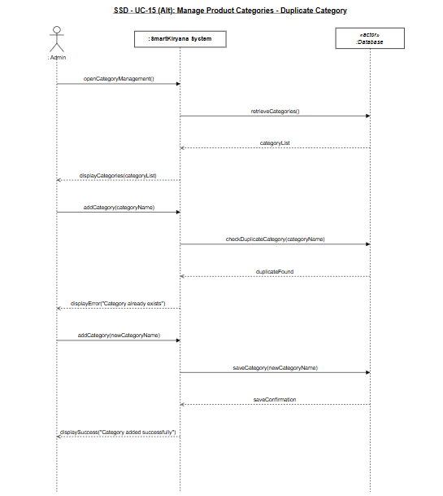

UC01 SD
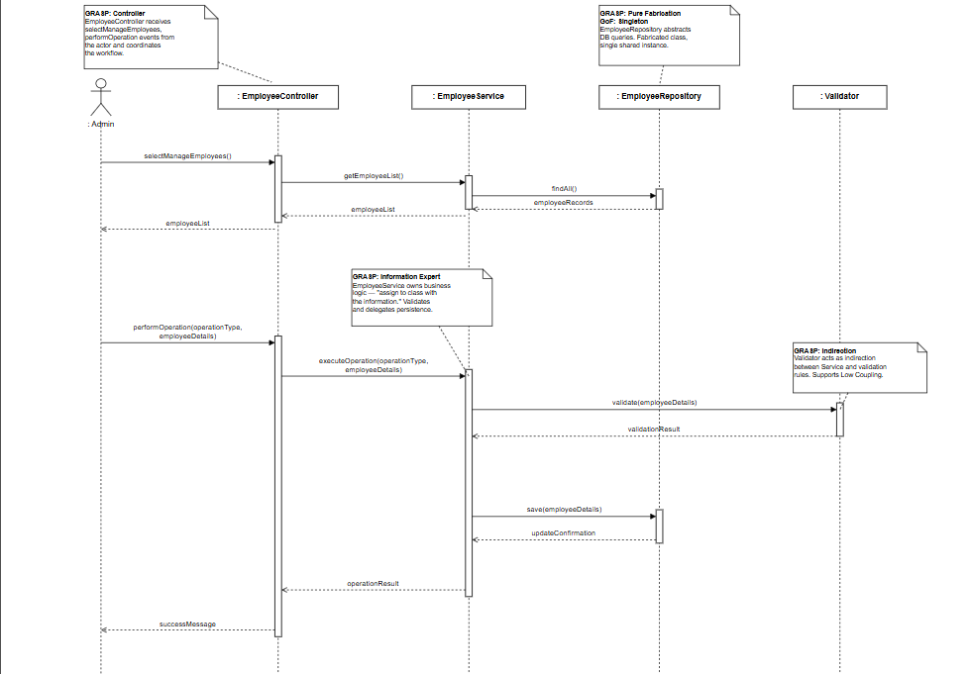

UC02 SD
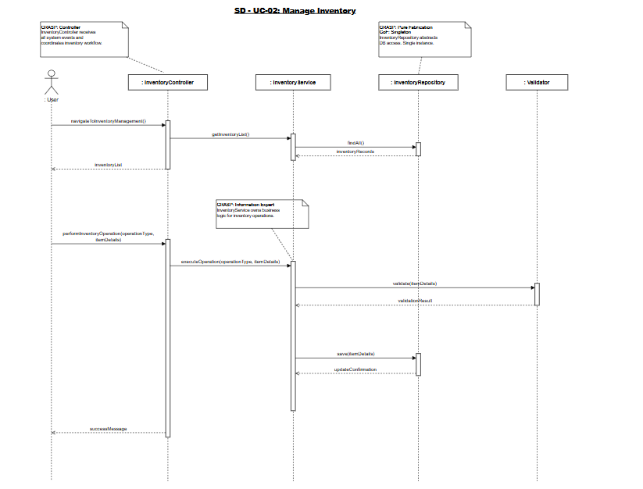

UC03 SD
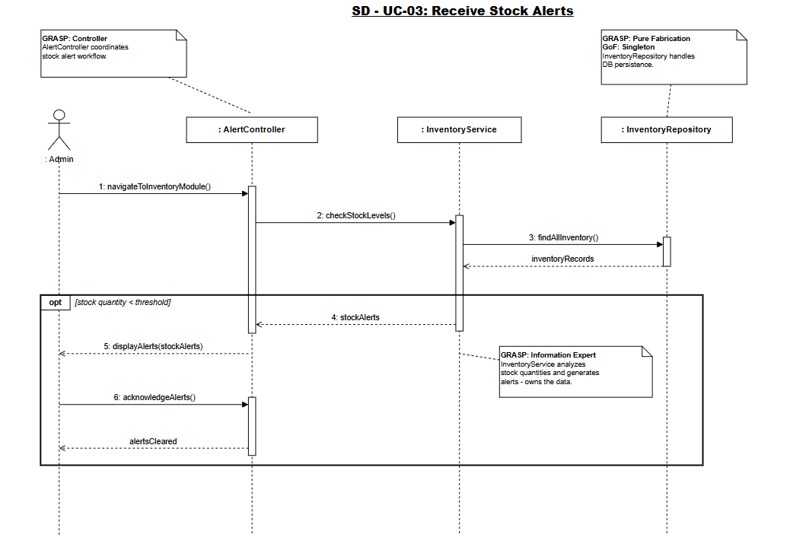

UC04 SD
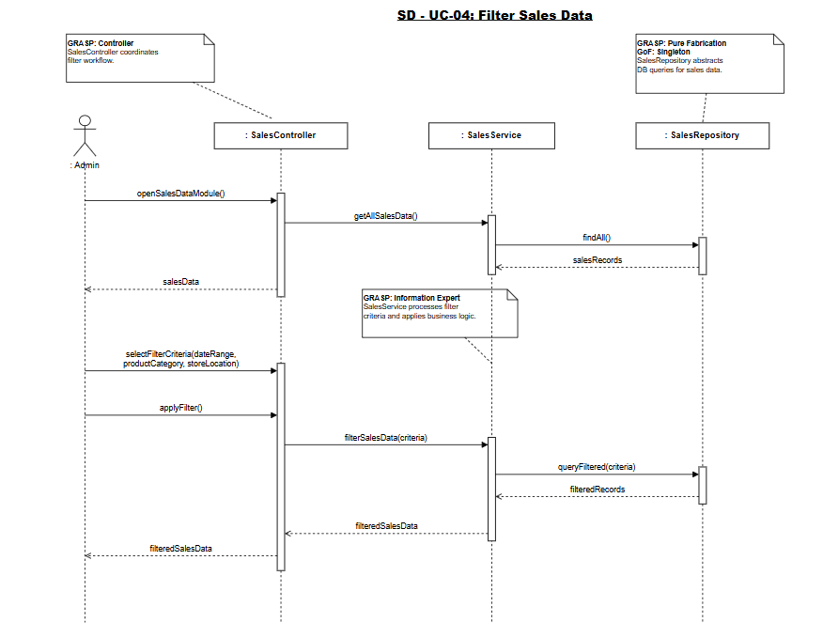

UC05 SD
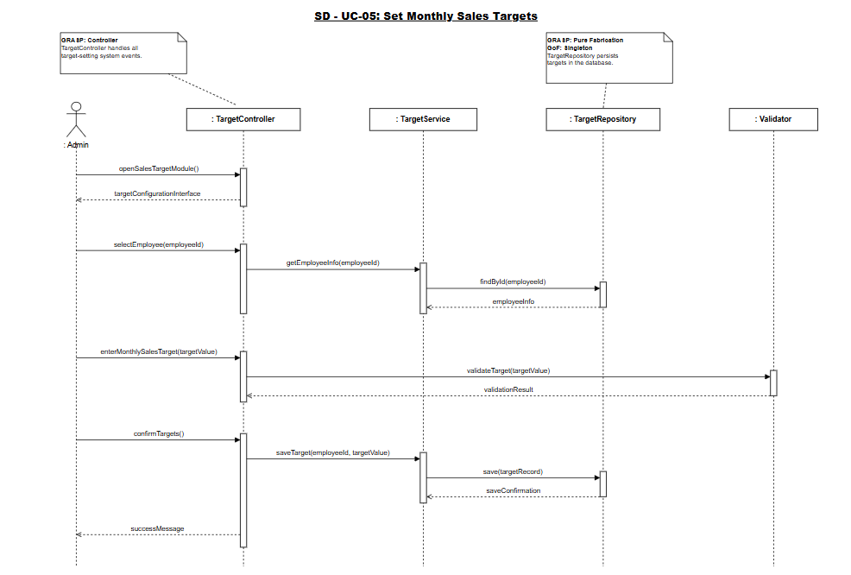

UC06 SD
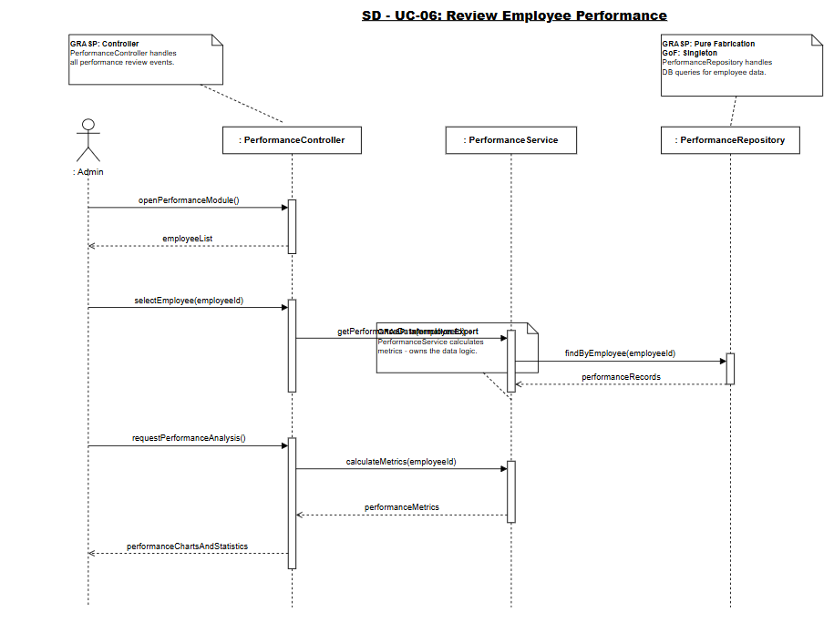

UC07 SD
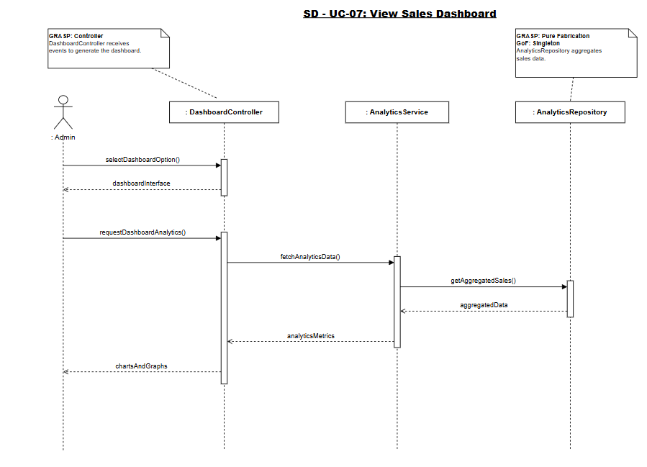

UC08 SD
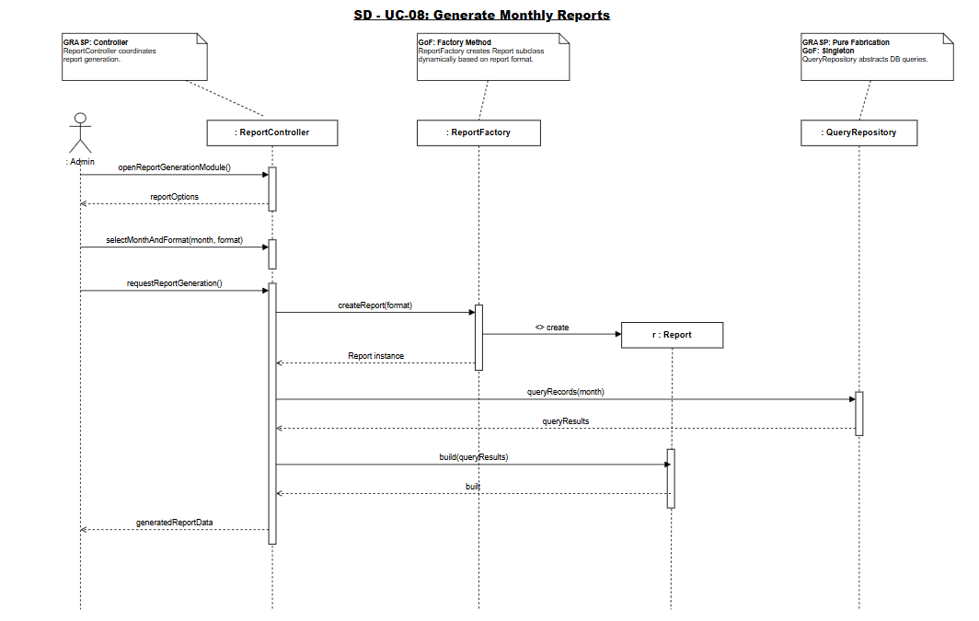

UC09 SD
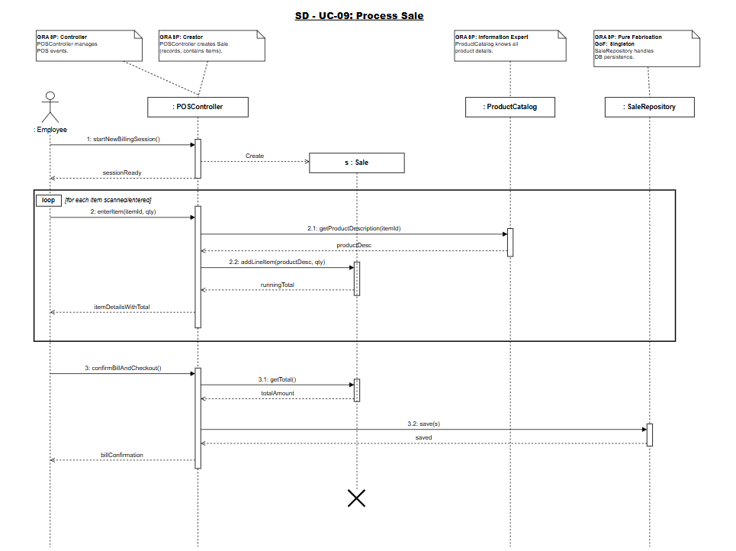

UC10 SD
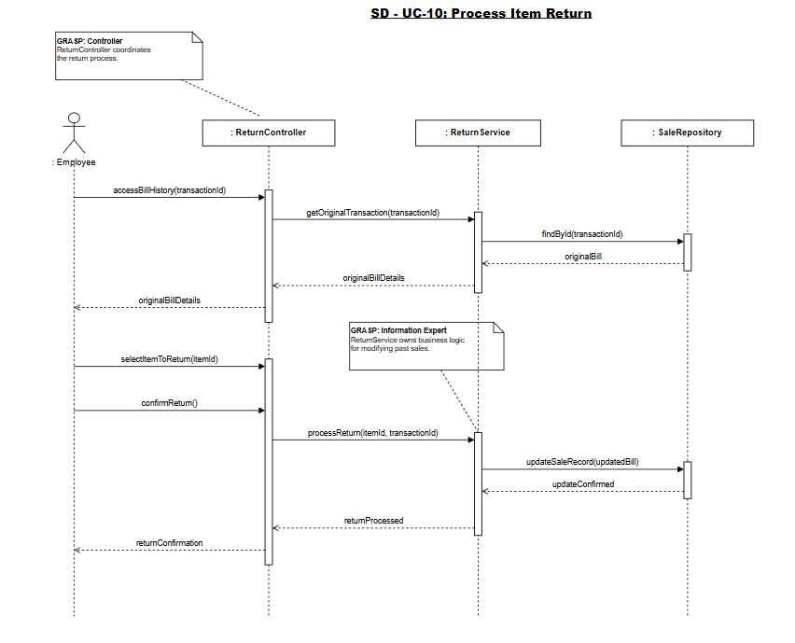

UC11 SD
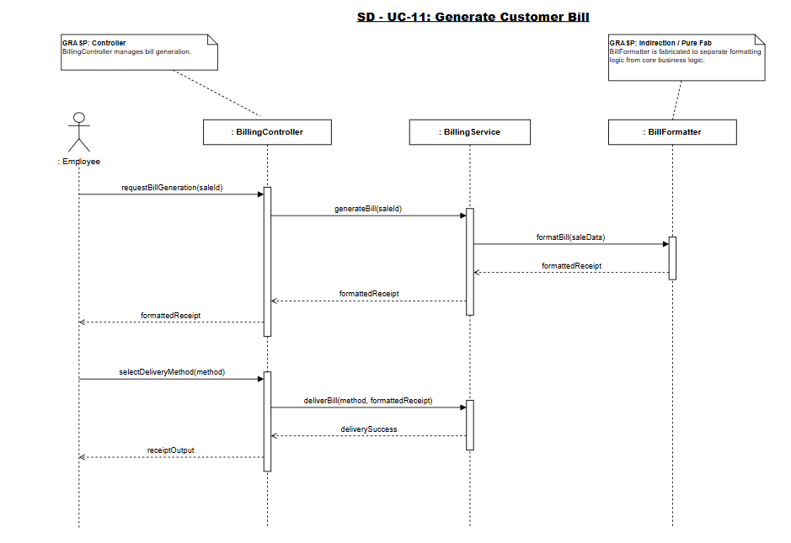

UC12 SD
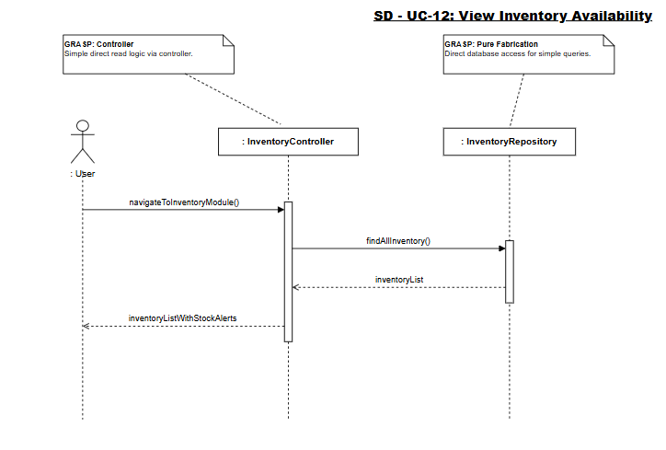

UC13 SD
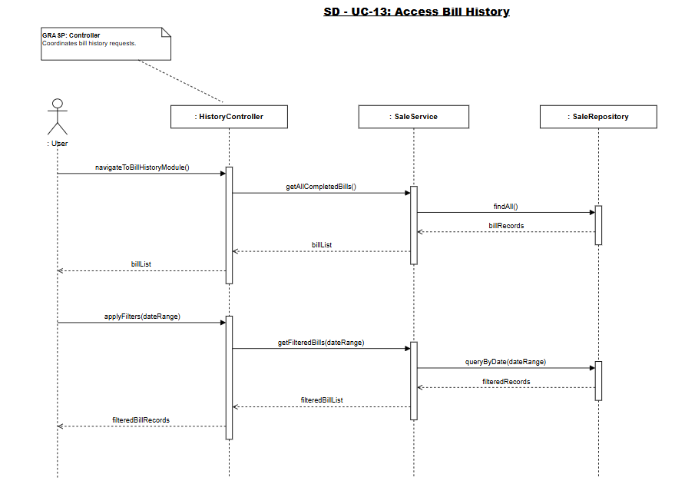

UC14 SD
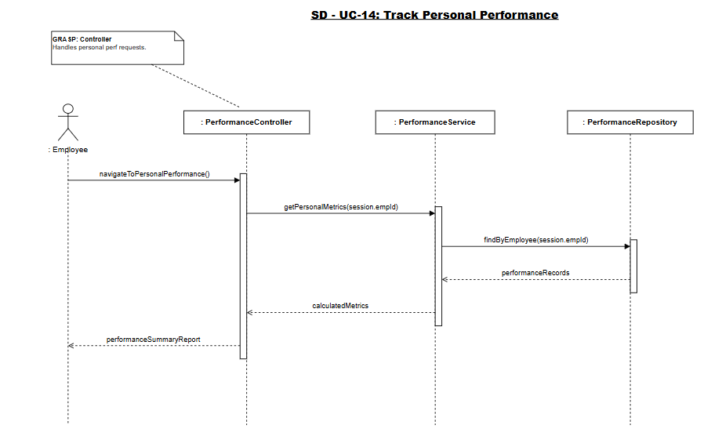

UC15 SD
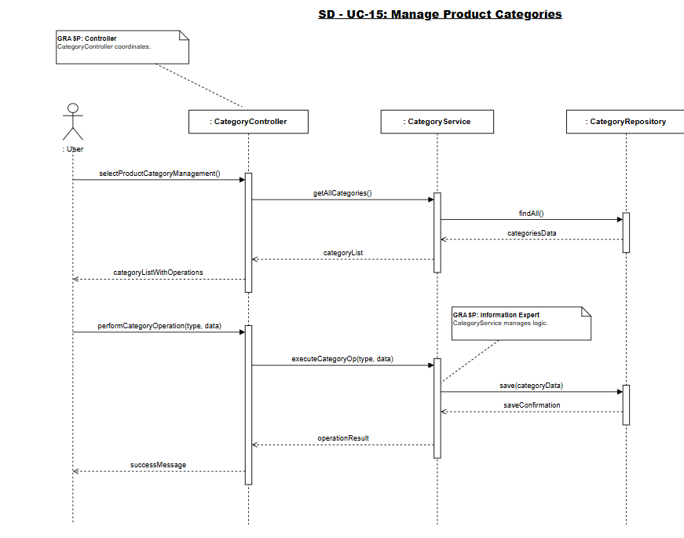

Class Diagram
