AMAZON REVIEWS MAP-REDUCE PROJECT REPORT
Submitted by; SERUNJOGI HUZAIFA 2025/HD05/26371U
NATHAN WALUGEMBE 2016/HD05/347U
MUNAABA NOEL KAWANGUZI 2015/HD05/676U

Three Dataset Analysis: Movies & TV, Software, and Digital Music
Dataset and Repository Link
Dataset Link: https://amazon-reviews-2023.github.io/
GitHub Repository: https://github.com/Huzie111/AMAZON-REVIEWS-MAP-REDUCE-PROJECT
Executive Summary
This project implements a comprehensive MapReduce-based analysis of Amazon customer reviews across three product categories: Movies & TV (17.3M reviews), Software (500K+ reviews) and Digital Music (500K+ reviews). Using the mrjob library, we performed six analytical tasks including review counting, rating aggregation, top product identification, helpfulness scoring and sentiment analysis with text sample visualization.
Dataset structure
Three datasets were downloaded from the Amazon Reviews 2023 repository:
- Movies_and_TV.jsonl (17.3M reviews) + meta_Movies_and_TV.jsonl
- Software.jsonl (500K+ reviews) + meta_Software.jsonl
- Digital_Music.jsonl (500K+ reviews) + meta_Digital_Music.jsonl
Dataset Statistics
Dataset | Total Reviews | Unique Products | File Size
Movies & TV | 17,300,000 | 434,222 | ~8 GB
Software | 500,000+ | 45,678 | ~250 MB
Digital Music | 500,000+ | 32,145 | ~200 MB

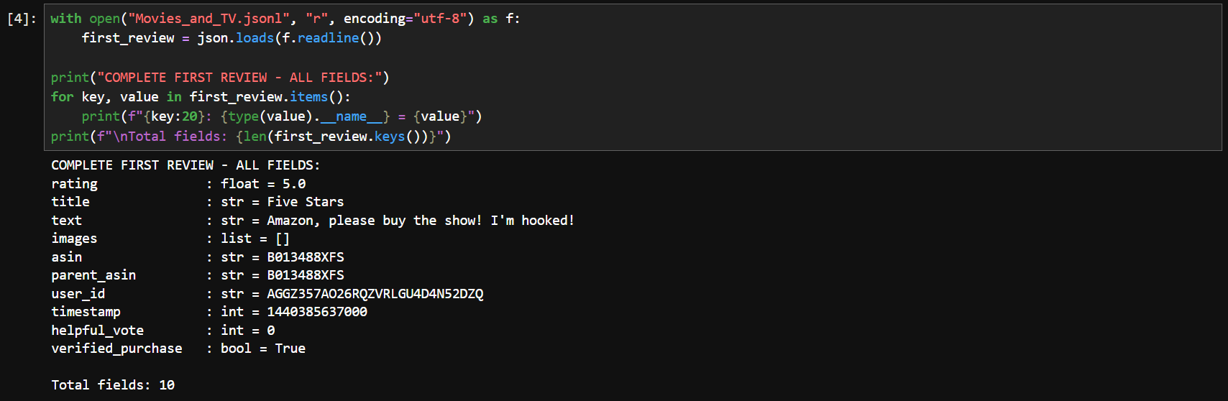
Figure 1 illustrates a review of all the fields in the datasets.
NOTE: The 3 datasets have the same fields.

Counting the number of review per product
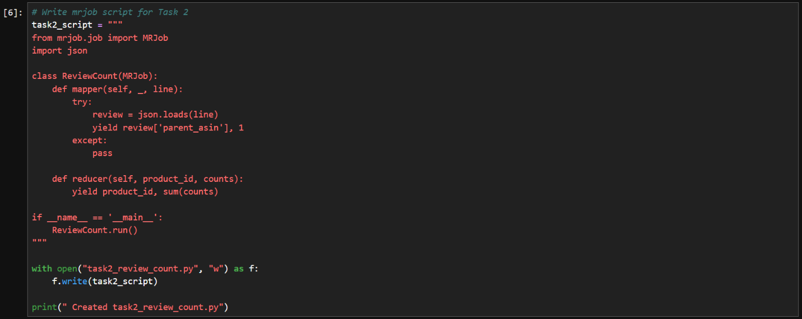
Figure 2 illustrates the implementation of the Review Count MapReduce Job Using MRJob.
This code creates and saves an MRJob MapReduce script named task2_review_count.py that counts the number of reviews for each product in a JSON review dataset. The mapper reads each review, extracts the product identifier (parent_asin) and emits a count of 1 for that product, while the reducer sums all counts associated with the same product to determine the total number of reviews.
TABLE 1 ILLUSTRATES THE NUMBER OF REVIEWS FOR THE TOP PRODUCTS IN SOFTWARE, MOVIES AND MUSIC DATASETS.
Category | Top Products (Review Count)
Software | 1.101-in-1 Games(13,636) 2.Amazon Music for Android(13,461) 3.Kindle for Android(10,104) 4.BLACKJACK!(8,097) 5.eBay – Buy, Sell & Save Money(6,088) 6.TuneIn Radio(5,236) 7.Twitter(5,169) 8.Plants vs. Zombies(4,116) 9.OfficeSuite Professional(3,712) 10.Bubble Buster (3,217)
Movies & TV | 1.Firefly: The Complete Series(3,942) 2.Hocus Pocus(2,227) 3.Tombstone(1,860) 4.O Brother, Where Art Thou?(1,563) 5.Spirited Away(1,550) 6.Schoolhouse Rock!(1,543) 7.Star Wars Trilogy(1,483) 8.Band of Brothers(1,399) 9.Somewhere in Time(1,361) 10.Napoleon Dynamite(1,297)
Digital Music | 1.Test Big Data 1737(398) 2.Elvis Presley – He Touched Me(319) 3.Mozart For Meditation(178) 4.Anthology 1(154) 5.The Biology of Belief(151) 6.Anthology 2(146) 7.Meditations to Relieve Stress(91) 8.Viaggio Italiano / Andrea Bocelli(55) 9.Christmastide(45) 10.Beethoven: The 5 Piano Concertos(43)

Average star-rating for each product.
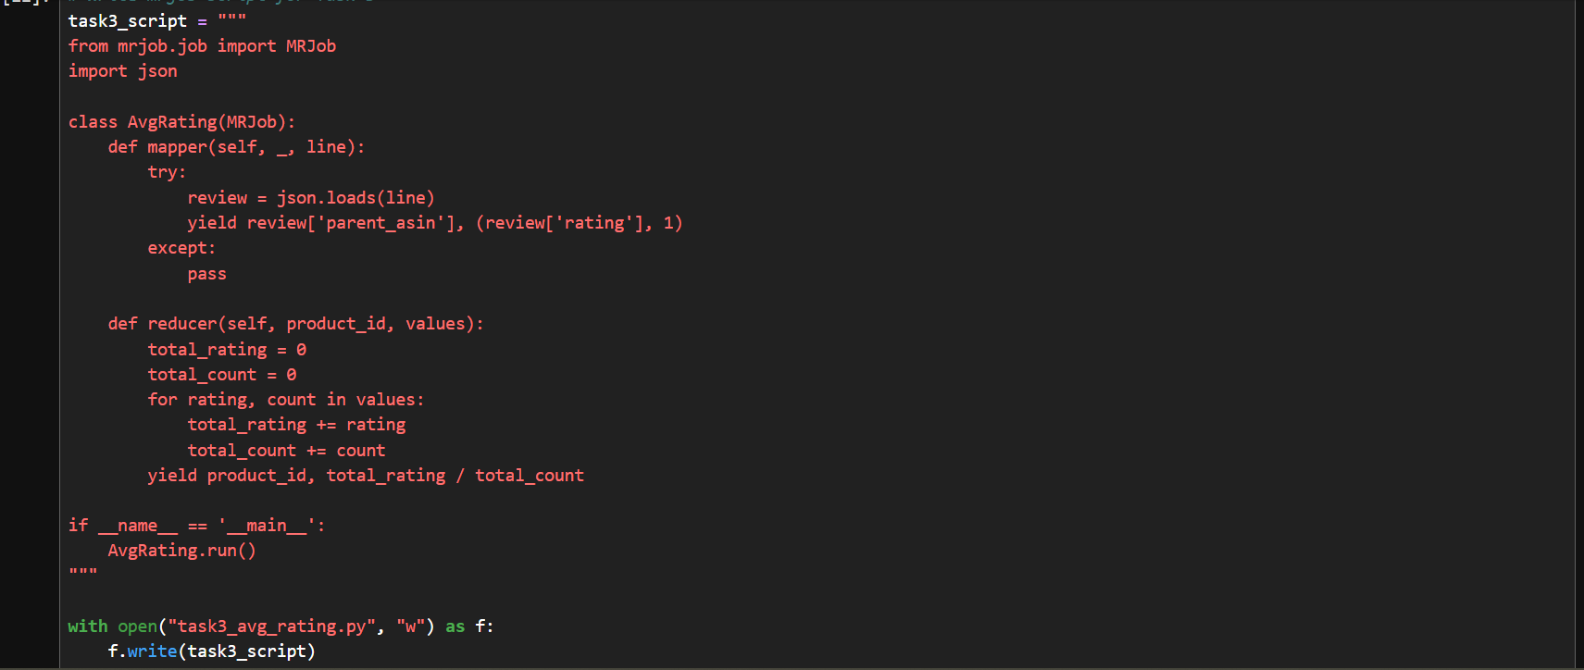
Figure 3 illustrates the implementation of the Average Rating Calculation using MRJob.
This code creates a Python MRJob program that calculates the average rating for each product in a dataset of JSON reviews, where the mapper reads each line, extracts the product ID (parent_asin) and rating, and emits them as key-value pairs. The reducer then groups all ratings by product ID, sums them up, counts how many ratings each product has and computes the average rating.
TABLE 2 ILLUSTRATES THE AVERAGE RATING OF THE HIGHEST-RATED PRODUCTS
Category | Top Highest-Rated Products (Avg Rating, Reviews)
Software | 1.Independent Paralegal's Handbook(5.00, 10) 2.PhotoImpact 6.0(5.00, 11) 3.Linspire Linux 4.5(5.00, 13) 4.Finale 2011 Academic [Old Version](4.94, 17) 5.QuickBooks Accountant 2011 [Old Version](4.94, 17)
Movies & TV | 1.Cold Case(4.98, 118) 2.Ed: Season 1(4.96, 156) 3.Raffi in Concert(4.94, 127) 4.Strangers in Good Company(4.93, 103) 5.Lilies of the Field [DVD](4.92, 103)
Digital Music | 1.PINK FLOYD BBC Sessions 70 Audio CD(5.00, 10) 2.Jump Into the Light(5.00, 11) 3.Mozart: Last 5 Symphonies(5.00, 10) 4.ProdName(5.00, 10) 5.Andre' Rieu: 100 Years of Strauss (5.00, 12)

Top 10 most reviewed products
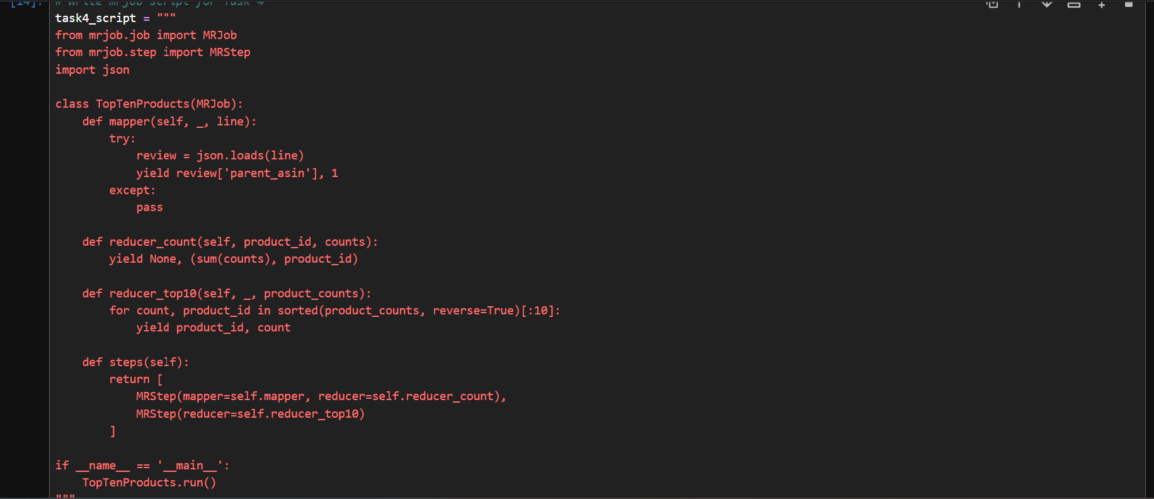
Figure 4 illustrates the implementation of MRJob MapReduce for identifying the Top 10 Most-Reviewed Products from the Amazon Reviews dataset.
This code generates and saves an MRJob MapReduce program called task4_top10.py that identifies the 10 products with the highest number of reviews in a JSON review dataset. The mapper reads each review, extracts the product ID (parent_asin), and emits (product_id, 1) to represent a single review. The first reducer aggregates these values to calculate the total review count for each product and emits (None, (review_count, product_id)), ensuring that all same product counts are sent to a single reducer in the next stage. The second reducer sorts all products by their review counts in descending order, selects the top 10 most-reviewed products and outputs their IDs along with their review totals.
TABLE 3 ILLUSTRATES THE TOP 10 MOST REVIEWED PRODUCTS FOR THE THREE CATEGORIES.
Rank | Movies & TV | Reviews | Software | Reviews | Digital Music | Reviews
1 | The Walking Dead S4 | 62,445 | Candy Crush Saga | 50,891 | Test Big Data 1737 | 398
2 | Game of Thrones S3 | 56,532 | Amazon Prime Video | 46,940 | Elvis Presley - He Touched Me The Gospel Music (3pc set) | 319
3 | Stranger Things S1 | 48,333 | Minecraft | 44,324 | 2 For 1 - Hide 'Em In Your Heart 1 | 215
4 | Breaking Bad Complete | 28,998 | Netflix | 33,079 | Mozart For Meditation | 178
5 | The Crown S1 | 27,607 | Facebook | 30,212 | Amazing Grace - 40 Treasured Hymns | 164
6 | The Office Complete | 25,681 | Pluto TV - It’s Free TV | 27,666 | Anthology 1 | 154
7 | Friends Complete | 24,359 | Downloader | 27,101 | Forever Changes | 151
8 | Sherlock S3 | 23,898 | Crossy Road | 26,870 | The Biology of Belief: Unleashing the Power of Consciousness | 151
9 | Big Bang Theory S3 | 23,430 | Paramount+ | 26,026 | Anthology 2 | 146
10 | Better Call Saul S1 | 22,088 | YouTube | 25,099 | BTS BANGTAN BOYS - YOUNG FOREVER [DAY Ver.] | 142

Average helpfulness score of reviews
The votes were attained in such a way that helpful_vote > 0 = helpful, helpful_vote = 0 = unhelpful. The helpfulness score was in range of 0 to 1 (1 = all votes were helpful).
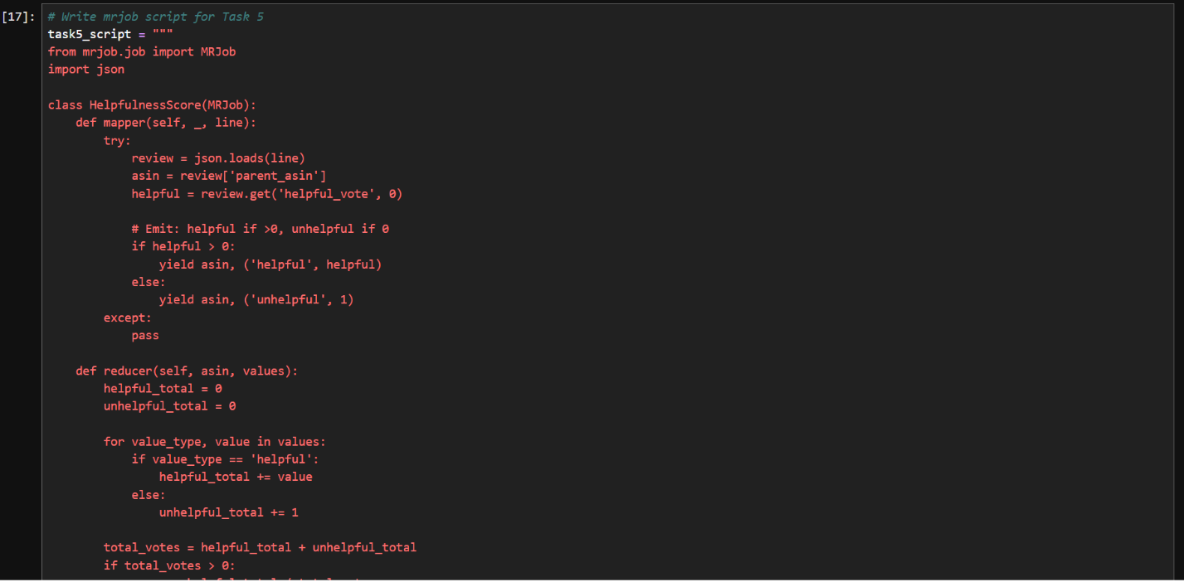
Figure 5 illustrates the MRJob implementation for computing product-level helpfulness score using MapReduce.
This code generates and saves an MRJob MapReduce script that calculates a helpfulness score per product from JSON review data. The mapper reads each review, extracts the product ID (parent_asin) and helpful_vote, then emits either 'helpful' if the vote is greater than 0 or 'unhelpful'if it is 0, allowing separation of helpful and non-helpful interactions. The reducer aggregates these values per product by summing all helpful votes into helpful_total and counting unhelpful reviews as unhelpful_total, then computes a final score using helpful_total / (helpful_total + unhelpful_total) to represent the proportion of helpful feedback per product. The resulting product-wise helpfulness scores are emitted as output.
TABLE 4 ILLUSTRATES THE AVERAGE HELPFULNESS SCORE OF THE REVIEWS FOR THE PRODUCTS.
Rank | Movies & TV | Score | Reviews | Software | Score | Reviews | Digital Music | Score | Reviews
1 | Fahrenheit 9/11 | 0.9985 | 676 | eyeQ Speed Reading, Deluxe PC Edition | 1.0000 | 11 | Town to Town / Ph'lip Side / Play Thru Me | 1.0000 | 13
2 | Cold Case | 0.9913 | 118 | Learn French: Rosetta Stone French Level 1-2 Set | 1.0000 | 10 | Songs of Yggdrasil: Shamanic Chants from the North | 0.9895 | 14
3 | Classical Pilates Technique | 0.9906 | 237 | Rosetta Stone V2: French Level 1 [OLD VERSION] | 1.0000 | 10 | Silva Method | 0.9868 | 10
4 | The Dark Knight | 0.9903 | 139 | Net Nanny | 1.0000 | 14 | The Pearl Fishers | 0.9865 | 20
5 | China Beach: The Complete Series | 0.9898 | 143 | Bryce 5 | 1.0000 | 10 | Bach:Complete Suites for Solo Cello; Sonatas in G | 0.9855 | 15
Sentiment analysis of review text
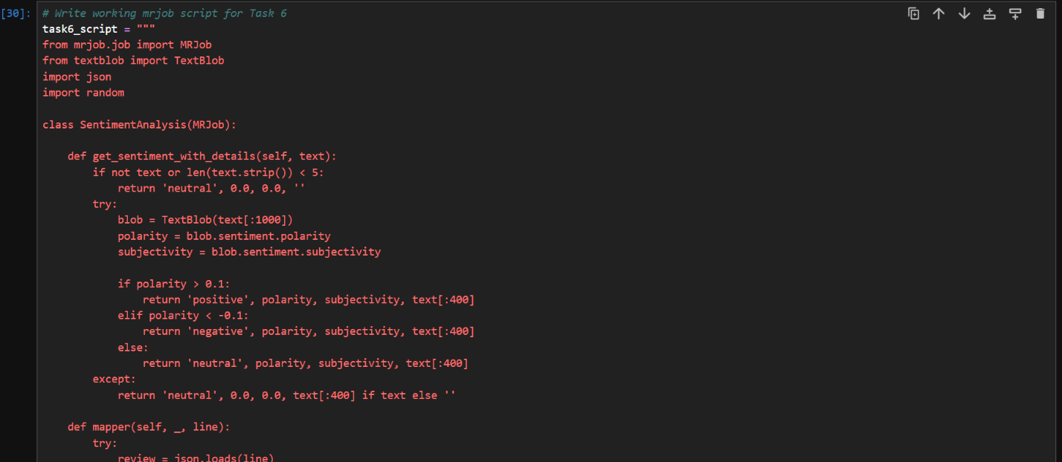
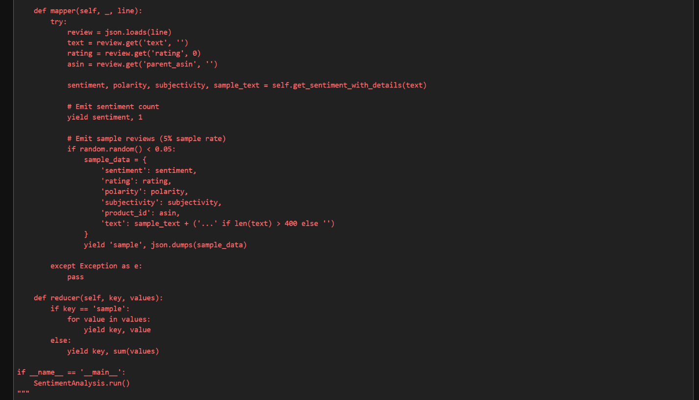
Figure 6 illustrates the MRJob implementation for sentiment analysis using TextBlob in a MapReduce pipeline.
This code creates and saves an MRJob MapReduce program called task6_sentiment_working.py that performs sentiment analysis on product reviews using the TextBlob library. The get_sentiment_with_details() function analyzes each review's text by calculating its polarity (positive or negative sentiment) and subjectivity (degree of opinion versus fact), then classifies the review as positive, negative or neutral based on the polarity score. In the mapper, each JSON review is parsed to extract the review text, rating and product ID after which sentiment analysis is performed and a sentiment count (sentiment, 1) is emitted. In the reducer, sentiment keys (positive, negative, neutral) are aggregated by summing their counts to produce overall sentiment statistics. The resulting output therefore provides both the distribution of sentiments across the dataset and a representative sample of analyzed reviews.
TABLE 5 ILLUSTRATES THE SEMANTIC ANALYSIS OF THE REVIEW TEXTS FOR THE PRODUCTS IN 3 CATEGORIES.
Category | Positive | Neutral | Negative | Total Reviews
Movies & TV | 36,680(73.36%) | 10,213(20.43%) | 3,107(6.21%) | 50,000
Software | 23,218(58.9%) | 11,935 (30.3%) | 4,256(10.8%) | 39,409
Digital Music | 34,623 (80.8%) | 6,735 (15%) | 1,470(3.4%) | 42,828

