**Regular Expression Practice Questions**

*Question 1- Write a RegEx pattern in python program to check that a string contains only a certain set of characters (in this case a-z, A-Z and 0-9).*

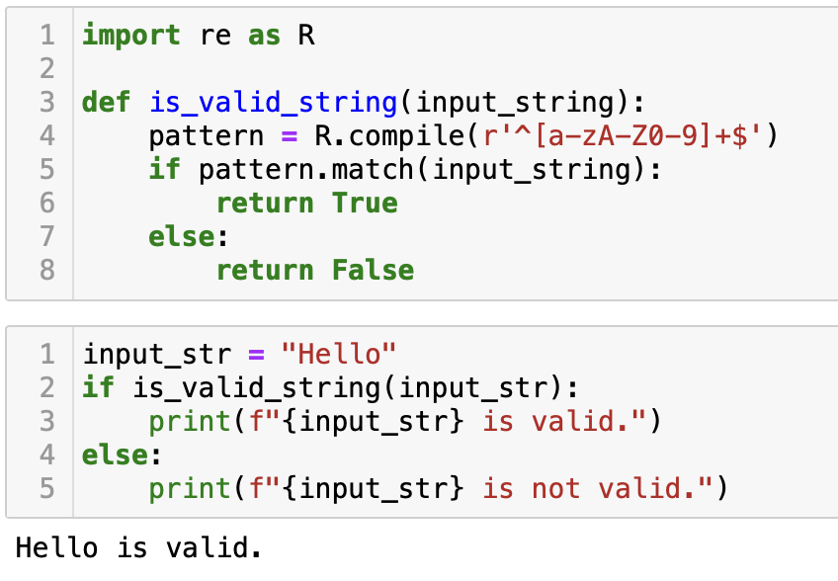 import re as R

def is_valid_string(input_string):

pattern = R.compile(r'^[a-zA-Z0-9]+$')

if pattern.match(input_string):

return True

else:

return False

#*Example*

input_str = "Hello"

if is_valid_string(input_str):

print(f"{input_str} is valid.")

else:

print(f"{input_str} is not valid.")

Question 2- Write a RegEx pattern that matches a string that has an a followed by zero or more b's

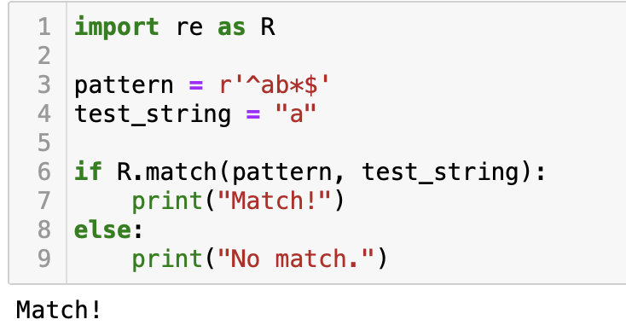import re as R

pattern = r'^ab*$'

test_string = "a"

if R.match(pattern, test_string):

print("Match!")

else:

print("No match.")

Question 3- Write a RegEx pattern that matches a string that has an a followed by one or more b's

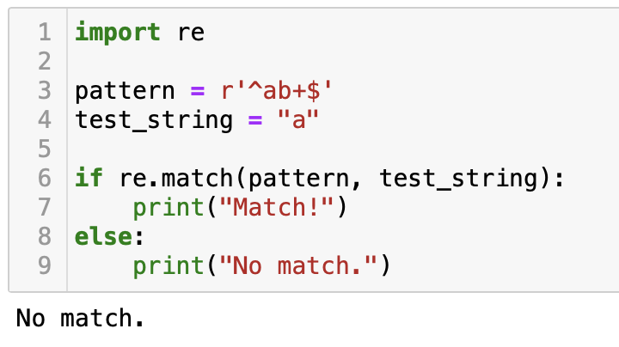import re

pattern = r'^ab+$'

test_string = "a"

if re.match(pattern, test_string):

print("Match!")

else:

print("No match.")

Question 4- Write a RegEx pattern that matches a string that has an a followed by zero or one 'b'.

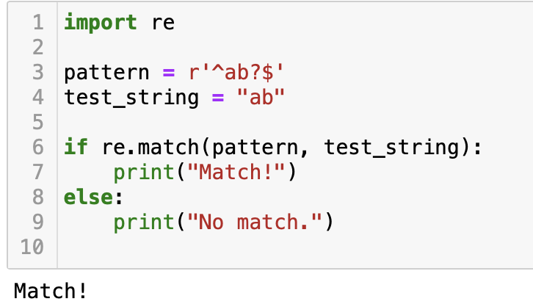import re

pattern = r'^ab?$'

test_string = "ab"

if re.match(pattern, test_string):

print("Match!")

else:

print("No match.")

Question 5- Write a RegEx pattern in python program that matches a string that has an a followed by three 'b'.

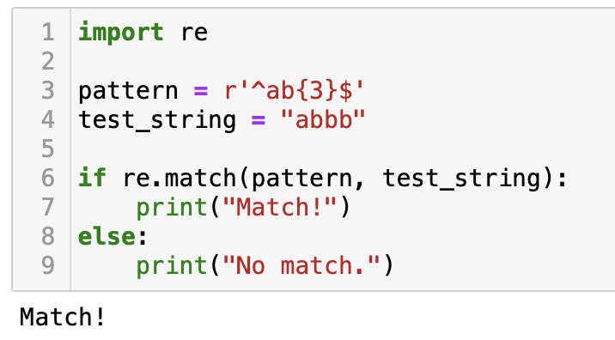import re

pattern = r'^ab{3}$'

test_string = "abbb"

if re.match(pattern, test_string):

print("Match!")

else:

print("No match.")

Question 6- Write a RegEx pattern in python program that matches a string that has an a followed by two to three 'b'.

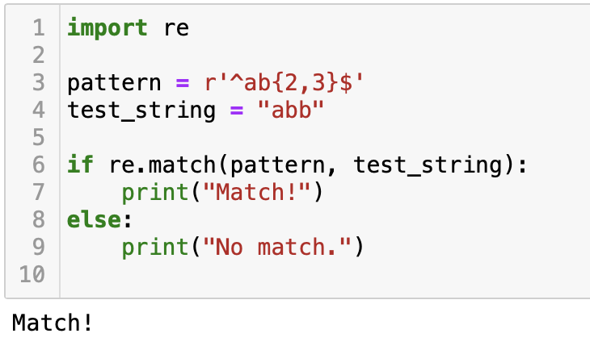import re

pattern = r'^ab{2,3}$'

test_string = "abb"

if re.match(pattern, test_string):

print("Match!")

else:

print("No match.")

Question 7- Write a Python program that matches a string that has an 'a' followed by anything, ending in 'b'.

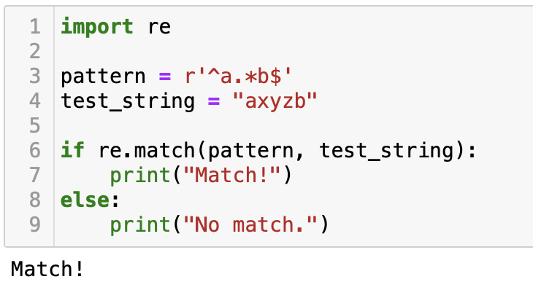import re

pattern = r'^a.&b $'

test_string = "axyzb"

if re.match(pattern, test_string):

print("Match!")

else:

print("No match.")

Question 8- Write a RegEx pattern in python program that matches a word at the beginning of a string.

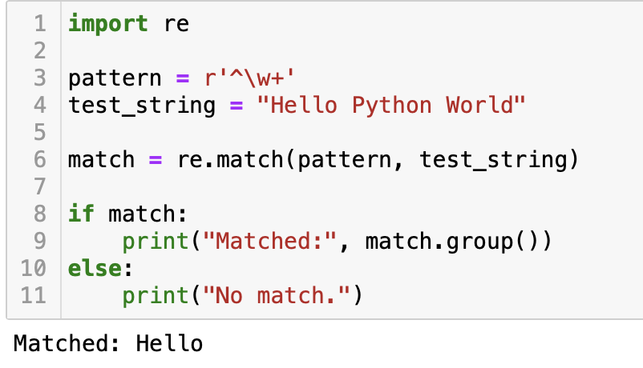import re

pattern = r'^\w+'

test_string = "Hello Python World"

match = re.match(pattern, test_string)

if match:

print("Matched:", match.group())

else:

print("No match.")

Question 9- Write a RegEx pattern in python program that matches a word at the end of a string.

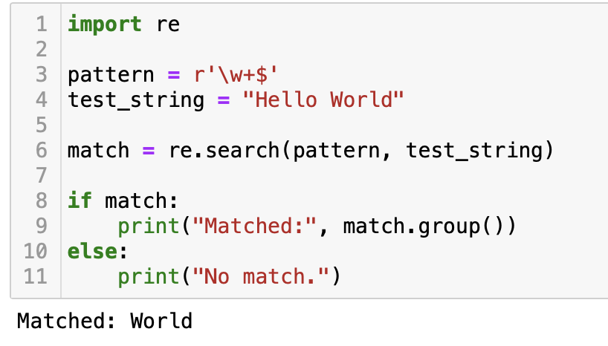import re

pattern = r'\w+$'

test_string = "Hello World"

match = re.search(pattern, test_string)

if match:

print("Matched:", match.group())

else:

print("No match.")

Question 10- Write a RegEx pattern in python program to find all words that are 4 digits long in a string.

Sample text- '01 0132 231875 1458 301 2725.' Expected output- ['0132', '1458', '2725']

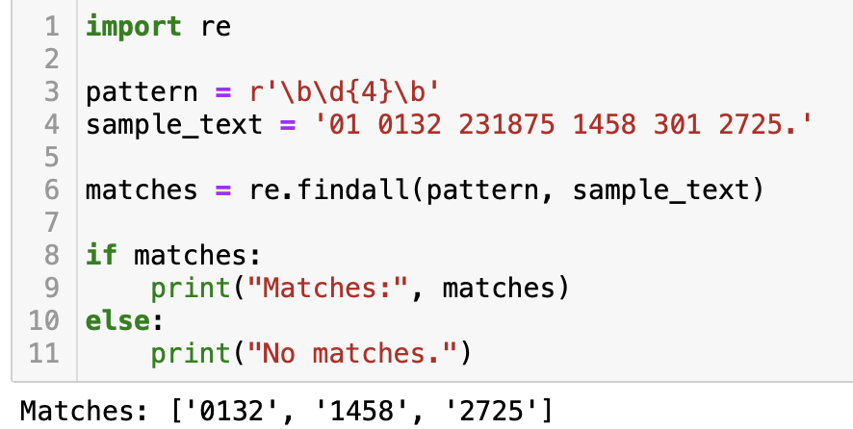import re

pattern = r'\b\d{4}\b'

sample_text = '01 0132 231875 1458 301 2725.'

matches = re.findall(pattern, sample_text)

if matches:

print("Matches:", matches)

else:

print("No matches.")