**SDA Lab Project**

**Submitted By:** Huzaifa Ahmed Khan (Fa22-Bse-079)

**Submitted To:** SirMukhtiar Zamin

**Date:** 11th November 2024

**Book Wala**

**Report:**

**Overview:**  
We are developing an online platform that offers licensed books for users to explore. This web application will allow readers to enjoy books, bookmark their progress, and return seamlessly to where they left off. Additionally, users can share their thoughts through reviews, ratings, and comments on the titles they've read.

**Advantages:**

* This web application will significantly enhance users' reading habits.
* It will aid in improving users' verbal communication skills.
* Users will have the opportunity to engage with one another through reviews and discussions.

**Key Features:**

* A wide variety of books are available for selection.
* Tools for highlighting key passages.
* Bookmarking functionality for easy return to previous reading points.
* Tailored book recommendations based on individual preferences and reading history.

**Target Users:**

* Students aiming to enhance their reading abilities.
* Avid readers interested in book discussions.
* Individuals learning a new language.

**Possible Challenges:**

* Creating a welcoming and enjoyable environment for all users.
* Keeping users motivated to read consistently.
* Regular upkeep of the web application to ensure it operates smoothly.

**Conclusion:**  
In summary, our web application aims to make a meaningful difference in users' reading and speaking skills, promoting literacy and effective communication in the process.

**Use Case Diagram:**

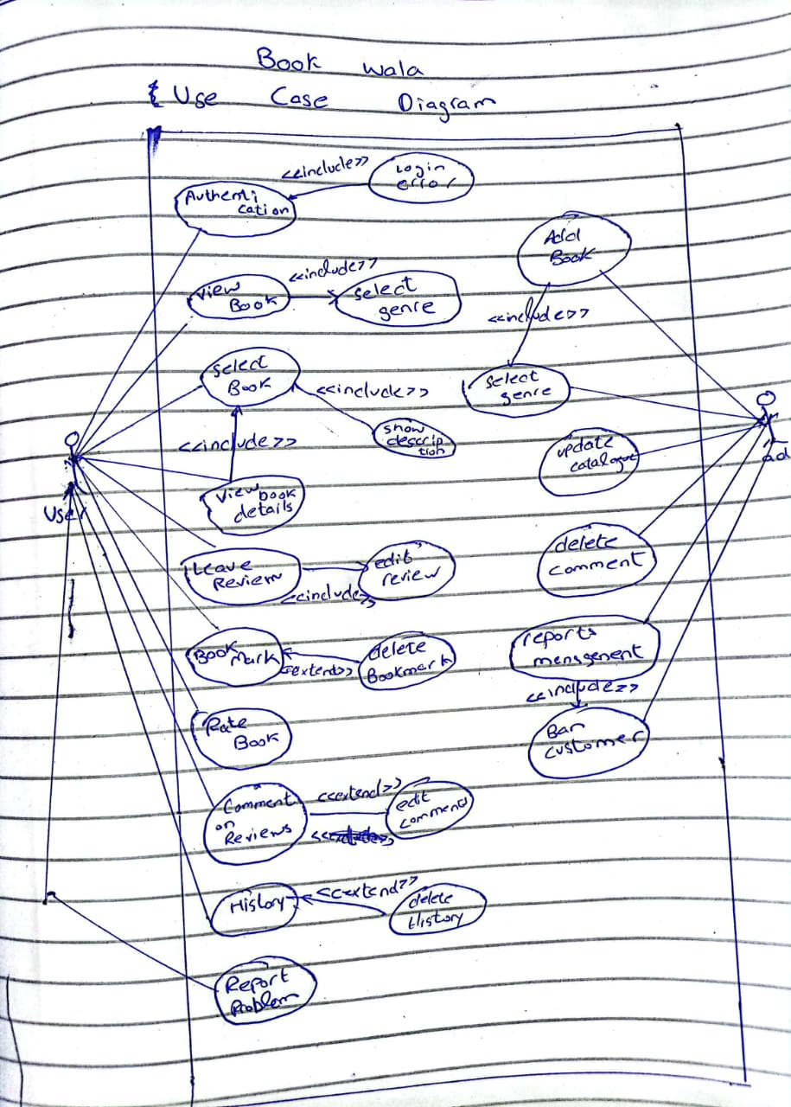

**Fully Dressed Use Case:**

|  |  |
| --- | --- |
| **Use Case** | **Submit and Review Feedback** |
| **Actors** | Customer, Admin |
| **Precondition** | Customer is logged in and has read or interacted with a book. The Admin is logged in. |
| **Trigger** | Customer finishes reading a book and wants to leave feedback. |
| **Basic Flow** | 1. Customer navigates to the book’s page.  2. Customer clicks on the "Leave a Review" button.  3. Customer writes a review, rates the book, and submits it.  4. The system stores the review and links it to the book and customer profile.  5. Admin logs into the system and navigates to the "Reviews" section.  6. Admin views the submitted review. |
| **Post Condition** | The review is available on the book's page for other users to read. The admin has viewed the review. |
| **Alternative Flow** | 3a. Customer tries to leave a review without being logged in.  - System prompts the customer to log in or create an account.  3b. Customer submits an incomplete review.  - System displays an error, asking for all required fields to be filled (e.g., rating, review text). |
| **Exception Flow** | 5a. Admin encounters an error while trying to view reviews (e.g., server issue).  - System shows an error message and logs the issue. |
| **Assumptions** | Customer is a valid registered user. The admin has the necessary permissions to read reviews. |
| **Priority** | Medium |
| **Frequency of Use** | Common (Multiple reviews daily, depending on traffic) |
| **Stakeholders** | Customers, Admin |
| **Success Guarantee** | The customer’s review is successfully posted, and the admin has access to read it without errors. |

**SSD:**

**Communication Diagram:**



