Knowledge-Based AI and Data-Driven Decision Support for Digital Transformation, Innovation, and Entrepreneurship in Manufacturing SMEs
Short Communication
Abstract
Manufacturing decision support increasingly combines machine-learning predictions with readable knowledge rules, but a plausible rule is not necessarily useful for controlling automation risk. We present a compact, evidence-gated hybrid architecture and investigate whether training-derived decision rules add reliable information beyond calibrated confidence for steel-defect quality triage. Using 1,941 UCI Steel Plates Faults observations, an internally calibrated gradient-boosting model predicts seven classes while a shallow decision tree provides a transparent agreement signal. A stratified 60/20/20 train/validation/test protocol compares confidence-only and knowledge-guided review policies at identical automation budgets. The classifier obtained 77.89% held-out accuracy and 77.76% macro-F1. Although ML–rule disagreement coincided with higher error (32.12% versus 16.67% on agreement cases), the naive hybrid increased observed selective error at 80% coverage from 14.79% to 16.72%; the paired-bootstrap interval for its 1.93-point difference included zero. A validation-only evidence gate rejected the lower-performing candidate on validation. This reproducible negative finding clarifies when symbolic guidance should be audited before deployment; manufacturing-SME transformation and entrepreneurial value are potential applications, not measured effects.
Keywords: knowledge-based AI; data-driven decision support; selective classification; manufacturing quality; digital transformation; innovation and entrepreneurship
1. Introduction
Data-intensive manufacturing promises better inspection decisions, yet high-quality process data and organizational readiness are persistent barriers, particularly in SMEs [1–4]. Machine learning can classify observed faults, but plant personnel also need a defensible policy for deciding which predictions can be accepted automatically and which require manual review. Selective prediction formalizes this trade-off as the error among accepted cases at a specified coverage [5].
Knowledge-based AI promises interpretability through explicit decision rules. However, an intelligible rule and a reliable rule are different things: a rule extracted from the same limited data as the predictor can be wrong or poorly aligned with prediction confidence. We therefore ask whether a shallow induced knowledge model contributes information useful for selecting safe automatic quality classifications beyond calibrated machine-learning confidence. The narrow experiment focuses on quality triage, not physical corrective actions, production optimization, or a demonstrated business transformation.
This distinction is consequential for manufacturing SMEs: digital-transformation studies identify technological, managerial, implementation, and financing constraints [6–10]. An inspectable rule layer may be attractive to quality engineers; nevertheless, a conservative-looking rule can move correct high-confidence cases into review while allowing less reliable cases through. We test whether including such rules improves the selective-risk/coverage frontier under a fixed human-review budget.
2. Related Work and Contribution
Probability calibration [11] and selective classification [5] motivate confidence-sensitive review. Industrial studies have examined uncertainty-aware evidential reasoning [12], reliable learning with sparse data [13], data–knowledge synergy [14], and knowledge-graph fault diagnosis [15–18]. Other machine-fault studies address noisy labels, limited labeled examples, and data-driven diagnostic methods [19–22]. Hybrid reasoning is therefore established; combining a tree with a classifier is not itself novel.
Related steel-surface studies emphasize visual defect recognition and neural feature extraction [23,24], while human-in-the-loop industrial inspection supports explainable operator interaction [25]. The specific gap examined here is methodological: rule agreement can correlate with prediction failure yet contain no useful information beyond confidence. Aggregate classification accuracy cannot establish a rule layer's value as a review-allocation policy.
We evaluate an evidence gate: (i) construct an agreement-based selection candidate and (ii) activate it only if a separate validation sample shows lower selective error than confidence-only selection at a fixed budget. We audit both policies on an untouched test set with paired uncertainty. This is a reproducible, narrowly scoped decision-policy test, not a claimed invention of a new hybrid-learning algorithm.
3. Data and Method
3.1 Dataset and partition
The Steel Plates Faults dataset [26] contains 1,941 observations with 27 numerical or binary inputs and one of seven fault labels. It contains no missing values according to its repository metadata. The archived matrix was checked for its expected 34 columns and one-hot target integrity. A fixed stratified split yielded 1,164 training, 388 validation, and 389 held-out test examples (seed 42). No test labels were used to fit models, induce rules, calibrate probabilities, or select operational cutoffs.
These are industrial fault records, not SME adoption observations; the source manufacturer is not assumed to be an SME. The unmodified upstream archive is identified by a SHA-256 digest. Manufacturing data-foundation methodologies [2] support treating provenance as a prerequisite to deployment rather than a peripheral documentation concern.
3.2 Probabilistic and symbolic models
A histogram-based gradient-boosted tree ensemble (180 boosting iterations, 15 maximum leaves, learning rate 0.07) produces multiclass probabilities. Sigmoid calibration uses three-fold cross-validation inside the training partition. Logistic regression with standardized inputs and a standalone shallow decision tree serve as predictive baselines. The symbolic component is a separate depth-four decision tree with a minimum of 30 samples per leaf. Its decision paths are exported as legible IF-THEN rules; these are induced from training data, not elicited from manufacturing experts or validated SOPs.
Let f(x) be the calibrated class-probability vector and g(x) the label assigned by the independent rule tree. The selected label is the maximum-probability class and c(x) is its probability. The agreement indicator A(x) equals one when the two predicted labels match. The fixed candidate knowledge-guided score applies a 35% confidence penalty to disagreement cases; this parameter is an illustrative predeclared intervention, not an optimized hyperparameter.
ŷ(x) = arg maxₖ fₖ(x); c(x) = maxₖ fₖ(x); A(x) = 1[g(x) = ŷ(x)] (1)
s₀(x) = c(x); sK(x) = c(x)[0.65 + 0.35A(x)] (2)
3.3 Validation-evidence gate
The proposed reliability gate tests whether the knowledge-guided ranking deserves to control decisions. At 80% target automatic coverage, validation records are ranked once by s₀ and once by sK; the lower observed selective-error policy is selected, with confidence-only winning a tie. The selected policy is then frozen before test evaluation. This safeguard does not guarantee improvement in new factories, but it prevents the symbolic component from being accepted merely because its logic appears plausible.
p* = 0 if Rvalid(s₀, 0.80) ≤ Rvalid(sK, 0.80); K otherwise (3)
A deployment would also require validation-derived cutoffs, process-owner approval of rule semantics, monitoring, and adjudication of rejected cases. Figure 1 distinguishes fitting a symbolic proxy from authorizing its use; rejection of the proposed hybrid is a valid gate outcome.
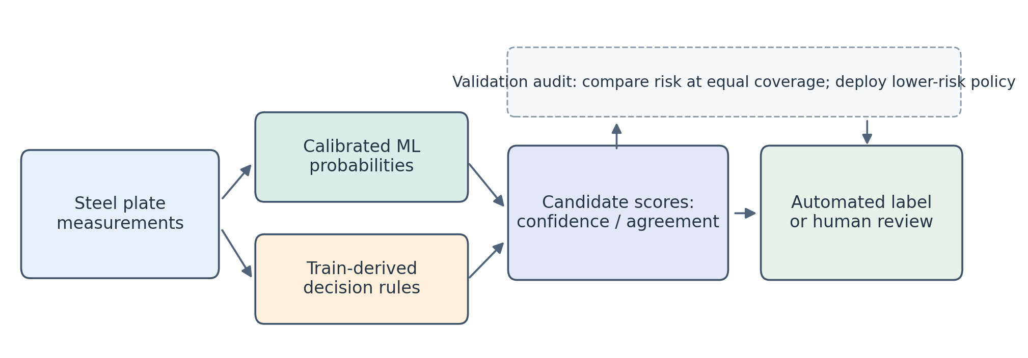
Figure 1. Evidence-gated knowledge-based decision-support architecture. Induced decision paths are inspectable but not expert-approved SOPs. The validation comparison controls whether the rule-assisted candidate is used.
4. Experimental Protocol
Predictive baselines are evaluated using held-out accuracy, macro-F1, multiclass Brier score, and log loss. Multiclass Brier score averages the per-case sum of squared differences between predicted probabilities and one-hot target indicators. This proper probabilistic metric complements class-label accuracy because the review policy depends on probabilities rather than just categorical outputs.
For ranking score s, let S(s,q) contain the top q-fraction of scores. Selective risk R(s,q) is the error proportion in this subset. Matched subsets at q = 0.60, 0.80, and 0.90 isolate ranking quality because the policies share identical base predictions. These test-set rankings are retrospective diagnostics, never live threshold-selection rules.
R(s,q) = [ Σᵢ∈S(s,q) 1(ŷᵢ ≠ yᵢ) ] / |S(s,q)| (4)
Separately, the top-80%-validation score cutoff for each policy is frozen and applied to test examples, so observed operational coverage can drift. A 2,000-resample paired test-set bootstrap yields a percentile 95% interval for R(sK,0.80) − R(s₀,0.80), recomputing matched ranks in each resample. It quantifies conditional sample variation, not model-retraining uncertainty.
5. Results
Table 1. Held-out defect classification (n = 389). Lower Brier scores indicate better probabilistic accuracy.
Model | Accuracy (%) | Macro-F1 (%) | Brier score
Logistic regression | 65.81 | 64.67 | 0.4699
Induced rules (tree) | 61.18 | 52.17 | 0.4904
Calibrated gradient boosting | 77.89 | 77.76 | 0.3213

The calibrated gradient-boosted classifier was the strongest tested predictive model, attaining 77.89% accuracy and 77.76% macro-F1 (Table 1). The rule tree agreed with its predicted class on 64.78% of held-out examples. Agreement alone did not provide a more reliable acceptance ordering.
The agreement audit exposes an instructive contrast. Among 252 agreement cases, the ensemble error rate was 16.67% and mean ensemble confidence was 73.96%. Among 137 disagreement cases, error was markedly higher at 32.12%, but mean confidence was already lower at 58.76%. Thus, disagreement correlates with difficulty, yet this observation does not show incremental decision value after confidence is considered. A hybrid system must establish the latter empirically.
Table 2. Retrospective selective error at matched coverage. Positive differences favor confidence-only selection.
Coverage (accepted n) | Confidence only (%) | Knowledge guided (%) | Difference (pp)
60% (233) | 7.73 | 12.02 | +4.29
80% (311) | 14.79 | 16.72 | +1.93
90% (350) | 18.86 | 19.14 | +0.29

At 80% automated coverage, confidence-only selection had a selective error of 14.79%, compared with 16.72% for the hybrid (Table 2). The difference was +1.93 percentage points, with a paired-bootstrap 95% interval from -0.64 to +4.18 points. The interval spans zero, so the point estimate should not be described as conclusive evidence of degradation. At 60% coverage, the hybrid ranked 12.02% incorrect cases among accepted records versus 7.73% for confidence alone; the difference narrowed by 90% coverage. Figure 2 displays diagnostic risk–coverage curves.
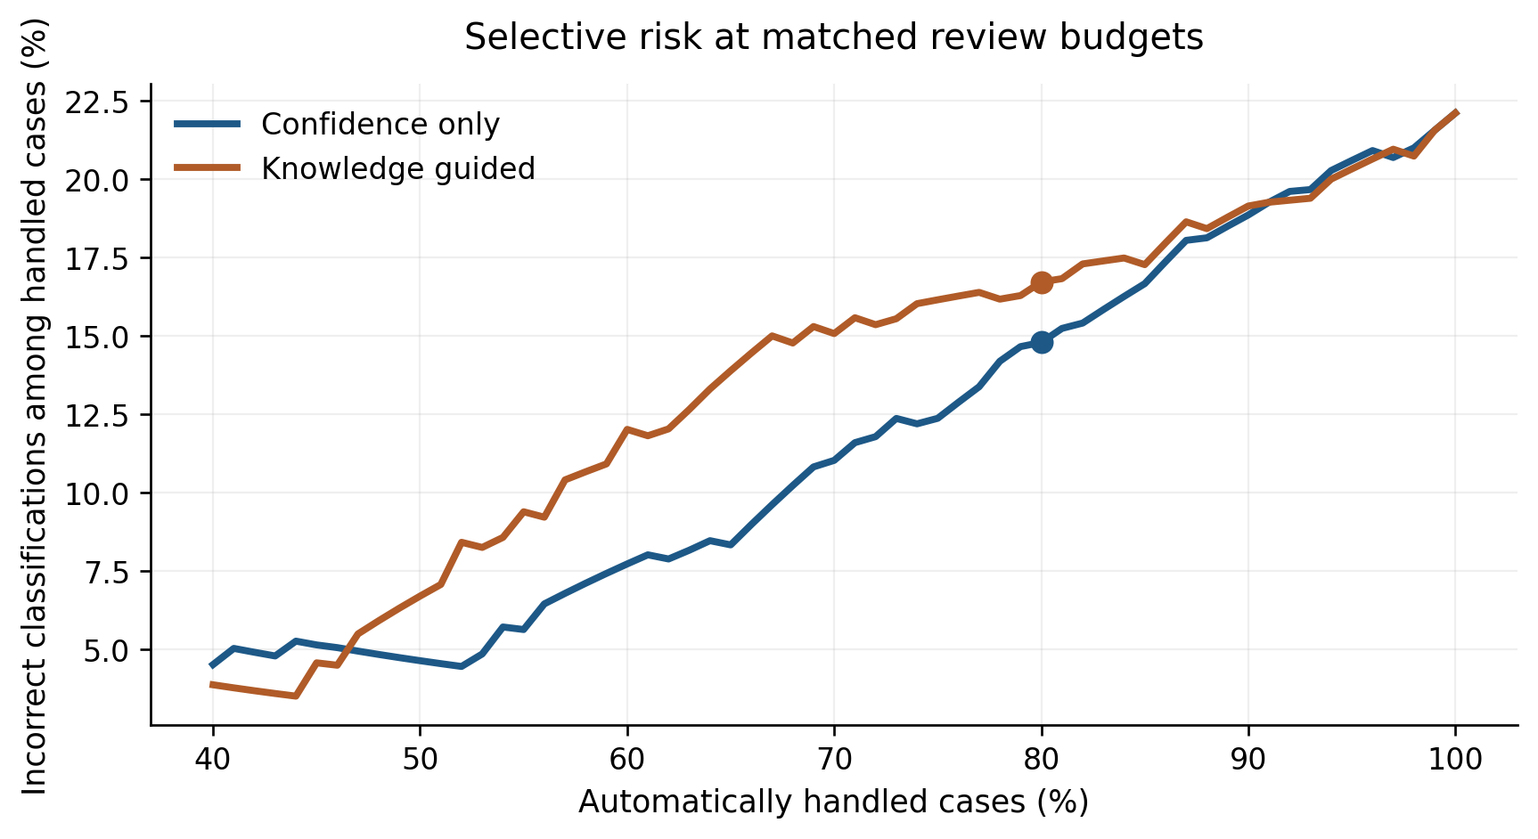
Figure 2. Held-out risk-coverage curves. The plotted fractions are retrospective equal-coverage rankings, not pre-deployment thresholds.
Using cutoffs fixed on validation data for a nominal 80% automated-coverage target, confidence-only selection achieved 77.12% test coverage with 13.67% selective error. The hybrid achieved 74.81% coverage with 16.15% error. These operational points are not coverage-matched and should not replace the controlled comparison in Table 2.
The evidence gate makes a separate prospective decision using only validation labels. Validation selective risk at 80% was 13.87% for confidence-only and 15.81% for knowledge-guided selection. Accordingly, the gate chose the confidence only policy. Its held-out selective error at equal 80% coverage was 14.79%. The evidence gate contributes a conservative decision protocol, not a new predictive accuracy gain; it correctly refrained from activating the candidate rule penalty in this experiment.
6. Discussion and Limitations
The negative result is informative because the additional symbolic model is intuitive but substantially less accurate than the calibrated ensemble. Its agreement signal can suppress high-confidence correct predictions and does not necessarily isolate the ensemble's mistakes. The findings support directly testing a rule layer rather than assuming that knowledge-style structure improves decisions. This experiment neither disproves knowledge-based reasoning in general nor evaluates expert-authored constraints, reasoning graphs, or neuro-symbolic models developed for other settings [12,14].
Disagreement cases already received lower ML confidence, so a uniform hybrid penalty could demote correct cases behind lower-quality agreement cases. The relevant question is whether a symbolic signal improves review ranking beyond confidence, not merely whether disagreement correlates with error. The validation comparison is only a preliminary filter and does not guarantee reliability under other samples or review budgets.
6.1 Interpretation for digital transformation and innovation
In a hypothetical SME workflow, measurements feed calibrated predictions and rule-path explanations; a validated selector sends uncertain cases to an inspector. Related work has studied manufacturing decision-support allocation [27], human-in-the-loop metal inspection [25], and SME AI resource orchestration [3]. A low-cost audit service could be an entrepreneurial opportunity, but adoption, commercialization, and economic benefit were not measured here.
A future SME study should measure SOP provenance, inspection costs, defect severity, throughput, and drift. Firm-level research links data integration to manufacturing decision-making [4], but the relevant operational target is action cost rather than accuracy alone.
6.2 Threats to validity
The benchmark is small and historical, and the experiment uses a single stratified partition. Rules are label-induced proxies, not knowledge-graph assertions [15–18] or approved SOPs. No action costs, temporal drift, external factories, SME status, or financial outcomes are observed. Bootstrap uncertainty conditions on fitted models; the fixed 0.65 penalty is illustrative, not an optimized policy.
The gate can overfit if many policies are tried on one validation set. Future studies need repeated and out-of-domain splits, expert-authored constraints, prospective review-capacity validation, and real process outcomes. The present negative baseline demonstrates neither superiority to neuro-symbolic alternatives nor digital-entrepreneurship gains.
7. Conclusion
This short communication introduces an evidence-gated protocol for evaluating whether a transparent knowledge layer adds decision value beyond calibrated machine-learning confidence in manufacturing quality triage. On the reported steel-fault benchmark, disagreement identified a higher-risk subgroup, but the naive agreement penalty failed to improve risk at matched review budgets. The validation gate rejected that penalty and retained the safer observed baseline. The central lesson is methodological: knowledge-guided decision support should be deployed on demonstrated incremental value rather than on interpretability alone. Transfer to manufacturing SMEs, cost reduction, and new digital services require expert-authored rules and independent operational trials.
Data and Code Availability
The Steel Plates Faults dataset is publicly available under CC BY 4.0 [26]. Source archive SHA-256: cb8eb9859198b63f053e443513036b401746fa517ef58bd17c846c6741c93919. The minimal Python source and reproduction instructions are at https://github.com/Hv240200/DBA_Journal (verified revision: 89bf6b99097017a1cefd5d5d4d3e988a1c1b8c56); generated numerical outputs and both figures accompany this manuscript and are reproducible by running the code. No private factory records were used.
Declaration of Generative AI Assistance
OpenAI ChatGPT assisted with manuscript drafting, research-code development, and figure layout. The human authors must verify the analysis, interpretation, citations, and final wording and remain fully responsible for the submitted work. This draft is not approved for submission without that review.
Declaration of Competing Interest
Author confirmation required: the authors must supply and approve their actual competing-interest disclosure. No declaration has been presumed.
Funding
Author confirmation required: list every relevant funding source and grant identifier, or confirm that no external funding supported the work.
CRediT Authorship Contribution Statement
Author confirmation required: identify all authors and verify each person's actual CRediT roles before submission.
References
[1] T. Masood, P. Sonntag, Industry 4.0: Adoption challenges and benefits for SMEs, Computers in Industry 121 (2020) 103261. https://doi.org/10.1016/j.compind.2020.103261.
[2] S. Meier, S. Klarmann, N. Thielen, et al., A process model for systematically setting up the data basis for data-driven projects in manufacturing, Journal of Manufacturing Systems 71 (2023) 1–19. https://doi.org/10.1016/j.jmsy.2023.08.024.
[3] E. Peretz-Andersson, S. Tabares, P. Mikalef, V. Parida, Artificial intelligence implementation in manufacturing SMEs: A resource orchestration approach, International Journal of Information Management 77 (2024) 102781. https://doi.org/10.1016/j.ijinfomgt.2024.102781.
[4] R. Colombari, A. Geuna, S.R. Helper, et al., The interplay between data-driven decision-making and digitalization: A firm-level survey of the Italian and U.S. automotive industries, International Journal of Production Economics 255 (2023) 108718. https://doi.org/10.1016/j.ijpe.2022.108718.
[5] Y. Geifman, R. El-Yaniv, Selective classification for deep neural networks, Adv. Neural Inf. Process. Syst. 30 (2017). https://papers.neurips.cc/paper/2017/hash/4a8423d5e91fda00bb7e46540e2b0cf1-Abstract.html.
[6] J. Brodeur, R. Pellerin, I. Deschamps, Operationalization of critical success factors to manage the Industry 4.0 transformation of manufacturing SMEs, Sustainability 14 (14) (2022) 8954. https://doi.org/10.3390/su14148954.
[7] A. Bianchini, I. Savini, A. Andreoni, M. Morolli, V. Solfrini, Manufacturing execution system application within manufacturing small–medium enterprises towards key performance indicators development and their implementation in the production line, Sustainability 16 (7) (2024) 2974. https://doi.org/10.3390/su16072974.
[8] Q. Chen, W. Zhang, N. Jin, X. Wang, P. Dai, Digital transformation evaluation for small- and medium-sized manufacturing enterprises using the fuzzy synthetic method DEMATEL-ANP, Sustainability 14 (20) (2022) 13038. https://doi.org/10.3390/su142013038.
[9] M.-A. Roy, G. Abdul-Nour, S. Gamache, Implementation of an Industry 4.0 strategy adapted to manufacturing SMEs: Simulation and case study, Sustainability 15 (21) (2023) 15423. https://doi.org/10.3390/su152115423.
[10] Y. Zhou, A. Păcală, Empowering manufacturing SMEs: Financial accessibility and sustainable practices in the age of digitalization, Sustainability 17 (8) (2025) 3571. https://doi.org/10.3390/su17083571.
[11] C. Guo, G. Pleiss, Y. Sun, K.Q. Weinberger, On calibration of modern neural networks, Proc. Int. Conf. Mach. Learn. 70 (2017) 1321–1330. https://proceedings.mlr.press/v70/guo17a.html.
[12] H. Fu, Q. Wang, C. Gong, Z.-G. Su, Incremental open-set evidential reasoning for uncertainty-aware fault diagnosis in rotating machinery, Knowledge-Based Systems 344 (2026) 116090. https://doi.org/10.1016/j.knosys.2026.116090.
[13] M. Feng, H. Shao, M. Shao, et al., Utilizing Bayesian generalization network for reliable fault diagnosis of machinery with limited data, Knowledge-Based Systems 305 (2024) 112628. https://doi.org/10.1016/j.knosys.2024.112628.
[14] C. Chen, X. Si, Z. Wang, Z. Zhang, C. Hu, DEFINED: A data-knowledge synergistic framework for few-shot class-incremental fault diagnosis, Knowledge-Based Systems 347 (2026) 116153. https://doi.org/10.1016/j.knosys.2026.116153.
[15] C. Peng, Y. Sheng, W. Gui, et al., Bearing fault diagnosis based on multimodal knowledge graphs under few-shot samples, Knowledge-Based Systems 330 (2025) 114604. https://doi.org/10.1016/j.knosys.2025.114604.
[16] Z. Mao, H.M. Wang, B. Jiang, J. Xu, H. Guo, Graph convolutional neural network for intelligent fault diagnosis of machines via knowledge graph, IEEE Transactions on Industrial Informatics 20 (5) (2024) 7862–7870. https://doi.org/10.1109/TII.2024.3367010.
[17] C. Peng, Y. Sheng, W. Gui, Z. Tang, C. Li, A rolling bearing fault diagnosis method based on multimodal knowledge graph, IEEE Transactions on Industrial Informatics 20 (11) (2024) 13047–13057. https://doi.org/10.1109/TII.2024.3431074.
[18] Y. Chen, M.J. Zhou, M. Zhang, M. Zha, Knowledge-graph-driven fault diagnosis methods for intelligent production lines, Sensors 25 (13) (2025) 3912. https://doi.org/10.3390/s25133912.
[19] F. Dunkin, X. Li, Z. Zhang, et al., Certainty from uncertainty: Multigranularity labeling inspired by quantum collapse for learning with noisy labels in fault diagnosis, IEEE Transactions on Industrial Informatics 21 (8) (2025) 6443–6454. https://doi.org/10.1109/TII.2025.3567264.
[20] X. Zhang, Z. Su, X. Hu, Y. Han, S. Wang, Semisupervised momentum prototype network for gearbox fault diagnosis under limited labeled samples, IEEE Transactions on Industrial Informatics 18 (9) (2022) 6203–6213. https://doi.org/10.1109/TII.2022.3154486.
[21] L. Lei, W. Li, S. Zhang, C. Wu, H. Yu, Research progress on data-driven industrial fault diagnosis methods, Sensors 25 (9) (2025) 2952. https://doi.org/10.3390/s25092952.
[22] S. Qiu, X. Cui, Z. Ping, et al., Deep learning techniques in intelligent fault diagnosis and prognosis for industrial systems: A review, Sensors 23 (3) (2023) 1305. https://doi.org/10.3390/s23031305.
[23] H. Ma, Z. Zhang, J. Zhao, A novel ST-YOLO network for steel-surface-defect detection, Sensors 23 (22) (2023) 9152. https://doi.org/10.3390/s23229152.
[24] K. Ragab, DSTEELNet: A real-time parallel dilated CNN with atrous spatial pyramid pooling for detecting and classifying defects in surface steel strips, Sensors 23 (1) (2023) 544. https://doi.org/10.3390/s23010544.
[25] T. Kotsiopoulos, G. Papakostas, T. Vafeiadis, et al., Revolutionizing defect recognition in hard metal industry through AI explainability, human-in-the-loop approaches and cognitive mechanisms, Expert Systems with Applications 255 (2024) 124839. https://doi.org/10.1016/j.eswa.2024.124839.
[26] M. Buscema, S. Terzi, W. Tastle, Steel Plates Faults, UCI Machine Learning Repository (2010). https://doi.org/10.24432/C5J88N.
[27] E. Mahmoodi, M. Fathi, M. Tavana, et al., Data-driven simulation-based decision support system for resource allocation in industry 4.0 and smart manufacturing, Journal of Manufacturing Systems 72 (2024) 287–307. https://doi.org/10.1016/j.jmsy.2023.11.019.

