**MEAN STACK DEVELOPER**

**Capstone Project**

**GROCERS**

**GitHub Repository Link:** [**https://github.com/orgs/TCS-meanstack-16/projects/1**](https://github.com/orgs/TCS-meanstack-16/projects/1)

**TEAM-16 MEMBERS**

1) Harshvardhan Sawal

2) Ian Haynes

3) Kranthi Kumar Reddy Anugu

4) Miguel Valdez

5) Lipi Boreddy

**Problem Statement:** To develop a dynamic website for online purchase of groceries.

We have three main users in this web application.

1) ADMIN

2) USER

1. EMPLOYEE

**ADMIN:** As an admin he/she should login through their credentials.

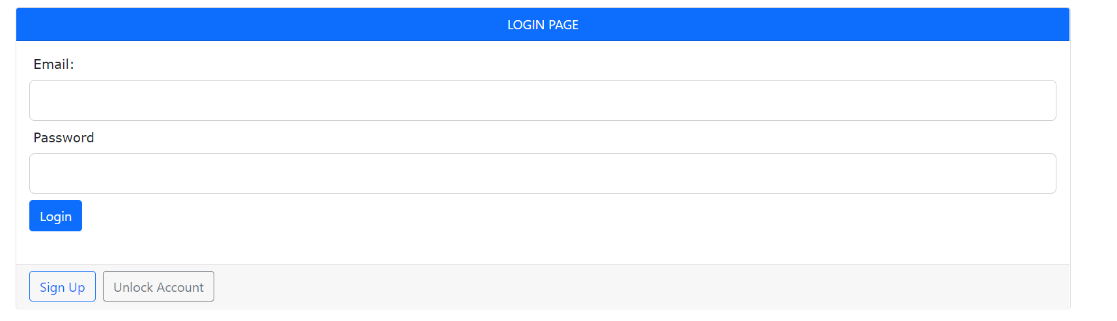

1. As an admin after successful login he/she has different functionalities.

* Add Products
* Update Products
* Delete Products
* View Requests
* Add Employee
* Delete Employee
* Generate Reports
* Logout

**Admin Dashboard:**

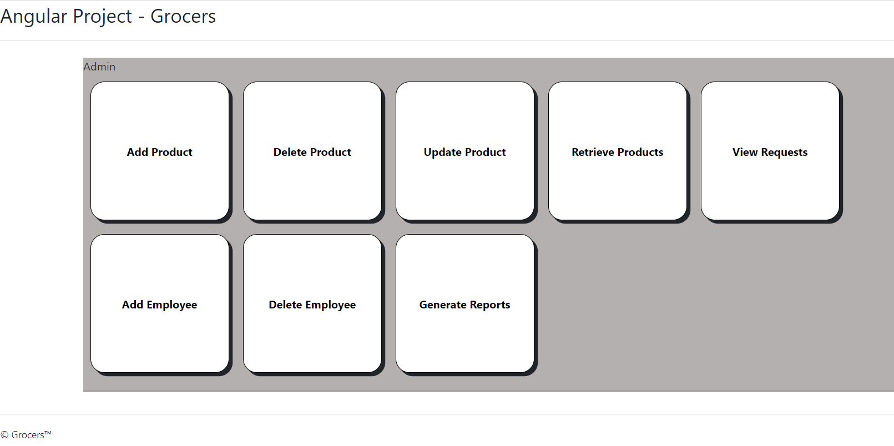

**Add Products: As an he can add different products and their details like**

* **Name**
* **Price**
* **Description**

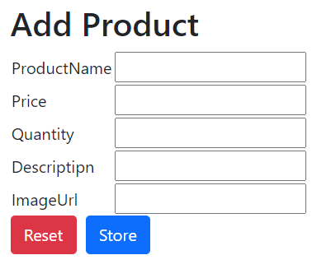

**Update Product:** The admin can update the details of a product using **product ID**.

* Price
* Image
* Description

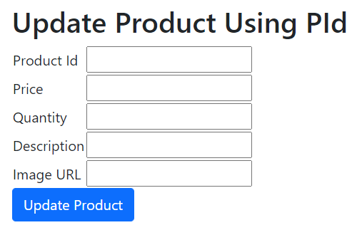

**Delete product:**

* 1)The admin can delete the product.
* 2)When the admin clicks on delete product in his dashboard.
* Admin will get the list of products that are available in a tabular format with an option to delete product.

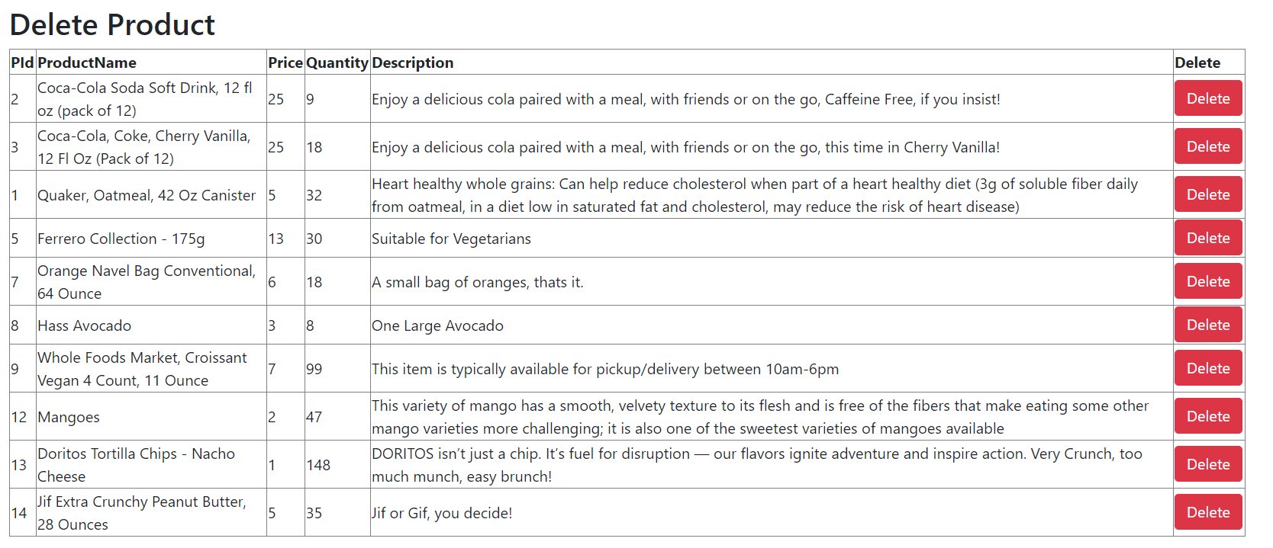

**Retrieve Products:** When the admin clicks on retrieve product’s he will get all the available products in the database in a tabular format.

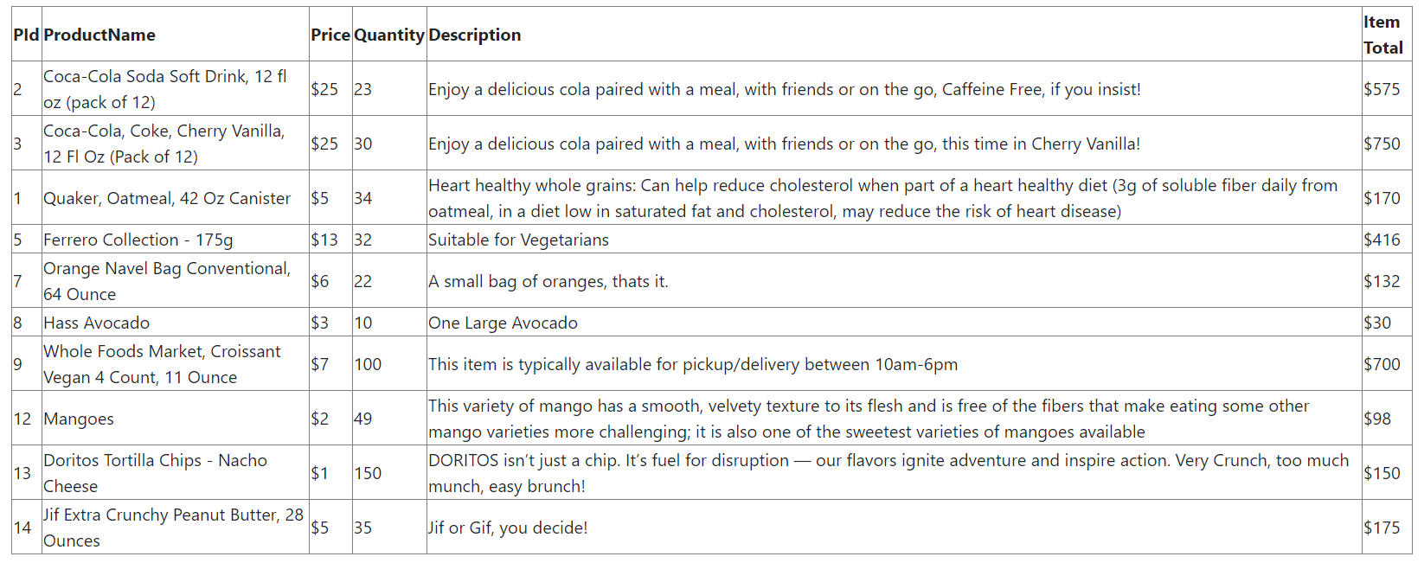

**View Requests:** Admin can view the request sent by the employee to update any product quantity, price or to add, delete any product.

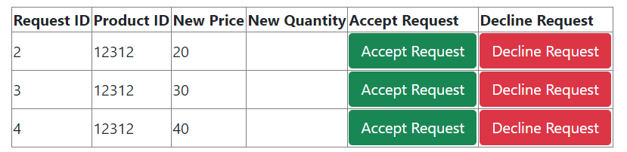

**Add Employee:** Admin can add new employees by adding their name and emailed.

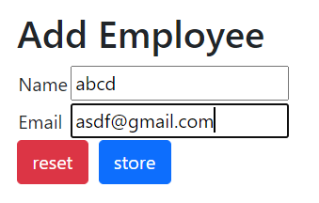

**Delete Employee:** Admin can delete the employee.

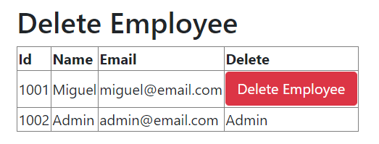

**Delete Employee code Snippet:**

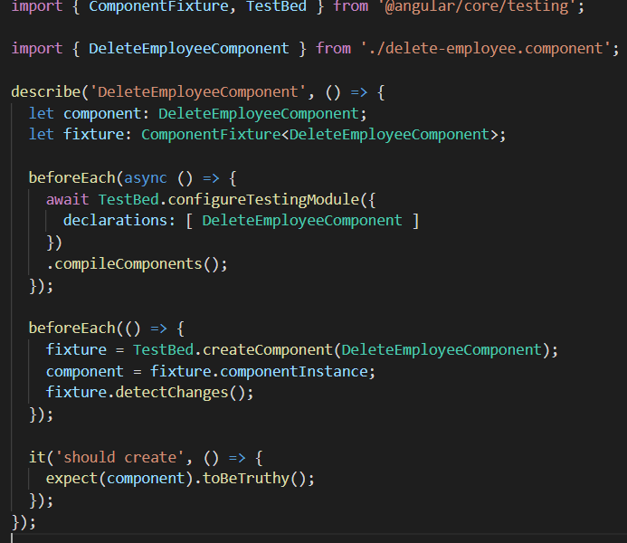

**Generate Reports:** Admin will be able to generate reports like

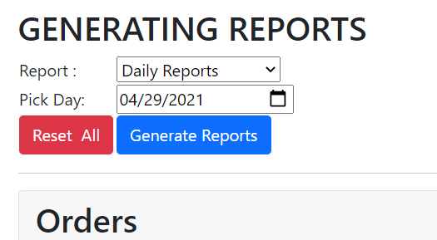

* How many products ordered on a particular day and the total price.

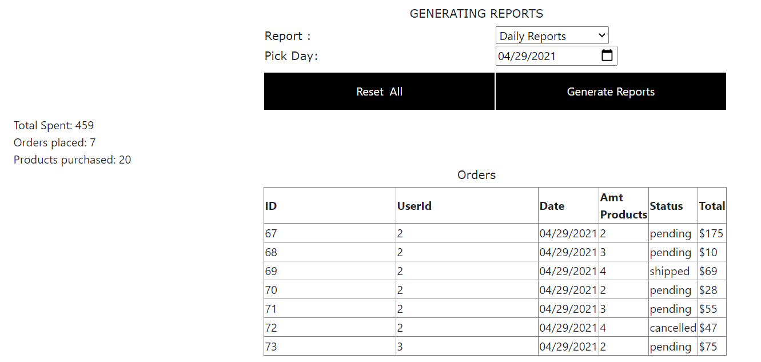

* The total number of products ordered between the particular dates.

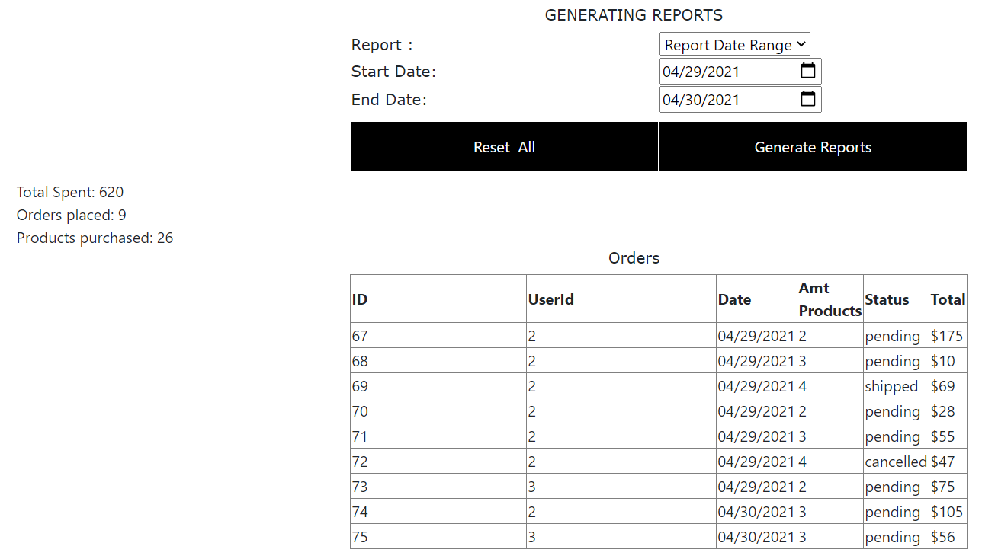

**Generate Reports code Snippet:**

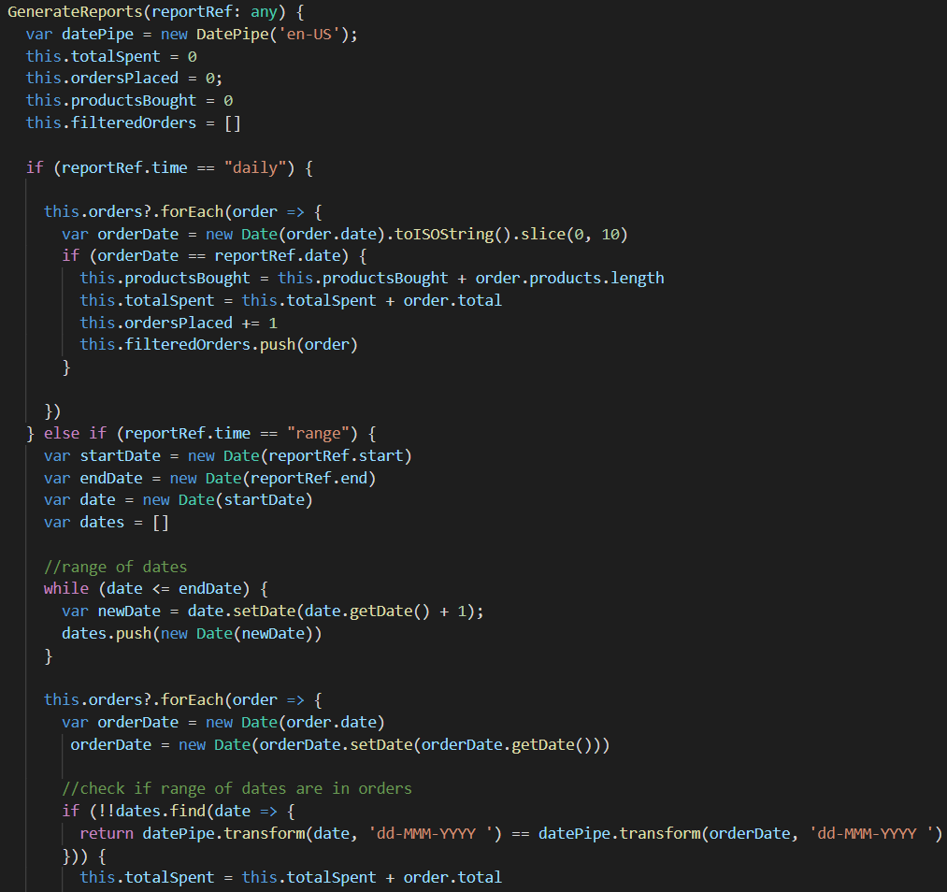

**USER**

Users can login with existing details or create an account be clicking in signup.

**Signup-page:** user had to enter the following details to create an account.

* FirstName
* LastName
* EmailId
* Address
* Pincode
* State
* City
* DON
* PhoneNumber
* Password

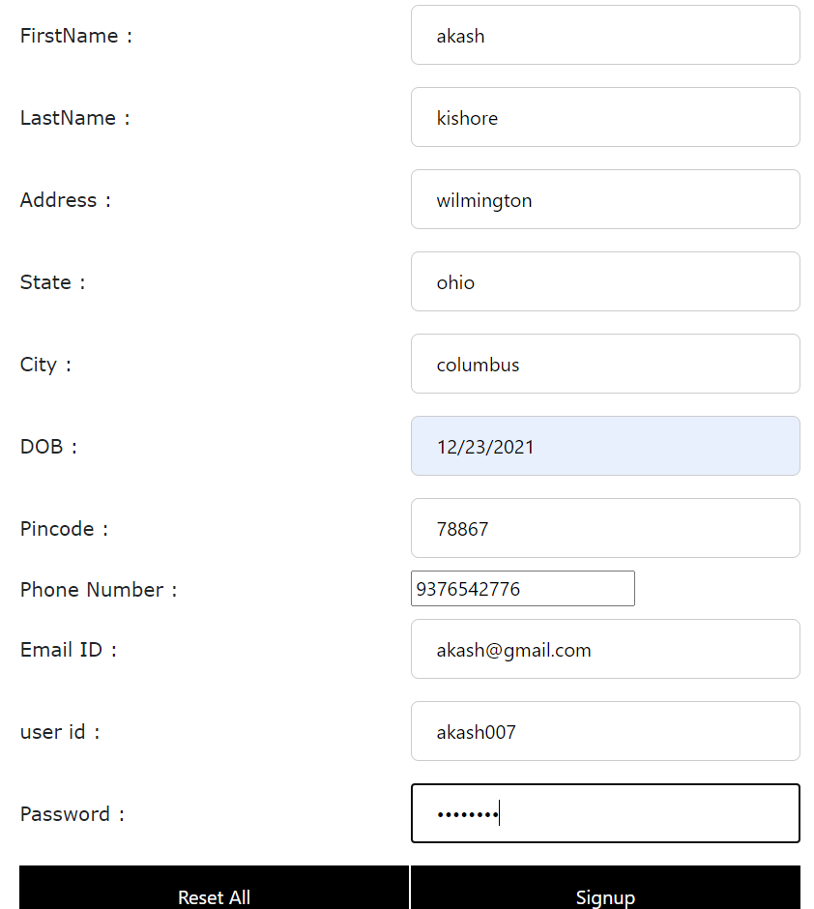

1. When the user is successfully login , then can see the user dash board.

Note: The user account gets locked when enters incorrect login credentials, the user account will get locked.

1. The user can raise a ticket to the employee with valid reasons.

**User Dashboard:**

* Cart
* Order Status
* Edit Profile
* Add Funds

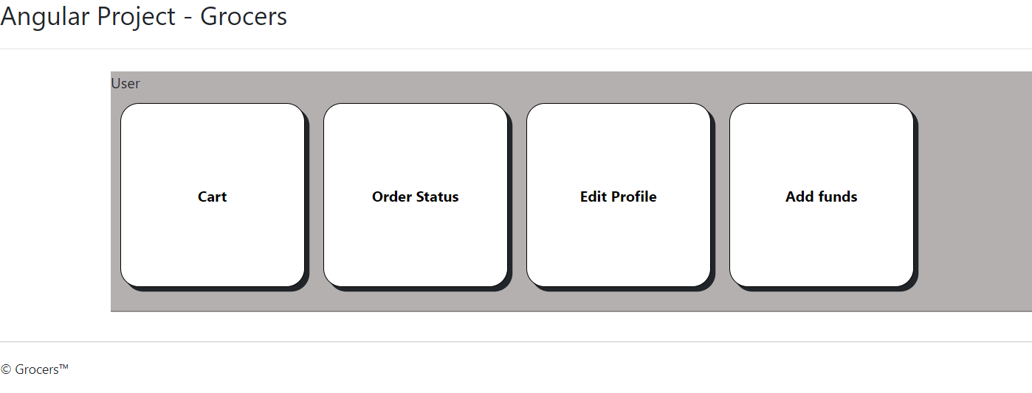

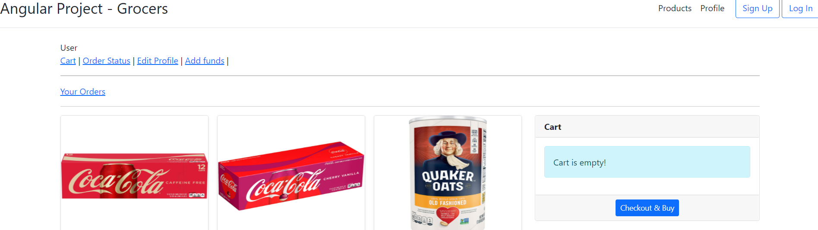

**Cart:** In the cart Component the user can do the following operations.

* Select Items from cart
* Delete Items from Cart
* Update quantity of Items in the cart
* View Items in the cart
* Checkout after adding all the products into the cart.

**Select Products:** User can add the products into the cat by clicking on add to cart.

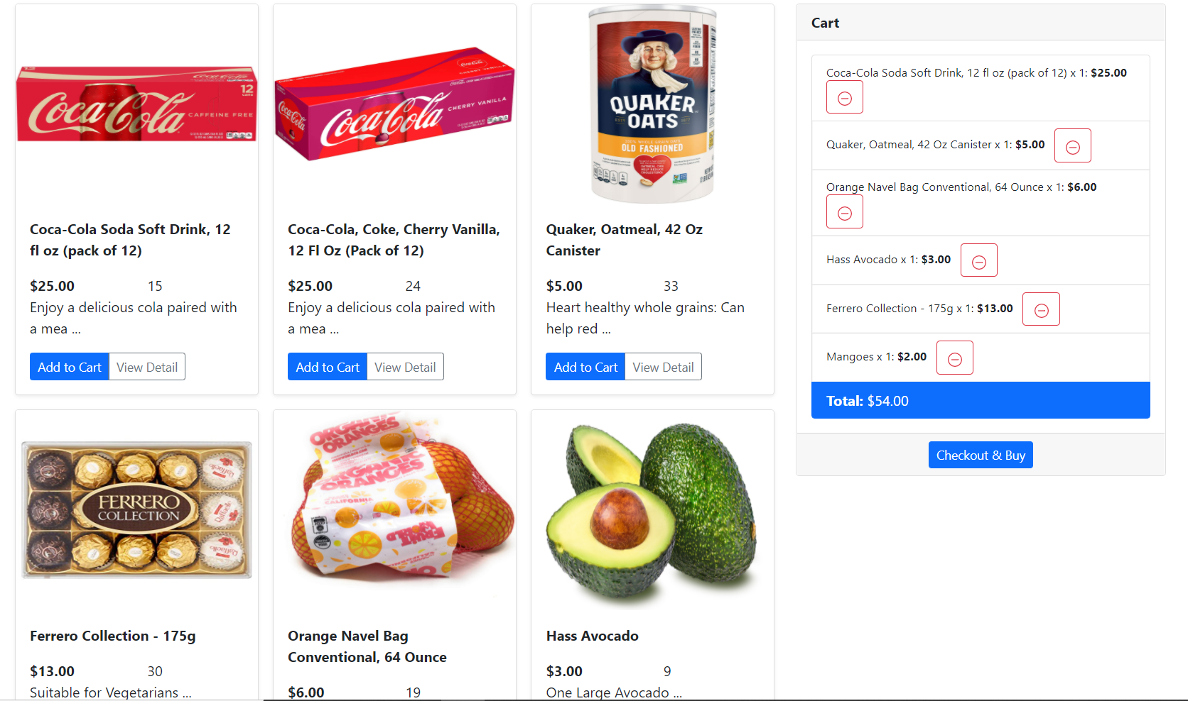

**Delete Products:** The user can delete the products from the cart if they don’t want that particular product.

**Update Products:** Update quantity of Items in the cart

**View Products:** View Items in the cart

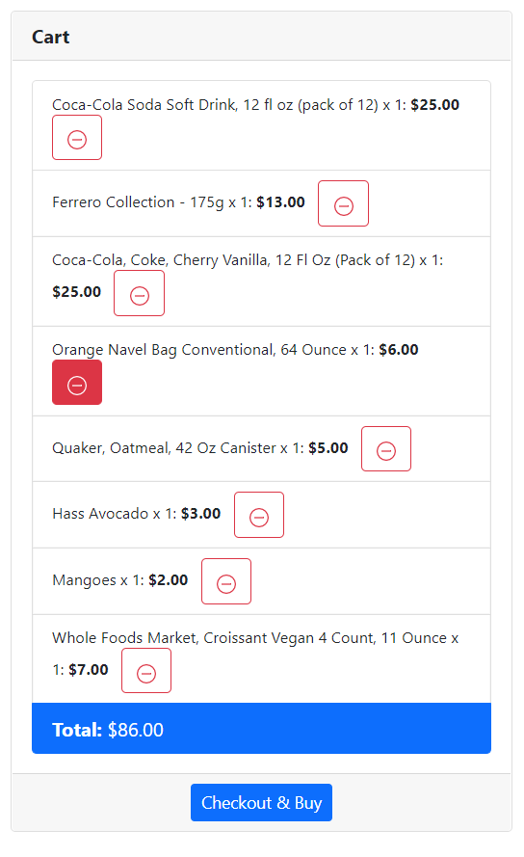

**Checkout-Cart:** When the user clicks on checkout-cart, It will display all the products that you have selected.

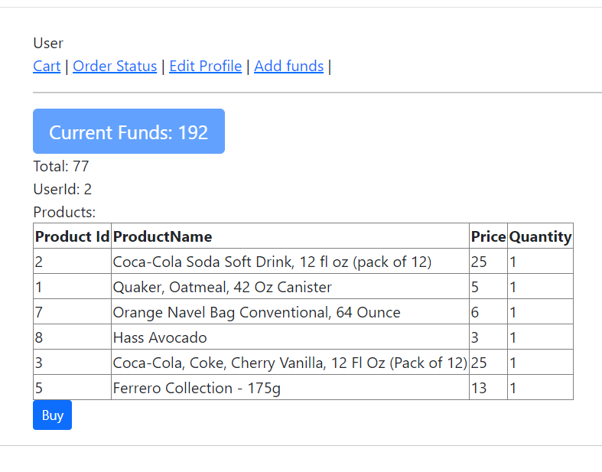

**Code snippet for checkout:**

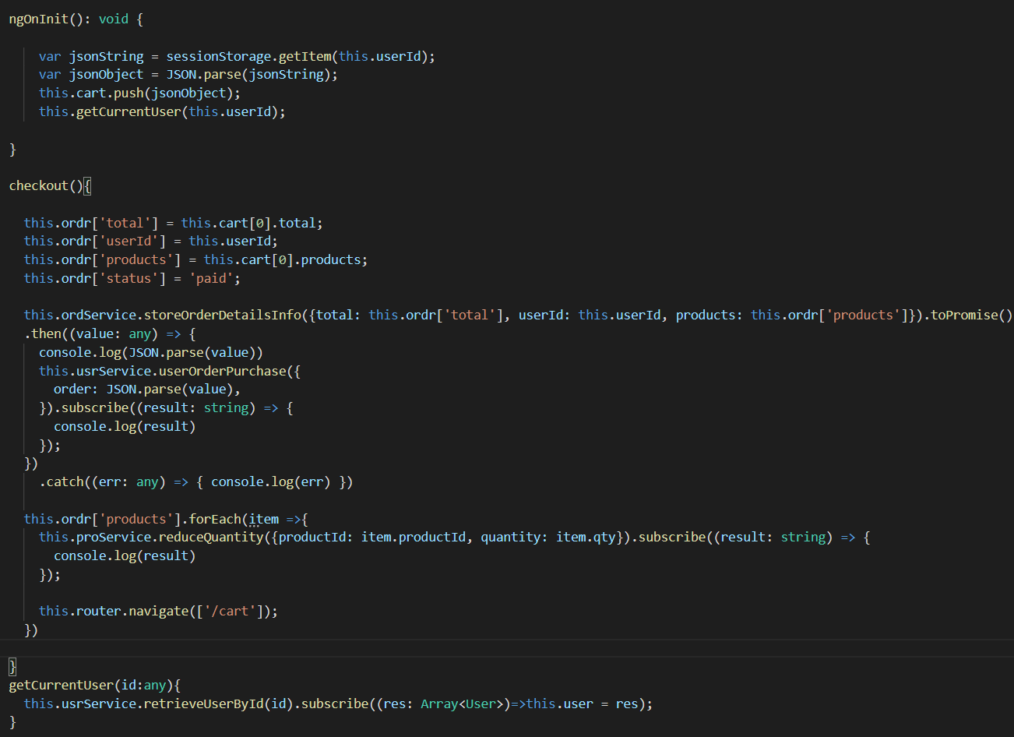

**Code Snippet for the cart component:**

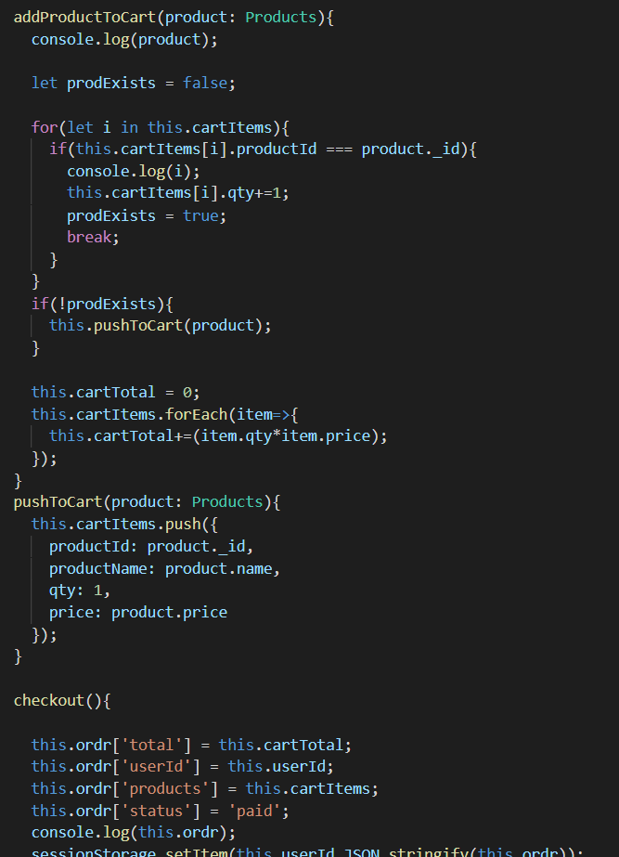

**Order Status:** user can check their orders history status like shipped, delivered.

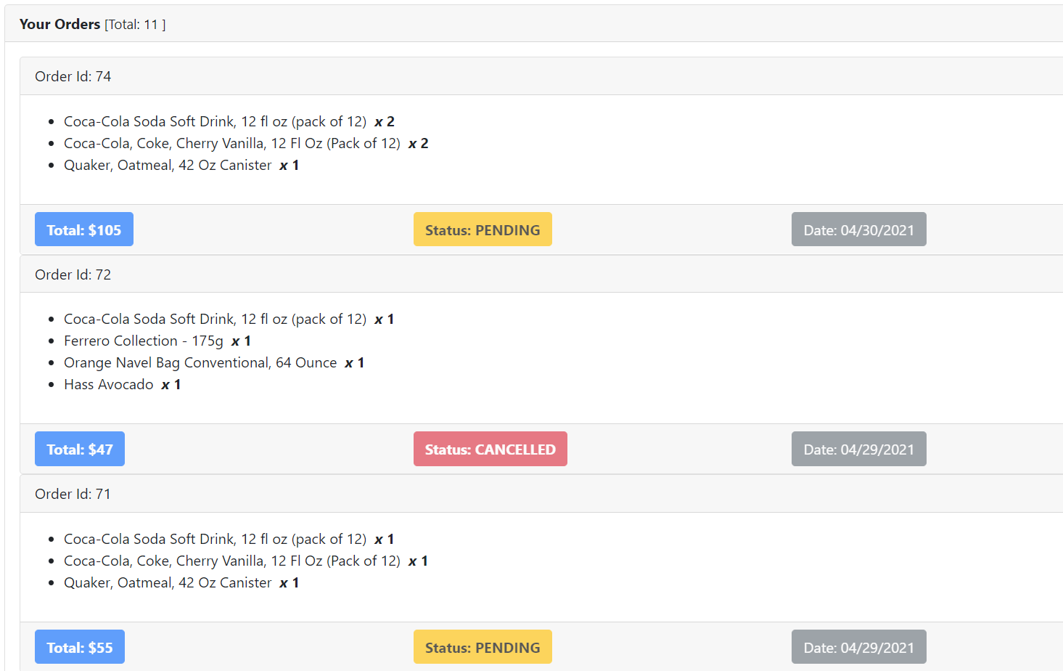

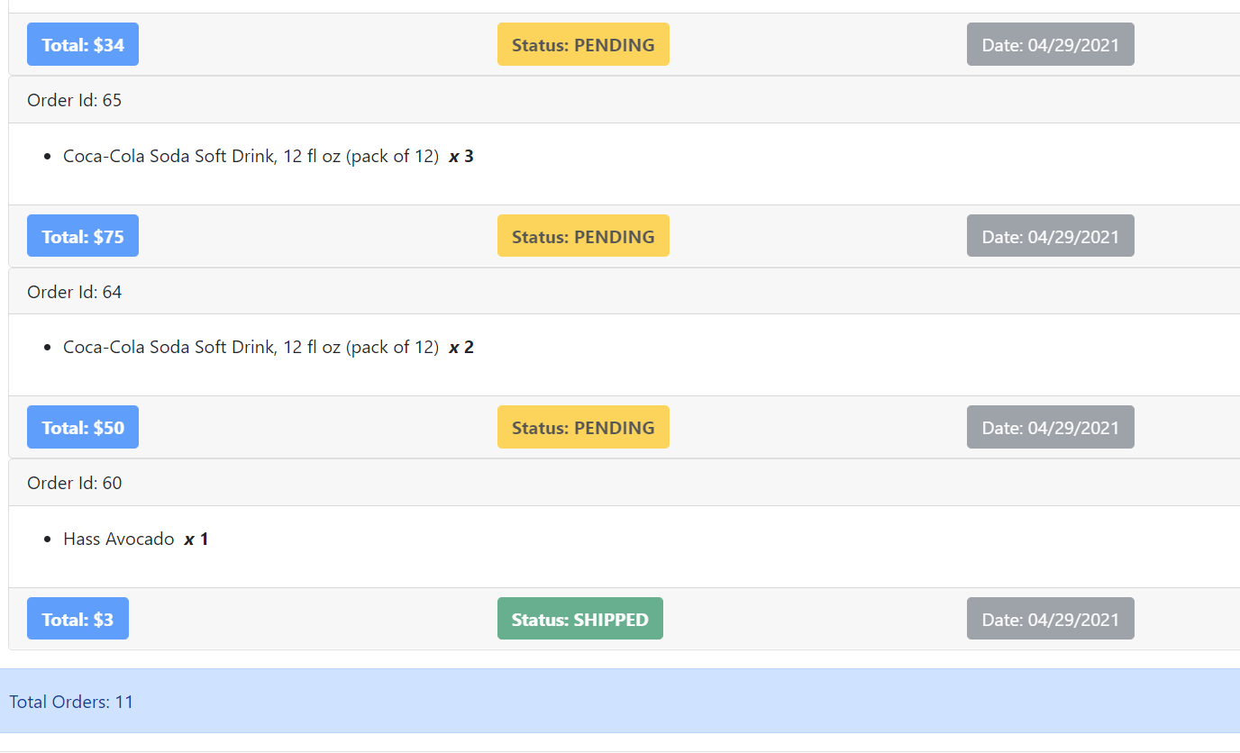

**Edit Profile:** The user can click on edit profile edit the

* FirstName
* LastName
* Password
* Email
* Address

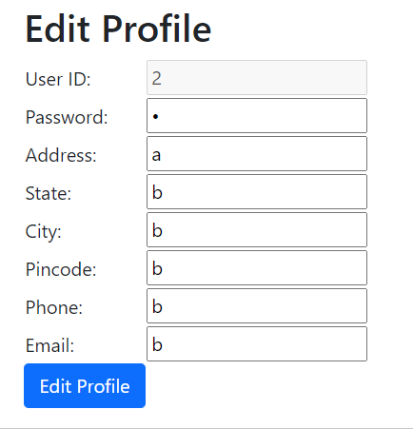

**Add-Funds:** The user can add funds to his account by entering the account Number, but we will provide default funds to the user.

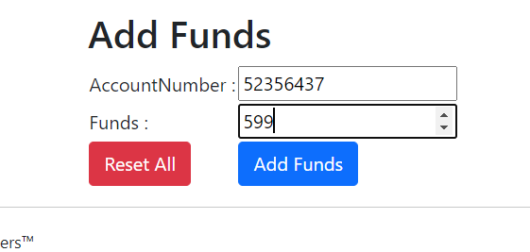

**EMPLOYEE PANEL**

1. The employee can sign-in by entering the login credentials like

* Email
* Password

1. After successful login the employee will see the dashboard with the following functionalities
   * Send Request
   * Update Order
   * Unlock Users
   * Edit Profile

**Employee Dashboard:**

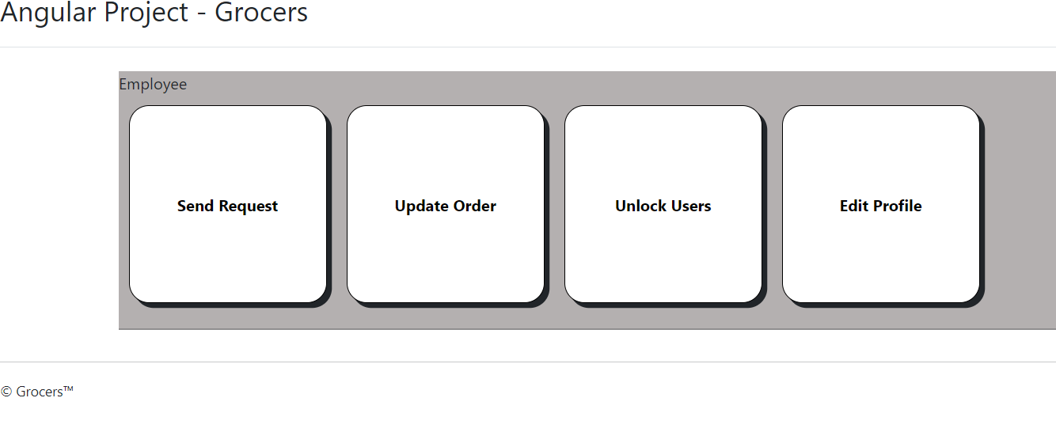

**Send Request:** Employee can send request to admin to change the price, quantity by entering the product Id.

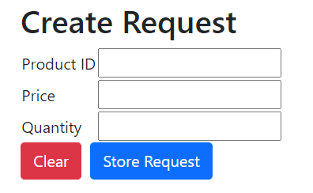

**Send request code Snippet:**

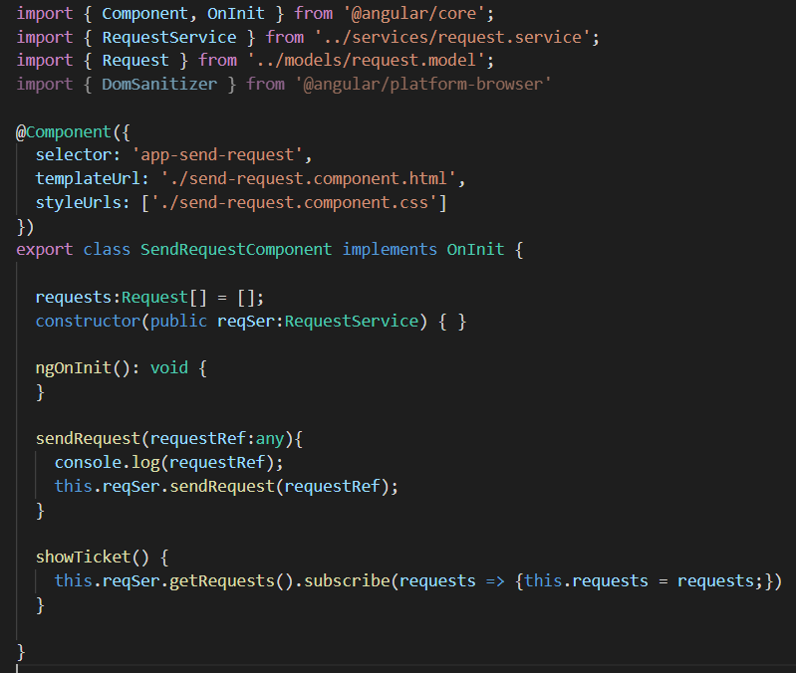

**Update Order: Employee can change the status of the order by entering the ordered ID.**

* Shipped
* Out for Delivery
* Delivered
* Pending
* Cancelled

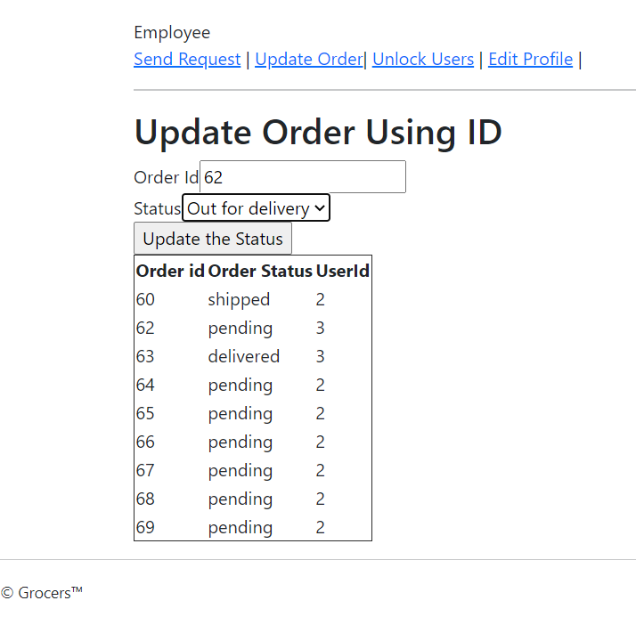

**Code snippet for Update Order:**

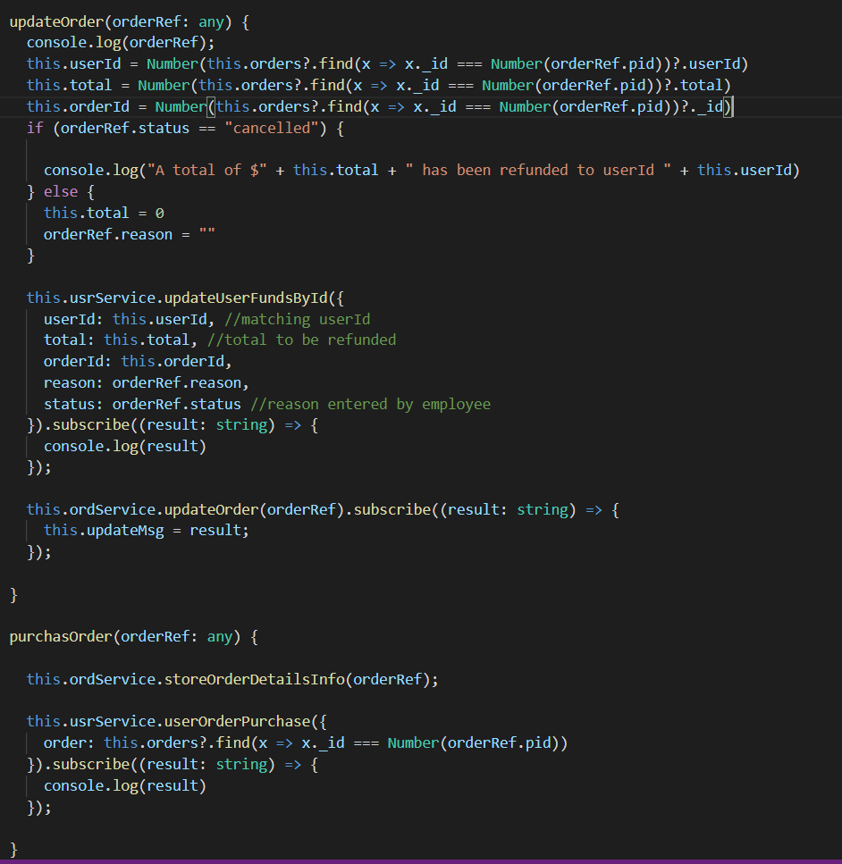

**Unlock Users:** Employee can unlock the user, Whenever employee raises a ticket to unlock the account the employee will access to unlock the user account.

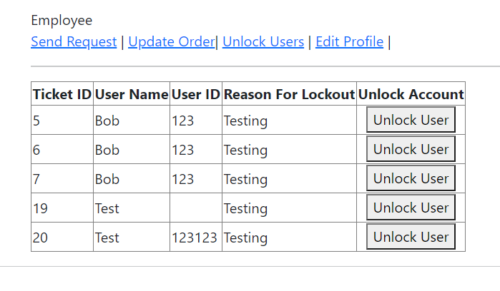**Edit-Profile:** Employee will be able to edit the password by clicking edit-profile on employee dashboard.

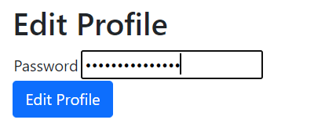

**Concepts used in the Project**

1) Angular

2) Nodejs

3) MongoDB

4) Expressjs

5) Typescript

6) Bootstrap

7) Session Storage

8) AWS Cloud for deployingApplication.

**Deploying Application on AWS CLOUD:**

**Conclusion:**