Outline
Healthy Wealthy is a fitness and lifestyle web application developed with Node.js, Express, EJS, and MySQL. It enables users to securely register, log in, and track their health activities. Authentication is handled with hashed passwords and session management, while login attempts are recorded for auditing.
The Achievements module allows users to log activities such as running, cycling, or yoga, with details including date, duration, and calories burned. These records are stored in the achievements table and displayed back to the user in a structured interface.
The Gear module provides a searchable catalogue of gym equipment, with options to filter by keyword or price range, view bargain gear, and access an API endpoint that returns gear data in JSON format.
The Weather module integrates with the OpenWeather API, letting users check conditions before planning workouts.
The database schema supports user accounts (user_data), achievements, gym gear, and login audits, ensuring data integrity through constraints and foreign keys. Together, these modules create a cohesive tool that combines activity tracking, resource browsing, and environmental awareness to promote healthier, more informed lifestyle choices.

Architecture
The application tier is built with Node.js and Express, it handles routing, validation, authentication, and rendering dynamic views with EJS. External APIs (OpenWeather) are integrated for weather data.
The data tier, which uses MYSQL, stores user accounts, achievements, gym gear, and login audits. Passwords are securely hashed with bcrypt, and queries use prepared statements for safety.
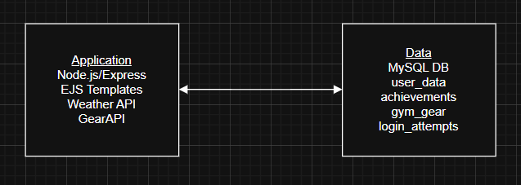

Data Model
The Healthy Wealthy app uses a relational schema in MySQL. The user_data table stores account details including username, names, email, and hashed password. The achievements table records fitness activities linked to users via user_id foreign key, forming a one-to-many relationship. The login_attempts table logs login attempts with timestamps, success flags, and reasons. It is also in a one-to-many relationship with user_data. The gym_gear table holds equipment names and prices for browsing and API queries and operates independently without foreign key link.
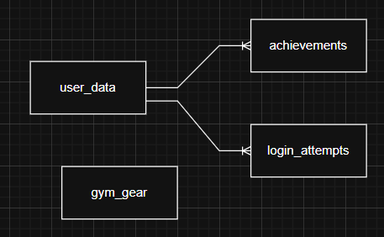

User Functionality
When users access Healthy Wealthy, they start at the homepage, which introduces the app and provides navigation links to key features such as registration, login, achievements, gear, and weather. This acts as the central hub for all user actions.

From the homepage, new users can register by filling out a form with their details. Input validation ensures usernames, emails, and passwords meet security requirements. Once registered, users can log in securely, with sessions maintained and login attempts recorded for auditing.


After logging in, users can explore the achievements pages. Here they can add new activities (e.g., running, cycling, yoga) with details such as date, duration, and calories burned. Achievements are displayed in a grid layout, making progress easy to review.


The Gym Gear modules lets users browse available equipment. They can view the full list, check bargain gear under £40, or search by keyword. Results are displayed in a styled table with hover effects for readability.


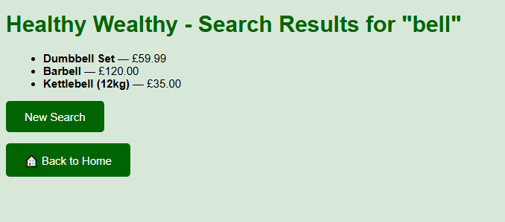
The Weather module allows users to check conditions before workouts. By entering a city name, they receive live data from the OpenWeather API, including temperature, humidity, wind speed, and condition, displayed in a weather card.
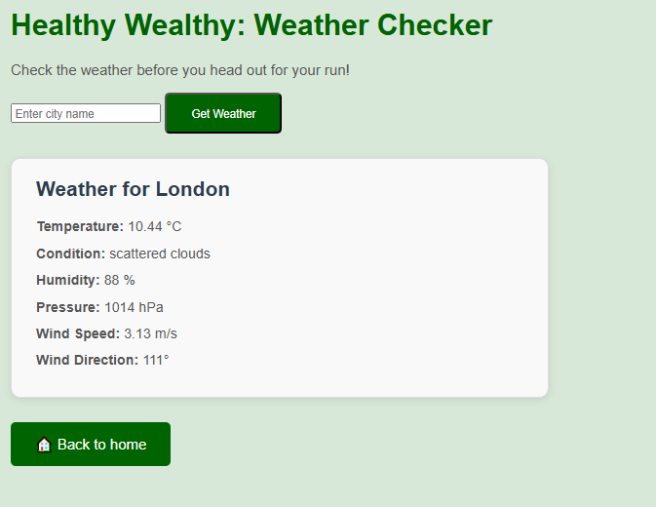
For developers or advanced users, the app also exposes an API endpoint (/api/gear) that returns gym gear data in JSON format, useful for integration or testing.
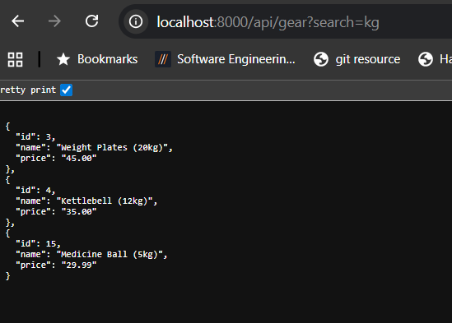
Finally, logged-in users can access user management features, including viewing all registered users and checking the audit history of login attempts. Logout functionality ensures sessions are securely terminated.

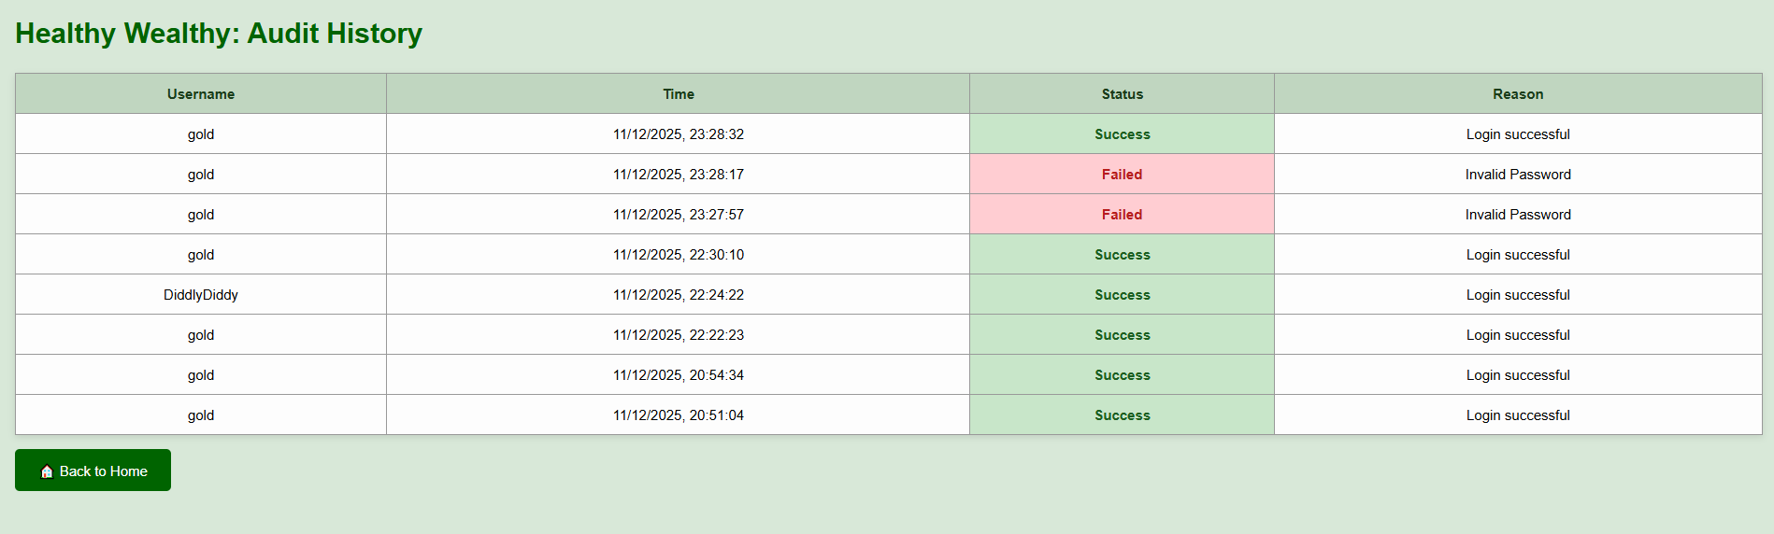
Advanced Techniques
One advanced technique implemented in Healthy Wealthy is the integration of the OpenWeather API using the request module. This allows users to enter a city name in the search box and immediately see the weather results displayed on the same page (weather.ejs), without being redirected elsewhere. This improves usability by keeping the search form and results together, creating a seamless user experience.
The technique combines server-side validation, input sanitization, and API integration. Validation ensures the city field is not empty, while sanitization prevents injection attacks. The request module is then used to fetch live weather data, which is parsed and rendered back into the same template.
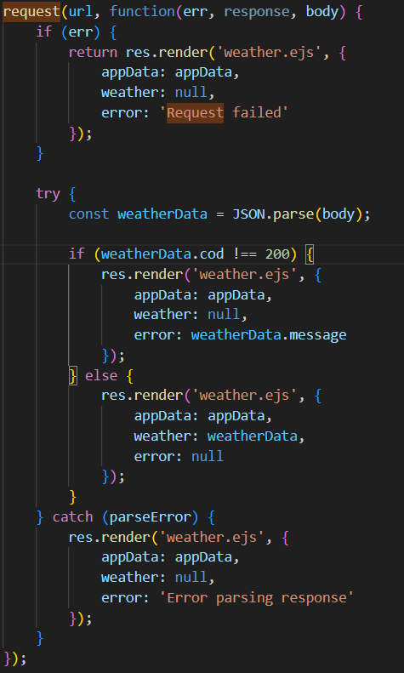
AI Declaration
No content generated by AI technologies has been used in this assessment.

