Team Project 1

For background information, please do a web search with ‘cross selling’.

You are to form a rectangular layout to maximize your expected profit. An exemplary rectangular layout is shown as follows:

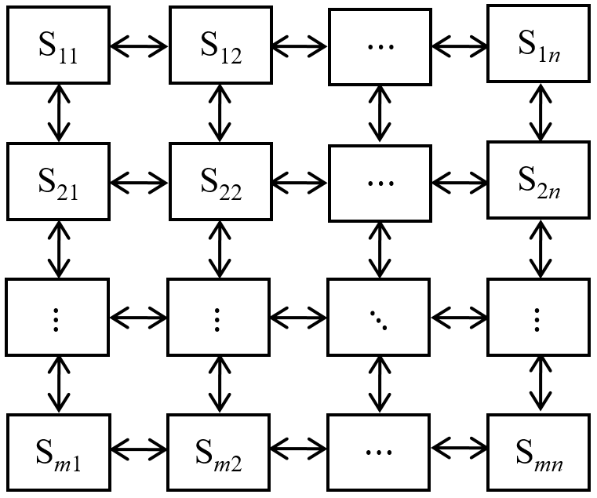

In the *table3by3.txt*, we have $m=3$ and n $=3$, which means overall 9 items to be assigned, and find a 9-by-9 matrix in which expected co-selling profit numbers for each pair among the 9 items appear. You may also check it out in *TableInfoSummary.xlsx*, spread sheet *3by3*.

If your solution, denoted as solution (1), is as follows

|  |  |  |
| --- | --- | --- |
|  | |  |
| 1 | 2 | 3 |
| 0 | 4 | 5 |
| 8 | 6 | 7 |

your expected profit is 134.27852. You may refer to the Excel file for computation.

For your sake, sample java files are provided for this *table3by3.txt*:

proj1/Individual.java

proj1/ValueTable.java

MyTextDataReader2.java

TestDriverReadTable.java

TestDriverReadTable2.java

In TestDriverReadTable.java, you will see how to read *table3by3.txt*, construct solution (1), and compute the objective value. In fact, it saves the associated object (Individual) into a file.

In TestDriverReadTable2.java, you will see how to read the saved (Individual) object and reconstruct it.

In the project, you are to use *table15by15.txt* and find your best solution. Submit your solution in a file, as produced in TestDriverReadTable.java, in addition to your codes with comments.