AI JOB MARKET
SALARY PREDICTION
Technical Output & Conclusion Report
12-stage data-quality-first, leakage-safe and deployable machine learning workflow

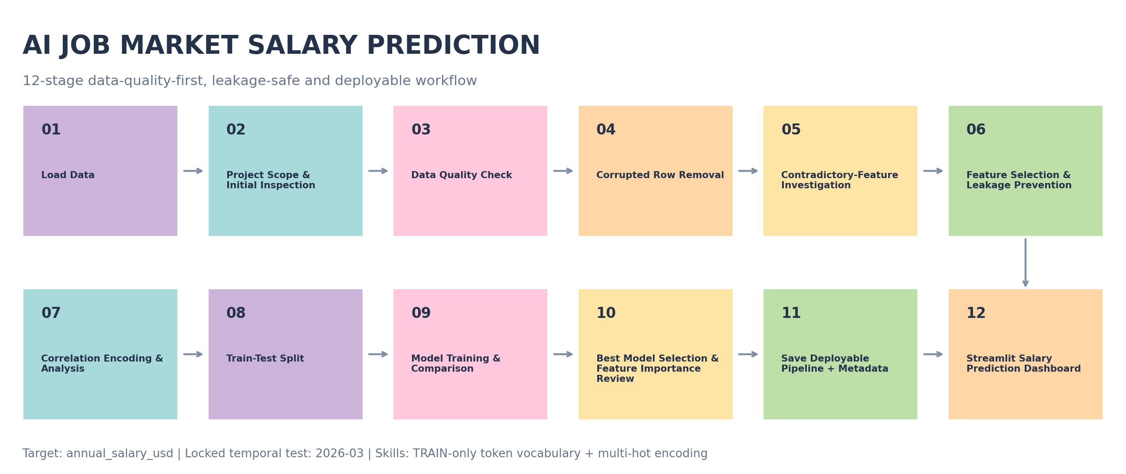
Figure 1. End-to-end 12-stage pipeline implemented in pineline.py.
Course | DATA SCIENCE WITH AI-ML – Semester II
Lecturer | Ms. Nguyen Ha Vy
Group | 03
Report basis | Actual pipeline run • 1,499 clean rows • model selected by temporal CV
Prepared from the supplied technical design and ai_jobs_market_2025_2026.csv • September 2026 academic project

00 | Executive Summary  Five requested outputs are answered with actual pipeline results, not hard-coded example values.

1,499  Clean rows | 1,201  Train / Dev | 298  Locked Test | 93  Skill tokens | 0.803  Final R²

The project preserves the 12-stage structure in Document_QD Project KHDL&AI, but strengthens model governance by declaring March 2026 as a locked temporal test and using development-period temporal cross-validation for model selection. This prevents the final holdout from becoming a tuning instrument.
Requested output | Actual result | Conclusion
1. Data basic clean | 1,500 → 1,499 rows; 0 missing cells; 0 duplicates; 1 corrupted category row removed. | PASS with documented logic risks
2. Data ready for ML | 1,201 TRAIN/DEV + 298 locked test; 93 skill tokens + distinct skill_count; blocked target-adjacent fields. | READY
3. Model comparison | Random Forest best CV MAE $12,554; CV R² 0.877. | SELECTED on CV
4. Best model & importance | Random Forest; locked-test MAE $14,961, RMSE $29,844, R² 0.803. | FINAL TEST COMPLETE
5. Salary prediction | Mean locked-test prediction $197,787; empirical 90% half-width ±$32,216. | DEPLOYABLE

Interpretation boundary The dataset contains strong synthetic-looking signals. Performance and importance should be presented as fit to this supplied snapshot, not as causal proof of real-world salary economics.

12 | 12-Stage Pipeline  The technical design is implemented as a reproducible sequence from raw ingestion to Streamlit inference.


Figure 2. Twelve stages with locked temporal test and TRAIN-only skill vocabulary.
Stage | Name | Operational purpose
1 | Load Data | Fingerprint the raw CSV and preserve row/column counts.
2 | Project Scope & Initial Inspection | Validate target, schema, dtypes and descriptive statistics.
3 | Data Quality Check | Check nulls, duplicates, hidden missing tokens and cardinality.
4 | Corrupted Row Removal | Remove the one row where the header value leaked into job_category.
5 | Contradictory-Feature Investigation | Audit experience mismatch and salary metadata consistency.
6 | Feature Selection & Leakage Prevention | Block identifiers, target-adjacent salary fields and redundant flags.
7 | Correlation Encoding & Analysis | TRAIN-only one-hot/ordinal/multi-hot diagnostics and target correlation.
8 | Train-Test Split | Reserve 2026-03 as locked test; fit preprocessing on TRAIN/DEV only.
9 | Model Training & Comparison | Compare five regression families with temporal CV.
10 | Best Model & Importance Review | Tune selected family, open locked test once, review importance.
11 | Save Deployable Pipeline + Metadata | Serialize preprocessing + model bundle and inference contract.
12 | Streamlit Dashboard | Use the same bundle for authenticated interactive inference.

Leakage control Although Stage 8 is the formal split stage in the 12-stage academic presentation, the locked-period mask is declared before any target-aware diagnostics. All learned transforms and the 93-token skill vocabulary are fit on development/TRAIN data only.

01 | Data Basic Clean  A null-free dataset was not accepted at face value; logic and categorical corruption were audited.

1500  Raw rows | 25  Raw columns | 0  Missing cells | 0  Duplicates

Basic structural checks found 0 missing cells and 0 duplicate rows. However, the categorical sanity check identified one corrupted row in the source field 'AI Engineering': the literal header value 'job_category' appeared as a record value. That row was removed and the field was canonically renamed to job_category, producing 1,499 clean records.
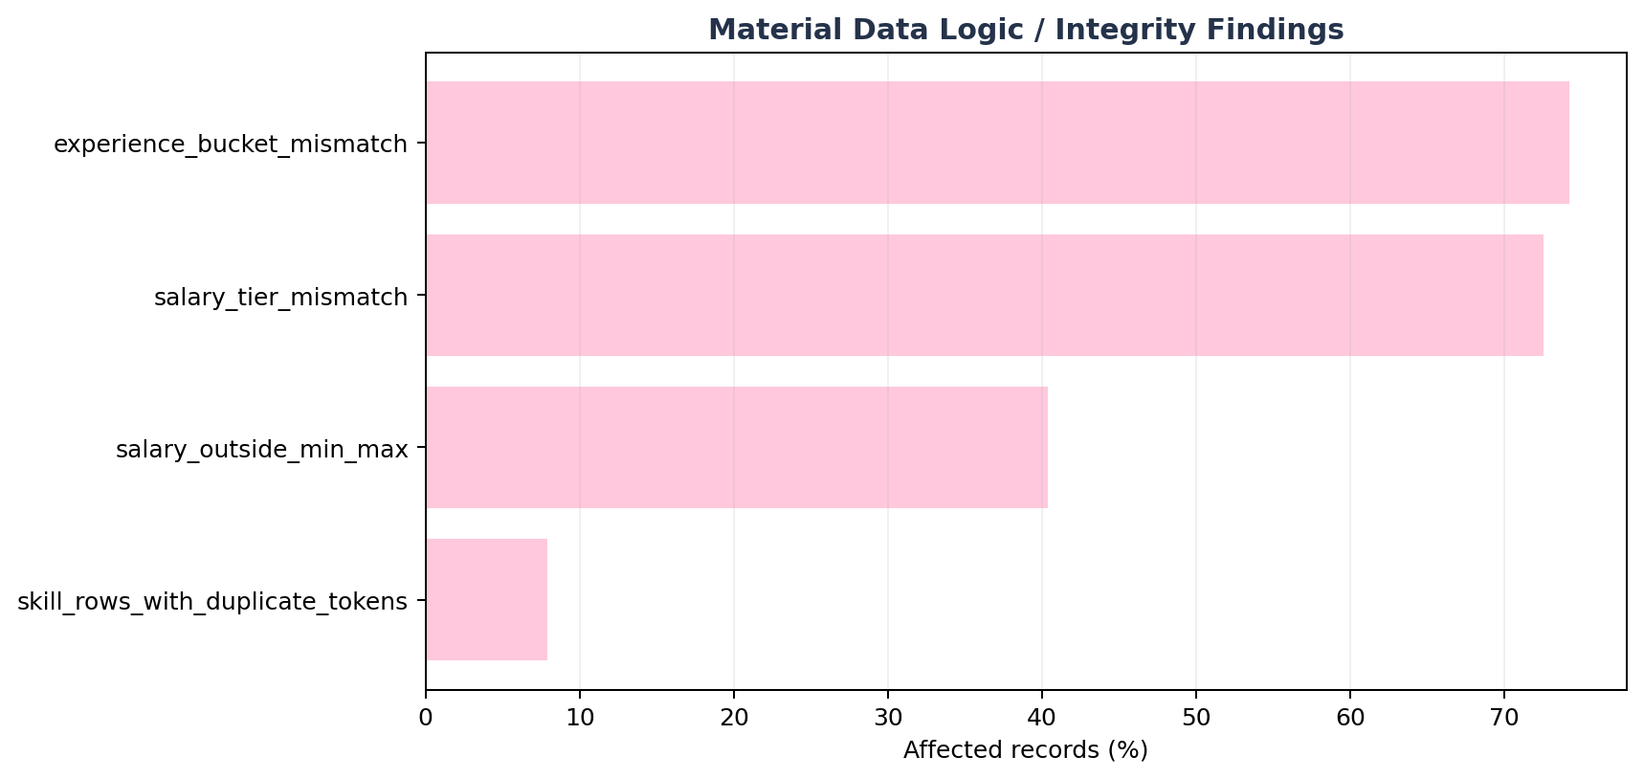
Figure 3. Share of clean rows affected by major logic/integrity findings.
issue | affected_rows | affected_pct | action
experience_bucket_mismatch | 1113 | 74.2% | Drop experience_level from primary model; retain years_of_experience as an ablation-sensitive numeric feature.
salary_outside_min_max | 605 | 40.4% | Block salary_min_usd and salary_max_usd from X.
salary_tier_mismatch | 1087 | 72.5% | Block salary_tier from X.
skill_rows_with_duplicate_tokens | 118 | 7.9% | De-duplicate skill tokens within each row before multi-hot encoding.

Conclusion – Data basic clean Structural cleanliness alone would have been misleading. The cleaned output is suitable for controlled modeling only after blocking inconsistent target-adjacent fields and explicitly treating experience semantics as a synthetic-risk warning.

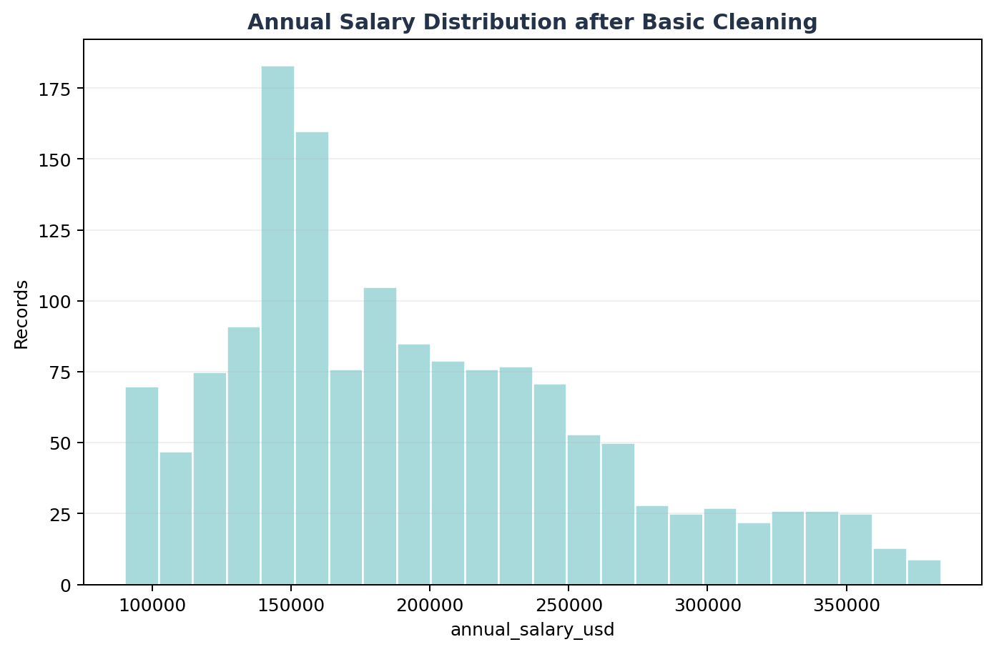
Figure 4. Target distribution after basic cleaning.

02 | Data Ready for Machine Learning  Leakage gate, temporal split, TRAIN-only encoding/scaling, multi-hot skills and skill_count.

1,201  TRAIN / DEV | 298  Locked Test | 93  Skill vocabulary | 189  Encoded features

The model input retains the technical design's 11 structured predictors and adds a skill-aware Phase-2 enhancement: required_skills is normalized into distinct pipe-separated tokens, multi-hot encoded by a vocabulary learned only from TRAIN/DEV, and accompanied by skill_count (distinct token count). In this supplied snapshot the TRAIN vocabulary contains 93 tokens.
Allowed model inputs:
feature | role
job_title | KEEP
job_category | KEEP
years_of_experience | KEEP
education_required | KEEP
city | KEEP
country | KEEP
remote_work | KEEP
company_size | KEEP
industry | KEEP
demand_score | KEEP
benefits_score_10 | KEEP
required_skills | PHASE2_MULTI_HOT
skill_count | ENGINEERED

Blocked fields include identifiers, target-adjacent salary metadata, contradictory/redundant experience flags, and non-serving metadata. This protects the model from learning the answer directly or from unstable derived signals.
feature | reason
job_id | Identifier, redundant/contradictory, derived flag, or non-serving metadata
salary_min_usd | Target leakage / target-adjacent
salary_max_usd | Target leakage / target-adjacent
salary_tier | Target leakage / target-adjacent
experience_level | Identifier, redundant/contradictory, derived flag, or non-serving metadata
posting_year | Identifier, redundant/contradictory, derived flag, or non-serving metadata
posting_month | Identifier, redundant/contradictory, derived flag, or non-serving metadata
is_senior | Identifier, redundant/contradictory, derived flag, or non-serving metadata
is_remote_friendly | Identifier, redundant/contradictory, derived flag, or non-serving metadata
is_llm_role | Identifier, redundant/contradictory, derived flag, or non-serving metadata
ai_salary_premium_pct | Identifier, redundant/contradictory, derived flag, or non-serving metadata
demand_growth_yoy_pct | Identifier, redundant/contradictory, derived flag, or non-serving metadata

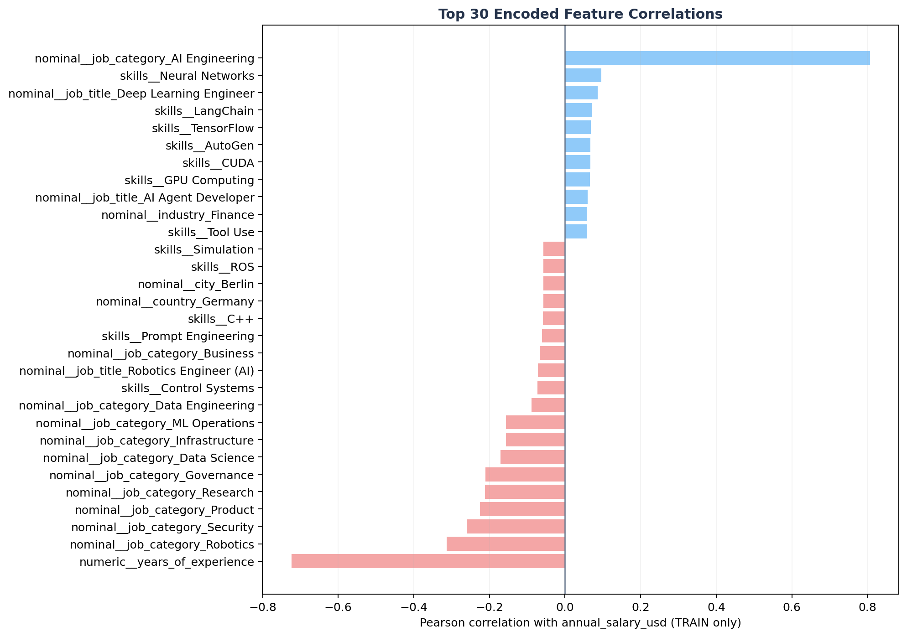
Figure 5. Top 30 TRAIN-only encoded correlations with annual_salary_usd.
Conclusion – Data ready for ML The encoded dataset is ready for modeling with 189 numeric columns. The strongest TRAIN-only encoded correlation is nominal__job_category_AI Engineering (r=+0.807); this is diagnostic association, not causal evidence.

03 | Model Comparison  Five regression families evaluated on the same expanding monthly temporal-validation folds.

model | CV_MAE_mean | CV_RMSE_mean | CV_R2_mean | CV_MAE_std
Random Forest | $12,554 | $23,018 | 0.877 | $3,180
Gradient Boosting | $13,372 | $25,333 | 0.856 | $1,399
Ridge Regression | $25,699 | $35,442 | 0.715 | $3,154
Linear Regression | $28,964 | $38,862 | 0.654 | $3,419
SVR (RBF) | $53,409 | $67,735 | -0.034 | $5,112

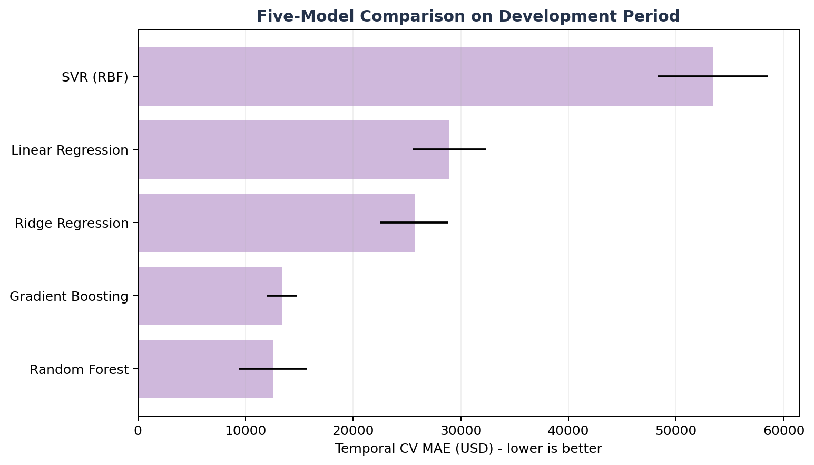
Figure 6. Temporal CV MAE across five candidate regression models.
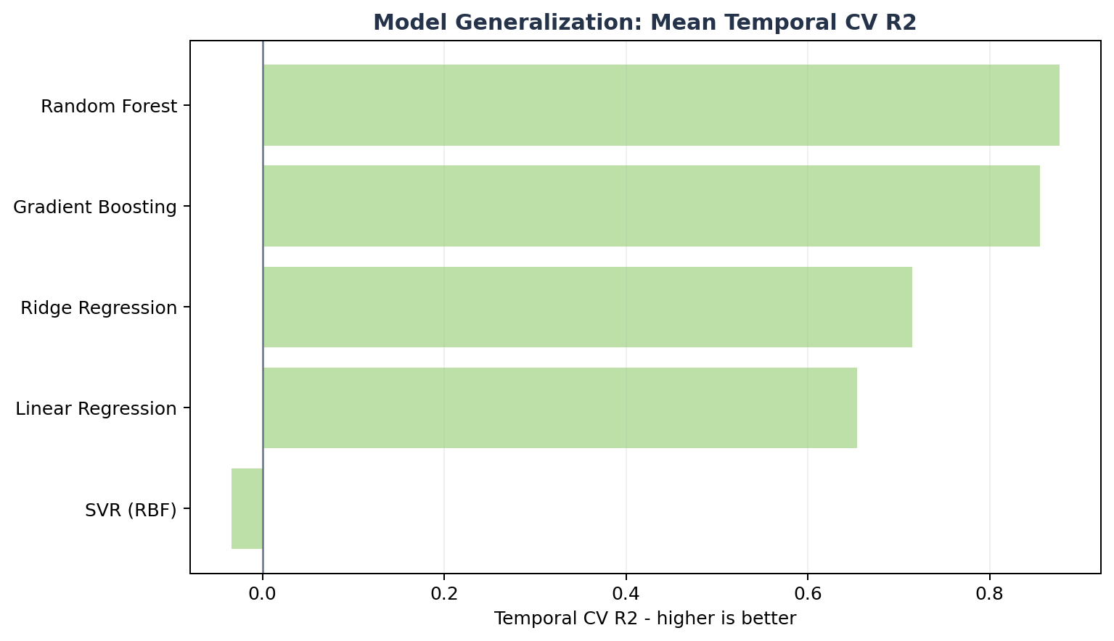
Figure 7. Mean temporal CV R² by model family.
Random Forest ranked first with mean temporal CV MAE $12,554 and mean CV R² 0.877. Its mean CV MAE was 6.1% lower than Gradient Boosting, the next-best model. Linear/Ridge were materially weaker, while SVR performed poorly in this sparse/high-dimensional encoded space.
Conclusion – Model Comparison Select Random Forest using development-period evidence. The locked March-2026 test remains outside candidate comparison and is opened only after this selection/tuning decision is frozen.

04 | Best Model Selection & Importance Feature Review  Final one-time locked-test evaluation plus model-behavior diagnostics.

Random Forest  Best model | $14,961  MAE | $29,844  RMSE | 0.803  R² | $4,467  MedAE

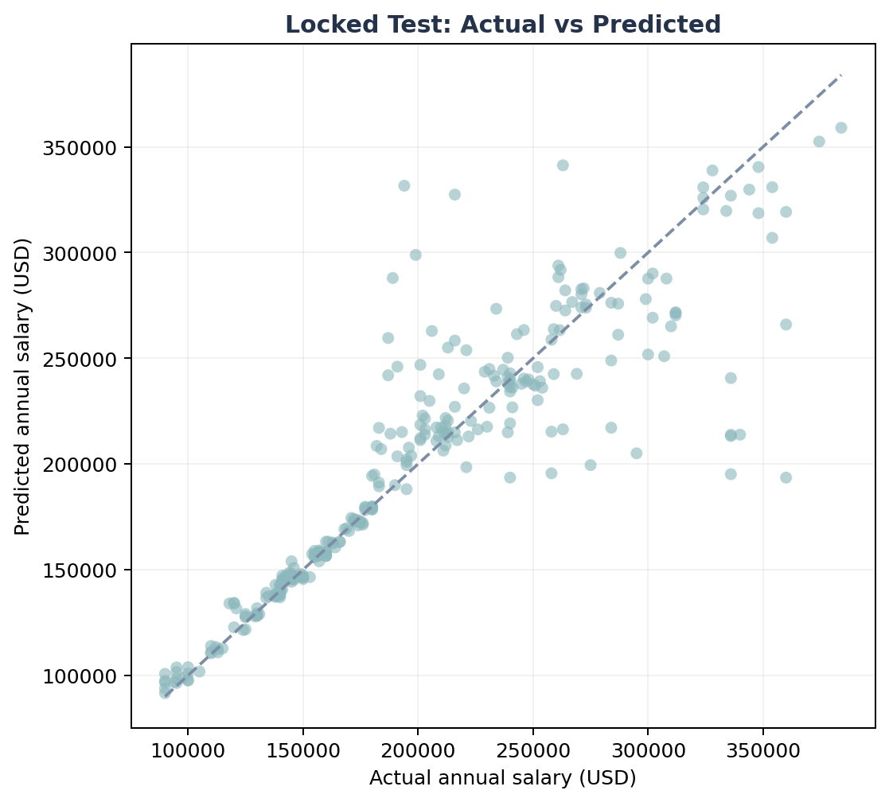
Figure 8. Locked test: actual versus predicted annual salary.
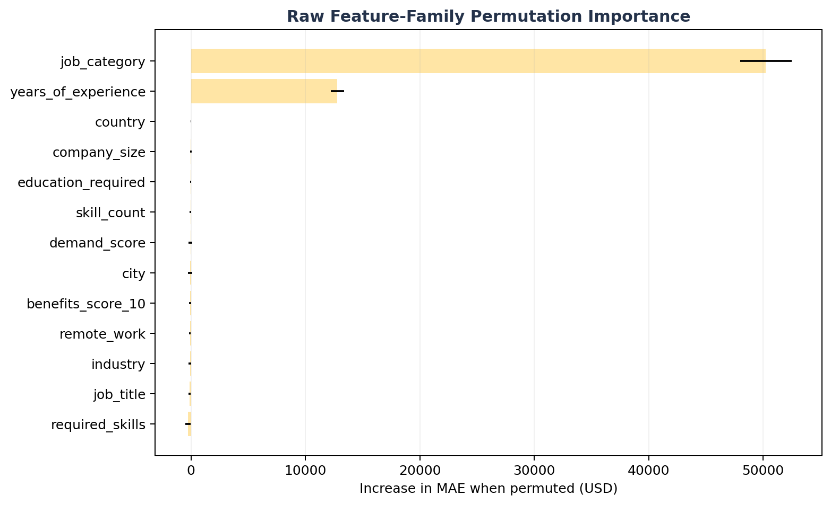
Figure 9. Raw feature-family permutation importance measured on final test.
raw_feature | importance_mean | importance_std
job_category | $50,242 | $2,246
years_of_experience | $12,796 | $600
country | $5 | $22
company_size | $-27 | $60
education_required | $-41 | $63
skill_count | $-48 | $72
demand_score | $-56 | $176
city | $-65 | $187

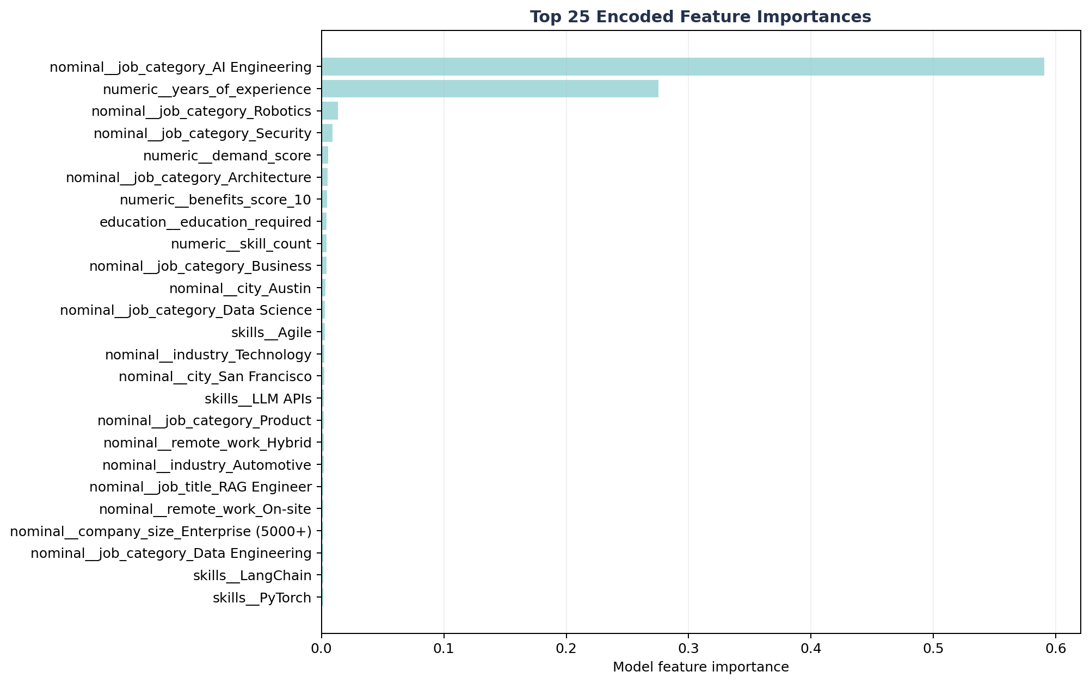
Figure 10. Top encoded feature importances inside the selected estimator.
encoded_feature | importance
nominal__job_category_AI Engineering | 0.5908
numeric__years_of_experience | 0.2753
nominal__job_category_Robotics | 0.0136
nominal__job_category_Security | 0.0091
numeric__demand_score | 0.0054
nominal__job_category_Architecture | 0.0050
numeric__benefits_score_10 | 0.0044
education__education_required | 0.0042
numeric__skill_count | 0.0041
nominal__job_category_Business | 0.0041

Conclusion – Best model & importance The final locked-test R² is 0.803. Permutation evidence is dominated by job_category and years_of_experience. Because these are embedded in a dataset with contradictory and synthetic-looking structure, their importance must be reported as model reliance rather than causal salary drivers.

05 | AI Market Job Salary Prediction  Deployable bundle, authenticated Streamlit interface and practical prediction interval.

298  Locked test rows | $197,787  Mean prediction | $194,694  Median prediction | $32,216  90% half-width

The selected Random Forest pipeline is serialized as artifacts/model_bundle.joblib together with metadata.json. Streamlit reads the same feature contract, category options, numeric ranges, 93-skill vocabulary and empirical validation-error interval used by the offline model. This avoids manual encoder/model mismatch during interactive prediction.

Figure 11. Salary prediction performance on the final locked period.
job_title | job_category | city | annual_salary_usd | predicted_salary_usd | absolute_error_usd
Data Scientist | AI Engineering | New York | $190,000 | $189,995 | $5
LLM Engineer | Infrastructure | Singapore | $140,000 | $139,978 | $22
Generative AI Engineer | Infrastructure | Bangalore | $140,000 | $140,025 | $25
AI Research Scientist | Governance | Bangalore | $146,000 | $146,074 | $74
Multimodal AI Engineer | ML Operations | San Francisco | $138,000 | $138,085 | $85
Deep Learning Engineer | Architecture | Austin | $180,000 | $179,911 | $89
Deep Learning Engineer | Infrastructure | Tokyo | $140,000 | $139,910 | $90
NLP Engineer | Data Science | Los Angeles | $157,000 | $156,892 | $108

Streamlit login The delivered streamlit.py includes a local demo login (admin / AIJob2026!) and supports replacement via Streamlit secrets or AIJOB_APP_USER + AIJOB_APP_PASSWORD_SHA256 environment variables. The demo credential must be changed before any shared deployment.

Conclusion – Salary Prediction The final model is suitable for academic salary benchmarking and scenario exploration inside this dataset’s empirical scope. A practical interval of approximately ±$32,216 is shown to communicate uncertainty instead of presenting an unexplained point estimate only.

06 | Overall Conclusion, Limitations & Run Guide  What can be claimed, what must not be claimed, and how to reproduce the project.

Overall conclusion:
- Data basic clean: 1,500 raw records became 1,499 canonical records after removing one corrupted categorical row; no nulls/duplicates were present, but major logic inconsistencies were documented.
- Data ready for ML: 1,201 development rows and 298 March-2026 locked-test rows; 93 TRAIN-only skill tokens plus skill_count; blocked leakage fields never enter X.
- Model comparison: Random Forest selected by lowest temporal-CV MAE ($12,554).
- Final model: Random Forest achieved locked-test MAE $14,961, RMSE $29,844, R² 0.803, and MedAE $4,467.
- Prediction: model bundle and metadata are deployable through Streamlit with an empirical ±$32,216 90th-percentile absolute-error interval.
Do not over-claim The supplied data does not establish that the learned feature relationships are faithful real-world labor-market economics. The project is appropriate for supervised-regression learning, pipeline design and controlled scenario exploration; external verified job-posting data is required for operational compensation decisions.

How to run
1. Install dependencies: pip install -r requirements.txt
2. Refresh all five output packs and the model bundle: python pineline.py
3. Launch the dashboard: streamlit run streamlit.py
4. Local demo login: admin / AIJob2026! (change before shared deployment).

Delivered artifact map
Artifact | Purpose
pineline.py | Runs all 12 stages and regenerates five evidence packs.
streamlit.py | Pastel technical dashboard + authenticated salary prediction.
assets/12_stage_pipeline.png | Presentation-ready 12-stage process image.
outputs/01_data_basic_clean | Basic cleaning results, logic audit and visuals.
outputs/02_data_ready_for_machine_learning | Split, leakage policy, encoded datasets, skills and correlations.
outputs/03_model_comparison | Five-model temporal CV comparison.
outputs/04_best_model_and_feature_importance | Final metrics, importance, residual and actual-vs-predicted charts.
outputs/05_salary_prediction | Predictions, interval columns and prediction summary.
artifacts/model_bundle.joblib + metadata.json | Serialized deployment contract.
reports/AI_Job_Market_Salary_Prediction_Report.docx | This presentation report.

References
- Document_QD Project KHDL&AI.docx — supplied Technical Specification Design; source of the 12-stage workflow and project scope.
- ai_jobs_market_2025_2026.csv — supplied project dataset; all numerical results in this report are recomputed from the delivered CSV.
- Chip Huyen (2022), Designing Machine Learning Systems: An Iterative Process for Production-Ready Applications, O’Reilly Media — end-to-end ML-system, deployment and monitoring principles.
- Cranes Varsity course materials: Introduction to Machine Learning; Regression and Classification Models; Feature Engineering and Data Analysis Techniques — supporting academic reference for regression metrics, encoding, correlation and feature selection.

