**STI Suite User Manual**

(Version 3.0, Updated on Jan. 2017)

Hongjiang Wei and Chunlei Liu

University of California, Berkeley, USA

**Introduction**

Quantitative susceptibility mapping (QSM) and susceptibility tensor imaging (STI) are two recently developed imaging methods for quantifying tissue’s magnetic property. Magnetic susceptibility offers a new contrast for high-resolution anatomical imaging; it further provides important information on tissue’s chemical composition, especially myelin and iron, and white matter microstructures of the brain. However, processing QSM and STI still requires advanced technical expertise. The growing application and wider acceptance of this new technique has generated a need for a comprehensive software package that can easily perform all these analysis. Here, we have developed such a tool named “STI Suite”. This software is based on our previous works1-13. In this Matlab-based software package, we have implemented the essential algorithms for phase processing, QSM, STI, and related analysis tools. To facilitate the dissemination and evaluation of these methods, we make STI Suite freely available at http://people.duke.edu/~cl160/ for non-commercial academic use.

STI Suite contains both Matlab command-line functions and graphical user interfaces (GUIs) for phase processing, QSM, STI, and related visualization and ROI analysis tools. In this manual, we will not only include the introduction of the programs, but will also include the physical and mathematical basis for deriving these methods. Please feel free to let us know if you have any questions. We will appreciate the users’ comments and suggestions on STI Suite.

1. **Release notes:**

**Version 3.0**

1. Brian extraction is improved to enable more automatic operation.
2. Variable inputs are enabled.
3. 2D phase processing is added which is designed for QSM recon based on 2D GRE-EPI data
4. A fast estimation of susceptibility – STAR- QSM is added.
5. A single button is added that performs the brain mask extraction, phase processing and QSM recon automatically.

**Version 2.0**

1. Multi-echo magnitude/phase or real/imaginary data loading.
2. iHAPERELLLA by pre-combine the Laplacian values to calculate the BG removal only one time.
3. Faster iLSQR method using optimized FFT operations.
4. User interface redesigned.
5. CPU time optimized.

**Testing data: (1) multiple echo human brain data**

**Spatial Resolution: 0.9x0.9x2 mm3**

**3 Echoes**

**(2) Single echo human brain data**

**(3) Single echo mouse brain data**

**(4) 2D GRE – EPI human brain data**

**Benchmark: Intel Core™ i7-4770 Processor, 3.40 GHz CPU, 4 cores**

**Brain extraction: 1 second**

**Laplacian and Combine: 12 seconds**

**Unwrapping: 1 second**

**V-SHARP: 26 seconds**

**STAR_QSM: 13 seconds**

Summary: With the optimization, we hope to make it available for routine application.

-- Hongjiang Wei

Jan, 2017

**2. Recommendations**

1. Multi-Core CPU: For the optimal performance, we recommend to use Intel Core™ i7 Processor, for 4 cores, you have a 4-fold gain of speed, and for 6 cores, you have a 6-fold gain of speed.
2. Sufficient RAM: 12G RAM is recommended. Minimum 8G RAM is required.
3. Display: Large screen, the size of text is 100% (default) are recommended. You can always customize the layout with Matlab guide.

**3. GUI customization**

1. Matlab command:

>> QSM_GUI

OR >> STISuite then click “QSM_GUI: QSM pipeline”

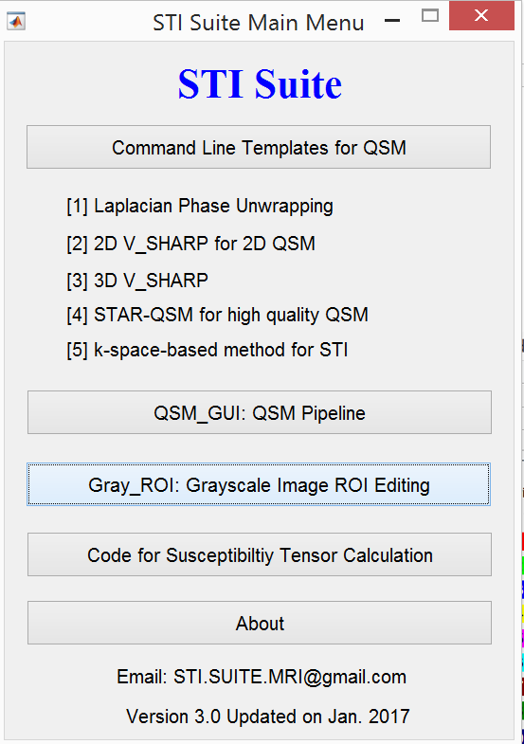

1. Click the small downward arrow to dock QSM-GUI to the Matlab window:

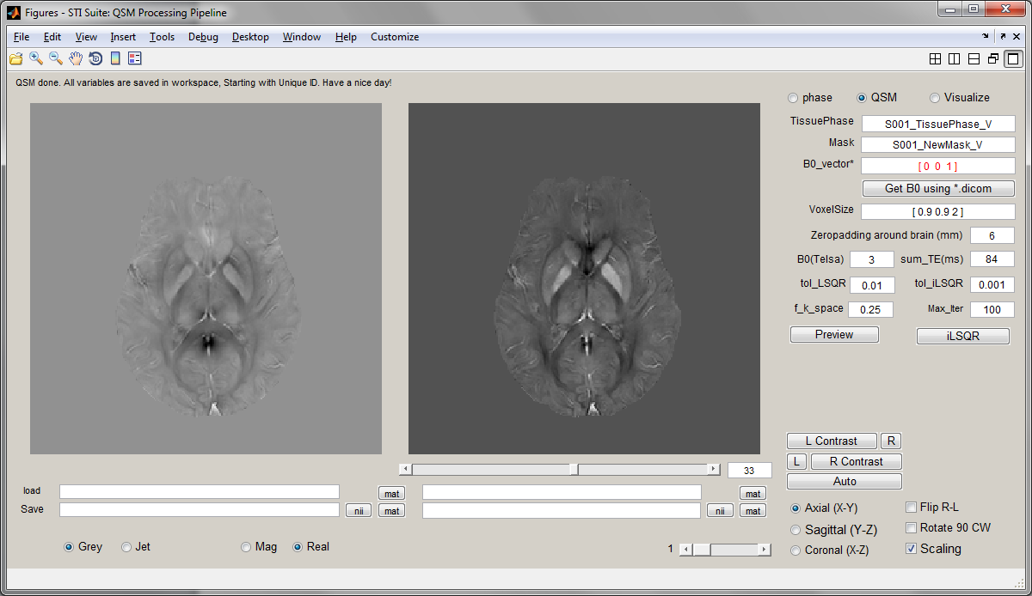

You get a user interface like this:

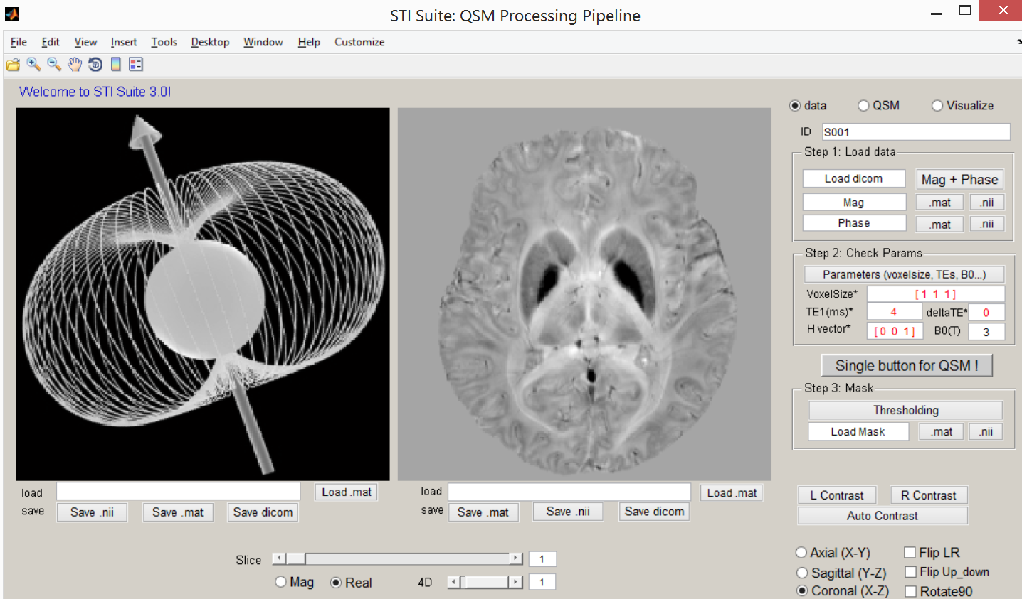

In this way, you can use the interface, while be aware of any output from the command window.

**4. Working with QSM_GUI**

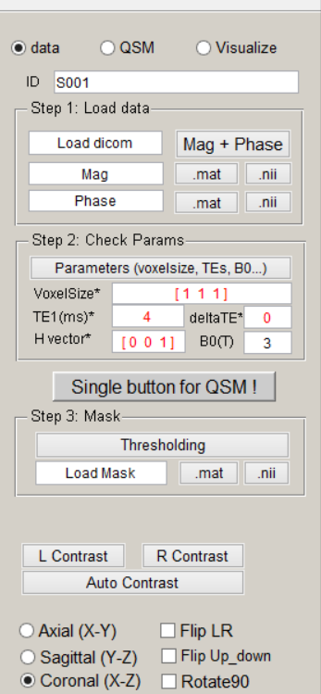

(1) For dicom magnitude/phase data

Click “Mag+Phase” button to select and load dicom file folder then wait for loading data, see the status bar on the left corner until ‘done!’

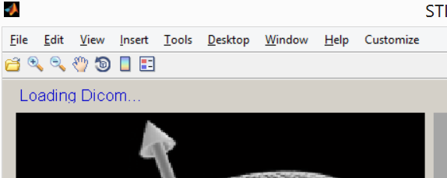

1. scan parameters will automatically appear on “Step 2”， if necessary, just to modify them
2. 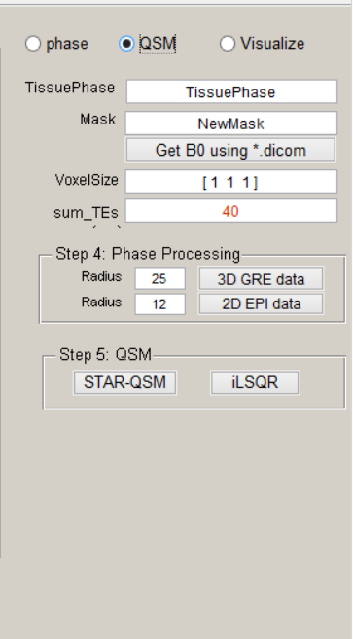Check the red color parameters then click “Single Button For QSM” including masking, phase processing and QSM recon. Otherwise go to (4) do a step by step recon,
3. Click “thresholding” button to generate the mask, you will be automatically taken to the next step for QSM.
4. Click “3D GRE data” button to generate the filtered phase.
5. Click “STAR-QSM” button to generate the QSM

Or “iLSQR” button. STAR-QSM is much faster and provides high quality QSM images with less streaking artifacts.

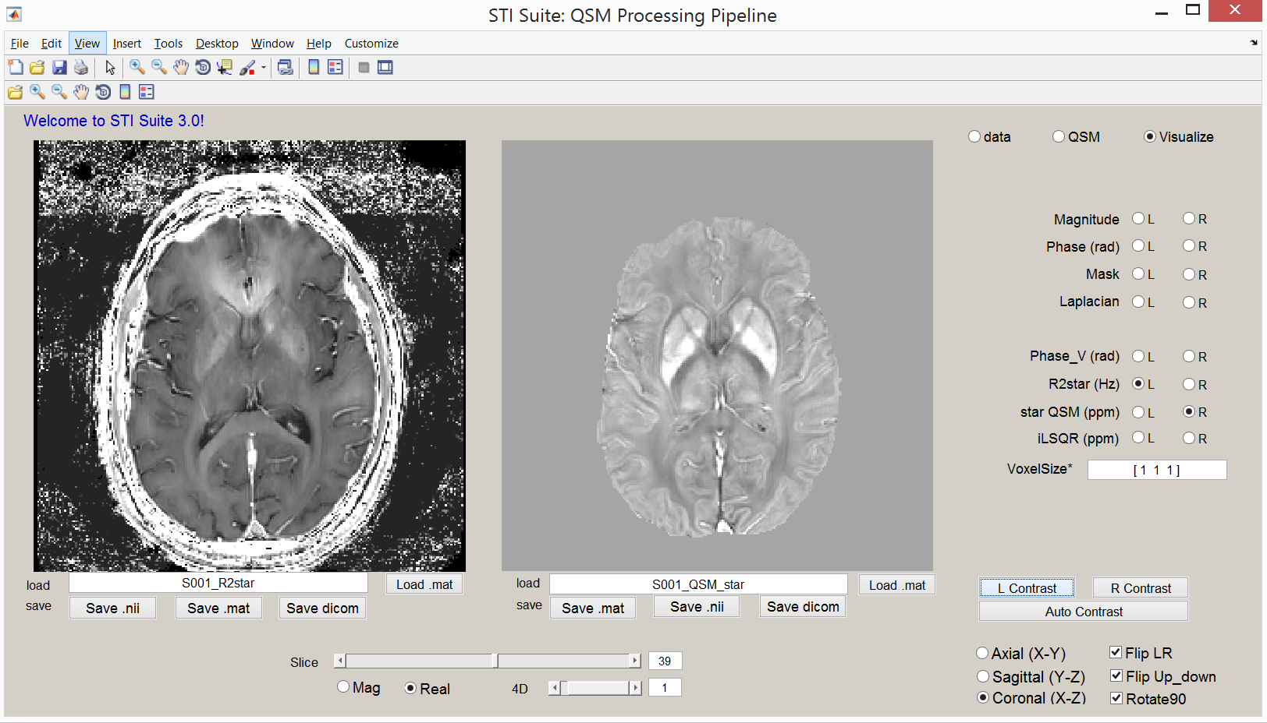

(6) you can adjust image contrast by “R contrast” for the right window and “L contrast” for the left window; click “Axial” and “sagittal” for different views

(7) click “save .mat” or “save .nii” or “save .dcm” to save the QSM to matlab file or nifti or dicom.

For oblique scan, B0_vector should be calculated from a dicom file associated with the multi-echo GRE scan. To request assistant, please contact [STI.Suite.MRI@gmail.com](mailto:STI.Suite.MRI@gmail.com).

1. **Gray_ROI for ROI editing.**

Matlab command:

>> Gray_ROI

OR >> STISuite



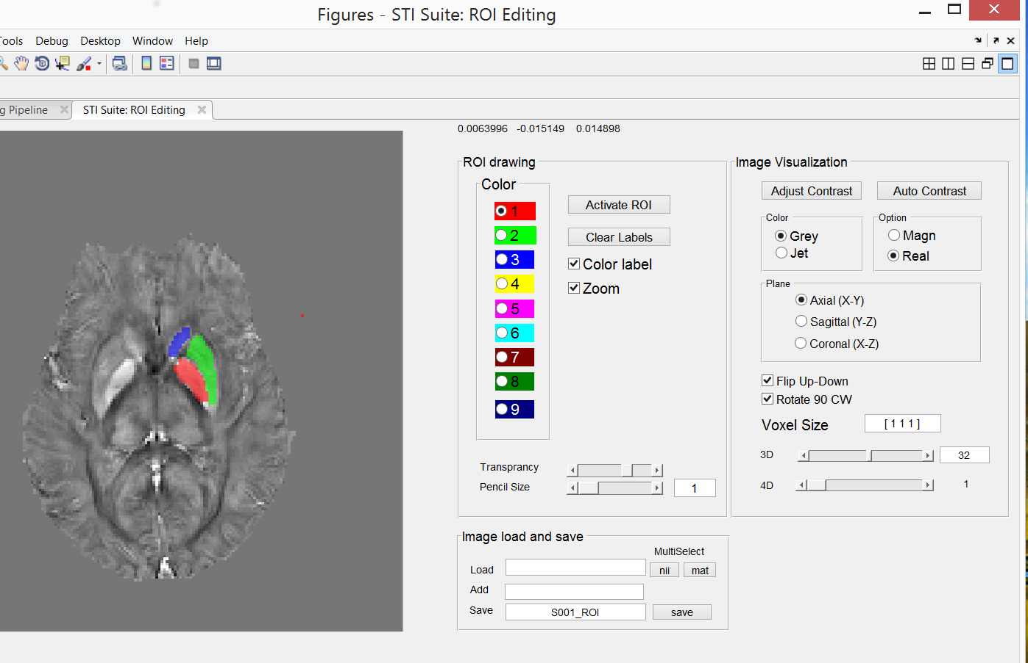

**Step 1: Load the data (3 options)**

Option 1: If we have *.nii or *.nii.gz file, we can click the “nii” button to load them.

Option 3: If we have *.mat file, we can click the “mat” button to load them.

**Step 2: Activate ROI editing and draw ROIs**

1. Push the “Activate ROI” button
2. Select the color
3. Set ROI color transparency
4. Select pencil size
5. Drawing ROI. During this, we can:

Use mouse wheel to navigate through different slices;

Change color labels to select different ROIs.

**Step 3: Save and load ROIs (2 options)**



**Option 1:** Fill in the ROI name, e.g. “S001_ROI”. Then click “save” to save it to workspace.

Two files, i.e. “S001_ROI_image” and “S001_ROI_struct” will be saved to workspace.

We can use “Load Image” to load “S001_ROI_image” into Matlab.

We can use “Load Struct” to load “S001_ROI_struct” into Matlab.

**Note**: We can load in both 3D and 4D data.

This allows ROIs for each volume of the 4th dimension. Save separate 3D ROIs for each volume.

**Zooming the images**

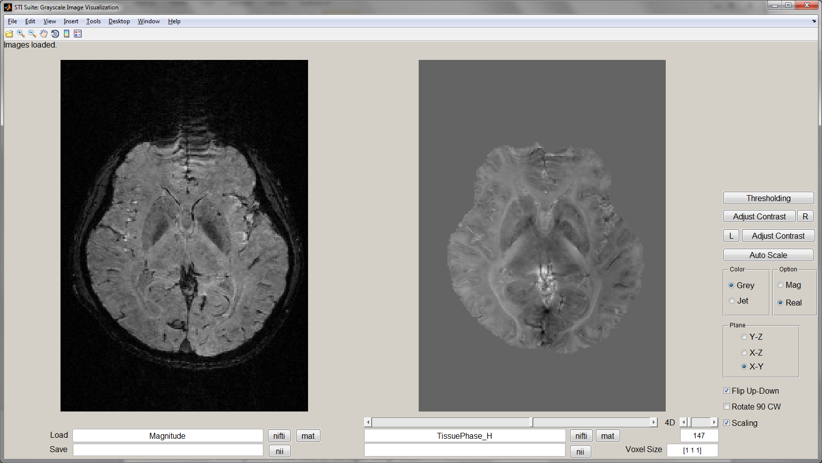

Zooming is enabled. Uncheck “Zoom” to enable zooming for subsequent slices.

**5. Acknowledgments**

* **Important: This is beta version of the STI Suite 3.0. Hongjiang Wei and Chunlei Liu reserve all the rights to the methods and this software.**
* The scripts for *.nii files are based on the work of Jimmy Shen, downloaded from Matlab Central: http://www.mathworks.com/matlabcentral/fileexchange/8797-tools-for-nifti-and-analyze-image
* We acknowledge Dr. Wei Li, former postdoc from Liu’s laboratory, for his contribution in developing majority of the methods.
* Dr. Chunlei Liu is supported by National Institutes of Health (NIH) through grant [R24MH106096](http://www.sciencedirect.com/science/article/pii/S1053811911000164#gts0005), grant R01 MH096979, and by National Multiple Sclerosis Society through grant RG4723 for performing the research that generated these software.
* Dr. Hongjiang Wei, postdoc from Liu’s Laboratory, developed this software under the supervision of Dr. Liu. He will continue to provide support to STI Suite.
* For questions regarding this software, please email: [STI.Suite.MRI@gmail.com](mailto:STI.Suite.MRI@gmail.com). We wish to keep a record of the users for improving the software.
* We appreciate the users’ comments and suggestions for improving **STI Suite**.

**6. References**

**1.** Wei H et al., , Liu C. Streaking artifact reduction for quantitative susceptibility mapping of sources with large dynamic range. *NMR in Biomedicine.* 2015 Oct;28(10):1294-303. doi: 10.1002/nbm.3383.

**2.** Wei H et al., , Liu C. Joint 2D and 3D phase processing for quantitative susceptibility mapping: application to 2D echo-planar imaging. *NMR in Biomedicine.* 2017 Apr;30(4). doi: 10.1002/nbm.3501.

**3**. Wei H et al., , Liu C. Investigating magnetic susceptibility of human knee joint at 7 tesla. Magn Reson Med. 2017 Jan 17. doi: 10.1002/mrm.26596. [Epub ahead of print]

**4**. Wei H et al., , Liu C. Imaging whole-brain cytoarchitecture of mouse with MRI-based quantitative susceptibility mapping. Neuroimage. 2016 Aug 15;137:107-15. doi: 10.1016/j.neuroimage.2016.05.033.

**5.** Li W, Wu B, Avram AV, Liu C. Magnetic susceptibility anisotropy of human brain in vivo and its molecular underpinnings. *Neuroimage.* 2012;59(3):2088-2097.

**6.** Li W, Wu B, Batrachenko A, et al. Differential developmental trajectories of magnetic susceptibility in human brain gray and white matter over the lifespan. *Human Brain Mapping.* 2013;doi: 10.1002/hbm.22360.

**7.** Li W, Wu B, Liu C. Quantitative susceptibility mapping of human brain reflects spatial variation in tissue composition. *Neuroimage.* 2011;55:1645-1656.

**8.** Liu C. Susceptibility tensor imaging. *Magn. Reson. Med.* Jun 2010;63(6):1471-1477.

**9.** Liu C, Li W. Imaging neural architecture of the brain based on its multipole magnetic response. *NeuroImage.* 2013;67:193-202.

**10.** Liu C, Li W, Johnson GA, Wu B. High-field (9.4 T) MRI of brain dysmyelination by quantitative mapping of magnetic susceptibility. *Neuroimage.* 2011;56(3):930-938.

**11.** Liu C, Li W, Wu B, Jiang Y, Johnson GA. 3D Fiber tractography with susceptibility tensor imaging. *Neuroimage.* 2012;59(2):1290-1298.

**12.** Liu C, Murphy NE, Li W. Probing white-matter microstructure with higher-order diffusion tensors and susceptibility tensor MRI. *Frontiers in Integrative Neuroscience.* 2013;7.

**13.** Wu B, Li W, Avram AV, Gho S-M, Liu C. Fast and tissue-optimized mapping of magnetic susceptibility and T2* with multi-echo and multi-shot spirals. *Neuroimage.* 2012;59(1):297-305.

**14.** Wu B, Li W, Guidon A, Liu C. Whole brain susceptibility mapping using compressed sensing. *Magn Reson Med.* 2012;67(1):137-147.