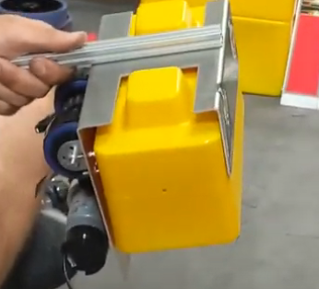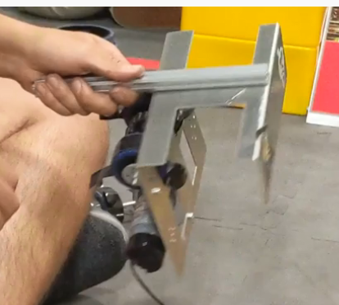

Good for retrieving only one stone.

Might be bad for releasing the stone on a tower. Left side might be too long.