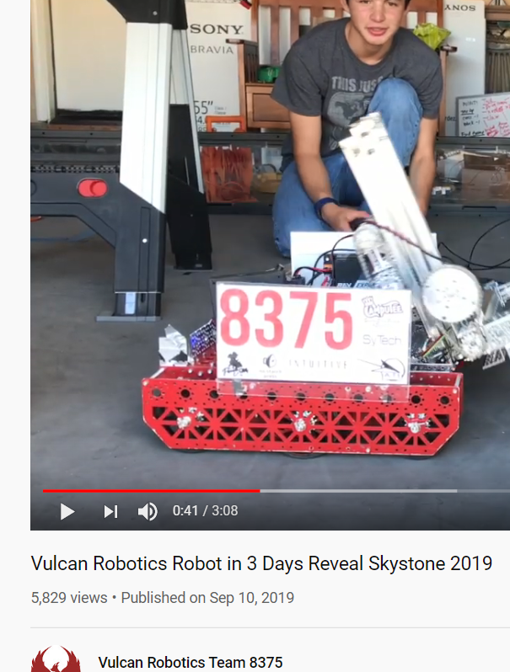

Rotating elevator to get under the alliance bridge and still build tall skyscrapers

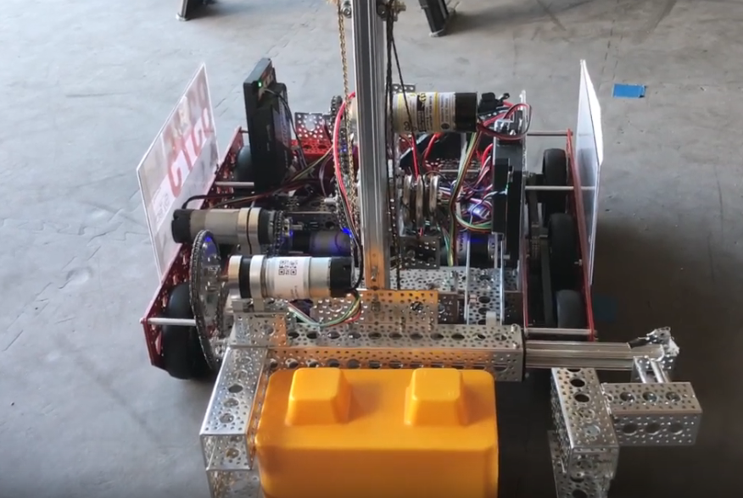

Squeezing style grabber using a lead screw