**[F29DC 2024 Lab 5 –](https://canvas.hw.ac.uk/courses/28951/files/3694381?wrap=1" \o "F29DC 2024 Lab 1 - Connectivity, VPCs, Subnets, VLANs.pdf" \t "_blank) Network Topologies  
- Shyam Sundar Velmurugan  
- H00418621**

Topology A configuration

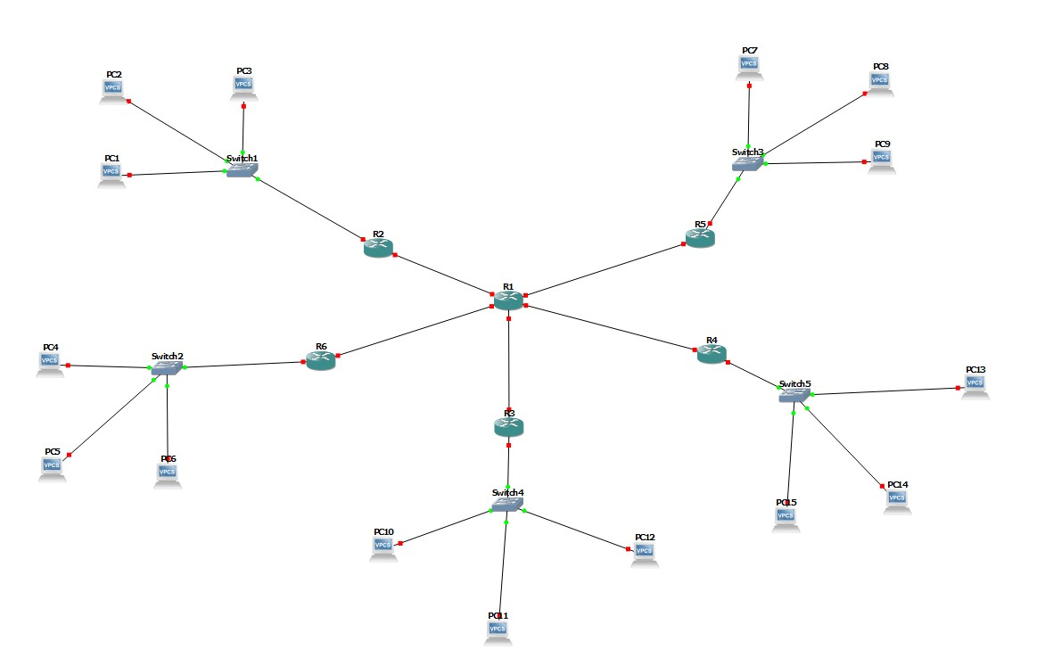

Image 1.1 : setting up all the VPC’s with their switches and respective routers to the main router

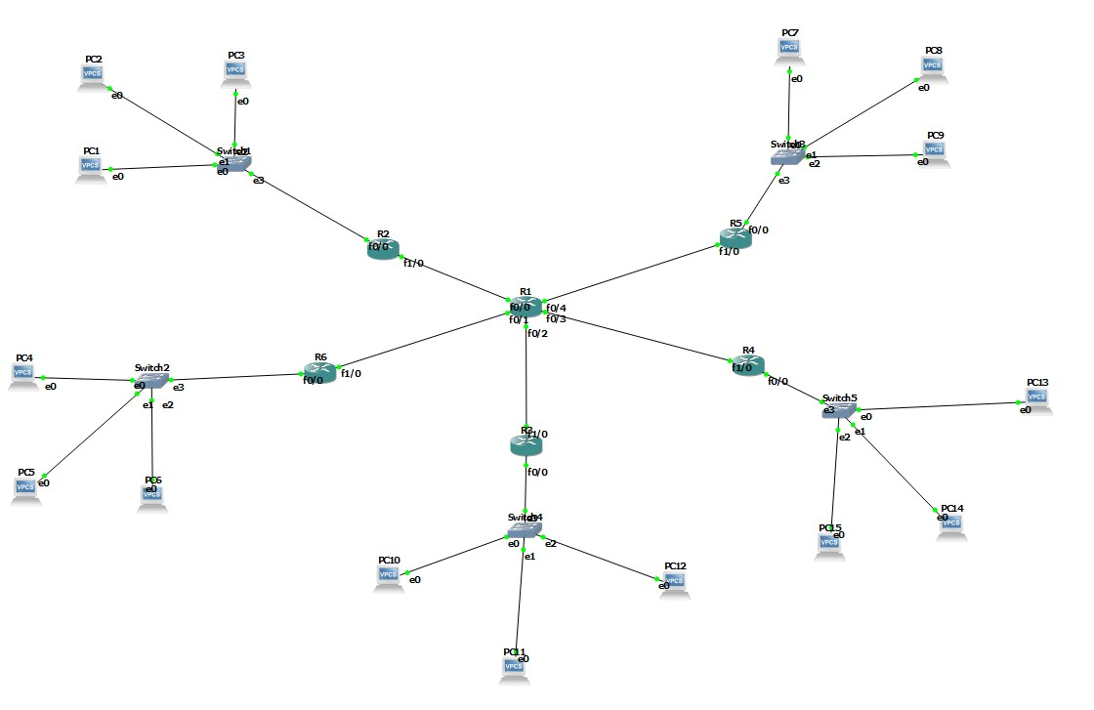

Image 1.2 : Starting the connections

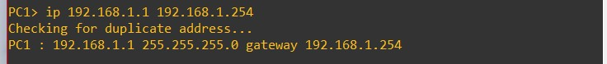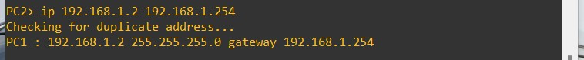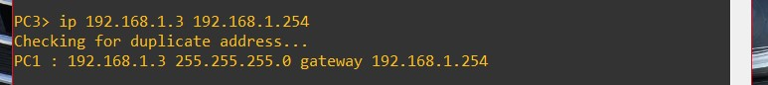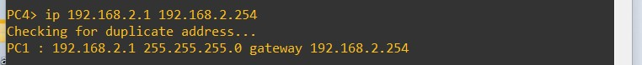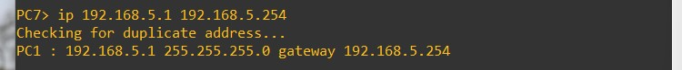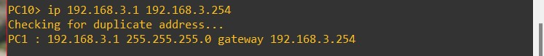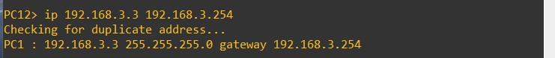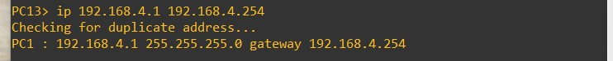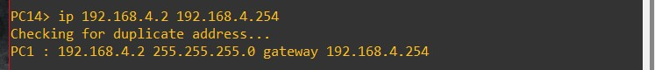

Image 1.3 : Providing all the IP addresses for the respective VPC’s.

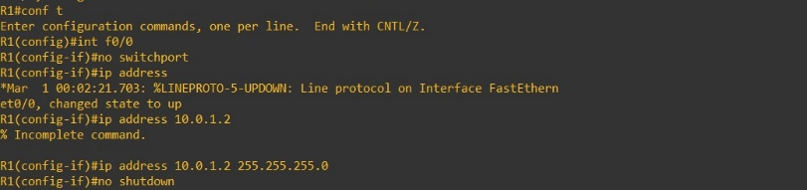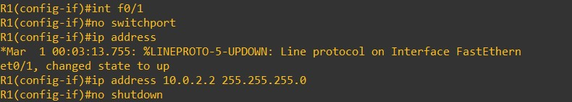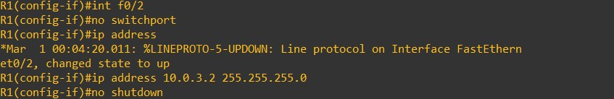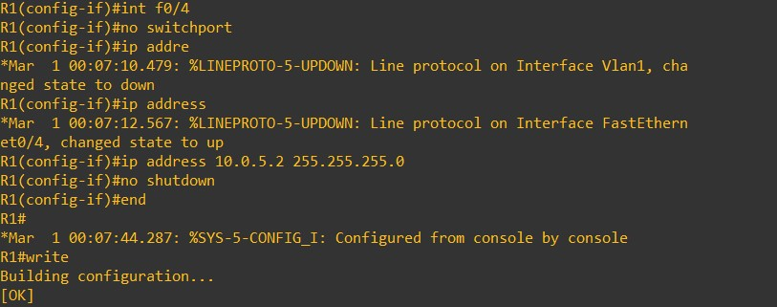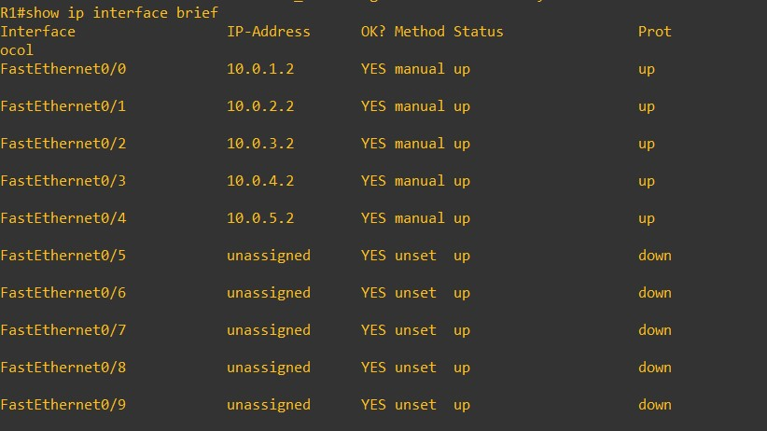

Image 1.4 : Providing ip’s for interfaces with their respective IP addresses in R1.

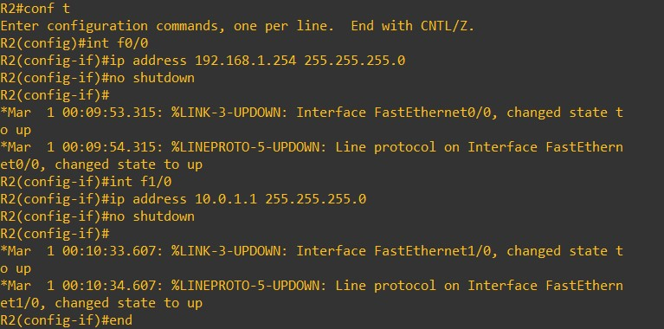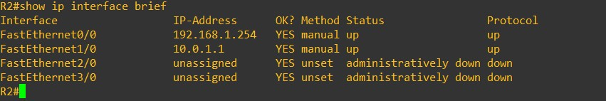

Image 1.5 : Providing ip’s for interfaces with their respective IP addresses in R2.

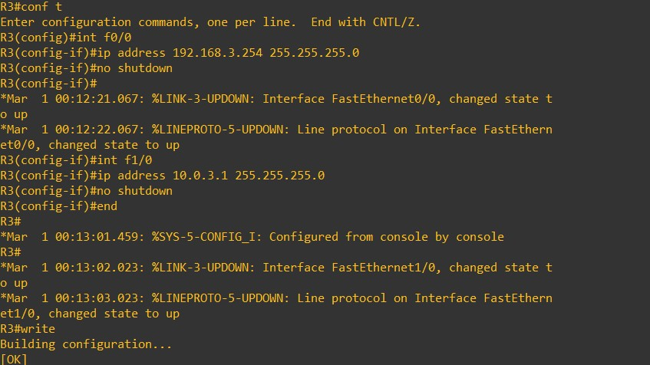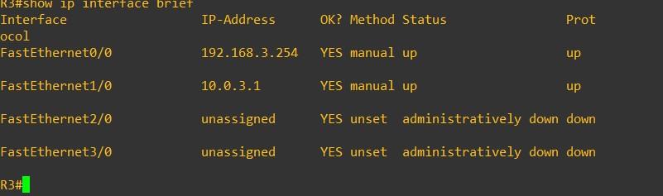

Image 1.6 : Providing ip’s for interfaces with their respective IP addresses in R3.

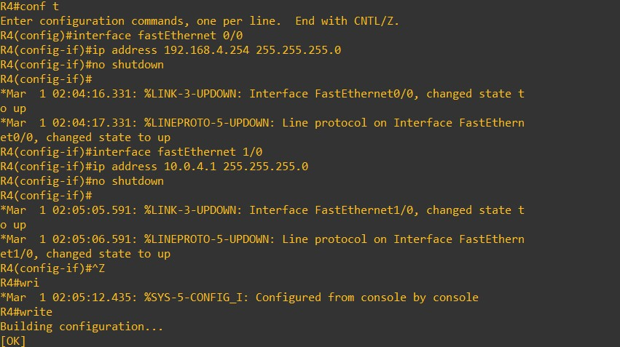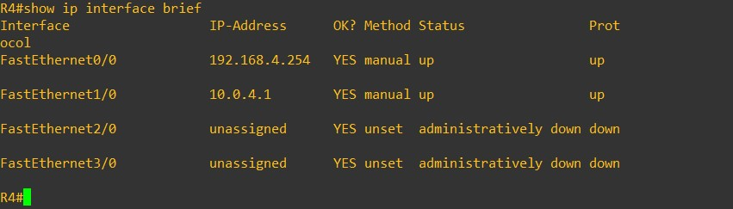

Image 1.7 : Providing ip’s for interfaces with their respective IP addresses in R4.

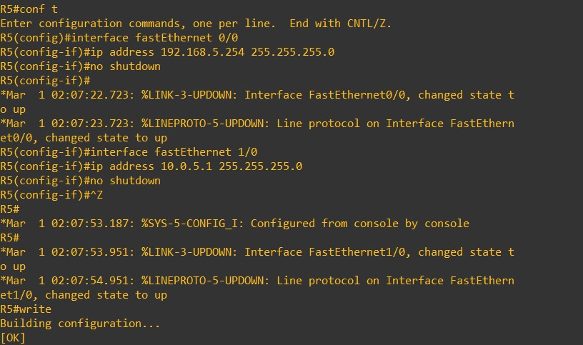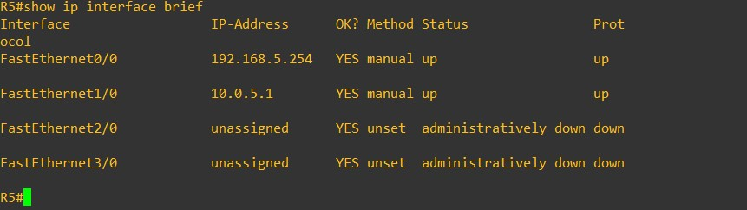

Image 1.8 : Providing ip’s for interfaces fE 0/0, fE 0/1 with their respective IP addresses in R5.

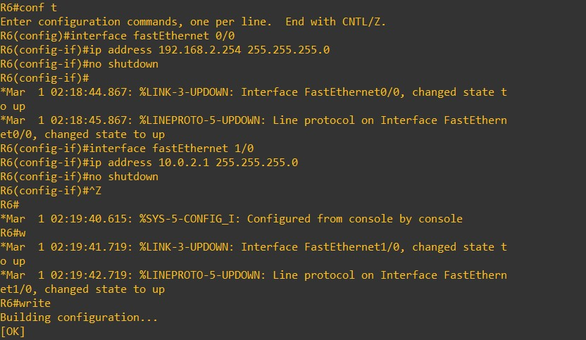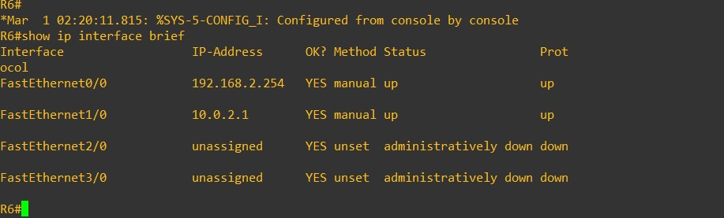

Image 1.9 : Providing ip’s for interface fE 0/0, fE 0/1 with their respective IP addresses in R6.

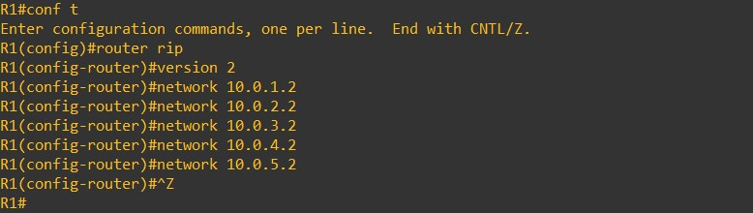

Image 1.10 : Setting up the R1’s RIP configuration.

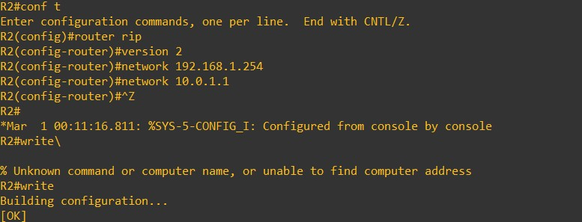

Image 1.11 : Setting up the R2’s RIP configuration.

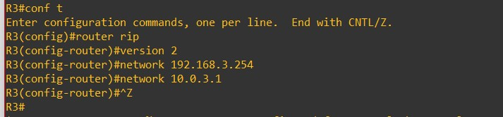

Image 1.12 : Setting up the R3’s RIP configuration.

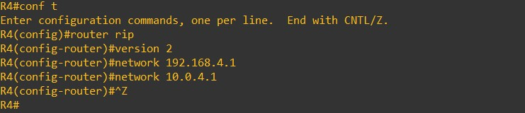

Image 1.13 : Setting up the R4’s RIP configuration.

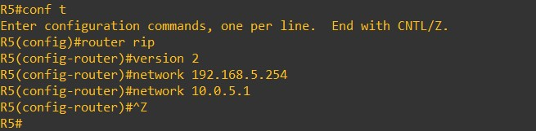

Image 1.14 : Setting up the R5’s RIP configuration.

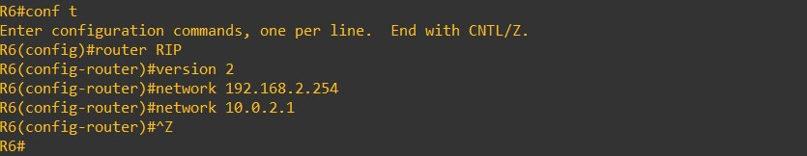

Image 1.15 : Setting up the R6’s RIP configuration.

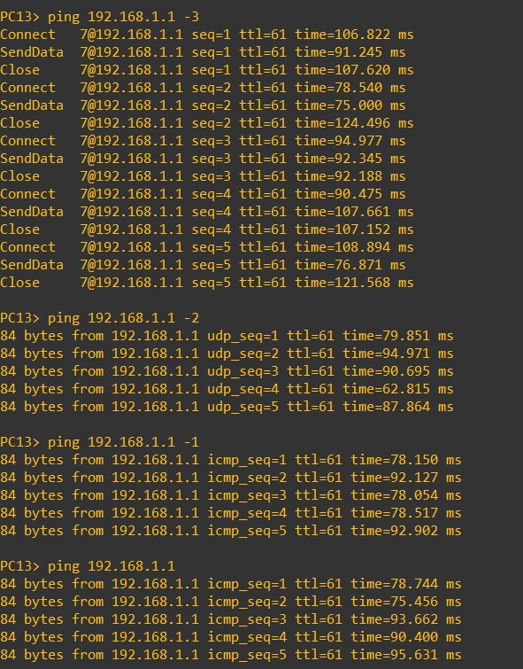

Image 1.16 : Trying to ping PC1 – PC13 using ICMP, TCP, UDP and normal ping.

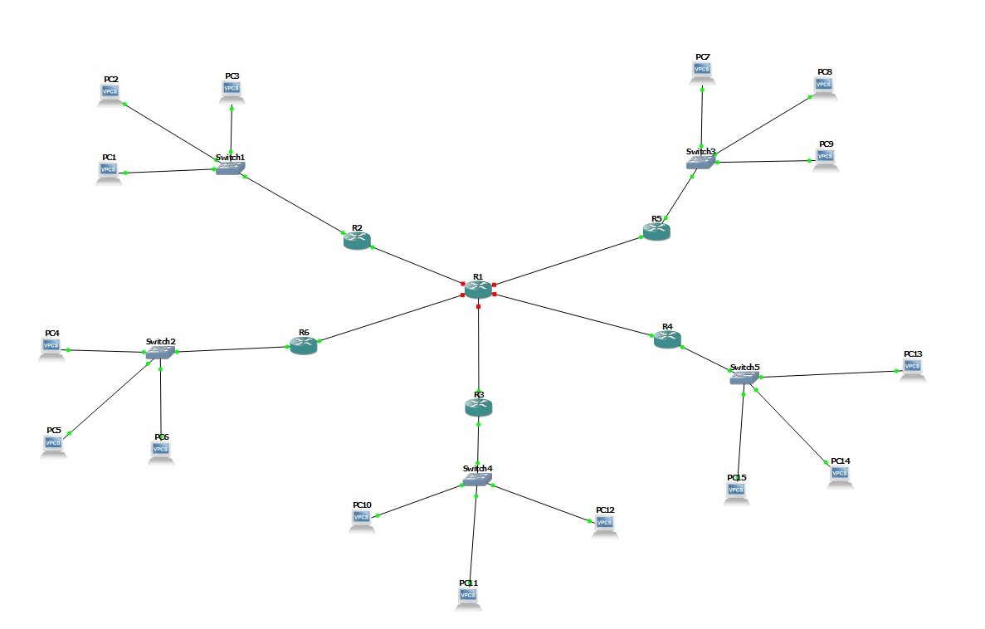

Image 1.17 : Stopping the main router R1 and checking if we can ping again.

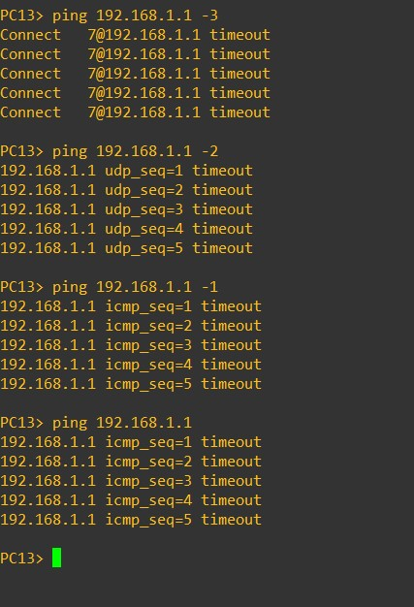

Image 1.18 : Trying to ping PC1 – PC13, it returns a timeout.

------------------------------------------------------------------------------------------------------------------------------------------