2020年技能考试真题1

1. 程序界面如图所示

程序功能：选中组合框中一项后，单击删除按钮，则删除该项

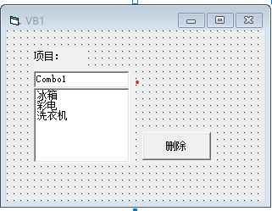

Private Sub Command1_Click()

Combo1.RemoveItem Combo1.ListIndex

End Sub

1. 程序界面如图所示：

程序功能：文本框中输入一个整数，并赋给变量a，如果a在【0，100】之间，则a为合理数，否则不是合理数

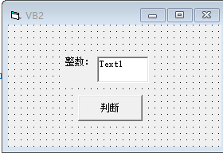

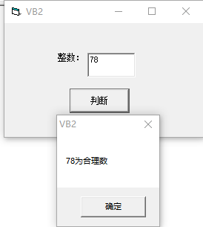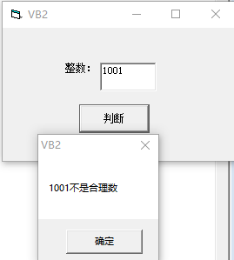

Dim a As Integer

a = Val(Text1.Text)

If a >= 0 And a <= 100 Then

MsgBox Text1.Text & "为合理整数", vbOKOnly

Else

MsgBox Text1.Text & "为不合理整数", vbOKOnly

End If

1. 程序界面如图：

随机产生10个【-1，1】之间的整数，统计0出现的次数，输出结果如图

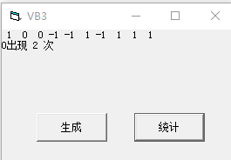

Dim a(1 To 10) As Integer

Private Sub Command1_Click()

Dim i As Integer

For i = 1 To 10

a(i) = Int(Rnd * 3 - 1)

Print a(i);

Next i

Print

End Sub

Private Sub Command2_Click()

Dim count As Integer

Dim i As Integer

count = 0

For i = 1 To 10

If a(i) = 0 Then

count = count + 1

End If

Next i

Print count

End Sub

2020年技能考试真题2

1. 程序界面如图：

程序功能：选中列表框中一项或多项，单击删除按钮，则删除

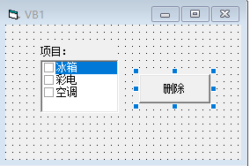

Private Sub Command1_Click()

For i = List1.ListCount - 1 To 0 Step -1

If List1.Selected(i) = True Then List1.RemoveItem i

Next i

End Sub

1. 求两位数中能被5和7整除的数之和，界面如图

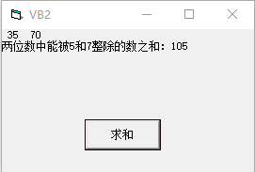

Private Sub Form_Click()

Dim i As Integer, sum As Integer

sum = 0

For i = 10 To 99

If i Mod 5 = 0 And i Mod 7 = 0 Then

Print i,

sum = sum + i

End If

Next i

Print

Print sum

End Sub

1. 随机生成10个【10，20】之间的整数并放入数组A中，统计生成个数最多的数及个数，如图所示（改版）（提示：需要用另一数组B记录数组A中各数出现的次数，最后在数组B中找最大值，注数组A、B下标要一致）

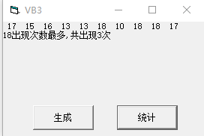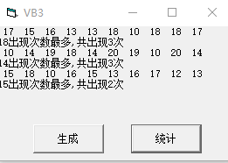

Option Base 1

Dim a(10) As Integer, b(10 To 20) As Integer

Private Sub Command1_Click()

Dim i As Integer

For i = 1 To 10

a(i) = Int(Rnd * 11 + 10)

Print a(i);

Next i

Print

End Sub

Private Sub Command2_Click()

Dim i As Integer, j As Integer, z As Integer, max As Integer

For i = 10 To 20

For j = 1 To 10

If a(j) = i Then b(i) = b(i) + 1

Next j

Next i

max = 0

For i = 10 To 20

If b(i) > max Then

max = b(i)

z = i

End If

Next i

Print z & "出现的次数最多，出现了" & max & "次"

End Sub

2020年技能考试真题3

1. 程序界面如图

程序功能：单击开始按钮，则文本框中的数每隔0.2秒加2，单击暂停按钮，则停止

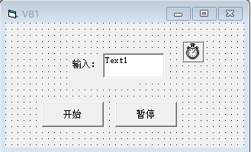

Private Sub Command1_Click()

Timer1.Enabled = True

End Sub

Private Sub Command2_Click()

Timer1.Enabled = False

End Sub

Private Sub Timer1_Timer()

Text1.Text = Val(Text1.Text) + 2

End Sub

1. 程序界面如图

程序功能：判断文本框中输入的两位数是不是八进制数

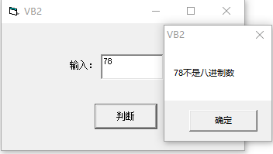 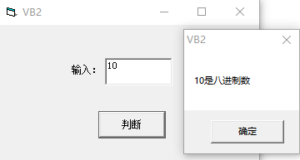

Private Sub Command1_Click()

a$ = Text1.Text

If Left(a, 1) >= "0" And Left(a, 1) <= "7" And Right(a, 1) >= "0" And Right(a, 1) <= "7" Then

MsgBox a & "是八进制数", vbOKOnly

Else

MsgBox a & "不是八进制数", vbOKOnly

End If

End Sub

1. 程序界面如图：

随机生成10个100以内(含0和100)的随机整数，并放入数组中，求其中的偶数平方和

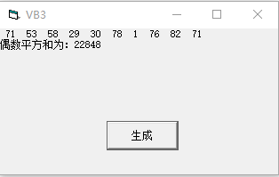

Private Sub Command1_Click()

Dim a(1 To 10) As Integer

For i = 1 To 10

a(i) = Int(Rnd * 101)

Print a(i);

Next i

Print

For i = 1 To 10

If a(i) Mod 2 = 0 Then

sum = sum + a(i)

End If

Next i

Print "偶数的平方和是"; sum

End Sub

用vb编程 一个正整数被称为奇妙平方数，如果此数的平方与它的逆序数的平方互为逆序数。例如，12^2=144, 21^2=441,12 与 21 互逆 ,144 与 441 互逆 ,12 就是奇妙平方数。找出 1-300 以内所有的奇妙平方数。

Private Sub Form_Click()

For i = 1 To 300

m = Val(StrReverse(i))

If i < m Then

If i ^ 2 = Val(StrReverse(m ^ 2)) Then

Print i; "^2="; i ^ 2; Spc(10); m; "^2="; m ^ 2

End If

End If

Next i

End Sub