1.累加
实例：求1+2+3+4...+100，在窗体上显示结果：
1+2+3+4...+100=结果
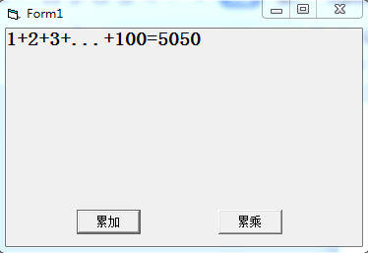

2.累乘
实例：100!，在窗体上显示结果：
100！=结果
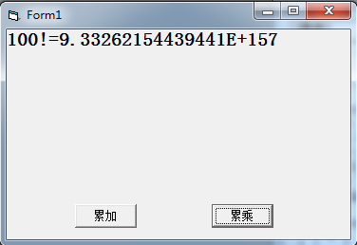

3.求平均
实例：求一组随机数的平均数，随机数的范围[1,100]，取10个随机数，在窗体上显示这10个随机数，并求这10个随机数的平均值。
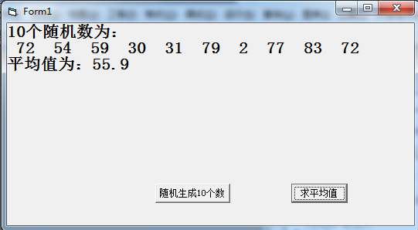

4.求最大/最小值
实例：随机产生10个[1,100]的正整数放入数组，显示产生的数，求最大值、最小值。
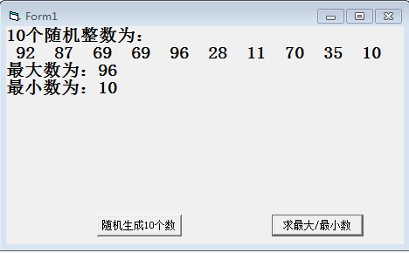

5.条件计数

实例：给定一个二进制数的字符串，统计出有多少个0和1，并输出！

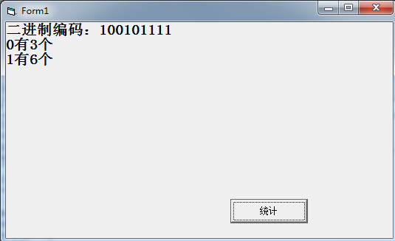

附答案：

1.

Dim i As Integer

Dim s As Integer

Private Sub Command1_Click()

s = 0

For i = 1 To 100

s = s + i

Next i

Print "1+2+3+...+100=" & s

End Sub

2.

Dim i As Integer

Dim v As Double

Private Sub Command2_Click()

v = 1

For i = 1 To 100

v = v * i

Next i

Print "100!=" & v

End Sub

3.

Dim i As Integer

Dim a(1 To 10) As Integer

Dim s As Integer

Private Sub Command1_Click()

Print "10个随机整数为："

s = 0

For i = 1 To 10

a(i) = Int(Rnd * 100 + 1)

Print a(i);

s = s + a(i)

Next i

End Sub

Private Sub Command2_Click()

Print

Print "平均值为：" & s / 10

End Sub

4.

Dim max As Integer

Dim min As Integer

Private Sub Command1_Click()

Print "10个随机整数为："

max = 0

min = 100

For i = 1 To 10

a(i) = Int(Rnd * 100 + 1)

Print a(i);

If a(i) > max Then

max = a(i)

End If

If a(i) < min Then

min = a(i)

End If

Next i

End Sub

Private Sub Command2_Click()

Print

Print "最大数为：" & max

Print "最小数为：" & min

End Sub

Private Sub Form_Load()

Randomize

End Sub

5.

Dim i As Integer

Dim s As String

Dim r As String

Private Sub Command1_Click()

s = "100101111"

For i = 1 To Len(s)

r = Mid(s, i, 1)

If r = 0 Then

m = m + 1

Else

n = n + 1

End If

Next i

Print "二进制编码：" & s

Print "0有" & m & "个"

Print "1有" & n & "个"

End Sub

