1.累加
实例：1+2+3+4...+100
Dim i As Integer, sum As Integer
sum = 0
For i = 1 To 100
sum = sum + i
Next i
Print sum
算法：1+2+3+4...+n
Dim i as integer,sum as integer
sum = 0
for i=1 to n
sum = sum+i
Next i
Print sum
n为任意正整数

2.累乘
实例：10!
Dim i As Integer, j As Double
j = 1
For i = 1 To 10
j = j * i
Next i
MsgBox "10!=" & j
算法：
Dim i As Integer, j As Double
j = 1
For i = 1 To n
j = j * i
Next i
MsgBox "n!=" & j
n为任意正整数
注意：10!意义：1*2*3*4...*10 这是阶乘也就是累乘

3.求平均
实例：求一组随机数的平均数，随机数的范围[1,100]，取10个随机数
Dim i As Integer, sum As Integer ‘i用于循环作用，sum用于累加作用
Dim n(1 To 10) As Integer ‘定义n数组下标从1开始 一共有10个元素
Dim average As Single ‘average 是用于计算平均数
Dim length As Integer ‘length是用于计算n数组的长度
Dim str As String ‘str是用于拼接字符串
sum = 0
str = ""
For i = LBound(n) To UBound(n)
n(i) = Int(Rnd * 100 + 1)
sum = sum + n(i)
str = str & n(i) & Space(1)
Next i
length = UBound(n) - LBound(n) + 1
average = sum / length
Print "所有数：" & str
Print "平均数：" & average
算法：
Dim i As Integer, sum As Integer
Dim a(1 To n) As Integer
Dim average As Single
Dim length As Integer
Dim str As String
sum = 0
str = ""
For i = LBound(a) To UBound(a)
n(i) = Int(Rnd * 100 + 1)
sum = sum + n(i)
str = str & n(i) & Space(1)
Next i
length = UBound(a) - LBound(a) + 1
average = sum / length
Print "所有数：" & str
Print "平均数：" & average
n为正整数 n为多少 值就有多少个 例：n为20 那么就有20个值
注意：
LBound(a)：用于求a数组的下标的下界
UBound(a)：用于求a数组的下标的上界

4.求最大/最小值
实例：随机产生10个[1,100]的正整数放入数组，显示产生的数，求最大值、最小值。
Dim a(1 To 10) As Integer
Dim maxa As Integer, mina As Integer
Dim i As Integer
'为每一个元素赋值随机数
For i = 1 To 10
a(i) = Int(Rnd * 100 + 1)
Next i
'打印10个随机数
For i = 1 To 10
Print a(i);
Next i
Print
'假设a(1)为最大值
maxa = a(1)
For i = 2 To 10
If a(i) > maxa Then
maxa = a(i)
End If
Next i
'假设a(1)为最小值
mina = a(1)
For i = 2 To 10
If a(i) < mina Then
mina = a(i)
End If
Next i
'输出最大值和最小值
Print "最大值：" & maxa
Print "最小值：" & mina

5.条件计数

实例：给定一个二进制数的字符串，统计出有多少个0和1，并输出！

Dim str As String, i As Integer, res As String

Dim zero As Integer, one As Integer

str = "100011000110"

'字符串分解为单个字符

For i = 1 To Len(str)

res = Mid(str, i, 1)

If res = 0 Then

zero = zero + 1

Else

one = one + 1

End If

Next i

Print str

Print "0的个数有：" & zero

Print "1的个数有：" & one

6.选择排序

实例：往数组中添加9个不连续的数字，使用选择排序进行排序(从小到大)。

Dim a, i As Integer, k As Integer, j As Integer

Dim t As Integer

a = Array(8, 5, 6, 7, 4, 3, 9, 2, 1)

For i = 1 To UBound(a)

Print a(i);

Next i

Print

For i = 1 To UBound(a) - 1

k = i

For j = i + 1 To UBound(a)

If a(j) < a(k) Then

k = j

End If

If i <> k Then

t = a(i)

a(i) = a(k)

a(k) = t

End If

Next j

Next i

For i = 1 To UBound(a)

Print a(i);

Next i

Print

7.冒泡排序

实例：往数组中添加9个不连续的数字，使用冒泡排序进行排序(从大到小)

'冒泡排序

Dim a, i As Integer, j As Integer, t As Integer

Dim ele

a = Array(8, 6, 5, 4, 3, 7, 2, 9, 1)

For i = 1 To UBound(a)

Print a(i);

Next i

Print

For i = UBound(a) To 2 Step -1

For j = 1 To i - 1

If a(j) < a(j + 1) Then

t = a(j)

a(j) = a(j + 1)

a(j + 1) = t

End If

Next j

Next i

'for each输出

For Each ele In a

Print ele;

Next ele

Print

8.直接排序

9.顺序查找

流程图：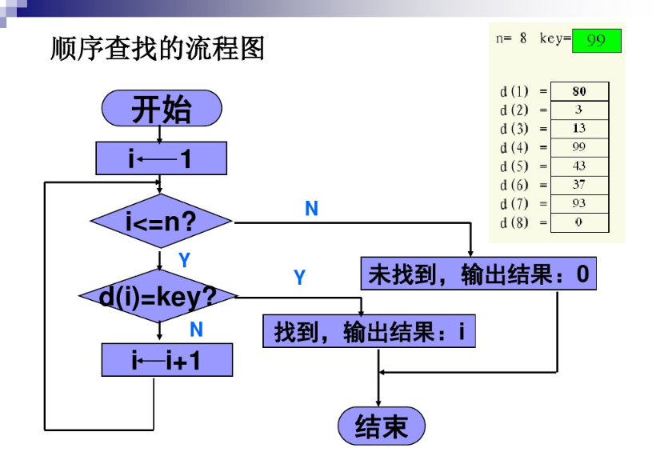
实例：添加6个不同的数字放入数组，找出最大值的位置，输出该位置！

Option Base 1 ‘数组的下标从1开始
Dim a, i As Integer, maxi As Integer
a = Array(8, 6, 5, 9, 3, 4)
For i = 1 To UBound(a)
Print a(i);
Next i
Print
maxi = 1
For i = 2 To UBound(a)
If a(i) > a(maxi) Then
maxi = i
End If
Next i
Print "最大值的位置：" & maxi
实例图：