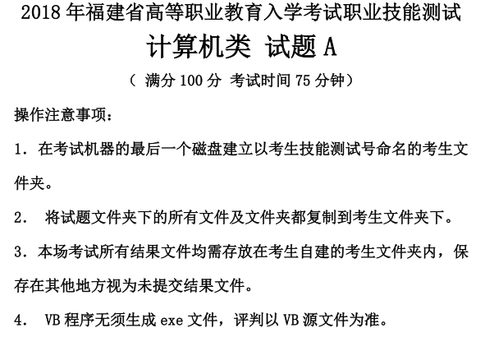
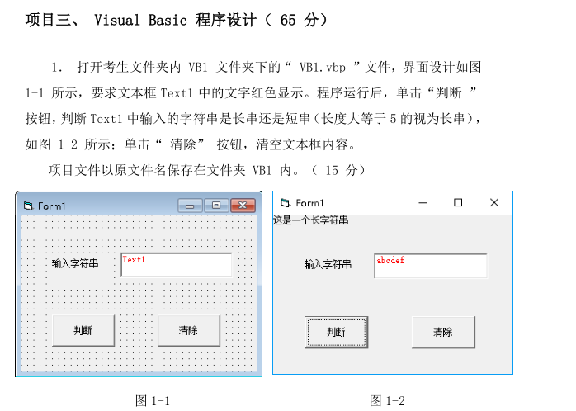
Private Sub Command1_Click()
If Len(Text1.Text) >= 5 Then
Print "这是一个长字符串"
Else
Print "这是一个短字符串"
End If
End Sub

Private Sub Command2_Click()
Text1.Text = ""
End Sub
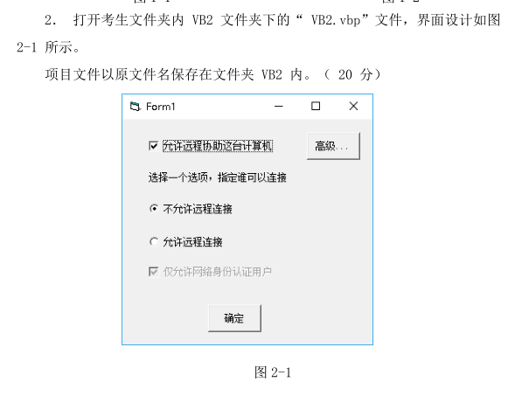
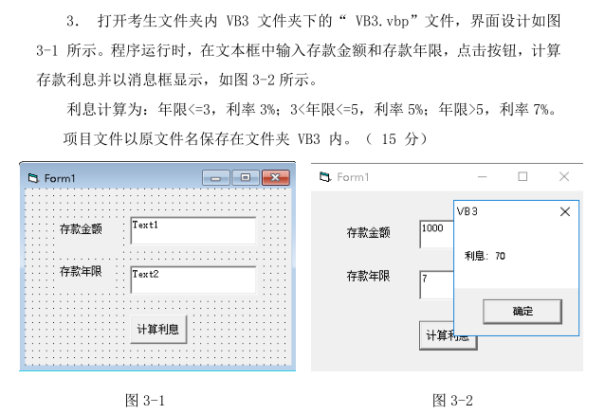
Private Sub Command1_Click()
Dim a, b
a = Val(Text1.Text)
b = Val(Text2.Text)
If b <= 3 Then
MsgBox "利息：" & a * 0.03, , "VB3"
End If
If b > 3 And b <= 5 Then
MsgBox "利息：" & a * 0.05, , "VB3"
End If
If b > 5 Then
MsgBox "利息：" & a * 0.07, , "VB3"
End If
End Sub
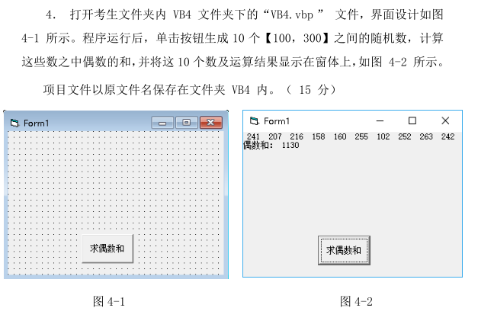
Private Sub Command1_Click()
Dim a(9), i, sum
Randomize
For i = 0 To 9
a(i) = Int(Rnd * 201 + 100)
Print a(i);
If a(i) Mod 2 = 0 Then
sum = sum + a(i)
End If
Next i
Print
Print "偶数和："; sum
End Sub

