# **Lab 2: Content Structuring Plus Increments**

Contents

Lab 2: Content Structuring Plus Increments 1

1. Introduction (Lab Component Requirements) 1
2. Confirm that you can connect to ITU Web Server remotely. 2
3. Create an HTML website with the following elements. 3
4. Web Page Validator 6
5. Debugging: 7

# Introduction (Lab Component Requirements)

Every week, you’ll learn HTML, CSS, JavaScript, and Web Server configurations until the end of the trimester. The knowledge you acquire should be incrementally applied to your lab. In other words, you’ll apply previous labs to your current labs to build your skills in the front end. Your work should be done individually, but I encourage you to ask for help from your classmates. You don’t want to get stuck on something unable to make progress. In the real world, developers consult their co-workers (in this case, your classmates) if all fails on their research to solve their issues – debugging and troubleshooting. Nevertheless, I advise you not to copy their work. HTML goals in this lab is to do the following.

1. Access ITU Web Server
2. Put comments on all your code
3. Incorporate Attributes
4. Implement the div Element
5. Add HTML Semantics
6. Use Special Characters
7. Specify Viewport
8. Debug your HTML Code
9. Validate your HTML Code
10. Preview your code on your mobile device.

# Confirm that you can connect to ITU Web Server remotely.

You can use any tools. Just make sure that you can upload or download the html code you want to be corrected. It was discussed in class.

1. What is the URL you’re using on the remote ITU Web Server? I showed you this during class session.

|  |
| --- |
| This is the path to my folder on the server:  /home/csc525/itustudents/xhuand93887  You can tell from the screenshot that I connected to the server using ssh and files are copied to the folder |

1. Cut and paste the method of tools/ways how you do it. I prefer you using AptanaStudio for everyone to use. Show that you can connect and SFTP your work to the remote server (ITU Web Server)

|  |
| --- |
| I use either FileZilla or ssh command in terminal to transfer files between my machine and ITU web server |

# Create an HTML website with the following elements.

Don’t worry about the layout and structure of your code for now. We’ll use CSS how to layout and

structure code. Your job here is that you know how to use the HTML code we learned so far.

There should not be an error.

1. <html>
2. Document type
3. <body>
4. <head>
5. <div>

Check the example of what I did during class. Create a menu container.

1. Include all the special characters you learn.
2. Viewport
3. Put a comment on all your code of what it does.

|  |
| --- |
| <!DOCTYPE html>  <html>  <!--Define the head of this html file-->  <head>  <title>CSC 525 Lab1 From Xin Huang</title>  <meta charset="utf-8">  <meta name="viewport" content="width=device-width, initial-scale=1.0">  </head>  <body>  <header>  <h1 style="text-align: center;">CSC 525 - HTML &amp; CSS Programming</h1>  </header>  <!--create a navigate bar using div element-->  <div class="navbar" style="color:red;text-align:center">  <a href="#Home">Home</a>  <a href="#Labs">Labs</a>  <a href="#Assignments">Assignments</a>  <a href="Contact">Contact</a>  </div>  <!--create another left menu bar-->  <div class="navbar">  <ul>  <li><a href="#">Lab1</a></li>  <li><a href="#">Lab2</a></li>  </ul>  </div>  <!-- divide another section and set the color to green-->  <div style="color:green">  <!--Section semantic tag -->  <section>  <h3>Mathematical Symbols</h3>  <ul>  <li>&forall;</li>  <li>&exist;</li>  <li>&sum;</li>  <li>&ni;</li>  </ul>  <h3>Greek Letters</h3>  <ul>  <li>&Alpha;</li>  <li>&Beta;</li>  <li>&Delta;</li>  </ul>    <h3>Others</h3>  <ul>  <li>&copy;</li>  <li>&reg;</li>  <li>&euro;</li>  <li>&amp;</li>  <li>&quot;</li>  </ul>  </section>  </div>  <!-- footer tag-->  <footer>  <address><b>Visit us at: 1234, Santa Clara, CA 95051</b></address>  </footer>  </body>  </html> |

|  |
| --- |
| Access the file on ITU server via broswer C:\Users\i844469\AppData\Local\Microsoft\Windows\INetCache\Content.Word\Screen Shot 2017-09-22 at 6.00.36 PM.PNG |

# Web Page Validator

1. Select a Web page of your choice, and validate it using the "validate by URI" tab of <http://validator.w3.org/>. Cut and paste of the sample error captured.

|  |
| --- |
| The website I chose is: <https://www.youtube.com/> and here is the sample of error |

1. Now, validate your code from section C you just created. There should not be an error.

|  |
| --- |
| I verified my html and this was the error found. |

# Debugging:

What are the errors you see? Correct the errors. You may test this on your different browsers and see what it looks like.

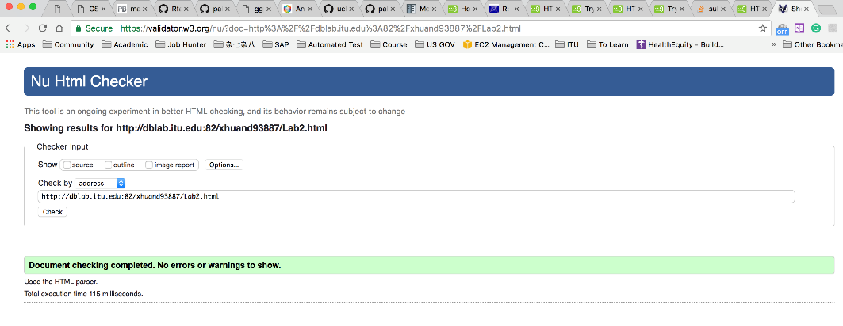

I fixed the bug and there is no bug now.