# LAB #3 HTML5/CSS3

# Introduction

This lab will give you plenty of exercises implementing CSS and HTML. All your work should be validated using the HTML and CSS Validator link below. There are HTML attached to this lab document and they should be modified without any errors to reflect the instruction given. See the slides for examples to do your lab.

HTML Validator: <https://validator.w3.org/>

CSS Validator: <http://jigsaw.w3.org/css-validator/>

# Exercises

Note: All your files CSS/HTML must have embedded comments. Put your name and the date. See the example below.

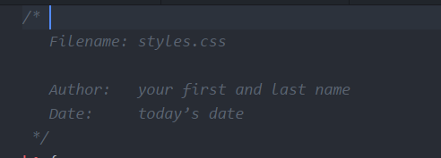

1. Create an embedded style sheet.

|  |
| --- |
| Instruction: Modify emdedded_css.html to reflect the image below. Create an embedded CSS. Turn in the modified HTML and upload to EMS. The instructions to reflect the image are listed below.   1. The heading and paragraph text should be centered. 2. The heading’s background must be “coral”. 3. The footer color must be yellow. |

1. Implement an ID selector, class selector, multiple selectors

|  |
| --- |
| Instruction: Modify css_id_class_multi.html to reflect the image below.  Create an embedded CSS. Turn in the modified HTML and upload to EMS. The instructions to reflect the image are listed below.   1. The heading’s background is black. 2. The heading and footer’s color is red. 3. The “Authentic Chicago-style pies” text has ID selector that aligned to the right. 4. The article tag should be aligned in the center. 5. The paragraph <p> should have a class selector name contact. It should be aligned to the right. 6. Add comment to all your stylesheet and HTML to document your work. You should have your name, author, title, and other things you might want to add. Check the slides for example. |

1. Create an external style sheet

|  |
| --- |
| Instruction: Modify external_css.html to reflect the image below. Create an external CSS. If you check the contents of this HTML file, the style sheet tag is commented it out. **Create** an style.css file and uncomment this tag. Turn in the CSS you created and upload to EMS. The instructions to reflect the image are listed below.   1. The heading’s background color is orangered. <h1> 2. The heading and article’s are aligned to the center. 3. The footer has a background color of green and the color of the text is white. 4. The footer’s paragraph should have class selector named “contact”. |

# LAB VALIDATION:

* 1. Validate the CSS below using http://jigsaw.w3.org/css-validator/. If the validation tool shows no comments on the validity of the CSS code, copy it into a new text document and save it. Make a few changes to the syntax of the style rules included in the copied code, and then validate the edited style sheet. How did the changes impact the validity of the CSS code?