Lab 4

# Introduction

We have covered basic HTML, deployment to ITU webserver, layout, navigation, links, and CSS so far. As a coder, you should be able to handle creating a web page presented to you. On this one, we are creating one page only that will be able to navigate within the page and external page. You may choose whatever layout and colors technique you want as long as it is similar to the “Layout Section” requirements below.

Note: This is basically similar presented to me years and years ago when I was working as entry level front end developer.

# Goals:

Implement Layout

Implement Navigation

Implement Links

Implement Basic HTML

# Directions

1. Needed. Logo – is provided. See the attached logo on this assignment. (Hint: Fixed Position)
2. Header: You may choose any color you want it should be fixed position or you may put image on it.
3. Navigation: You have to use horizontal navigation just like we discussed during the lesson. You should be able to click and hover over. When you click, it should scroll down the page. You may choose the colors you want before and after hovering the links. As you see the example below, it has red divider.

See the demo as an example like this one.



1. Links: This is another part of a right layout. You may use float: right properties.
2. Contents: This is where you should be able to click on the navigation from #3 item and scroll down to this section. It has right and left layout.
   1. Home – This should be active link. It must have a divider.
   2. Who Am I – See the contents of your page section to insert.
   3. News - See the contents of your page section to insert.
   4. About - See the contents of your page section to insert.
   5. Contact Us - See the contents of your page section to insert.
3. Turn in yourname.html and style.css files. You may upload this to EMS.

Note:

1. You may help each other out how to do this, but this is an individual assignment. I have an algorithm to scan your code and see the percentage of similarities. Try your best to work on this. You may ask me also for help and I may guide you.
2. You may use the demo example to start. You may download the contents using SFTP get command or use GUI to get it.

<http://dblab.itu.edu:82/mcastro/html/navigation_horizontal.html>

<http://dblab.itu.edu:82/mcastro/html/layout_demo.html>

1. If you can do this by yourself, you’re halfway done to your Signature Assignments.

# Layout Section

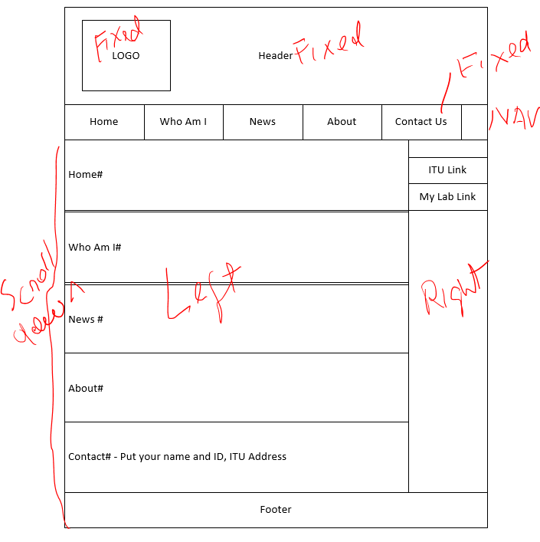

# Contents of Your Page

Home#

Mind and body united equals happy life.

It took me a long time to realize how tense I became when I was not doing something I truly believed in or when I was put in a situation when I had to pretend.

Believe me, without realizing it, we spend most of our time pretending. This is why most of us are stressed.   
  
So I made a decision to make sure my mind and body were in scrunicity. So as I go through my daily business, I am especially sensitive to any tension in my body.   
  
And any time I feel any tension, I remind myself to relax, loosen up and empty my mind. Almost do a mini meditation. Then I come back to whatever I am doing and do it in a way that feels acceptable to me.

Who Am I #

The “Who Am I?” question has **far-reaching changes** than you realize when you first ask it. It also requires some effort to uncover the answer. Once you find out who you are, a powerful force emerges. You want to dig deeper. You want to find out more. You start asking other questions such as:

News #

To empower people and advance global prosperity through inventive, industry-linked Silicon Valley education.

ITU pioneers a modern, industry-focused educational model to deliver education globally. ITU's educational pedagogy cultivates innovative thinking, ethical leadership, and entrepreneurial spirit through practical, industry relevant curriculum that reflects Silicon Valley's culture. ITU closes the employment skills gap and empowers people to lead successful, enriching lives as meaningful contributors to the global community.

The purpose of ITU is to foster excellence in education for students particularly interested in the high-tech entrepreneurial field. All our programs have an applied nature, with an emphasis on specialty areas tailored to the market needs of Silicon Valley companies. Students are actively encouraged to affiliate or intern with relevant local industry firms from the very beginning of their academic studies as an integral part of ITU’s academic pedagogy. As such, the hallmarks of an ITU education include:

About#:

Established in 1994 by Dr. Shu-Park Chan, International Technological University (ITU) provides excellence in education for the future leaders of Silicon Valley corporations, leveraging the best of Silicon Valley’s technology and business models to advance developing economies throughout the world. ITU reflects and enhances Silicon Valley’s unique business culture with six industry-oriented departments that provide high-quality academic and practical training and offer unparalleled educational programs in electrical engineering, digital arts, computer science, computer engineering, software engineering, engineering management, and business administration. ITU degree programs aim to cultivate forward-thinking engineers, engineering managers, and business entrepreneurs and administrators with a deep understanding of professional ethics, intellectual property law, environmental protection, and other contemporary issues. International Technological University is a non-profit, accredited by the Accrediting Commission for Senior Colleges and Universities of the Western Association of Schools and Colleges, 985 Atlantic Avenue, # 100, Alameda, CA 94501, 510-748-9001. ITU is also recognized by the Bureau of Private Postsecondary Education (BPPE).

Footer#:

Posted by: Your Name Here  
Contact information: <a href="mailto:Your email addres@itu.edu"> Your email addres@itu.edu