**Cloud Cluster Simulation Framework Documentation**

(Python Flask & Docker)

**M VENKAT CHARAN**

# System Overview

This system simulates a simplified cloud cluster environment using Docker containers as nodes. It provides the following core functionalities:

- Node Management: Add or remove Docker-based nodes with specified CPU core capacity.  
- Pod Scheduling: Deploy pods with CPU resource requirements using a First-Fit scheduling algorithm.  
- Node Health Monitoring: Detects unreachable nodes via periodic heartbeat checks.  
- Partial Failure Recovery: When nodes are stopped, associated pods are removed.  
- RESTful API Interface: Manage the cluster via API, with a basic web UI for status visualization.

# System Testing

Test Case 1: Add a Node

Description: Add a node to the cluster with specified CPU cores  
Input: cpu_cores = 5 via web form  
Expected Output: Node appears in node list with "running" status  
Command:  
curl -X POST http://127.0.0.1:5005/add_node -F "cpu_cores=2"

Verification:

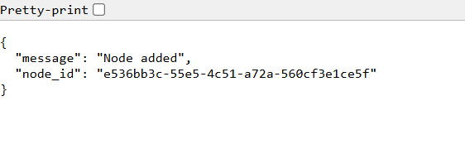-

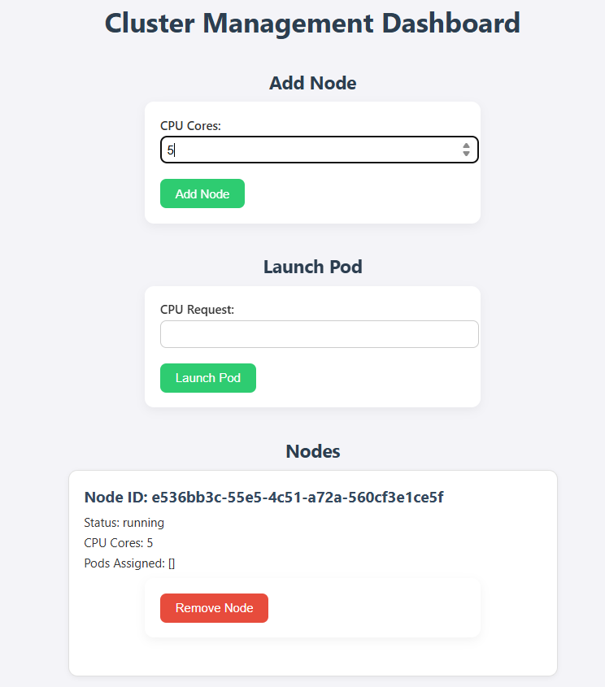

Test Case 2: Launch a Pod

Description: Launch a pod with specific CPU requirement  
Input: cpu_request = 1  
Expected Output: Pod is assigned to a node with sufficient CPU  
Command:  
curl -X POST http://127.0.0.1:5005/launch_pod -F "cpu_request=1"

Verification:  
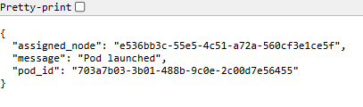

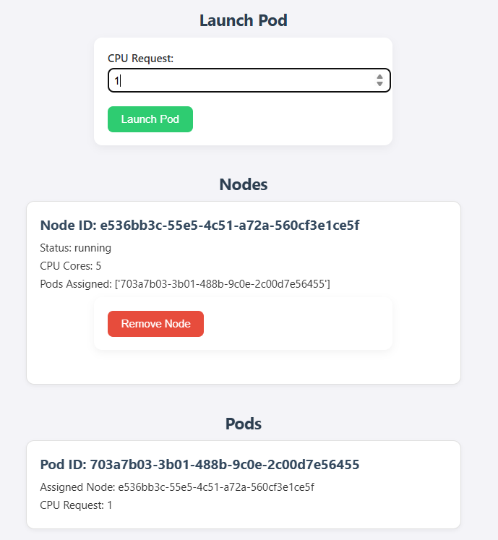

Test Case 3: View Node and Pod Lists in UI

Description: Use Web UI to inspect nodes and pods  
Expected Output: Nodes and pods shown in tables with CPU usage and status  
Access: http://127.0.0.1:5005/  
Verification:

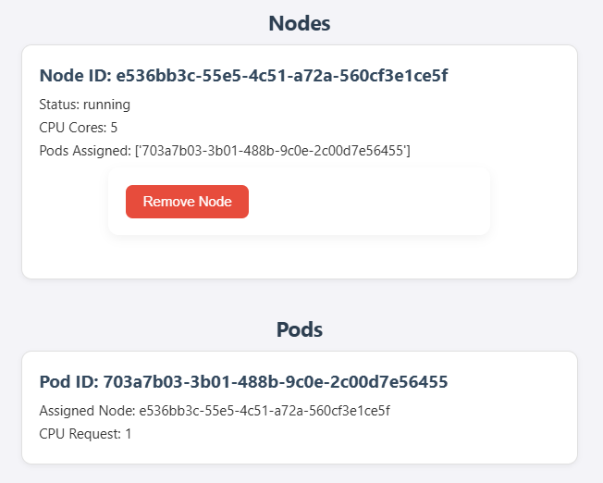

Test Case 4: Stop a Node and Verify Pod Removal

Description: Stop a node and verify its removal and associated pods  
Steps:  
1. Get node_id via UI or list_nodes API  
2. Execute delete command  
Command:  
curl -X DELETE http://127.0.0.1:5005/stop_node/<node_id>  
Expected Output:  
- Node is removed from list  
- Associated pods are removed from pod list  
Verification:

Before Node Removal

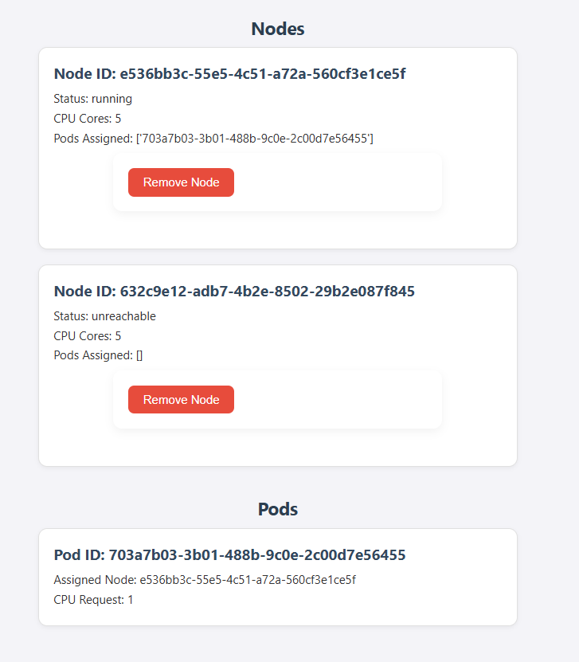

After 10 seconds of Node Removal:-

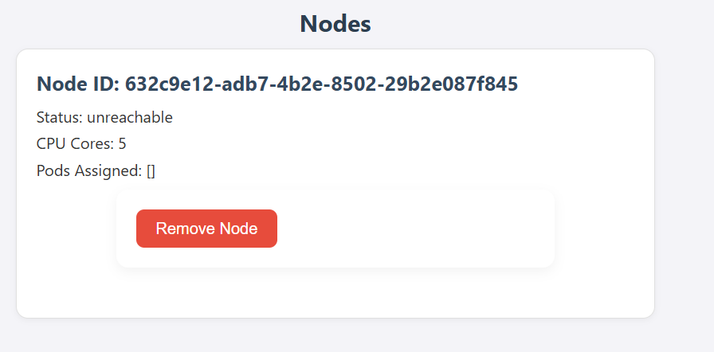

Test Case 5: Health Monitor - Simulate Node Failure

Description: Stop Docker container manually to simulate node failure  
Steps:  
1. Get container_id via `docker ps`  
2. Run: docker stop <container_id>  
3. Wait 10–20 seconds  
Expected Output: Node status changes to "unreachable"  
Verification:

**Before Deletion in Docker Desktop:-**

**Status:-Running**

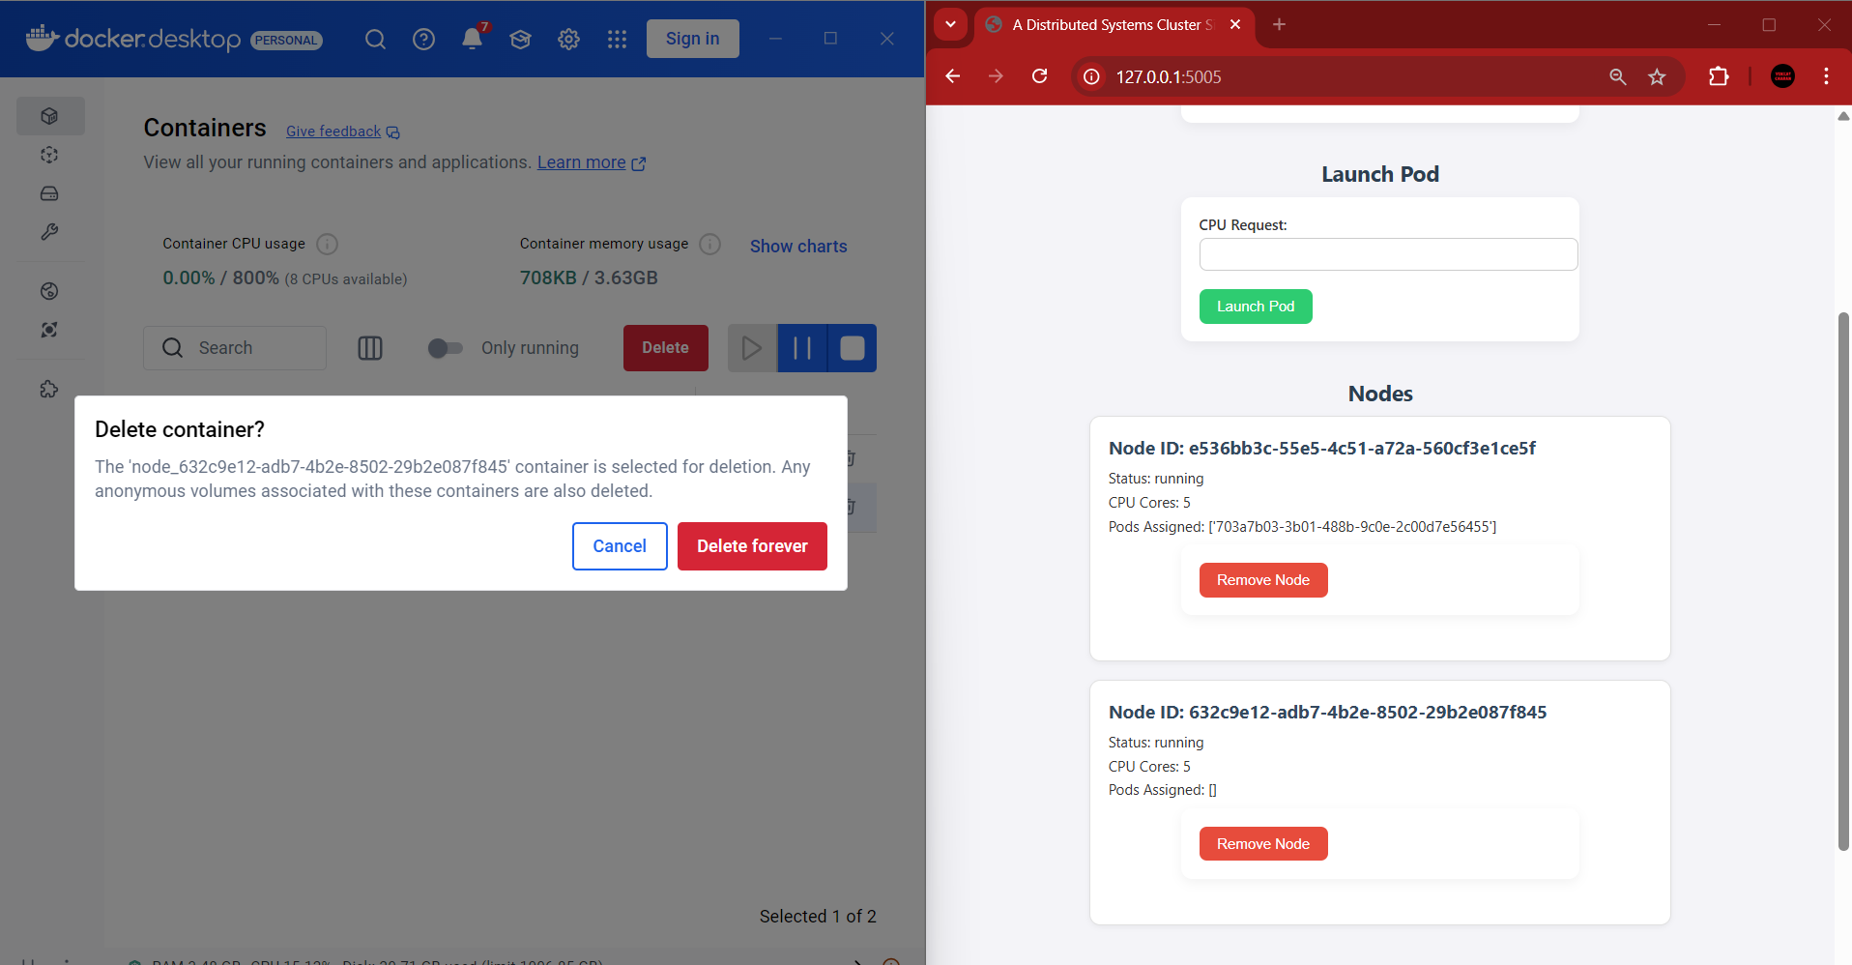

**After Deletion in Docker Desktop:-**

**Status:-Unreachable**

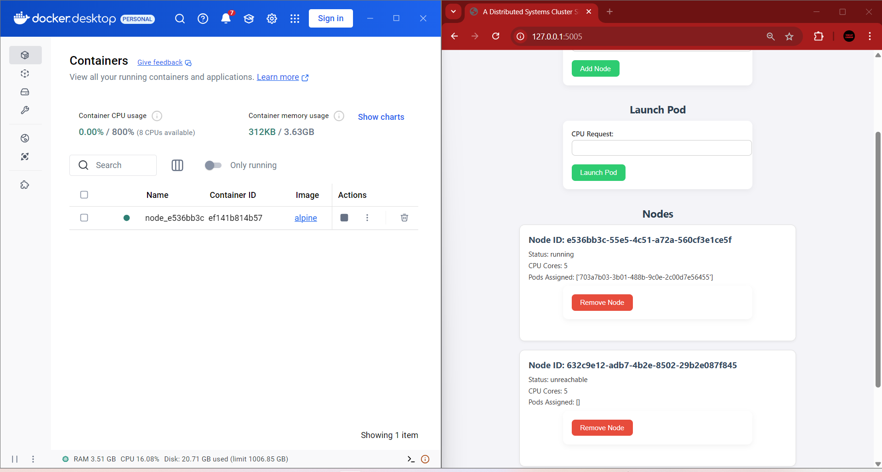

# API Endpoints

/ [GET] - View cluster status and web UI  
/add_node [POST] - Add a node with specified cpu_cores  
/list_nodes [GET] - List all nodes in JSON format  
/stop_node/<node_id> [DELETE] - Stop and remove a node and its pods  
/launch_pod [POST] - Launch a pod with a CPU request  
/pod_status/<pod_id> [GET] - Get the node assignment of a pod

# Architecture Summary

- Nodes: Docker containers with defined CPU cores  
- Pods: Workload requests tracked in memory (not real containers)  
- API Server: Flask app managing the REST API  
- Node Manager: Handles node lifecycle using Docker SDK  
- Pod Scheduler: First-Fit logic in schedule_pod()  
- Heartbeat Monitor: Background thread checking node health

# Assumptions

- Docker must be installed and running  
- Python dependencies: flask, docker  
- Run using `python app.py`  
- Pods are simulated (not actual containers)

# Technology Stack

- Python: Main language  
- Flask: Web framework  
- Docker SDK (Python): Docker control  
- Docker: Used to simulate nodes  
- HTML/CSS: Basic web UI