# Walkthrough

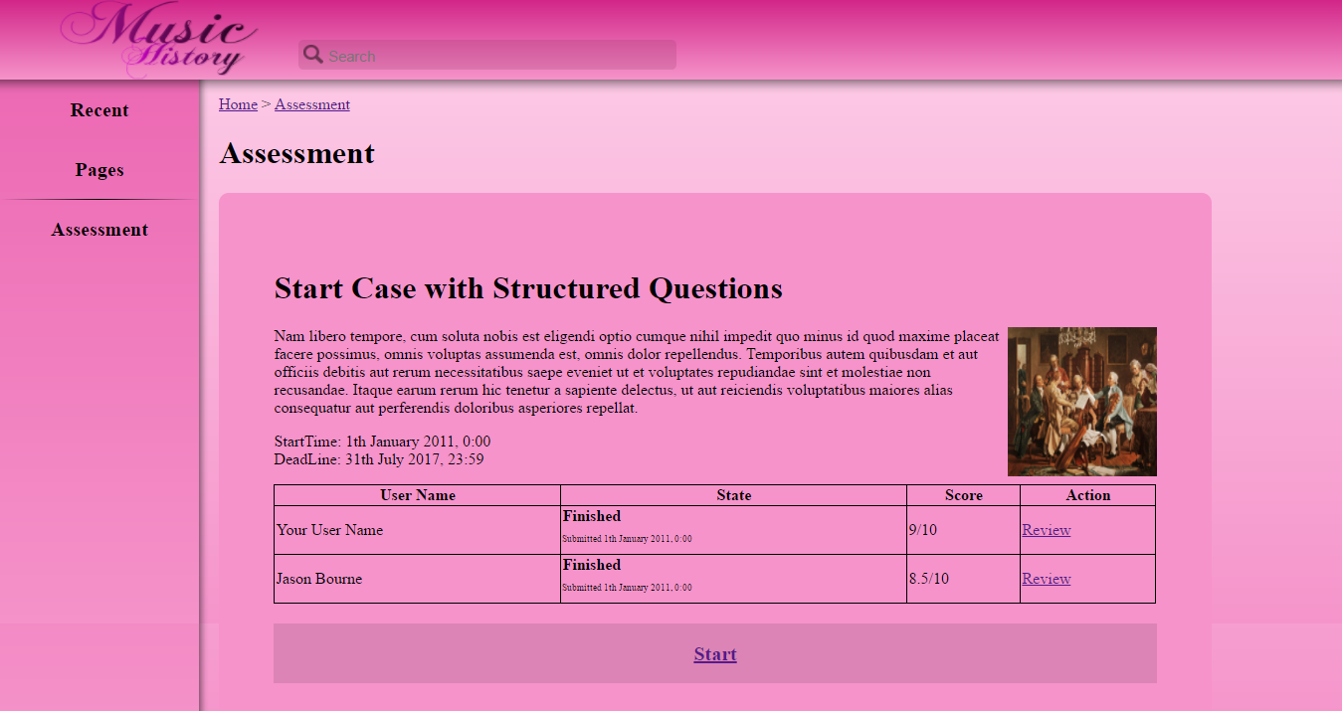

The sub-domain in focus for this prototype is Music History. The problem-based learning activity

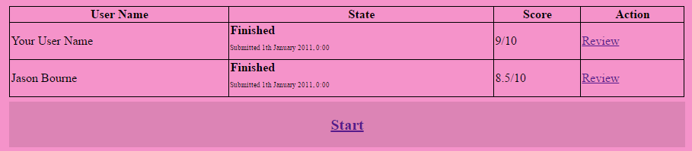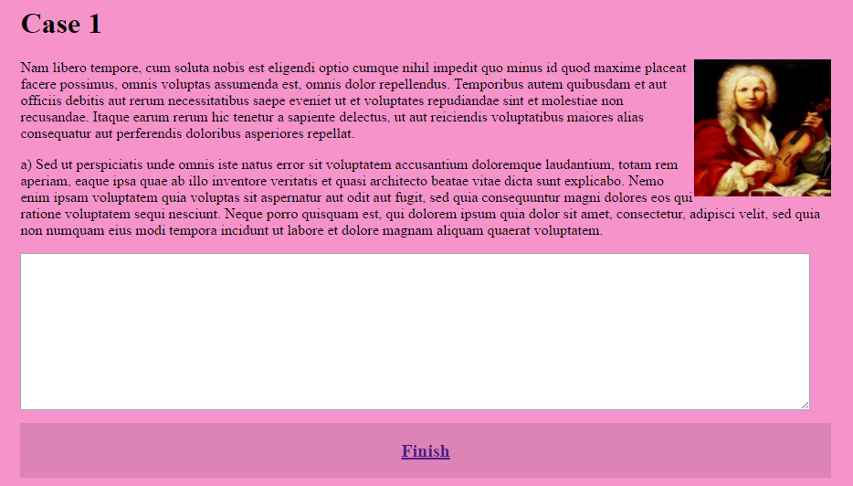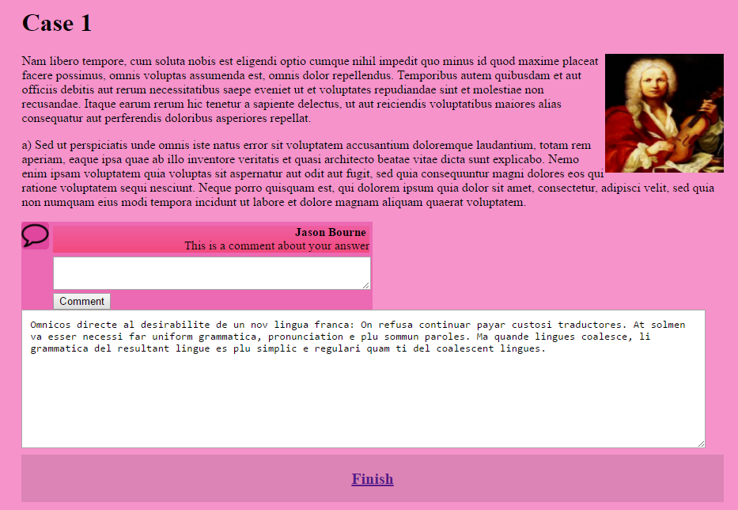

# Colour Scheme

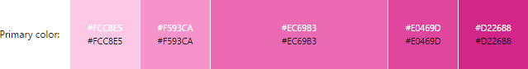

# Border Scheme

# Font Scheme

# Resources

1. Images used
   1. <https://upload.wikimedia.org/wikipedia/commons/0/09/Woody_Guthrie_2.jpg>
   2. <https://upload.wikimedia.org/wikipedia/commons/3/35/Et_selskab_af_danske_kunstnere_i_Rom.jpg>
   3. <https://upload.wikimedia.org/wikipedia/commons/3/3a/HaydnPlaying.jpg>
   4. <https://upload.wikimedia.org/wikipedia/commons/d/d5/Family_Making_Music_c1630s_Jan_Miense_Molenaer.jpg>
   5. <https://upload.wikimedia.org/wikipedia/commons/6/6a/Michelangelo_Caravaggio_020.jpg>
   6. <https://upload.wikimedia.org/wikipedia/commons/e/ee/Christian_and_Muslim_playing_ouds_Catinas_de_Santa_Maria_by_king_Alfonso_X.jpg>
   7. <https://upload.wikimedia.org/wikipedia/commons/9/98/Antonio_Vivaldi_portrait.jpg>
   8. <https://upload.wikimedia.org/wikipedia/commons/6/6a/Johann_Sebastian_Bach.jpg>
   9. <https://upload.wikimedia.org/wikipedia/commons/thumb/2/29/Comment_alt_font_awesome.svg/2000px-Comment_alt_font_awesome.svg.png>
   10. <https://pixabay.com/p-1294834/?no_redirect>
2. Code used
   1. Other references  
      <https://www.w3schools.com/html/default.asp>
   2. For jQuery  
      <http://ajax.googleapis.com/ajax/libs/jquery/1.3/jquery.min.js>
   3. For making tables  
      <https://www.w3schools.com/html/html_tables.asp>
   4. For toggling show/hide comments  
      <https://www.w3schools.com/howto/howto_js_toggle_hide_show.asp>
   5. For sending comments to other users  
      <https://stackoverflow.com/questions/25796300/how-do-i-append-text-from-a-textbox-to-a-div>