# Walkthrough

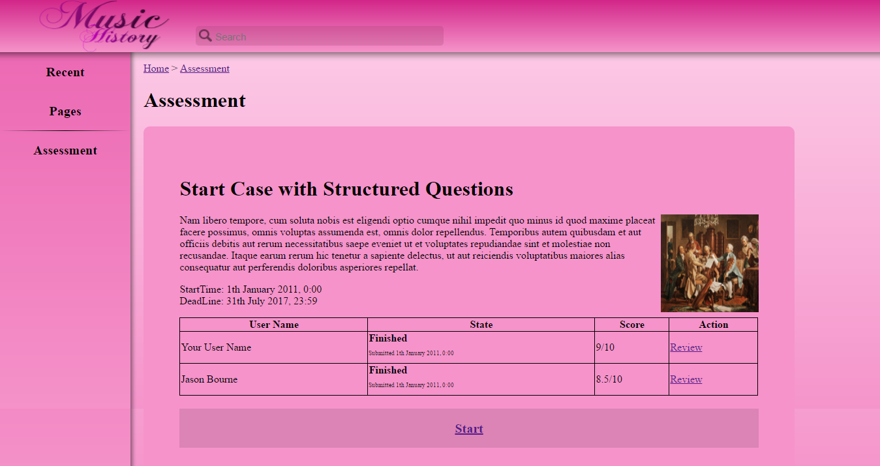

The sub-domain in focus for this prototype is Music History. The problem-based learning activity being supported is Case with structured questions.

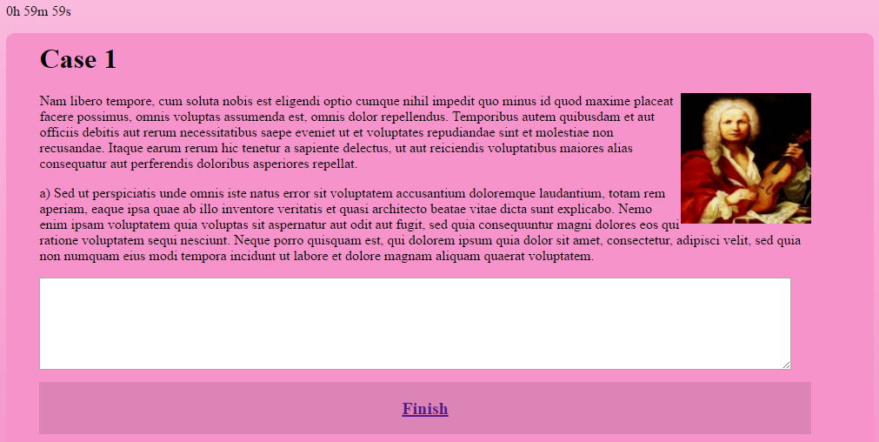

The user starts the assessment by clicking on the “Start” button at the bottom of the screen. The user is presented with a case description, followed by a series of questions below. The user must type the answer in the text area directly below each question and they must finish all the case questions before the time remaining shown at the top of each Case expires.  
Once the user is finished answering all the questions, the user can now proceed to the next case, along its own set of questions, by clicking the “Next” button. After answering the last case, the user clicks the “Finish” button to finish the assessment. The user is now sent to the assessment starting screen where the user can see their results in a table.

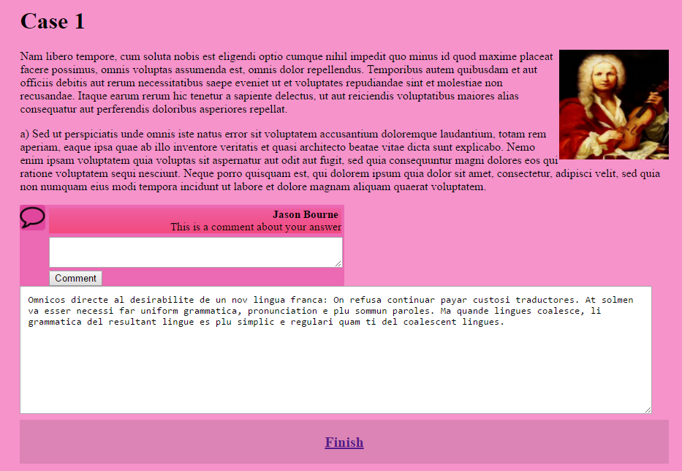

The user can also review their answers after finishing their attempt. They can also review answers provided by the members of their peer group. The user is presented with the case questions along with the answers being reviewed. The user can leave comments in response to each answer and see comments provided by other peers. The comments section can be hidden or shown, toggled by clicking the comment icon in the left side of the screen. The user can review the next case, with the “Next” button until they finish reviewing all the case questions.

## Out of Scope

* Notifications for unseen user comments from peers (including the number of comments) in the left navigation panel
* Clicking a comment should also highlight the section of the answer it is citing.
* A panel in the right-hand sidebar showing a list of all the cases in the current assessment and the case the user is currently answering is highlighted.

## Functionally unimplemented

* The timer, for when the assessment is being attempted, is shown but is only a static text.  
  It should be counting down all the way to 0 seconds where it should then say “EXPIRED”
* The comments should be initially hidden and will only pop-up after the comment icon is clicked.  
  The comment section should also be floating on top of the rest of the screen instead of pushing elements down.

# Colour Scheme

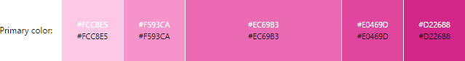

The colours chosen for the design are listed below

* **#FCC8E5 upper background**
* **#F593CA text/article boxes, lower background**
* **#EC69B3 lower branding bar, left navigation panel**
* **#E0469D upper branding bar/ comment sections**
* **#D22688 website logo**

The colours scheme for the website is monochromatic for a harmonious feel to match the sub-domain of interest of the website.

The slight vertical gradient creates slow movement from the top toward the bottom of the screen, where the user’s focus will usually move. The textboxes contrast from the lighter background to dark textboxes pull in the user’s attention closer to the text. The textboxes are not too dark a to make the text hard to read. The branding bar, left navigation panel, and textboxes are similar in colour and hence similar in value so user’s don’t get distracted away from the main content in the text boxes.

# Border Scheme

1)

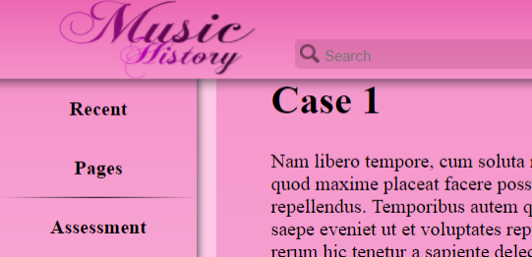

The border between the branding bar and the content below, and between the left navigation panel and the content area to the right, consists of a gradient of black fading in opacity. This creates a shadowing effect which gives the user a sense of height in the webpage. This sense of height helps the user to distinguish between areas of the page so they can find it easier to focus on one section at a time.

2)

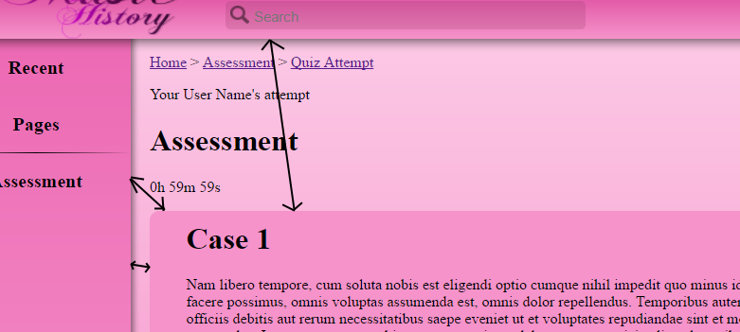

The distance between the text box and the other elements of the page gives grouping among the elements of the content area. This allows the user to sort elements with different aesthetics together but with work a similar goal and apart from other elements with a different function. The elements being grouped together are problem-based learning activity related elements, such as the assessment title, the time remaining, and the case question itself.

3)

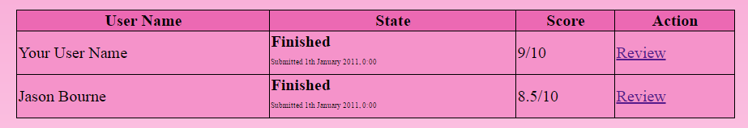

The table has headings with darker colours with lighter coloured cells to make it easier for the user to know what the data in each cell means. The data within the cells are consistent in format so the user can distinguish between different data.

# Font Scheme

|  |  |  |
| --- | --- | --- |
| Font | Styles | Description |
| Times New Roman | Normal | Makes up most of the text in the website. E.g. paragraphs, descriptions, system status, etc. |
| Bold | Titles, links and button names |
| Calibri | Normal | User’s answer to case questions. User comments |
| Bold | User name in the peer comments |

Times New Roman in normal style is used for long descriptions the user needs read to understand the question. The serifs in the font help make the text easier to read thus allowing the user to read the text faster so they spend more time answering the questions than reading. The same also applies for system status and buttons to prevents the user from wasting time for every interaction. The bold style is used for titles to give them more weight form the rest of the text and help the user orient themselves in the system.

Calibri is used for the user’s input in the case questions and comments because the user needs to be able to construct their answer easily, they need to be able to distinguish from other text to be able to focus on it. Therefore, a different font was used which is just as simple and fast to read.

# Resources

1. Images used
   1. <https://upload.wikimedia.org/wikipedia/commons/0/09/Woody_Guthrie_2.jpg>
   2. <https://upload.wikimedia.org/wikipedia/commons/3/35/Et_selskab_af_danske_kunstnere_i_Rom.jpg>
   3. <https://upload.wikimedia.org/wikipedia/commons/3/3a/HaydnPlaying.jpg>
   4. <https://upload.wikimedia.org/wikipedia/commons/d/d5/Family_Making_Music_c1630s_Jan_Miense_Molenaer.jpg>
   5. <https://upload.wikimedia.org/wikipedia/commons/6/6a/Michelangelo_Caravaggio_020.jpg>
   6. <https://upload.wikimedia.org/wikipedia/commons/e/ee/Christian_and_Muslim_playing_ouds_Catinas_de_Santa_Maria_by_king_Alfonso_X.jpg>
   7. <https://upload.wikimedia.org/wikipedia/commons/9/98/Antonio_Vivaldi_portrait.jpg>
   8. <https://upload.wikimedia.org/wikipedia/commons/6/6a/Johann_Sebastian_Bach.jpg>
   9. <https://upload.wikimedia.org/wikipedia/commons/thumb/2/29/Comment_alt_font_awesome.svg/2000px-Comment_alt_font_awesome.svg.png>
   10. <https://pixabay.com/p-1294834/?no_redirect>
2. Code used
   1. Other references  
      <https://www.w3schools.com/html/default.asp>
   2. For jQuery  
      <http://ajax.googleapis.com/ajax/libs/jquery/1.3/jquery.min.js>
   3. For making tables  
      <https://www.w3schools.com/html/html_tables.asp>
   4. For toggling show/hide comments  
      <https://www.w3schools.com/howto/howto_js_toggle_hide_show.asp>
   5. For sending comments to other users  
      <https://stackoverflow.com/questions/25796300/how-do-i-append-text-from-a-textbox-to-a-div>