Real Time Graphics Lab B.

# Week 2 – Lab B

## Exercise 1.

Modify the vertex list of the cube to draw a hexagonal cylinder..

### Solution:

To create the vertex and indices of a cylinder

const auto radius = 1.0f;

const auto pi = 3.14;

SimpleVertex vertices[] =

{

{ XMFLOAT3(0.0f, 1.0f, 0.0f), XMFLOAT4(0.0f, 0.0f, 1.0f, 1.0f) },

{ XMFLOAT3(radius*XMScalarCos(XM_PI/3), 1.0f, radius*XMScalarSin(3.14/3)), XMFLOAT4(0.0f, 1.0f, 0.0f, 1.0f) },

{ XMFLOAT3(radius * XMScalarCos(XM_PI *2 / 3), 1.0f, radius * XMScalarSin(XM_PI*2 / 3)), XMFLOAT4(0.0f, 1.0f, 1.0f, 1.0f) },

{ XMFLOAT3(radius * XMScalarCos(XM_PI *3/ 3), 1.0f, radius * XMScalarSin(XM_PI *3 / 3)), XMFLOAT4(1.0f, 0.0f, 0.0f, 1.0f) },

{ XMFLOAT3(radius * XMScalarCos(XM_PI *4/ 3), 1.0f, radius * XMScalarSin(XM_PI *4 / 3)), XMFLOAT4(1.0f, 0.0f, 1.0f, 1.0f) },

{ XMFLOAT3(radius * XMScalarCos(XM_PI *5/ 3), 1.0f, radius * XMScalarSin(XM_PI *5 / 3)), XMFLOAT4(1.0f, 1.0f, 0.0f, 1.0f) },

{ XMFLOAT3(radius * XMScalarCos(XM_PI *6/ 3), 1.0f, radius * XMScalarSin(XM_PI *6 / 3)), XMFLOAT4(1.0f, 1.0f, 1.0f, 1.0f) },

{ XMFLOAT3(0.0f, -1.0f, 0.0f), XMFLOAT4(0.0f, 0.0f, 1.0f, 1.0f) },

{ XMFLOAT3(radius * XMScalarCos(XM_PI / 3), -1.0f, radius * XMScalarSin(3.14 / 3)), XMFLOAT4(0.0f, 1.0f, 0.0f, 1.0f) },

{ XMFLOAT3(radius * XMScalarCos(XM_PI * 2 / 3), -1.0f, radius * XMScalarSin(XM_PI * 2 / 3)), XMFLOAT4(0.0f, 1.0f, 1.0f, 1.0f) },

{ XMFLOAT3(radius * XMScalarCos(XM_PI * 3 / 3), -1.0f, radius * XMScalarSin(XM_PI * 3 / 3)), XMFLOAT4(1.0f, 0.0f, 0.0f, 1.0f) },

{ XMFLOAT3(radius * XMScalarCos(XM_PI * 4 / 3), -1.0f, radius * XMScalarSin(XM_PI * 4 / 3)), XMFLOAT4(1.0f, 0.0f, 1.0f, 1.0f) },

{ XMFLOAT3(radius * XMScalarCos(XM_PI * 5 / 3), -1.0f, radius * XMScalarSin(XM_PI * 5 / 3)), XMFLOAT4(1.0f, 1.0f, 0.0f, 1.0f) },

{ XMFLOAT3(radius * XMScalarCos(XM_PI * 6 / 3), -1.0f, radius * XMScalarSin(XM_PI * 6 / 3)), XMFLOAT4(1.0f, 1.0f, 1.0f, 1.0f) },

Sample Output:

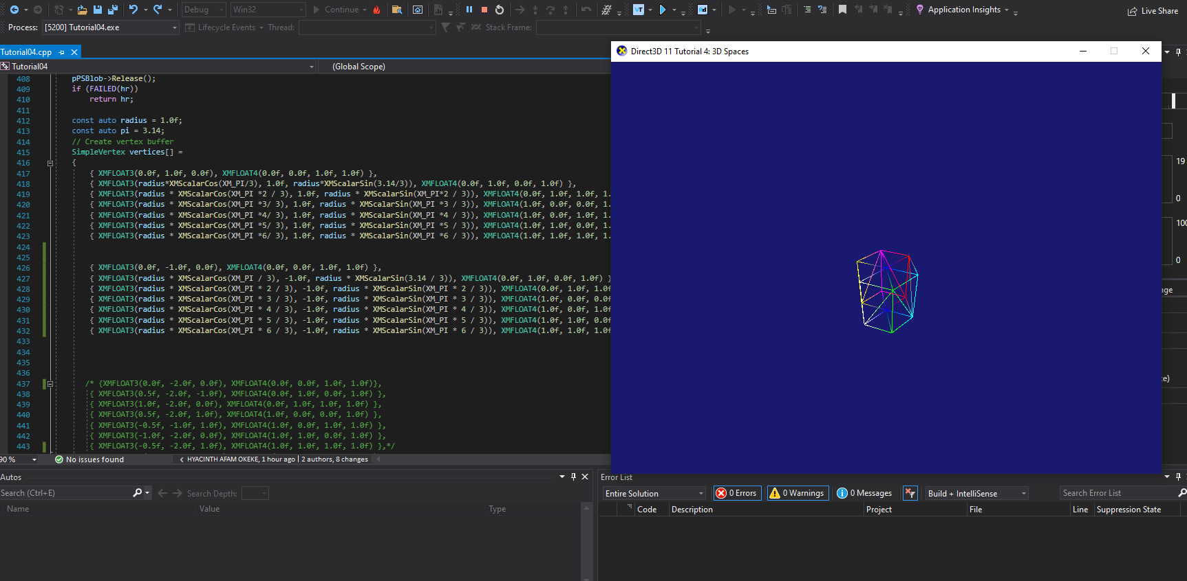

### Test data:

N/A

### Reflection:

### Metadata:

N/A

### Further information:

N/A

**Exercise 2:**

Modify the cube vertex list in the sample to specify a flat 3D grid and display it as a wireframe.

Solution:

const int m = 7;

const int n = 8;

float w = -1.0f;

float d = 1.0f;

float halfWidth = 0.5f * w;

float halfDepth = -1.5f * d;

float dx = w / (n - 1);

float dz = d / (m - 1);

constexpr auto nVertices = m * n;

constexpr auto nStrips = (m - 1) * (n - 1) * 2;

SimpleVertex gridVertices[100] = {};

for (int i = 0; i < m; ++i) {

float z = halfDepth - i * dz;

for (int j = 0; j < n; ++j) {

float x = -halfWidth + j * dx;

gridVertices[i * n + j].Pos = XMFLOAT3(x, 0.0f, z);

gridVertices[i * n + j].Color = XMFLOAT4(1.0f, 1.0f, 1.0f, 0.0f);

}

};

WORD gridIndices[nStrips * 3] = {};

int k = 0;

for (int i = 0; i < m - 1; ++i) {

for (int j = 0; j < n - 1; ++j) {

gridIndices[k] = i * n + j;

gridIndices[k + 1] = i * n + (j + 1);

gridIndices[k + 2] = (i + 1) * n + j;

gridIndices[k + 3] = (i + 1) * n + j;

gridIndices[k + 4] = i * n + (j + 1);

gridIndices[k + 5] = (i + 1) * n + (j + 1);

k += 6;

}

};

Sample Output:

