Real Time Graphics Lab B.

# Week 2 – Lab B

## Exercise 1.

Modify the vertex list of the cube to draw a hexagonal cylinder..

### Solution:

To create the vertex and indices of a cylinder

const auto radius = 1.0f;

const auto pi = 3.14;

SimpleVertex vertices[] =

{

{ XMFLOAT3(0.0f, 1.0f, 0.0f), XMFLOAT4(0.0f, 0.0f, 1.0f, 1.0f) },

{ XMFLOAT3(radius*XMScalarCos(XM_PI/3), 1.0f, radius*XMScalarSin(3.14/3)), XMFLOAT4(0.0f, 1.0f, 0.0f, 1.0f) },

{ XMFLOAT3(radius * XMScalarCos(XM_PI *2 / 3), 1.0f, radius * XMScalarSin(XM_PI*2 / 3)), XMFLOAT4(0.0f, 1.0f, 1.0f, 1.0f) },

{ XMFLOAT3(radius * XMScalarCos(XM_PI *3/ 3), 1.0f, radius * XMScalarSin(XM_PI *3 / 3)), XMFLOAT4(1.0f, 0.0f, 0.0f, 1.0f) },

{ XMFLOAT3(radius * XMScalarCos(XM_PI *4/ 3), 1.0f, radius * XMScalarSin(XM_PI *4 / 3)), XMFLOAT4(1.0f, 0.0f, 1.0f, 1.0f) },

{ XMFLOAT3(radius * XMScalarCos(XM_PI *5/ 3), 1.0f, radius * XMScalarSin(XM_PI *5 / 3)), XMFLOAT4(1.0f, 1.0f, 0.0f, 1.0f) },

{ XMFLOAT3(radius * XMScalarCos(XM_PI *6/ 3), 1.0f, radius * XMScalarSin(XM_PI *6 / 3)), XMFLOAT4(1.0f, 1.0f, 1.0f, 1.0f) },

{ XMFLOAT3(0.0f, -1.0f, 0.0f), XMFLOAT4(0.0f, 0.0f, 1.0f, 1.0f) },

{ XMFLOAT3(radius * XMScalarCos(XM_PI / 3), -1.0f, radius * XMScalarSin(3.14 / 3)), XMFLOAT4(0.0f, 1.0f, 0.0f, 1.0f) },

{ XMFLOAT3(radius * XMScalarCos(XM_PI * 2 / 3), -1.0f, radius * XMScalarSin(XM_PI * 2 / 3)), XMFLOAT4(0.0f, 1.0f, 1.0f, 1.0f) },

{ XMFLOAT3(radius * XMScalarCos(XM_PI * 3 / 3), -1.0f, radius * XMScalarSin(XM_PI * 3 / 3)), XMFLOAT4(1.0f, 0.0f, 0.0f, 1.0f) },

{ XMFLOAT3(radius * XMScalarCos(XM_PI * 4 / 3), -1.0f, radius * XMScalarSin(XM_PI * 4 / 3)), XMFLOAT4(1.0f, 0.0f, 1.0f, 1.0f) },

{ XMFLOAT3(radius * XMScalarCos(XM_PI * 5 / 3), -1.0f, radius * XMScalarSin(XM_PI * 5 / 3)), XMFLOAT4(1.0f, 1.0f, 0.0f, 1.0f) },

{ XMFLOAT3(radius * XMScalarCos(XM_PI * 6 / 3), -1.0f, radius * XMScalarSin(XM_PI * 6 / 3)), XMFLOAT4(1.0f, 1.0f, 1.0f, 1.0f) },

Sample Output:

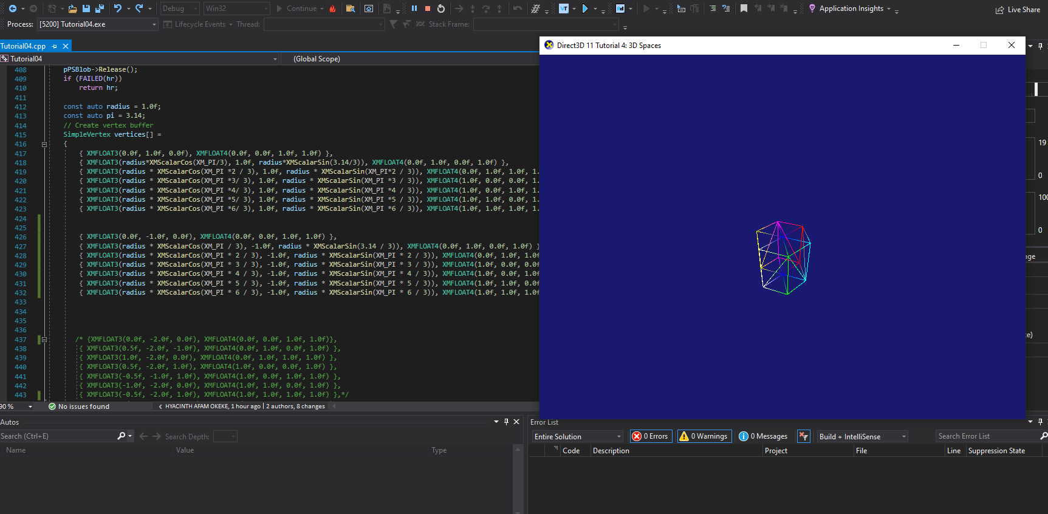

### Test data:

N/A

### Reflection:

### Metadata:

N/A

### Further information:

N/A

**Exercise 2:**

Modify the cube vertex list in the sample to specify a flat 3D grid and display it as a wireframe.