Real Time Graphics Lab D.

# Week 4 – Lab D

### Exercise 1. Create your own vertex shaders

### Sample Output:

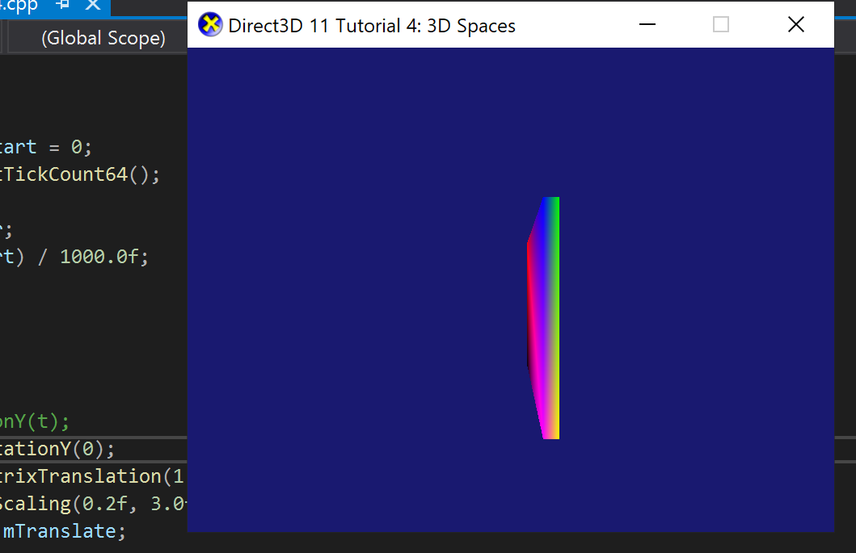

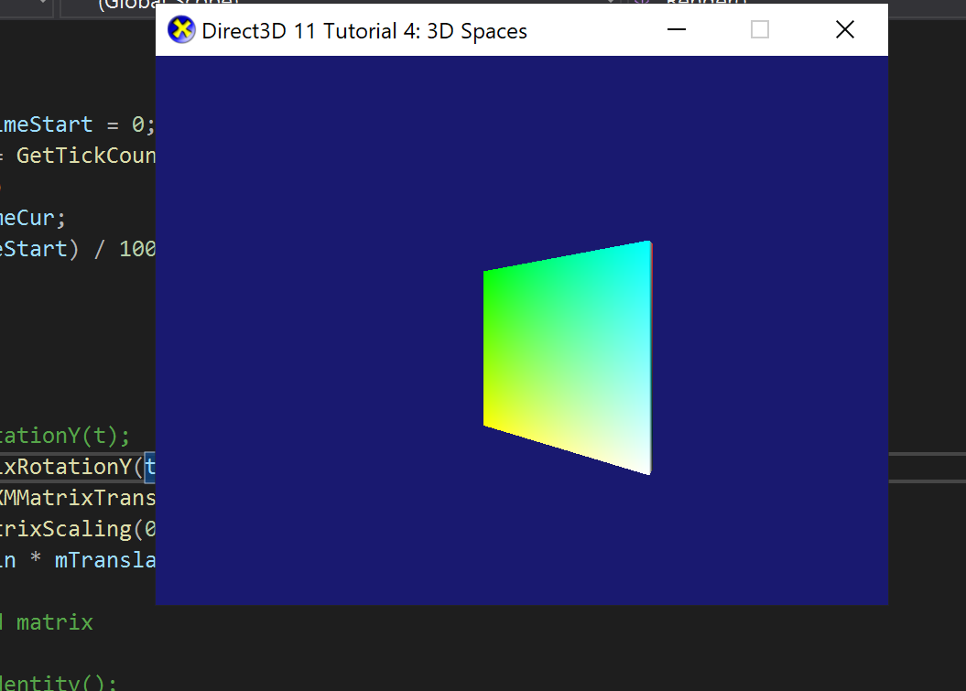

Test Data:

N/A

Solution:

### 

### 

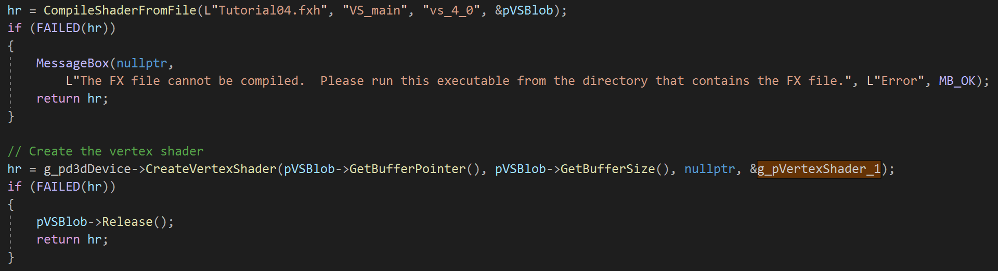



### Reflection:

This exercise was quite straight forward assuming I understood the task, after doing all that was stated in the exercise the resulting output is shown above.

Meta data:

Vertex Shader

Further Information:

Exercise 2. Create your own pixel shaders

Solution:

Test Data:

Sample Output:

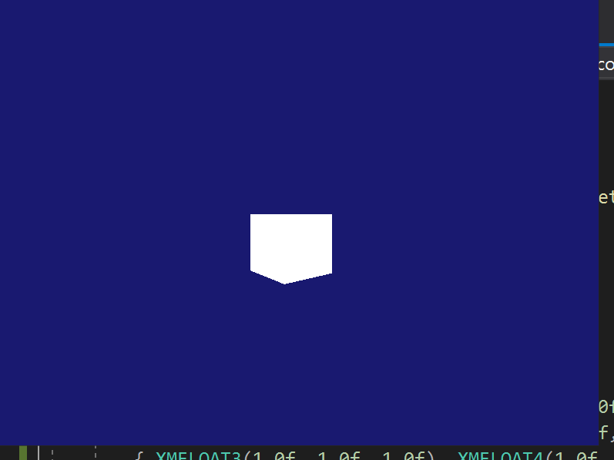

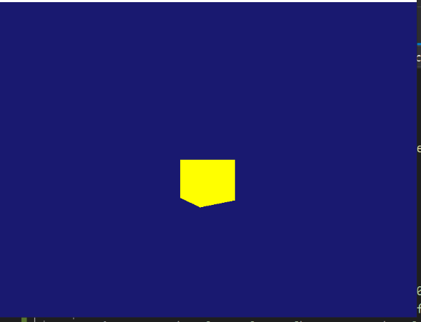

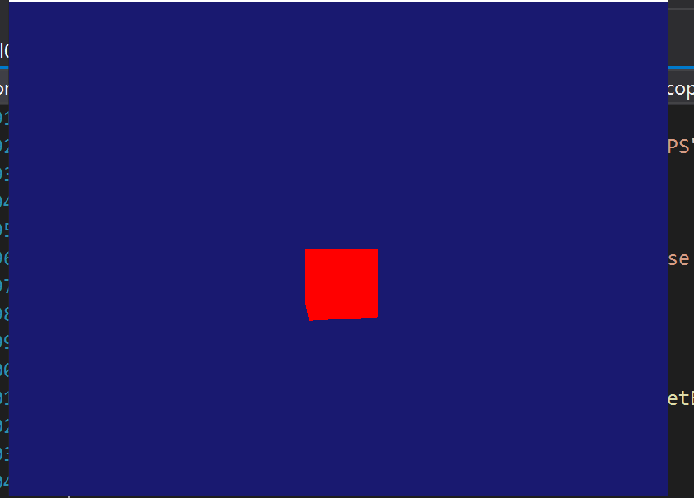

### Reflection:

This was a bit tricky and confusing, I tried using the vertex shader to produce cubes of different colours but could not, I did it the other way around and saw results. I hope I did the right thing.

Meta data:

Pixel Shader

Further Information:

Exercise 3. Cornell box in vertex shaders

Sample Output:

Test Data:

Sample Output:

### Reflection:

Meta data:

Cornell

Further Information:

Exercise 4. Define Model-View-Projection in vertex shader (optional)

Exercise 5. Vertex shader point cloud (Optional)ers

Exercise 6. Per-vertex diffuse lighting

Solution:

Test Data:

Sample Output:

### Reflection:

I was able to get the code but could not see the output, I guess somethings are mixed up and I cannot seem to know how to fix this..

Meta data:

Diffuse Lightning

Further Information:

Exercise 7. Per-pixel diffuse lighting

Solution:

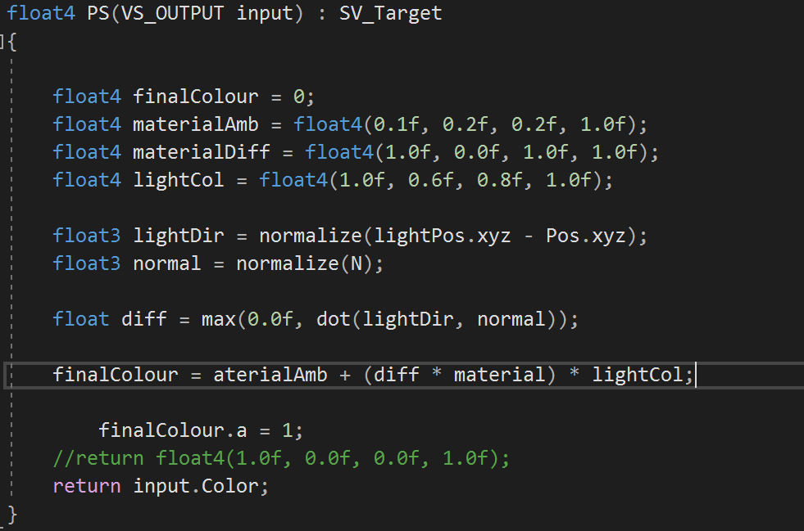

Test Data:

Sample Output:

### Reflection:

My code is not working after several hours of debugging, attached is the error response from the compiler.



Meta data:

Diffuse Lighting

Further Information:

Exercise 8. Per-pixel specular lighting

Sample Output:

Test Data:

Sample Output:

### Reflection:

Meta data:

Further Information:

Exercise 9. Multiple materials and light sources

Sample Output:

Test Data:

Sample Output:

### Reflection:

Meta data:

Further Information: