Real Time Graphics Lab 5.

# Week 5 – Lab E

Exercise 1. A wooden cube, wrap your cube in a wooden texture.

### Solution:

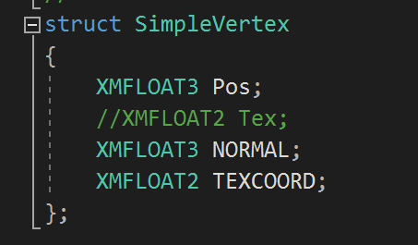

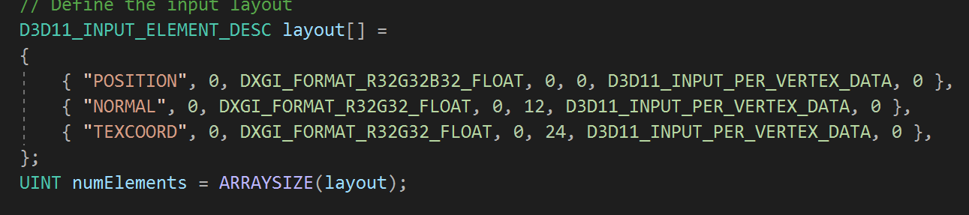

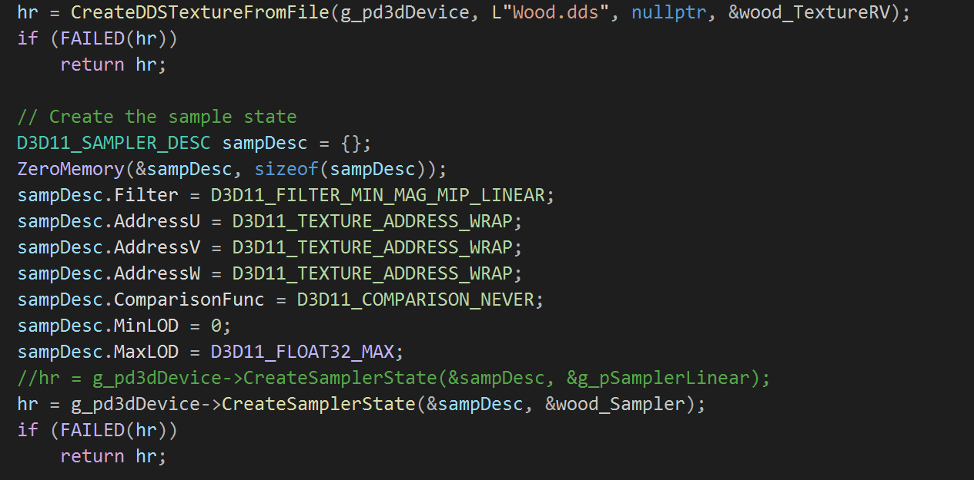

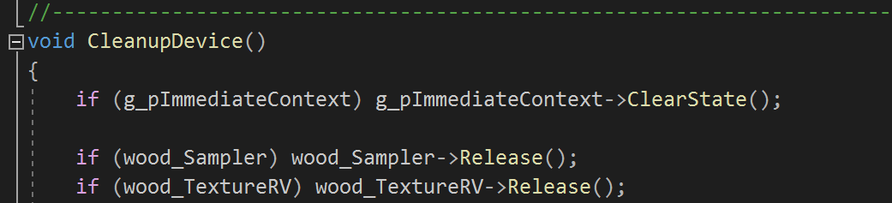



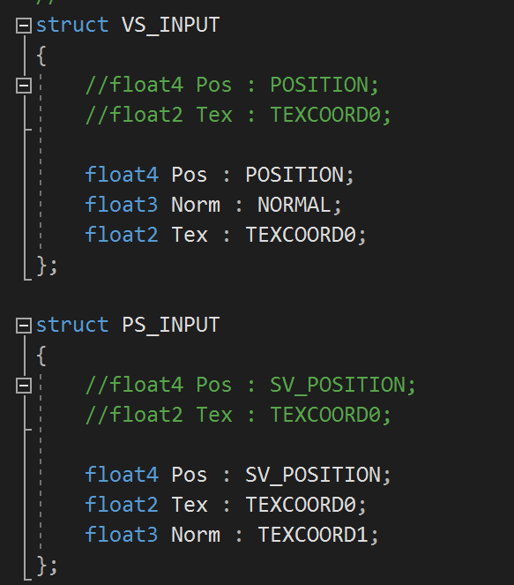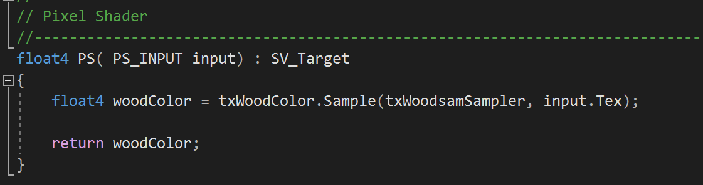

Sample Output:

### Reflection:

After several attempts I was able to wrap my cube with the wooden texture, this was fun todo.

**Metadata:**

**Wooden Texture**

**Exercise 2:** Texture wrapping mode

Create a texture-mapped cube using the coin texture “Coin.dds”, such that different faces of the   
cube has different number of coin patterns;

Solution:



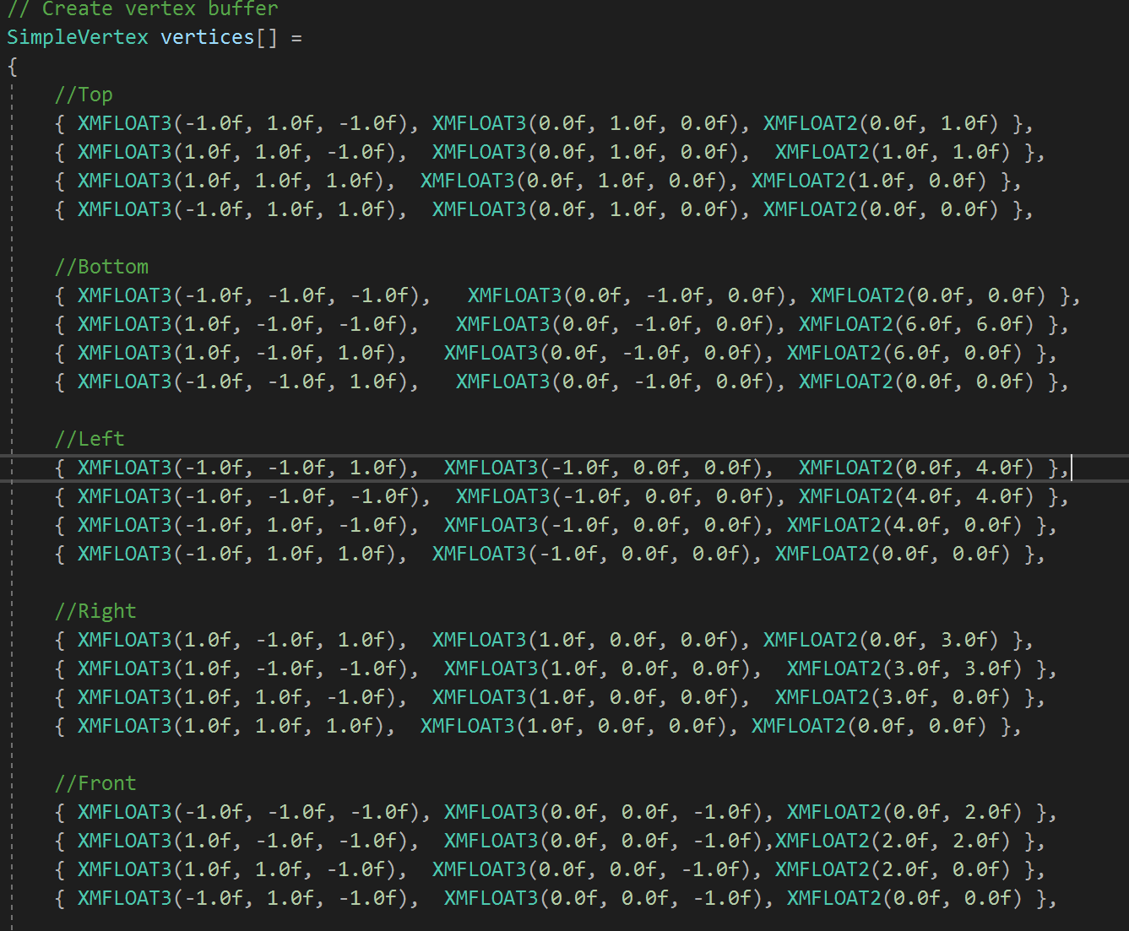

Sample Output :

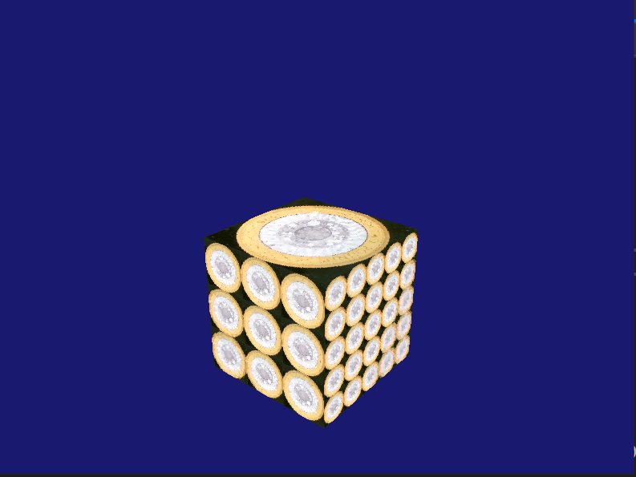

Reflection:

Metadata :

Coin Texture

Exercise 3. Mipmapping   
Create mipmaps of a loaded texture and use HLSL sampleLevel( ) to map the cube with different   
level of mipmaps.

*Solution:*

*Test data:*

*Sample output:*

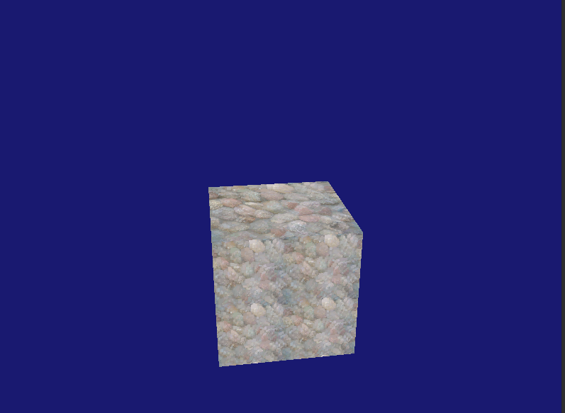

*Reflection:*

*Metadata:*

*Further information:*

Exercise 4. Texture filtering techniques.   
Scale the cube along the view direction to create a long rectangular object. Using different filtering   
techniques to deal with the minification and magnification issues on texture mapping and observe   
how visual quality of the rendered image is being changed.

*Solution:*

*Test data:*

*Sample output:*

*Reflection:*

*Metadata:*

*Further information:*

Exercise 5. Multiple texturing   
Use a coin texture and a tile texture to create the following effect.

*Solution:*

*Test data:*

*Sample output:*

*Reflection:*

*Metadata:*

*Further information:*

Exercise 5a. An open box   
Create the following open box effects using the wood.dds and rock.dds textures.