Assignment E Lab Book

# Week 5 – Lab E

## Q1. Basic Vectors

1. Why are some methods in-lined and others not?

Frequently called functions are in-lined this helps to save, while does not frequently called does not necessarily need to be in-lined.

Solution:

### Add the following new methods:

-Vector product (i.e. cross product)

Solution:

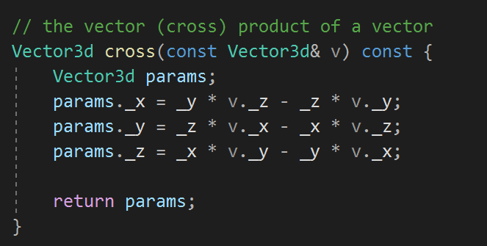

-Scalar product (dot product)



Add new methods which overload the following binary operators:

* + vector addition
* - vector subtraction
* * scalar product
* ^ vector product
* += vector addition
* -= vector subtraction
* << stream out
* >> stream in
* - vector inversion (reverse the vector)

Solutions :

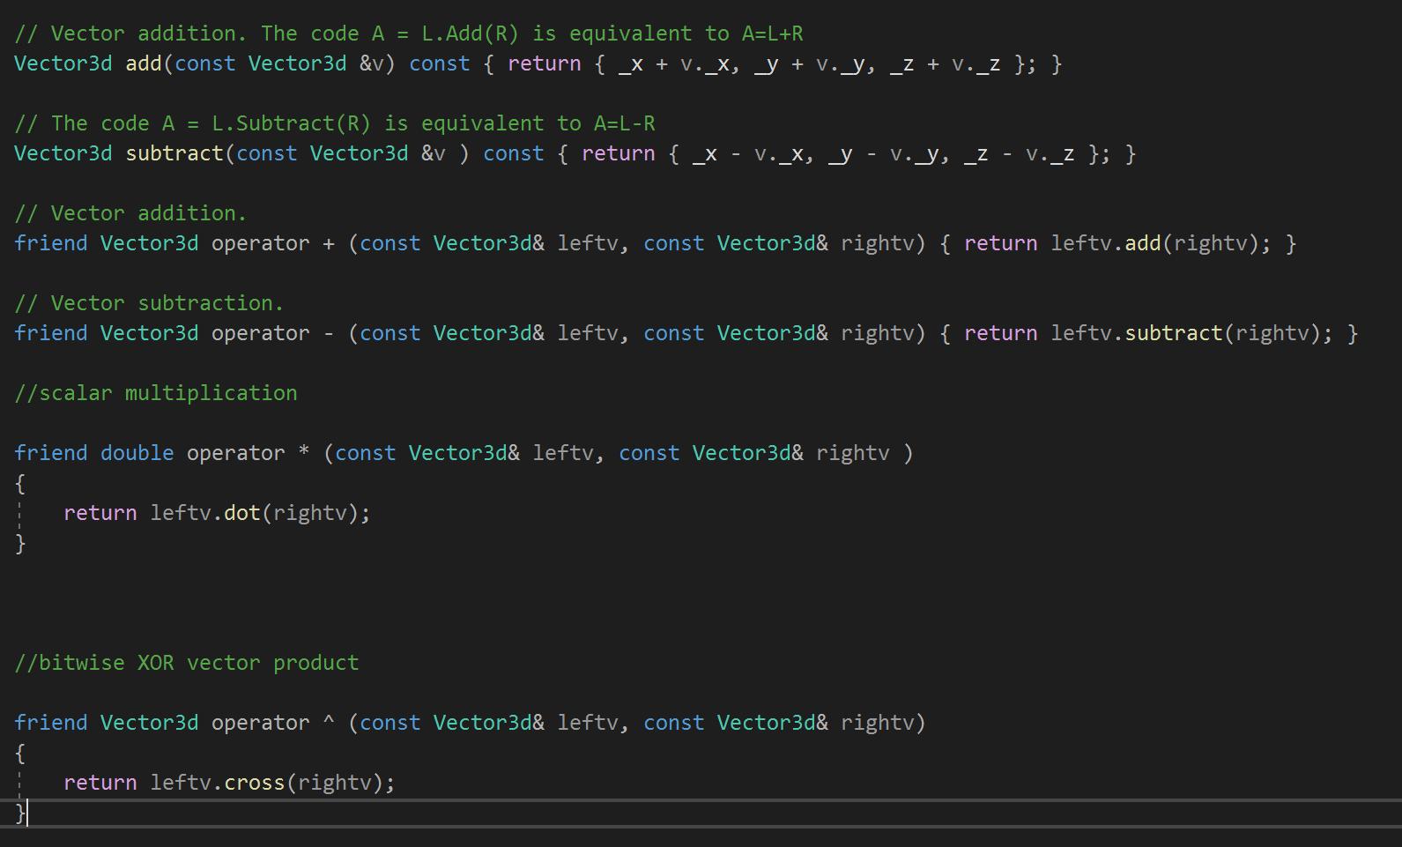

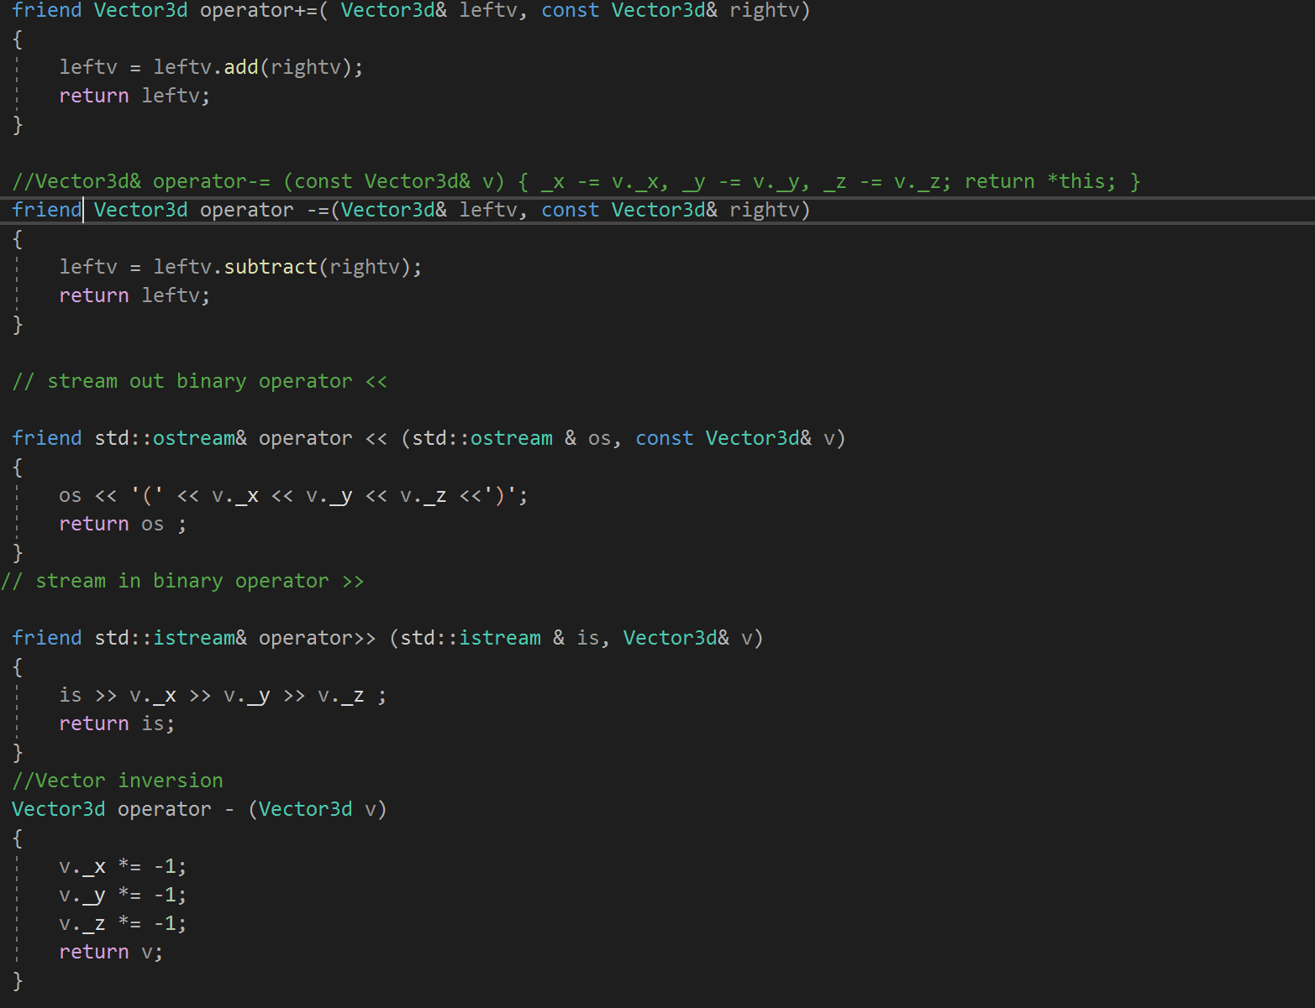

### Sample Output :

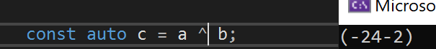



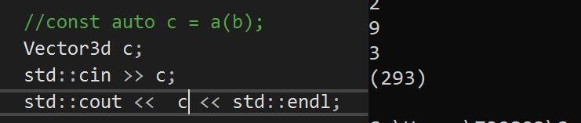



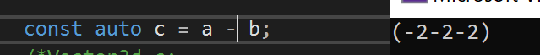



### Test data:

### 1,2,3

### **Reflection:**

### This was am interesting one, because it was quite fun to do but i got stuck at the += operators.

### Metadata:

N/A

### Further information:

N/A

## Q2. Commutativity

Implement both a standard method and overload the * operator to multiply a vector by a single double. Also implement the multiplication of a single double by a vector.

Solution (a):

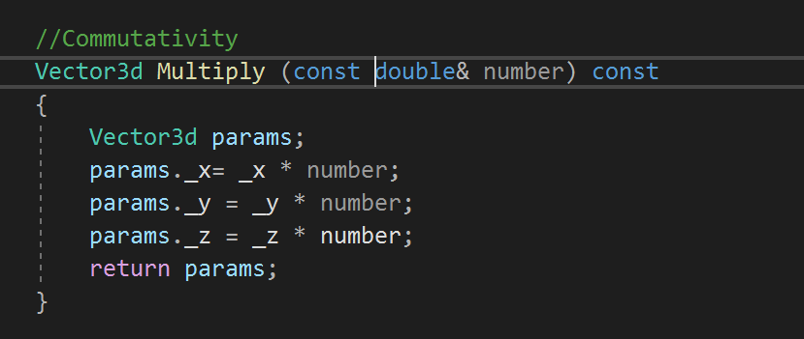

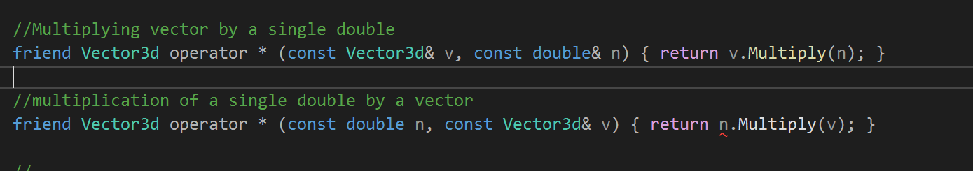

Sample Output



Test Data:

N/A

Reflections:

Multiplying a vector by a single a single double was well understood, while multiplying

## Q3. Matrices

Perform the following matrix operations:

* Addition
* Subtraction
* Multiplication
* Streaming in and out
* Inverse
* Transpose

Solution:

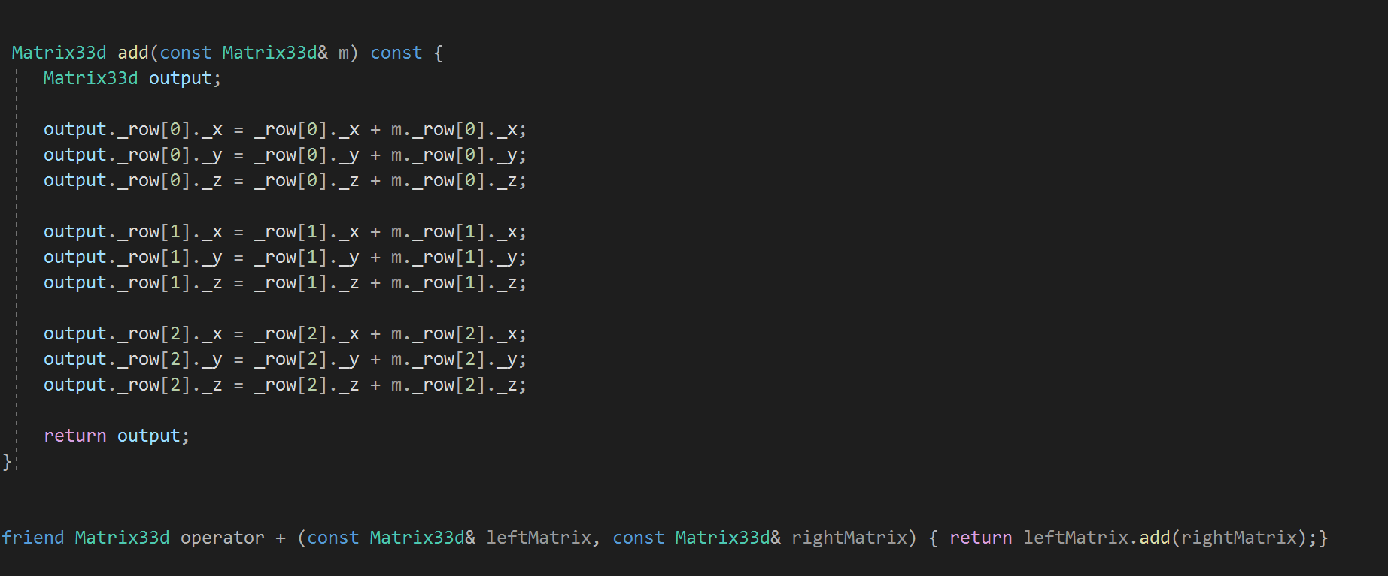

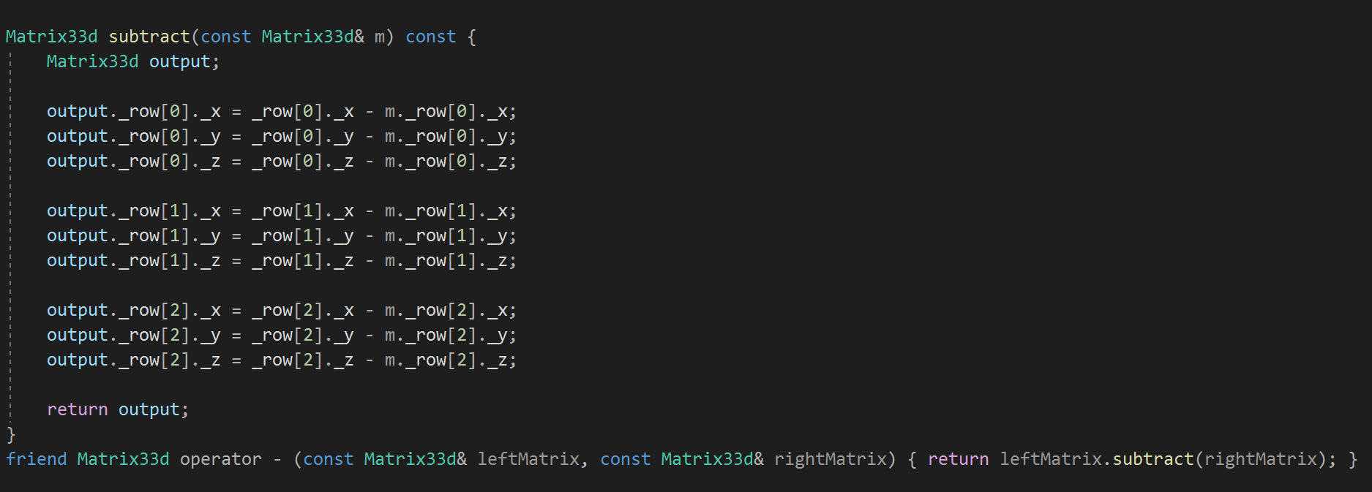

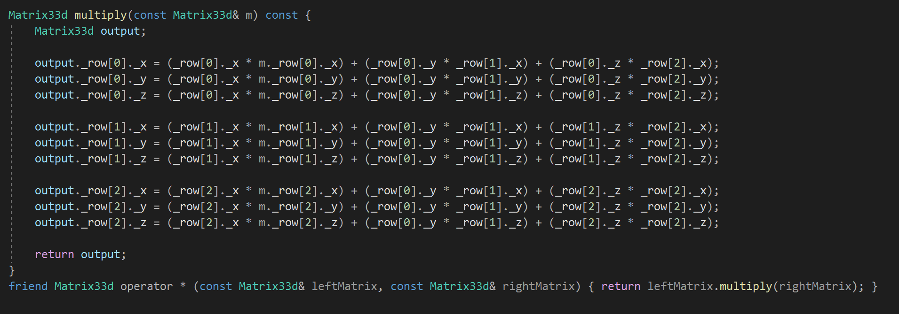

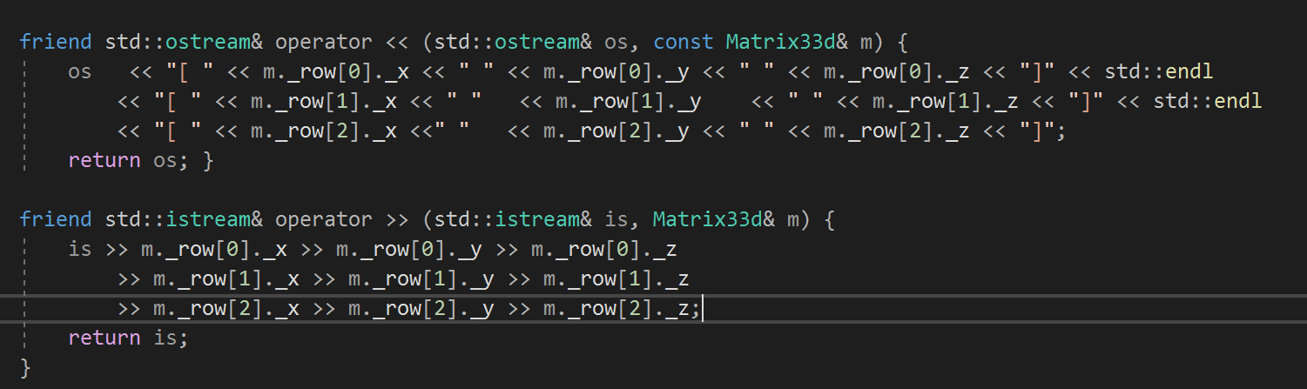

Test data:

Sample output:

Reflection:

Metadata:

Further information:

## Q4. Vector and Matrix Multiplication

## Expand your Matrix33d class to be able to multiple a Vector3d object by a Matrix33d object.

**Sample Output :**

**Test Data:**

Reflections:

## Q5. Internal data structures

.