Assignment F Lab Book

# Week 6 – Lab F

## Question 1. Big strings

Expand this class to contain at least the following functionality:

* Constructors
* Destructor
* Assignment operator
* Stream in and out
* Index operator

Solution

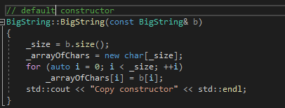

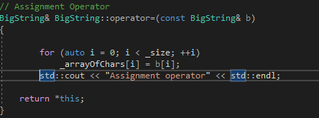

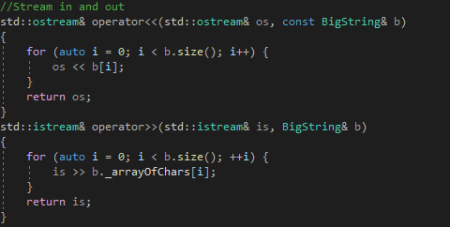

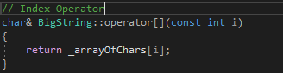

### Sample Output :



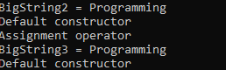

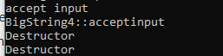

### Test data:

### **Reflection:**

### This was a bit straight forward mostly using destructors.

### Metadata:

Gang of Three

### Further information:

N/A

## Question 2. Test harness

Include at least the following tests:

1. Pass BigString to a function, by value
2. Pass BigString to a function, by reference
3. Return BigString from a function, by value
4. Return BigString from a function, by reference
5. Assign one BigString object to another

Solution

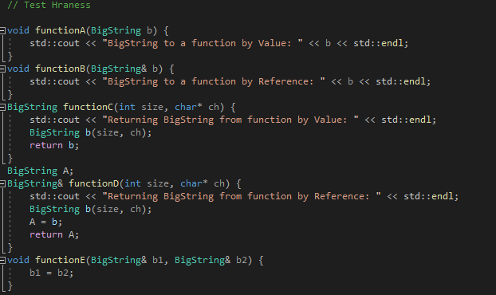

### Sample Output :

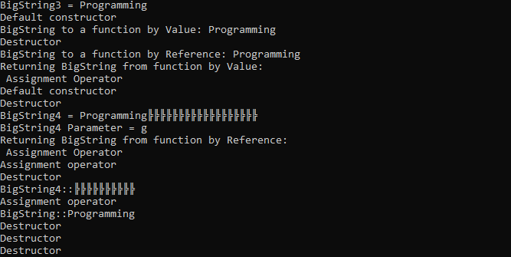

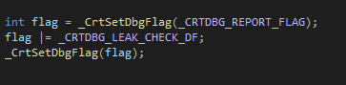

### Test data:

### **Reflection:**

### I am not sure I understood the memory leaks properly. Detecting memory leaks from my piece of is not so clear to me at the moment.

### Metadata:

Harness Testing

### Further information:

N/A

## Question 3. Optimisation