MIDTERM COMPUTATION REVIEWER

CS 402
  - Modelling and Simulation
  - Linear Models, Non-Linear Models, and Simulation Math
A clear, worked reviewer based on the computations shown in the Midterm Week 01 and Week 02-03 slides.
What this reviewer covers
1. Constant-speed distance and the meaning of a linear model
2. Using y = mx + b, finding slope, and solving for an unknown
3. First differences, changing rates, and D(x) = x^2
4. Unity computations: unit conversion, clamping, and smooth following
5. Practice problems with a complete answer key

Study tip: Cover each solution, solve the problem yourself, then compare every substitution and unit.

START HERE

Quick Formula Sheet
distance = speed x time
Use when the object starts at position 0.

y = mx + b
Output = rate x input + initial value.

m = (y2 - y1) / (x2 - x1)
Slope is the change in output divided by the change in input.

D(x) = x^2 = x times x
The output is the input multiplied by itself.

speed in m/s = speed in km/h / 3.6
Unity physics uses meters and seconds.

How to Decide Which Computation to Use
What the problem gives | What to do
Speed and time; starts at 0 | Use distance = speed x time.
Rate plus a starting value | Use y = mx + b.
Two points or a table | Compute slope with change in y / change in x.
A table with equal x-steps | Find first differences in y.
Constant first differences | Classify as linear.
Changing first differences | Classify as non-linear.
A square rule | Substitute into D(x) = x^2.

Unit check
The rate's denominator must match the input. Example: meters/second must be multiplied by seconds.

WEEK 01

1. Linear Models: Constant Rate of Change
A relationship is linear when equal changes in the input always produce equal changes in the output. Its graph is a straight line.
y = mx + b

Symbol | Meaning | In a car-position problem
y | Dependent variable or output | Position of the car
x | Independent variable or input | Elapsed time
m | Slope or constant rate | Speed
b | y-intercept or initial value | Starting position at x = 0

Fast Interpretation
- m > 0: the output increases as x increases.
- m < 0: the output decreases as x increases.
- b is the value of y when x = 0.
- The units of m are output units per input unit, such as meters per second.
Common mistake
Do not forget b. The formula distance = speed x time assumes the starting position is 0. If the object already started somewhere else, add that initial value.

2. Worked Example: 60 km/h Car
A car travels at a constant speed of 60 kilometers per hour and starts at 0 kilometers. Find the distance after 1, 2, 3, and 5 hours.
distance = speed x time

Step-by-Step
- Identify the rate: speed = 60 km/h.
- Use time in hours because the rate is per hour.
- Multiply 60 by each time value.
Time | Substitution | Distance
1 h | 60 km/h x 1 h | 60 km
2 h | 60 km/h x 2 h | 120 km
3 h | 60 km/h x 3 h | 180 km
5 h | 60 km/h x 5 h | 300 km

Why it is linear
Every additional hour adds exactly 60 km. The first difference is always +60 km.

Fresh Example
A conveyor moves products at 12 items/minute. After 7 minutes: output = 12 x 7 = 84 items. The same linear idea works outside transportation.

3. Worked Example: Position With an Initial Value
At 8:00 AM, a car is already 100 meters from a checkpoint. It then moves at 20 meters per second. Find its position after 5, 10, 15, and 20 seconds.
y = 20x + 100
m = 20 m/s and b = 100 m

One Complete Substitution
- Choose x = 5 seconds.
- Substitute: y = 20(5) + 100.
- Multiply: y = 100 + 100.
- Add the initial position: y = 200 meters.
Time x (s) | 20x | + 100 | Position y (m)
0 | 0 | + 100 | 100
5 | 100 | + 100 | 200
10 | 200 | + 100 | 300
15 | 300 | + 100 | 400
20 | 400 | + 100 | 500

Sanity check
At x = 0, y must equal 100. Every additional second must add 20 meters.

4. Finding Slope, Intercept, and Missing Values

A. Find slope from two points
Using (0, 100) and (20, 500):
m = (500 - 100) / (20 - 0) = 400 / 20 = 20 m/s

B. Find the intercept
The intercept is the output when x = 0. From the table, y = 100 at x = 0, so b = 100 meters.

C. Solve for time
When will the car reach 700 meters?
- Start with 700 = 20x + 100.
- Subtract 100: 600 = 20x.
- Divide by 20: x = 30 seconds.

D. Build a model from words
A drone begins 40 meters from home and travels away at 12 m/s.
y = 12x + 40

After 7 seconds: y = 12(7) + 40 = 84 + 40 = 124 meters.
Exam habit
Write the model before substituting numbers. It makes the role of every number visible and reduces sign errors.

WEEK 02 AND 03

5. First Differences: Linear or Non-Linear?
When x increases by equal amounts, subtract consecutive y-values. These results are the first differences.
first difference = next output - current output

Traffic Delay Table From the Slides
Cars | Delay | First difference
100 | 5 min | -
200 | 7 min | 7 - 5 = +2
300 | 11 min | 11 - 7 = +4
400 | 17 min | 17 - 11 = +6
500 | 25 min | 25 - 17 = +8

Conclusion
The x-step is always +100 cars, but the delay changes by +2, +4, +6, and +8 minutes. Because the rate is changing, the relationship is non-linear.

Compare With a Linear Table
Cars x | Delay y | First difference
1 | 2 | -
2 | 4 | +2
3 | 6 | +2
4 | 8 | +2
5 | 10 | +2

6. Quadratic Example: D(x) = x^2
The rule x^2 means multiply x by itself. This is non-linear because equal x-steps do not create equal first differences.
x | Substitution | D(x) = x^2 | First difference
1 | 1 x 1 | 1 | -
2 | 2 x 2 | 4 | +3
3 | 3 x 3 | 9 | +5
4 | 4 x 4 | 16 | +7
5 | 5 x 5 | 25 | +9

Why the Changes Are 3, 5, 7, 9
4 - 1 = 3; 9 - 4 = 5; 16 - 9 = 7; 25 - 16 = 9. The first differences change, so the function is non-linear.

Second Differences
Subtract the first differences: 5 - 3 = 2, 7 - 5 = 2, and 9 - 7 = 2. A constant second difference is a strong clue that the model is quadratic.

Fresh Example
Find D(6): D(6) = 6^2 = 6 x 6 = 36. The increase from D(5) to D(6) is 36 - 25 = 11, continuing the odd-number pattern.
Do not confuse the two traffic examples
The 100-to-500 car table demonstrates changing differences. The separate D(x) = x^2 table demonstrates a square rule. They are both non-linear examples, but they do not use the same x-scale.

7. Linear vs. Non-Linear at a Glance
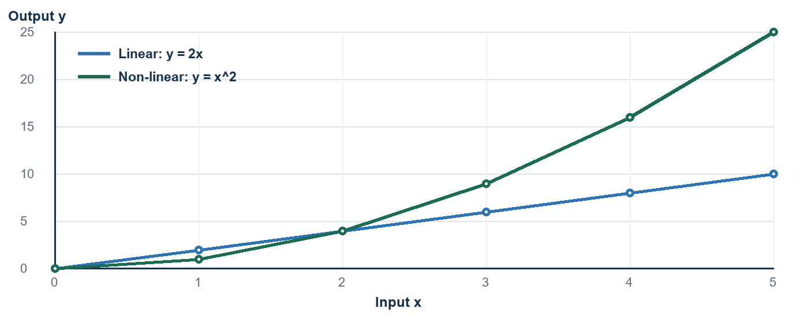
Equal x-steps create constant changes for y = 2x and increasing changes for y = x^2.
Test | Linear | Non-linear
Rate of change | Constant | Changes
First differences | Constant | Not constant
Typical graph | Straight line | Curve or another non-straight shape
Example | y = 2x + 3 | y = x^2

Three-Step Classification Check
- Confirm that the x-values increase by equal steps.
- Subtract consecutive y-values.
- Constant differences mean linear; changing differences mean non-linear.

8. Simulation Computations in the Unity Slides

A. Convert km/h to m/s
The CarMovement script uses speedMS = speedKPH / 3.6 because Unity's distance unit is treated as a meter and physics time is in seconds.
60 km/h / 3.6 = 16.67 m/s

At this constant speed, the car travels about 16.67 meters in 1 second and about 83.33 meters in 5 seconds.

B. Velocity vector
new Vector3(speedMS, rb.velocity.y, rb.velocity.z) sets the x-speed to the converted value while preserving the current y- and z-components. The scripted motion is mainly along the x-axis.

C. Clamp the road count
RoadNumber = Mathf.Clamp(RoadNumber, 0, Roads.Length) keeps the requested count within the array capacity. If Roads.Length = 99 and RoadNumber = 120, the clamped value is 99.

D. Smooth following with interpolation
The camera uses Lerp for position and Slerp for rotation. The blend fraction is approximately smoothing x Time.deltaTime.
blend = 5 x (1/60) = 0.0833
At 60 frames/second, the camera closes about 8.33% of the remaining gap per frame.

If the positional gap is 12 meters, the first correction is about 12 x 0.0833 = 1 meter. The exact motion eases because the remaining gap becomes smaller each frame.
Important distinction
The linear-model formula predicts position from a constant rate. Lerp produces smooth easing toward a target, so its step size changes as the gap changes.

9. Common Mistakes and Fast Fixes
Mistake | Why it is wrong | Fast fix
Using y = mx and ignoring b | The object may not start at 0. | Check the value at x = 0.
Mixing seconds with km/h | The time unit does not match the rate. | Convert units first.
Computing y2 - y1 only | Slope also depends on the x-step. | Divide by x2 - x1.
Calling any increasing table linear | Linear means constant increase, not merely increasing. | Calculate first differences.
Writing x^2 as 2x | Squaring means x times itself. | Example: 5^2 = 25, not 10.
Comparing differences with unequal x-steps | Raw differences are not comparable. | Use slope for each interval.

The 20-Second Check
- What is the input x?
- What is the output y?
- What are the units?
- Is there an initial value b?
- Is the rate constant or changing?
- Does the final answer make physical sense?
Memory line
Linear: same input step -> same output change. Non-linear: same input step -> changing output change.

10. Practice Set
Try these without looking at the answer key. Show the formula, substitution, calculation, and unit.
- A car travels at 60 km/h for 5 hours from position 0. How far does it travel?
- A cart begins 40 meters from a marker and moves at 12 m/s. Write its model and find its position after 7 seconds.
- For y = 20x + 100, when does y reach 460 meters?
- A table contains (0, 50), (2, 80), and (4, 110). Find m and b, then write the model.
- Classify y-values 6, 10, 14, 18 when x increases by 1. Show the differences.
- Classify delays 5, 7, 11, 17, 25 when the input increases equally. Show the differences.
- For D(x) = x^2, find D(8). Then find the increase from D(7) to D(8).
- Convert 72 km/h to m/s.
- At 50 frames/second, positionSmooth = 8. What Lerp blend fraction is used for one frame? If the gap is 5 units, approximately how far is the first correction?
- A car starts at 300 meters and moves toward the checkpoint at 15 m/s. Write the model and find its position after 8 seconds.
Scoring guide
One point for the correct model, one for substitution, one for arithmetic, and one for a correctly labeled final answer.

11. Answer Key - Problems 1 to 5
Problem 1
d = 60 x 5 = 300 km.

Problem 2
Model: y = 12x + 40. At x = 7: y = 12(7) + 40 = 84 + 40 = 124 meters.

Problem 3
460 = 20x + 100; 360 = 20x; x = 18 seconds.

Problem 4
m = (80 - 50) / (2 - 0) = 30/2 = 15. Since y = 50 when x = 0, b = 50. Model: y = 15x + 50.

Problem 5
10 - 6 = 4, 14 - 10 = 4, 18 - 14 = 4. The first difference is constant, so the relationship is linear.

12. Answer Key - Problems 6 to 10
Problem 6
Differences: +2, +4, +6, +8. They change, so the relationship is non-linear.

Problem 7
D(8) = 8^2 = 64. D(7) = 49, so the increase is 64 - 49 = 15.

Problem 8
72 / 3.6 = 20 m/s.

Problem 9
Time.deltaTime = 1/50 = 0.02 s. Blend = 8 x 0.02 = 0.16, or 16%. First correction = 5 x 0.16 = 0.8 unit.

Problem 10
Moving toward the checkpoint makes the slope negative: y = -15x + 300. At x = 8: y = -15(8) + 300 = -120 + 300 = 180 meters.

Final One-Minute Review
- Constant rate -> linear -> y = mx + b.
- Changing first differences -> non-linear.
- x^2 means x multiplied by itself.
- km/h to m/s -> divide by 3.6.
- Always label the final answer with units.
Source: CS402 - Modelling and Simulation - MIDTERM.pdf, slides 1-102. Reviewer wording and additional examples were created for study use.

