**6 way-Smart Traffic Light Controller**

**Table of Contents**

1. Abstract
2. Introduction
3. Motivation of the Project
4. Problems Solved by the Project and How ?
5. State of the Art
6. Technical Features and Elements of the project
7. Block Diagram and Circuit Diagram
8. Software and Hardware Used
9. New features
10. Better options than used ones
11. Testing/Implementation
12. Addition Information
13. Conclusion
14. REFERENCES

**Abstract**

Increase in population has lead to hefty increase in the number of vehicles on roads which in return lead to traffic jams, accidents and problems for traffic police and the citizens who are on foot on roads. In this project we have tried to design a new kind of traffic lights which could be used for 6 way roads which sounds quite weird but we will be needing such roads in future to divert the traffic and these traffic lights are smart as well as they will work on the base of density of jam on a particular road. This system will be a microprocessor based system and this microprocessor will control the traffic light by circuit using the sensors which will be determining the jam level on the roads. This how this system will work with the help of the sensors jam level displayer tool is another feature added to a system controlled by the microcontroller which is a traffic sign informs the drivers about the level of jam before reaching the road.

**Introduction**

The increase in jams lead to degradation of many resources which include the looseness of petrol, exhaustion of automobiles’, and lateness of employers, in addition to fatigue for both the Citizens and traffic policemen. There are a lot of problem with the normal traffic lights, the main problem is heavy jam because traffic lights do not check/configure the level of jam on a particular route and also the 6 way factor makes this system more special because then the traffic could be diverted to more direction than it was usually done before in the 4 way normal traffic lights controller. Solution to the problem of the traffic light that don’t care of the level of traffic is to use sensors to so this and set the delay time. In addition to delay time problems there is problem representing of emergency cars, like the ambulance, police, and fire brigade. This problem need of evaluation of the traffic policeman, then there is need for manual control of the traffic light. So, yes we have to keep in mind all the aspects and make the traffic light controller as automatic and advanced as possible, also we have to take care about its robustness as we have to also make a manual component with it for emergency cases.

Ganiyu R. A., 2014 [1] introduced a traffic light control system; the design consists of the microcontroller, and light emitting diode (LED). The sensing unit is designed utilizing a pressure switch which will sense the weight of any car that steps on it. When the pressure switch is pushed, a logic one is applied on the microcontroller to inform the control unit that there is car at that particular node. The system was designed to sample all the lanes in turn to detect whether there is an automobile on any lane and this action added a period of 15sec to the delay time by the microcontroller which is configuring the traffic light action.

Sachin Jaiswal, 2013 [2] presented control system consist of microcontroller, IR sensors, in line of sight configuration across the loads to detect the density at the traffic signal, and for VIP automobile RF transmitters are installed on it while the receivers installed on traffic light control circuit to control the state of the traffic light. Three levels of jam and delays are defined high, medium, low density.

Shilpa S. Chavan, 2009 [3] introduced Intelligent Traffic Light Controller, which consist of infrared sensor mounted on the road to detect the vehicles, this acts as an input to the ITLC unit. This input signal indicates the length of vehicles on each road. The controller generates output signals for Red, Green and Orange Signal and monitors their timings, taking into consideration the length of vehicles on each road.

Mohammed Ehsan Safi, 2016 introduced a special method in which the ultrasonic sensor was used to detect the density of the jam in that particular road. Thus the traffic lights used to go green, yellow and red accordingly[4].

**Motivation of the project**

There are a lot of factors which led to the idea of this project, firstly the time which is wasted due to heavy traffic jams on the traffic lights. Then due to these traffic jams road rage happens most of the times which even sometimes lead to bad outcomes. Thus we came up with this idea which included 6 way traffic light control system with a smart element in it which is the ultrasonic sensor part to sense the jam level a particular road and accordingly lights will go on.

**Problem Solved and How?**

The problem as mentioned above is related to traffic levels, road rage due to the traffic and then it would also help the traffic cops a lot. How are these problems solved? This question makes the project unique. We actually first of all have changed the concept of 4 way traffic light system to 6 way traffic light system so that we could divert the traffic to 2 other places which is north-west and south-east. Also the element which is the use of ultrasonic sensor on all the 6 ways makes this system more unique. The sensor will help us to measure the density of traffic along a particular way and thus we would be able to control the traffic lights according to those reading from the sensors.

**State of Art**

The existing knowledge regarding the making of the traffic lights controller system is 4 way traffic light controller. In which the layout is similar to the figure below.

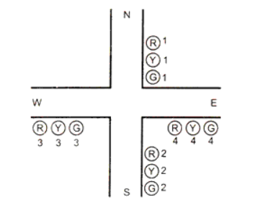

|  |  |  |  |
| --- | --- | --- | --- |
| S. No. | Existing state of art | Drawbacks in existing state of art | Overcome |
| 1. | A normal 4 way traffic light controller system | This is not smart as the light goes R,Y,G based on time | Convert 4 way to 6 way and install sensors to help measure the traffic on the road |
| 2. | Smart traffic light controller (but not 6 way ) | As it is not a 6 way controller the traffic is not diverted | Make it a 6 way traffic controller. |

**Technical features and Element**

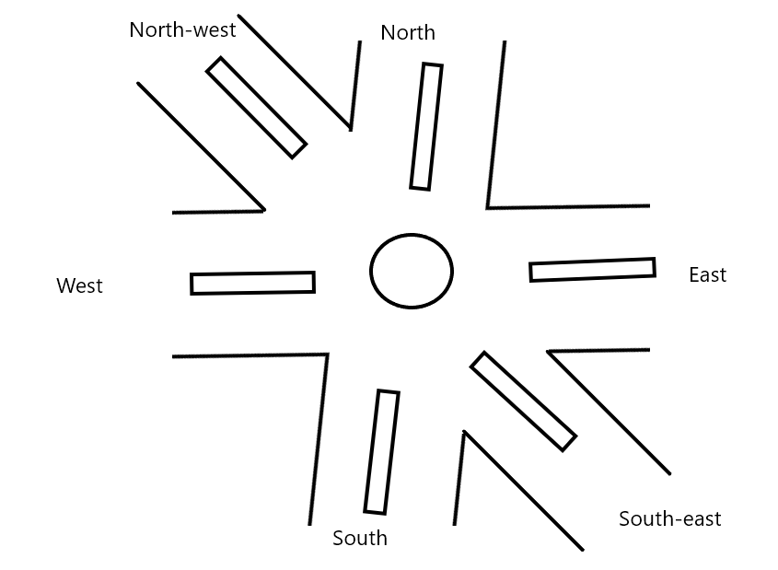

The model proposed in this project, as depicted in the above block diagrams, consists of processing unit presented by the microprocessor which control all the working in the system, ultrasonic sensors which are used to determine jam on the road, continuously switch from one mode to the other which is from auto to manual or manual to auto, manual mode is made to be used by Traffic policeman. The number of sensors depends on the length of the street and the increase of sensors increase the accuracy of the level of jam calculation but that increase the cost too, The minimum number of sensors is six because of the 6way path which we have considered in this project to estimate the level of jam.

Some things more to be noted about the dual system are, when it work in the manual mode the traffic light work according to traffic policeman choices using the manual control switches this mode is important in the emergency like a police car or ambulance, while the system be in the auto mode is determine the delay time of the traffic light according the sensors in the road by processing unit (microcontroller). The processing unit determines which road has more jam and gives it more delay time for green signal to reduce the crowd, but at the same time isn't determining the level of jam in the other road and give it the delay according to that level.

**Block Diagram and Circuit Diagram/ Interfacing Diagram**

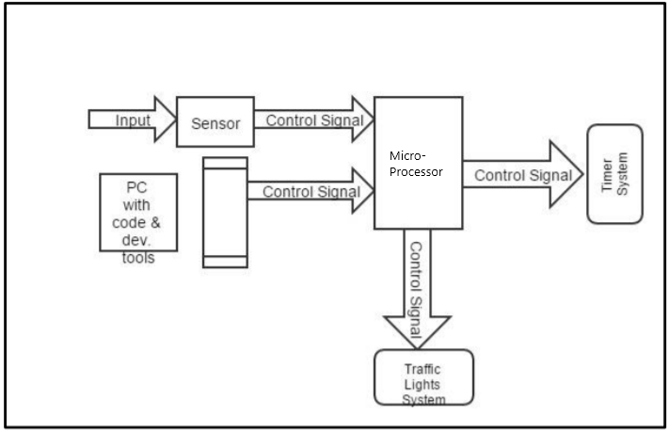

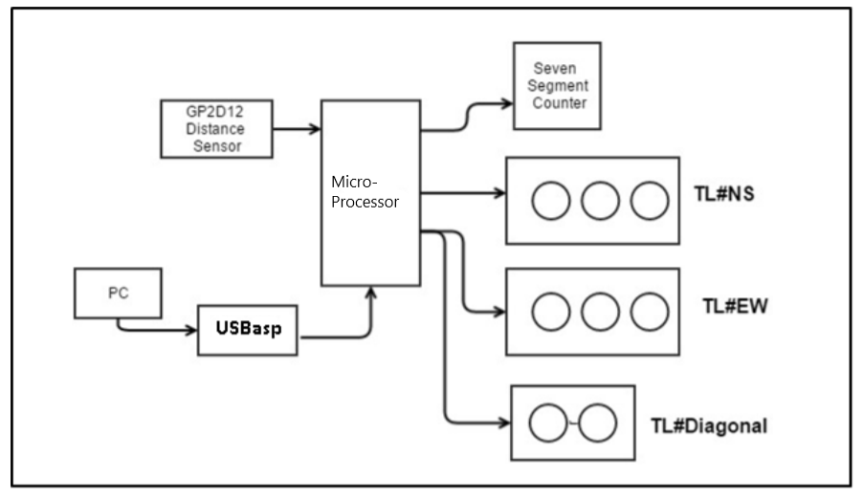

**Software and Hardware Used**

• Breadboard • 7-segment counter • GP2D12 Distance Measurement Sensor • 3 LED Green • 3 LED Red • 2 LED Yellow • 10 kOhm Resistor • 15 330 Ohm Resistor • Jumpers, wiring • Micro-Processor(8086/8085)

**New Features(Originality)**

There are actually 3 bi-directions that traffic lights can handle.

These are:

• From North◊South & South◊North (Vertical)

• From East◊West & West◊East (Horizontal)

• From West-North◊East-South (Diagonal)

Vertical and Horizontal movement of traffic is considered to be important than diagonal, since these are assumed to be busy and large roads. Consequently, traffic lights have three lights (green, yellow and red), which should always be functioning. On contrast, the diagonal road is rarely used. It is only activated when some car is reaching it. For more efficiency, it has only two lights (green and red). The threshold value for Distance sensor is 24 meters. Hence, if some car is in 100 meters from traffic light, then it will be off. However, if there is some bus that is within 24 meters, the diagonal traffic light joins the whole system. Moreover, the traffic light system has a countdown timer that gives 10 seconds for each action. When 2 seconds left, traffic changes its state to yellow, and then goes to the next action.

**Better options than this**

There are some drawbacks of this system, like the roads are not 6 way here in India which would be a huge task to change. But once changed which we definitely will be doing in future this is would help to fight the traffic jams and the chaos due to them. Till that time the normal 4 way is the only way for us.

Secondly this could be very difficult to manage so even one small problem could lead to damage in sense of accidents there would be a lot of blind spots in this model of roads. Thus the 4 way method is a better than the 6 way one.

**Testing and Implementation**

This model is just a prototype so the testing part is not done yet and talking about the implementation, it is also on paper only.

**Conclusion**

This project was aimed to beat the problem which we face currently in the traffic lights system, which include big traffic jams, time wastage and its side effects. There are a lot of things to be considered in this project which can be turned out to drawbacks, which are 6 way roads are not available but this is a prototype which could be used in future. Then there are some other problems also which could be faced due to blind spots(because of 6 way roads).

But this has more pros than cons which were discussed through out the project. This is a unique approach to make our roads safe, help us in time management even if that time is in seconds.

**Reference**

[1] Ganiyu R. A., Arulogun O. T., “Development Of A Microcontroller-Based Traffic Light System For Road Intersection Control”, International Journal of Science & Technology Research, Volume 3, ISSUE 5, May 2014

[2] Sachin Jaiswal,“Intelligent Traffic Control Unit”, International Journal of Electrical, Electronics and Computer Engineering, ISSN No. (Online): 2277-2626, 2013.

[3] Shilpa S. Chavan, “Assessment DESIGN OF INTELLIGENT TRAFFIC LIGHT CONTROLLER USING EMBEDDED SYSTEM”, Second International Conference on Emerging Trends in Engineering and Technology, 2009.

[4] Mohammed Ehsan Safi,“Smart Traffic light controller based on Microcontroller”, Department of electrical, University of Technology, 2016