|  |
| --- |
| Rocket Launcher interactive |
| **Nightfall** |
| [Updated 6/14/2012] |
| Version 1.1  All work Copyright © 2012 by Rocket Launcher Interactive.  All rights reserved. |
| **Numerous** |
|  |



|  |
| --- |
| May 20, 2012 |

**Table of Contents**

[Your Table of Contents should go here. Make sure that your document’s sections are hyperlinked to their corresponding pages.]

**Version History**

[This is where you keep track of the detailed changes made to your document throughout the course of development.]

6.14.2012 | Sam

* Updated the majority of design doc
* Story and gameplay elements added
* Levels 1 and 2 detailed
* Story Bible entered

[This is the body of your video game design document. You should add and delete sections as they pertain to your game’s design.]

1. **Game Overview**

The player plays as a courier in the late 1700’s who is transporting a mysterious package. The player’s stagecoach is attacked by a werewolf while transporting the package through a forest. Stranded, the player must make their way through the forest while being hunted by werewolves.

1. **Game Play Mechanics**

Potential Sound-Detection System:

Specific actions raise a sound meter on the player’s HUD. Once it’s full it depletes to empty and there is a chance of a werewolf attack. The attacking werewolf would appear directly behind the player and wait to attack until the player turns around. If the player doesn’t turn around immediately, instead proceeding forward, the spawned werewolf will follow the player, breathing loudly and making audible footsteps.

1. **Camera**

The entire game should be experienced in a first person perspective. There will be occasions where the POV is high jacked from the player’s control, but only when an important story element is active.

1. **Controls**
2. **Saving and Loading**

We should employ a Save Anywhere save-system. All the cool kids are doing it. Probably just saves a vector of the player’s current location, then loads said vector when you continue the game.

1. **Interface**

There will be minimal HUD elements. The lantern the player carries with them throughout the game displays how much “health” the player has left. Whenever the player would take damage the flame in the lantern depletes itself. When the flame completely disappears he is open to the horrors of the night and dies.

Water is instant death. Yay, easy out!

1. **Menu and Screen Descriptions**
2. **Game World**

The game takes place in a valley which is located beside a giant lake. The player enters the north part of the valley and is swept along it’s winding roads to the south-western corner.

1. **Levels**

**Level 1 | The Long Road**

The player is driving the stagecoach through the woods at breakneck speeds to an unknown destination. The coach lurches and the player hears a shattering sound. The player then looks back and the coach is on fire. The werewolf jumps through the fire at the player. The player ducks and the werewolf misses and attacks one of the horses causing the stagecoach to flip forward. The player gets knocked out from the crash.

The player then comes to underneath some rubble from the stagecoach, the layer then lifts a panel that was holding him down and sees the werewolf feasting on one of the horses, and another biting the second horse, which manages to struggle free and run off into the woods. Terrified the player hides back underneath the panel. He slowly peeks back out and sees more werewolves approaching the dead horse and quickly hides back under the wreckage. After a couple seconds a howl is heard in the distance and the player hears/sees the werewolves drag the dead horse into the woods. The player then frees himself from the wreckage and says, “it is dark I can barely see a thing.” Just as the player picks up a lamp, you are attacked by a werewolf. The player is chased to a canyon with a broken bridge. The player looks around and notices an uprooted tree expanding the length of the canyon. The player then begins to cross the canyon by way of the uprooted tree. The werewolf pursues the player across the log, however, being large in stature the werewolf moves slower. upon reaching the other side of the canyon the player then has to repeatedly kick the log to cause it to break. The player then climbs back up toward the road and notices a guard tower in the distance and figures it would be safe to rest there for the night and proceeds toward the tower.

**Level 2.1 | Observing the Lifeless Farmlands**

The player makes their way up the winding road towards the tower. As they get closer to their objective they realize it’s actually an observatory overlooking the lake.

When they arrive at the base of the tower they find no signs of life; the observatory has been abandoned for quite some time. Looking for respite the player heads into the tower and begins to ascend it’s winding stairs, which is difficult given the tower’s steampunk nature.

Upon reaching the top of the tower they overlook the valley which they came from the side of. Directly to the south-east on the far side of the playspace is an illuminated tower. Making a mental note of the alleged most-immediate route they head back down the mountain which the tower is on and enter the Lifeless Farmlands.

**Level 2.2 | Lifeless Farmlands**

The expansive terrain here gives off a lonely and compelling atmosphere. Should the player be attack there is really nowhere to run to except the occasional patch of cornstalks. Eventually the player happens upon a barn sandwiched between two batches of unsurpassable boulders. Realizing the quickest way past is through the barn the player navigates his way through the semi-ancient structure.

Forced to the upstairs of the barn by the wreckage of a collapsed beam and roof debris, the player hears the familiar howl of a wolf pack and hides in the shadows. The pack of werewolves that carried off the mauled horse carcass from earlier drag the dead animal into the building, directly below the player.

1. **Game Progression**
2. **Characters**
3. **Non-player Characters**
4. **Enemies**

* Werewolves
* Werehorse
* Terrified/Crazy Villagers

1. **Weapons**
2. **Items**
3. **Abilities**
4. **Vehicles**
5. **Script**
6. **Puzzles/Mini-games**
7. **Bonuses**
8. **Cheat Codes**
9. **Sound Bible**
10. **Story Bible**

Nightfall is part of an overarching story. The idea is that if Nightfall is successful there will be sequels, all of which culminate in one final game. Each entry in the series is mostly (if not completely) self contained, apart from the final chapter.

The overarching story is as follows:

It’s 1942 in an alternate timeline. Tesla was the decided winner in the race for electrically-engineered dominance. Hitler’s Nazi scientists manage to open a portal to an alternate world where the abominations of alleged myth were exiled to by an ancient order of monks and demon hunters. With the portal open, these monstrosities are free to wreak havoc on earth.

A concerted Allied effort creates a time machine fueled by Nikolai Tesla’s research and scientists are sent back to the respective time periods of the various monsters released by the portal in an effort to find ways of combating these creatures.

An Ally scientist by the name of (BLANK) is sent back to the late 1700’s to try and find something, anything, to combat werewolves, one of the main forces let loose by the Nazis’ portal. Upon hearing that silver can be weaponized to combat the werewolves he makes contact with a researcher from that time period. A courier is sent to deliver the plans to (BLANK), ignorant of the role he is about to fulfill in earth’s salvation.

1. **Art Bible**

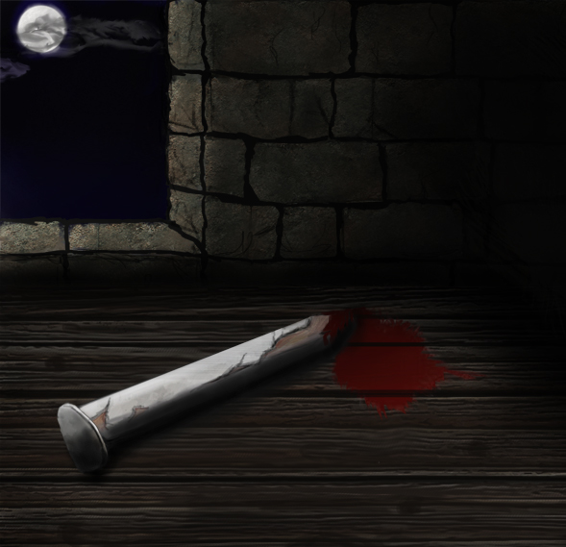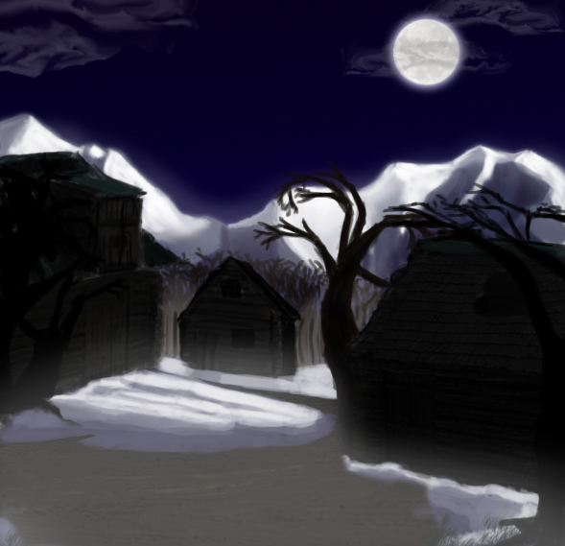

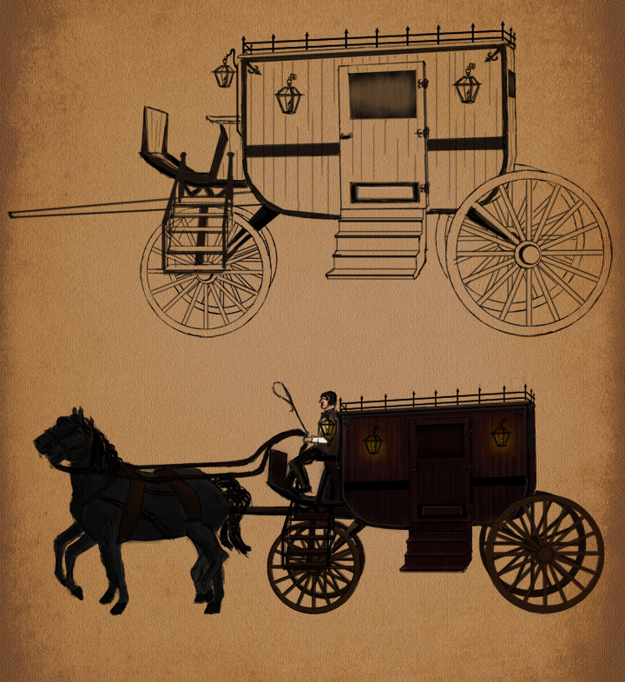

1. **Design Notes**
2. **Future Features**