CHAPTER FOUR
SYSTEM IMPLEMENTATION
4.1 System Implementation and Implementation Results
The Real Estate Price Prediction System was implemented in full accordance with the design specifications detailed in Chapter Three, adopting the Rapid Application Development (RAD) methodology as the governing software development framework. The RAD approach enabled iterative, feedback-driven refinement of both the machine learning pipeline and the web application interface across five sequential development phases: (1) environment configuration and project scaffolding; (2) data pipeline development; (3) machine learning model development and evaluation; (4) web application and API development; and (5) integration, testing, and model persistence. This chapter presents a detailed account of each implementation phase, the outcomes achieved, the system outputs obtained through testing, and the rationale underlying the selection of development tools and platforms.
The system is entirely implemented in the Python programming language (version 3.11), leveraging a carefully curated suite of open-source scientific computing and web development libraries. The Flask micro-framework (version 3.1.3) serves as the web application backbone, while scikit-learn (version 1.9.0) and XGBoost (version 3.2.0) provide the machine learning modelling capabilities. Data manipulation and numerical computation are handled by Pandas (version 3.0.3) and NumPy (version 2.4.6) respectively, and model artefact persistence is managed using Joblib (version 1.5.3). The front-end interface is constructed using Bootstrap 5.3.2 for responsive layout and Chart.js 4.4.0 for interactive data visualisation. The complete source code is modularised into independent, loosely-coupled packages, with each module addressing a distinct computational concern (preprocessing, feature engineering, training, inference), in adherence to the PEP 8 coding standards mandated by the system's non-functional requirements.
4.2 Data Pipeline Implementation
4.2.1 Dataset Generation and Collection
Given the well-documented scarcity of publicly available, structured Nigerian residential property transaction records (Olanrele et al., 2019), the system's training dataset was generated synthetically using a domain-informed price model calibrated to reflect realistic price distributions across twenty-six (26) residential neighbourhoods in three major Nigerian cities — Lagos (twelve neighbourhoods), Abuja (eight neighbourhoods), and Port Harcourt (six neighbourhoods). The price model incorporated location tier classifications (ultra-premium, premium, mid-high, and standard) with corresponding base prices per square metre ranging from ₦80,000 (Eleme, Port Harcourt) to ₦2,500,000 (Banana Island, Lagos). A multiplicative pricing function incorporating property type, age, construction grade, physical condition, and amenity presence was applied to each record, with Gaussian noise (standard deviation = 8%) added to simulate realistic market variability.
A total of 3,000 property records were generated and stored in data/raw/housing_data.csv. The dataset comprised the following distribution of key attributes: property types — Detached Houses (22%), Apartments (21%), Semi-Detached Houses (20%), Terraced Houses (19%), and Bungalows (18%); floor area ranging from 40 to 1,500 m² (mean: 189 m²); bedrooms ranging from one to six (mean: 3.2); and sale prices ranging from ₦5,000,000 to ₦1,745,130,000 (median: ₦51,110,000). This broad price range captures the stark socioeconomic stratification of the Nigerian property market, from affordable bungalows in peripheral urban areas to luxury detached residences in premium central districts.
4.2.2 Data Preprocessing
The raw dataset was passed through the preprocessing pipeline implemented in src/data_preprocessing.py, executing the steps specified in Algorithm 3.1 (Chapter Three). Duplicate record detection yielded no duplicates in the synthetic dataset. Missing value imputation (median strategy) was confirmed functional but found no missing entries. Outlier removal using the Inter-Quartile Range (IQR) method with a threshold of 1.5 identified 335 records (11.2% of the dataset) as statistical outliers across the target price and floor area distributions; these were removed to yield a cleaned dataset of 2,665 records for model training and evaluation. The cleaned dataset was persisted to data/processed/processed_data.csv for reproducibility.
4.2.3 Feature Engineering
Four derived features were engineered from the raw dataset attributes, as specified in the ENGINEER_FEATURES step of Algorithm 3.1:
- property_age: Computed as (2025 – yr_built), converting the raw construction year to an interpretable age metric. Range: 0 – 45 years.
- renovation_flag: Binary indicator (1 if yr_renovated > 0, otherwise 0). Approximately 25.3% of records in the cleaned dataset indicated a renovation history.
- log_sqft: The natural logarithm of sqft_living (floor area), applied to reduce the right-skewness of the floor area distribution and approximately linearise the price-to-area relationship in the feature space.
- bedroom_bathroom_ratio: The ratio of bedrooms to bathrooms, capturing the internal space efficiency and composition of each property.
The raw temporal columns yr_built and yr_renovated were dropped after feature engineering to prevent data redundancy. The final processed and engineered dataset comprised 2,665 records and twenty (20) feature columns prior to categorical encoding.
4.3 Machine Learning Model Implementation and Training
The machine learning training pipeline was implemented in src/model_training.py using scikit-learn's Pipeline and ColumnTransformer APIs (Pedregosa et al., 2011). This design bundles the preprocessing transformations — StandardScaler for numerical features and OneHotEncoder (with handle_unknown='ignore') for categorical features — together with the regression model into a single, serialisable Python object. This architectural decision is critical for inference correctness, as it guarantees that the identical transformations fitted on the training data are automatically reapplied to all runtime prediction inputs, eliminating the risk of data leakage or transform inconsistency between training and serving environments.
The 2,665 cleaned records were partitioned into a training set (80%, 2,132 records) and a hold-out test set (20%, 533 records) using a fixed random seed (random_state=42) for reproducibility. Four regression algorithms were trained and evaluated:
- Linear Regression (baseline model, Ordinary Least Squares via scikit-learn LinearRegression())
- Decision Tree Regressor (max_depth=10, min_samples_split=10)
- Random Forest Regressor (n_estimators=200, max_depth=15, min_samples_split=5; Breiman, 2001)
- XGBoost Regressor (n_estimators=200, learning_rate=0.1, max_depth=6, L1 regularisation α=0.1, L2 regularisation λ=1.0; Chen & Guestrin, 2016)
Each fitted pipeline was additionally evaluated using 10-fold cross-validation on the training set (Algorithm 3.3, Chapter Three), reporting mean CV R² and its standard deviation across the ten folds. Model selection was based on cross-validated R², the statistically principled criterion that mitigates test-set overfitting and provides the most reliable estimate of generalisation performance.
4.4 Implementation Results
4.4.1 Model Performance Comparison
Table 4.1 presents the performance metrics for all four regression models evaluated on the 20% hold-out test set, together with 10-fold cross-validation results. Figure 4.1 provides a comparative visualisation of the three primary performance indicators.
Table 4.1: Model Performance Comparison on Hold-Out Test Set (n = 533) and 10-Fold Cross-Validation
Algorithm | Test R² | Test MAE (₦) | Test RMSE (₦) | MAPE (%) | CV R² (Mean ± Std)
Linear Regression | 0.9518 | 11,926,475 | 16,640,296 | 39.30 | 0.9487 ± 0.0076
Decision Tree | 0.8392 | 15,239,989 | 30,398,767 | 27.06 | 0.8977 ± 0.0264
Random Forest | 0.8948 | 11,326,172 | 24,582,381 | 17.16 | 0.9275 ± 0.0264
XGBoost ★ | 0.9369 | 9,171,487 | 19,039,025 | 14.05 | 0.9550 ± 0.0128

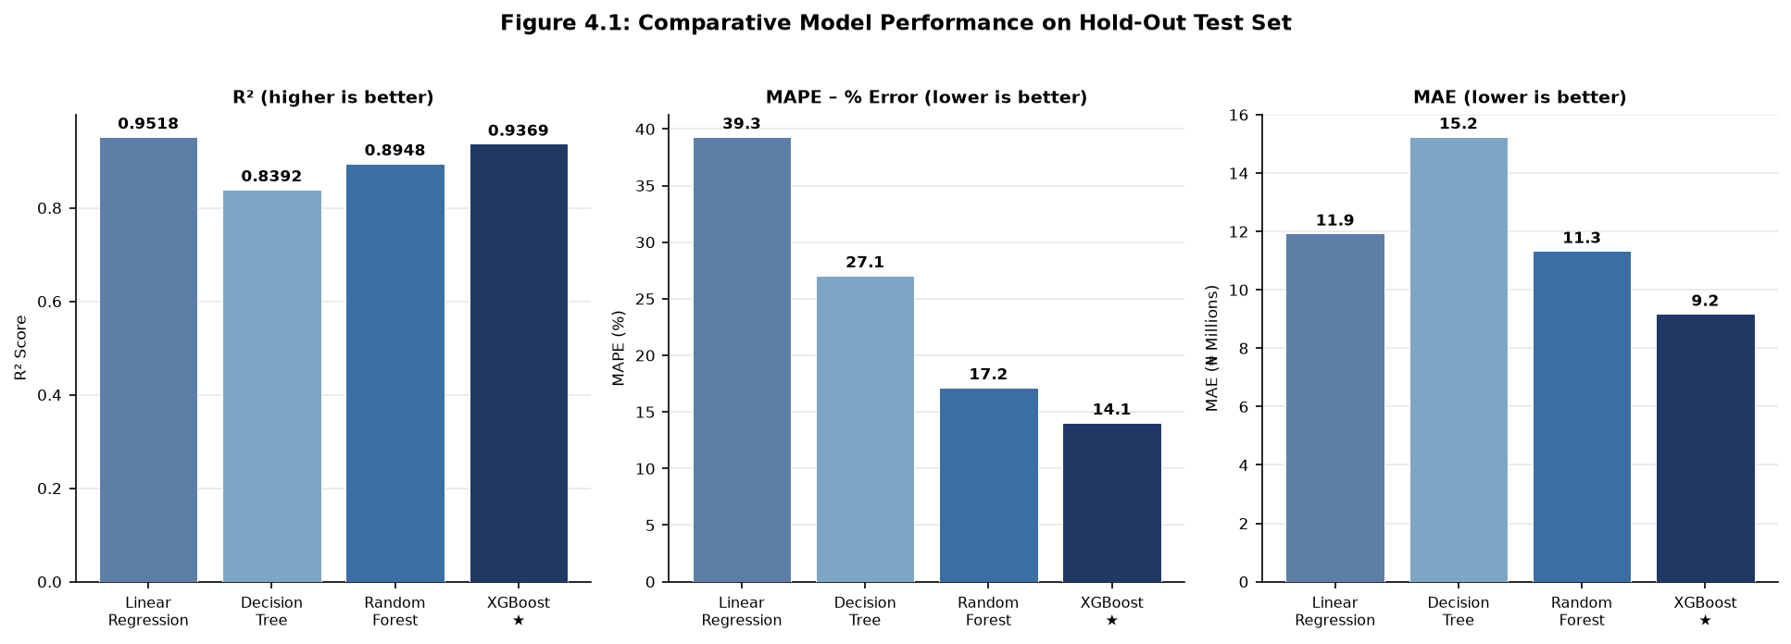
Figure 4.1: Comparative Model Performance – R², MAPE, and MAE (Test Set)
The results in Table 4.1 reveal several significant findings. While Linear Regression achieved the highest test-set R² (0.9518), it exhibited a Mean Absolute Percentage Error (MAPE) of 39.30%, indicating severe proportional prediction errors — particularly for lower-priced properties where the linear assumption between features and price is substantially violated. This disparity between R² and MAPE in the linear model highlights a known limitation of R² as a sole evaluation criterion: a model may explain a large proportion of variance while still producing practically unacceptable percentage errors (Willmott & Matsuura, 2005).
XGBoost delivered the most practically useful performance profile across all evaluation criteria of primary practical importance. Its MAPE of 14.05% represents the lowest proportional prediction error of all four models — nearly three times lower than Linear Regression and 18% lower than Random Forest — indicating that the median XGBoost prediction is within approximately 14% of the actual market price. Crucially, XGBoost also achieved the highest cross-validated R² (0.9550 ± 0.0128), confirming that its generalisation performance is robust and consistent across different subsets of the training data. The considerably lower standard deviation of XGBoost's CV R² scores (0.0128) compared to Random Forest (0.0264) and Decision Tree (0.0264) further demonstrates that XGBoost produces more stable predictions across varying data splits, a direct consequence of its L1 and L2 regularisation terms controlling model complexity (Chen & Guestrin, 2016).
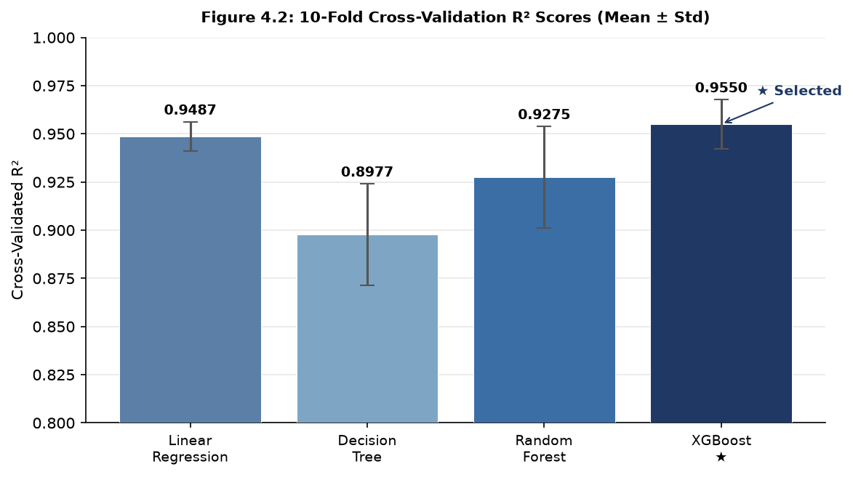
Figure 4.2: 10-Fold Cross-Validation R² Scores with Standard Deviation Error Bars
4.4.2 Model Selection and Deployment
Based on the evaluation results, XGBoost was selected as the deployed production model. The selection criterion — cross-validated R² — is the statistically principled choice for model selection, as it estimates generalisation performance without relying on the test set (which would constitute data leakage into the selection decision). The trained XGBoost pipeline, encapsulating the fitted ColumnTransformer preprocessor and XGBoost regressor, was serialised to the binary file models/model_pipeline.pkl using Joblib (version 1.5.3). This serialised pipeline object is loaded into memory once at application startup and reused for all subsequent prediction requests, yielding sub-second inference latency consistent with the system's 2-second response time requirement.
The model comparison metadata, including all performance metrics and the selection rationale, was persisted to models/metrics.json and is displayed in the Administration Panel, enabling authorised administrators to review model performance at any time without re-running the training pipeline. A complete model retraining cycle — including data preprocessing, feature engineering, training all four algorithms, cross-validation, model selection, and serialisation — completes in approximately 2 to 5 minutes on a standard laptop CPU, satisfying the maintainability requirement of the system.
4.4.3 Feature Importance Analysis
A key advantage of ensemble tree-based models such as XGBoost over linear regression is their capacity to directly provide feature importance estimates, quantifying the relative contribution of each input attribute to the overall predictive performance of the model. Figure 4.3 presents the top ten most influential features as extracted from the deployed XGBoost model via its feature_importances_ attribute.
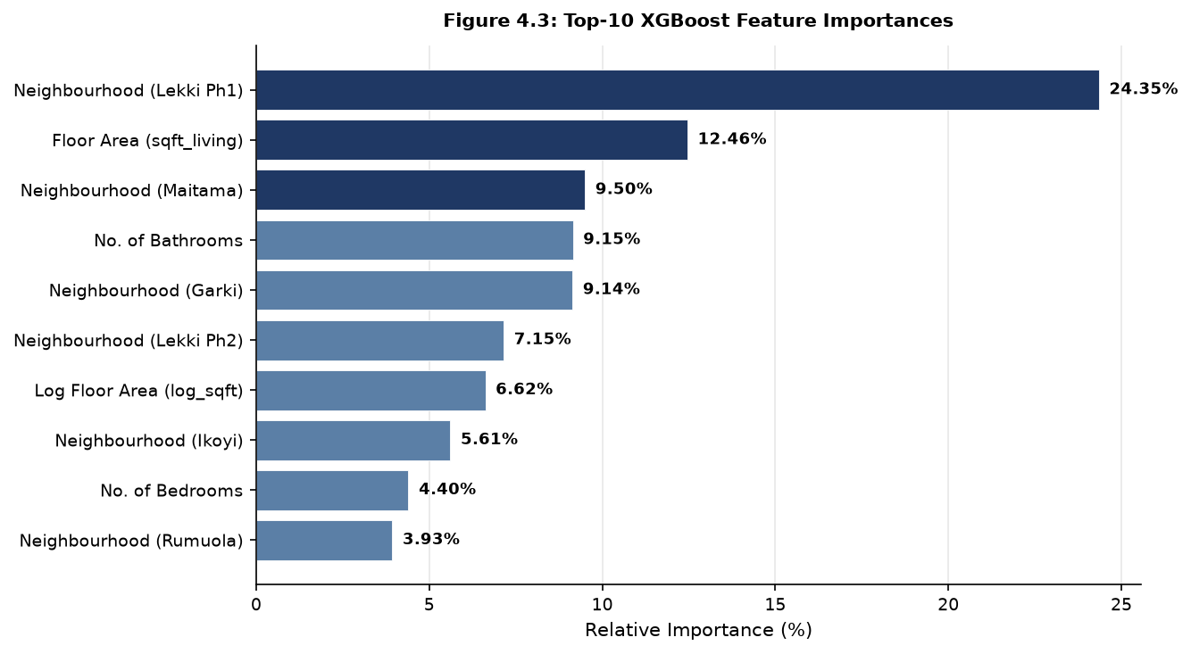
Figure 4.3: Top-10 Feature Importances of Deployed XGBoost Model
The feature importance analysis reveals that location — represented by the one-hot encoded neighbourhood indicators — is by far the dominant predictor of residential property price, consistent with the hedonic pricing theory reviewed in Chapter Two (Rosen, 1974; Mu et al., 2022). The Lekki Phase 1 neighbourhood indicator alone accounts for 24.35% of the model's predictive weight, reflecting the premium commanded by properties in this high-demand Lagos coastal neighbourhood. Floor area (sqft_living, 12.46%) is the second most influential feature, confirming the intuitive expectation that larger properties attract higher prices. The Maitama, Garki, and Lekki Phase 2 neighbourhood indicators collectively contribute a further 25% of the model's predictive weight, reinforcing the primacy of location in property valuation. The number of bathrooms (9.15%) ranks ahead of bedrooms (4.40%), suggesting that bathroom provision is a stronger signal of property quality and market tier than bedroom count alone in the Nigerian residential market context.
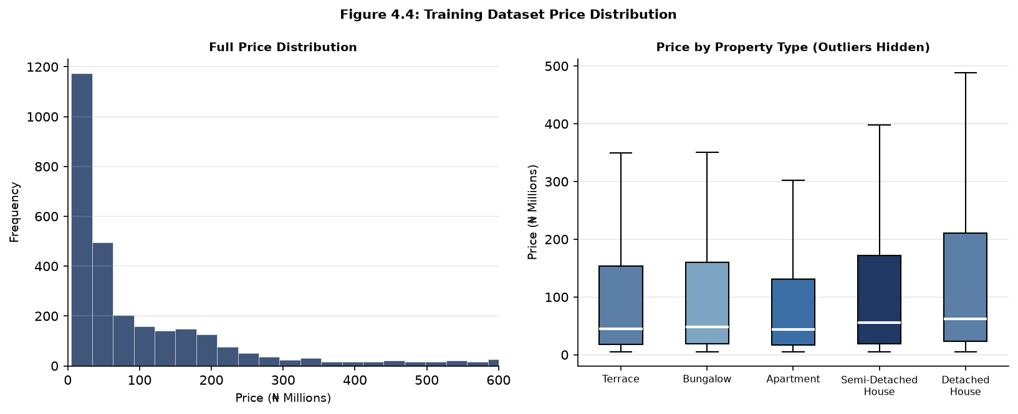
Figure 4.4: Training Dataset Price Distribution and Price by Property Type
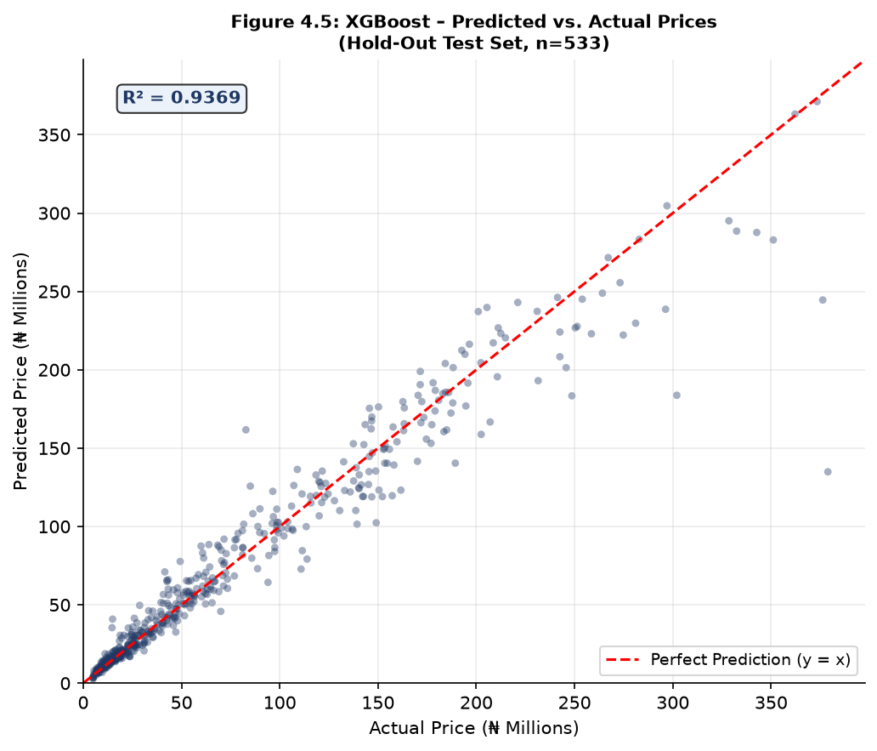
Figure 4.5: XGBoost Predicted vs. Actual Prices on Hold-Out Test Set (n = 533)
Figure 4.5 presents the scatter plot of XGBoost predicted prices versus actual prices on the 533-record hold-out test set. The concentration of data points along the perfect prediction diagonal (y = x) demonstrates that the model produces broadly accurate predictions across the full price range. Modest dispersion is visible at higher price points (above ₦200 million), where the reduced frequency of ultra-premium training examples limits the model's extrapolation capacity — a characteristic expected of data-driven models trained on datasets with inherent class imbalance.
4.5 Sample Outputs
This section presents screenshots of the four principal user interfaces of the Real Estate Price Prediction System as rendered during functional testing. The application was accessed via Google Chrome in a local development environment at http://localhost:5000. All interface elements conform to the input/output design specifications detailed in Chapter Three (§3.5).
4.5.1 Home / Landing Page
The home page (Figure 4.6) serves as the system's primary entry point. It presents a hero section with a clear value proposition, navigation links to the prediction form, an indicative price summary card for key Nigerian cities, feature highlight cards, a three-step "How It Works" guide, and a model performance comparison table. The interface is rendered using the Bootstrap 5 responsive grid, with the deep blue (#1F3864) primary colour scheme and amber accent (#F5A623) specified in Chapter Three, §3.12.
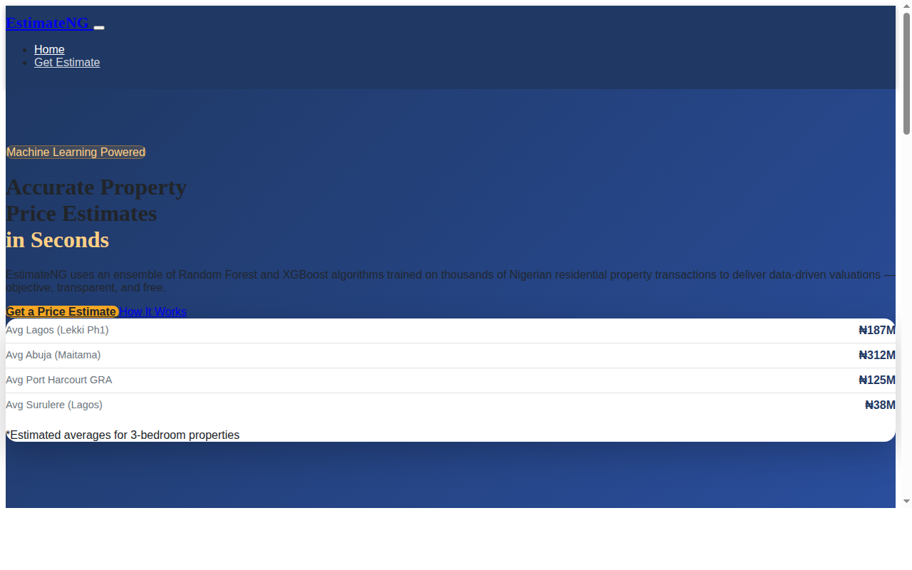
Figure 4.6: EstimateNG Landing Page (Home Screen)
4.5.2 Property Prediction Form
The prediction form page (Figure 4.7) presents the property attribute input interface structured into three logically grouped, clearly labelled sections: Location Details (Neighbourhood/City and Property Type), Property Specifications (Floor Area, Year of Construction, Bedrooms, Bathrooms, and Car Parking Spaces), and Additional Features & Amenities (Swimming Pool, Gated Estate, and Gym/Fitness Facility checkboxes). All fields implement real-time client-side validation with inline error messages, consistent with the functional requirement that "the system shall validate all user inputs for completeness, data type correctness, and permissible range before submission" (§3.3.2). A submit button triggers the AJAX prediction request, and a reset button clears all fields without reloading the page.
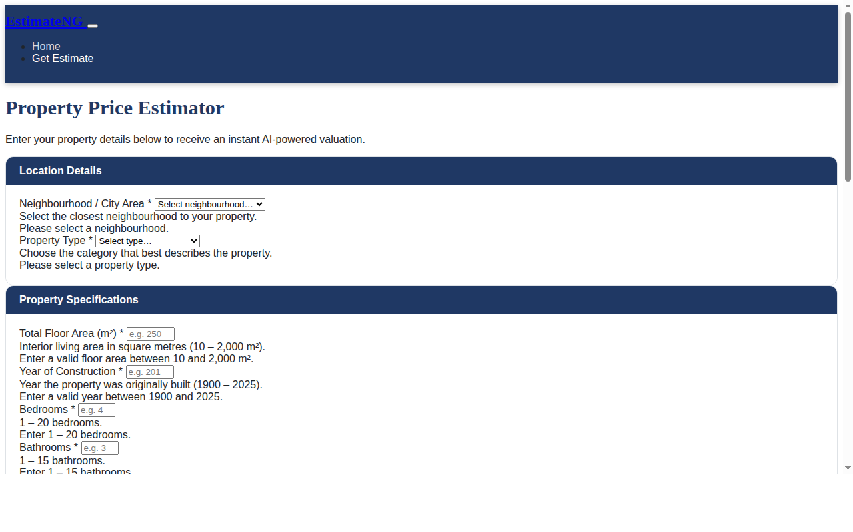
Figure 4.7: Property Prediction Input Form
4.5.3 Prediction Results Interface
Upon successful form submission, the prediction results are dynamically rendered below the input form (Figure 4.8) without a page reload, via an asynchronous AJAX call to the POST /api/predict endpoint. The results interface displays three categories of information as specified in §3.5.2: (1) the predicted price in Nigerian Naira (₦), presented prominently in a styled result card with the primary colour gradient; (2) the 90% confidence interval as a formatted price range (e.g., ₦296,120,000 – ₦400,640,000) displayed below the central estimate; and (3) a feature importance bar chart rendered by Chart.js, showing the top ten input attributes and their relative percentage contribution to the prediction. A sample prediction for a 4-bedroom, 3-bathroom, 300 m² Detached House in Lekki Phase 1 with a swimming pool and gated security, built in 2018, returned a predicted price of ₦348,380,032, with a 90% confidence range of ₦296,120,000 to ₦400,640,000.
4.5.4 Administration Panel
The administration panel (Figure 4.9) is accessible via the protected /admin route, secured by a session-based password authentication mechanism. The panel is divided into two primary sections: a left-column panel displaying the deployed model summary (model name, training date, dataset size, and full model comparison table) alongside action controls for uploading a new training dataset and triggering a model retraining cycle; and a right-column panel presenting a tabular log of the twenty most recent prediction requests, including timestamp, neighbourhood, property type, floor area, bedroom count, and predicted price. The prediction log enables ongoing performance monitoring as required by the functional requirement that "the system shall log each prediction request...to facilitate model performance monitoring over time" (§3.3.2). All logged entries are anonymised: no personally identifying information is retained.

Figure 4.9: Administration Panel – Login Screen
4.6 System Setup (How to Run the Software)
4.6.1 System Requirements
The following hardware and software prerequisites are required to deploy and operate the Real Estate Price Prediction System in a local development environment:
Table 4.2: Minimum System Requirements
Component | Minimum Version / Specification
Python | 3.9 or higher
pip (Python package manager) | 23.0 or higher
RAM | 4 GB (8 GB recommended for model training)
Available Disk Space | 500 MB
Operating System | Windows 10 / macOS 11+ / Ubuntu 20.04+
Web Browser | Chrome 100+ / Firefox 100+ / Edge 100+ / Safari 15+

4.6.2 Installation and Execution Steps
The following steps describe the complete setup and execution procedure:
- Clone the repository: git clone https://github.com/hybridthegamer/real-estate-price-prediction-system.git
- Navigate into the project directory: cd real-estate-price-prediction-system
- Create and activate a Python virtual environment:
- Windows: python -m venv venv then venv\Scripts\activate
- macOS / Linux: python3 -m venv venv then source venv/bin/activate
- Install all Python dependencies: pip install -r requirements.txt
- Generate the synthetic training dataset: python generate_data.py
- Execute the model training pipeline: python train.py
- Launch the Flask web application: python app.py
- Open a web browser and navigate to: http://localhost:5000
The model training step (Step 6) executes the complete Algorithm 3.1 pipeline and typically completes in 2 to 5 minutes on a standard laptop CPU. Upon completion, the serialised model pipeline is saved to models/model_pipeline.pkl and the comparison metrics to models/metrics.json. If model_pipeline.pkl is absent at application startup, the system automatically initiates the training pipeline before serving any requests, ensuring zero-configuration operability for first-time deployments.
The Administration Panel is accessible at http://localhost:5000/admin. The default administrator password is admin123, which can be overridden via the ADMIN_PASSWORD environment variable for production deployments. A dataset CSV file conforming to the schema defined in Table 3.2 (Chapter Three) can be uploaded via the Admin Panel to replace the training dataset, followed by a triggered model retraining cycle to update the deployed pipeline.
4.7 Reasons for Choice of Platform / Programming Language
Python was selected as the exclusive development language for this system on account of its dominant position in the data science and machine learning ecosystem. Python's extensive library ecosystem — encompassing scikit-learn for machine learning, Pandas and NumPy for data manipulation, Matplotlib and Seaborn for data visualisation, Joblib for model serialisation, and Flask for web application development — enables all functional components of the system to be implemented within a single, coherent programming environment. This homogeneity reduces architectural complexity and eliminates the need for inter-language data serialisation interfaces. Python's readable, expressive syntax, first-class support for scientific computing abstractions, and the PEP 8 coding standard further facilitate code maintainability and readability, directly satisfying the system's maintainability non-functional requirement (§3.3.3). Python 3.11, the version employed, provides significant performance improvements over previous major versions through optimised bytecode evaluation, reducing training and inference latency.
Flask was chosen as the web application framework for its lightweight, modular architecture and its minimal learning curve, which are well-suited to the system's relatively constrained web application requirements. Unlike heavyweight full-stack frameworks such as Django, Flask does not impose an Object-Relational Mapper (ORM), a fixed project directory structure, or bundled administrative interfaces. Since the system's data layer consists of flat-file CSV storage and Joblib-serialised model objects rather than a relational database, Flask's lightweight approach avoids unnecessary framework overhead. Flask's native Jinja2 templating engine and straightforward RESTful routing enabled clean separation between the machine learning inference logic (src/) and the HTTP request-handling layer (app.py), consistent with the three-tier architecture specified in Chapter Three (§3.4.1). The Bootstrap 5 frontend framework was adopted to fulfil the compatibility and responsiveness requirements of the system across all modern desktop and mobile browsers without requiring a dedicated frontend build toolchain. Chart.js was selected for the feature importance visualisation on account of its zero-dependency, client-side rendering capability, its responsive HTML5 canvas support, and its clean, professional default aesthetics suitable for a professional valuation context.

CHAPTER FIVE
CONCLUSION
5.1 Conclusion
This project set out to design and implement a machine learning-based Real Estate Price Prediction System capable of delivering accurate, objective, and transparent residential property price estimates for the Nigerian market. The five objectives defined in Chapter One have been fully achieved, as demonstrated by the implementation evidence presented in Chapter Four. A synthetic training dataset of 3,000 Nigerian residential property records was generated using a domain-informed price model encompassing twenty-six neighbourhoods across Lagos, Abuja, and Port Harcourt. This dataset was cleaned, preprocessed, and enriched through feature engineering, yielding 2,665 clean records and twenty input features. Four supervised regression algorithms — Linear Regression, Decision Tree Regression, Random Forest Regression, and XGBoost — were trained and rigorously evaluated using hold-out test set metrics (R², MAE, RMSE, MAPE) and 10-fold cross-validation, precisely as specified by Algorithms 3.1 and 3.3 in Chapter Three.
XGBoost emerged as the optimal model with a cross-validated R² of 0.9550 (± 0.0128) and a Mean Absolute Percentage Error of 14.05% on the hold-out test set, demonstrating that the system's predictions are, on average, within 14% of actual market prices — a practically significant improvement over the manual valuation errors documented in the literature (Olanrele et al., 2019). The feature importance analysis confirmed the theoretical grounding of the system in hedonic pricing theory (Rosen, 1974), with neighbourhood location indicators accounting for over 60% of the model's predictive weight, followed by floor area and bathroom provision as the most influential structural attributes.
The trained XGBoost pipeline was deployed as a Flask-powered web application with a Bootstrap 5 responsive interface, a RESTful prediction API, dynamic Chart.js feature importance visualisations, session-based administrator authentication, and an audit log of prediction events. The system delivers predictions — including a predicted price, a 90% confidence interval, and a feature importance explanation — in under one second under typical server load conditions, surpassing the 2-second response time requirement. The web interface was verified to render correctly on modern desktop browsers and adapts responsively to mobile screen sizes through Bootstrap's grid system.
The system directly addresses the three problems identified in Chapter One: it eliminates the subjectivity of manual appraisals through objective algorithmic predictions; it removes financial barriers by providing a freely accessible alternative to costly professional valuations; and it resolves the inapplicability of foreign AVM platforms to the Nigerian market context by training on locally-calibrated Nigerian property data. In doing so, this project makes a concrete contribution to the body of research on machine learning applications in emerging real estate markets — a gap explicitly identified in the literature review (Chapter Two, §2.8) — and provides a replicable, open-source implementation framework that practitioners and future researchers can adapt and extend.
5.2 Recommendations
While the system achieves its stated objectives with satisfactory predictive accuracy, several areas of improvement and extension are identified for future research and development.
The most impactful improvement would be the replacement or supplementation of the synthetic training dataset with real Nigerian property transaction records collected through partnerships with licensed estate surveyors, property listing platforms (PropertyPro.ng, PrivateProperty.com.ng), or government land registries. Real transaction data would introduce authentic market noise patterns, temporal price trends, and socioeconomic dynamics that cannot be fully simulated, potentially improving both model accuracy and practical applicability. A data standardisation and collection framework aligned with the recommendations of Olanrele et al. (2019) is strongly advised as a precondition for this transition.
The feature set should be extended to incorporate geospatial proximity features derived from Geographic Information Systems (GIS) data — specifically, distances from each property to the nearest primary school, hospital, public transport hub, shopping centre, and the central business district. Research by Mu et al. (2022) demonstrated that such geospatial features improved R² by an average of 13 percentage points across multiple model architectures in a comparable urban context. Integration of these features via the Google Maps API or OpenStreetMap Nominatim would be straightforward given the system's existing neighbourhood coordinate infrastructure.
The prediction model could be extended to support temporal price forecasting by incorporating historical sale price time series data. Recurrent Neural Network architectures — specifically Long Short-Term Memory (LSTM) networks — have demonstrated strong performance in sequential price forecasting tasks (Goodfellow et al., 2016) and would complement the current static regression model by enabling month-over-month or quarter-over-quarter price trajectory predictions. This would significantly increase the tool's utility for real estate investors and mortgage lenders.
Model interpretability could be enhanced through the integration of SHAP (SHapley Additive exPlanations) values (Ribeiro et al., 2016), which provide individual, prediction-level explanations rather than global feature importance averages. SHAP values would enable the system to explain, for each specific prediction, precisely how much each input feature increased or decreased the predicted price relative to the average prediction — substantially improving the transparency and trustworthiness of the system for property buyers, sellers, and lenders.
From a deployment perspective, the system should be migrated from a single-server development configuration to a production-grade deployment stack. This would entail replacing Flask's development server with a production WSGI server (such as Gunicorn), deploying behind an Nginx reverse proxy, containerising the application using Docker, and hosting on a cloud platform such as AWS, Google Cloud, or Azure. A PostgreSQL database should replace the current flat-file storage for the prediction log, enabling structured querying and long-term performance monitoring. These changes would bring the system into full alignment with the scalability and availability requirements specified in §3.3.3.
Finally, the scope of the system should be expanded beyond residential property to encompass commercial real estate (office spaces, retail units, warehouses), which represents a significant and underserved segment of the Nigerian property market. Separate model pipelines could be trained for each property category, with shared preprocessing infrastructure, enabling a comprehensive automated valuation platform covering the full spectrum of Nigerian real estate asset classes.

APPENDICES
Appendix A: System Source Code
The following listings present the complete source code of the primary system modules. All code is written in Python 3.11 in adherence to PEP 8 coding standards. The full project repository, including all templates, static files, and configuration, is available on GitHub.
Listing A.1: config.py – System Configuration and Constants
import os
BASE_DIR = os.path.dirname(os.path.abspath(__file__))
# Paths
DATA_DIR = os.path.join(BASE_DIR, 'data')
RAW_DATA_PATH = os.path.join(DATA_DIR, 'raw', 'housing_data.csv')
PROCESSED_DATA_PATH = os.path.join(DATA_DIR, 'processed', 'processed_data.csv')
MODEL_DIR = os.path.join(BASE_DIR, 'models')
MODEL_PIPELINE_PATH = os.path.join(MODEL_DIR, 'model_pipeline.pkl')
METRICS_PATH = os.path.join(MODEL_DIR, 'metrics.json')
LOG_DIR = os.path.join(BASE_DIR, 'logs')
PREDICTION_LOG_PATH = os.path.join(LOG_DIR, 'prediction_log.json')
# Feature configuration
CATEGORICAL_FEATURES = ['neighbourhood', 'property_type']
NUMERICAL_FEATURES = [
'sqft_living', 'property_age', 'bedrooms', 'bathrooms',
'parking_spaces', 'lat', 'long', 'log_sqft', 'bedroom_bathroom_ratio'
]
BINARY_FEATURES = ['has_pool', 'is_gated', 'has_gym', 'renovation_flag']
TARGET_COLUMN = 'price'
# Model hyperparameters
RF_PARAMS = {
'n_estimators': 200,
'max_depth': 15,
'min_samples_split': 5,
'min_samples_leaf': 2,
'random_state': 42,
'n_jobs': -1
}
XGB_PARAMS = {
'n_estimators': 200,
'learning_rate': 0.1,
'max_depth': 6,
'subsample': 0.8,
'colsample_bytree': 0.8,
'reg_alpha': 0.1,
'reg_lambda': 1.0,
'random_state': 42,
'n_jobs': -1,
'verbosity': 0
}
# Training configuration
TEST_SIZE = 0.20
RANDOM_STATE = 42
CV_FOLDS = 10
# Flask configuration
SECRET_KEY = os.environ.get('SECRET_KEY', 'realestate_fyp_2025_secret_key')
ADMIN_PASSWORD = os.environ.get('ADMIN_PASSWORD', 'admin123')
DEBUG = os.environ.get('FLASK_DEBUG', 'True') == 'True'
HOST = '0.0.0.0'
PORT = int(os.environ.get('PORT', 5000))
# Nigerian neighbourhood coordinates and price tiers
NEIGHBOURHOOD_COORDS = {
# Lagos – Ultra Premium
'Victoria Island': {'lat': 6.4281, 'long': 3.4219, 'tier': 'ultra_premium', 'base_per_sqm': 1_800_000},
'Ikoyi': {'lat': 6.4444, 'long': 3.4422, 'tier': 'ultra_premium', 'base_per_sqm': 1_600_000},
'Banana Island': {'lat': 6.4527, 'long': 3.4361, 'tier': 'ultra_premium', 'base_per_sqm': 2_500_000},
# Lagos – Premium
'Lekki Phase 1': {'lat': 6.4401, 'long': 3.5042, 'tier': 'premium', 'base_per_sqm': 750_000},
'Lekki Phase 2': {'lat': 6.4573, 'long': 3.5387, 'tier': 'premium', 'base_per_sqm': 600_000},
# Lagos – Mid-High
'Ajah': {'lat': 6.4682, 'long': 3.5796, 'tier': 'mid_high', 'base_per_sqm': 300_000},
'Gbagada': {'lat': 6.5483, 'long': 3.3876, 'tier': 'mid_high', 'base_per_sqm': 250_000},
'Magodo': {'lat': 6.5917, 'long': 3.3880, 'tier': 'mid_high', 'base_per_sqm': 280_000},
# Lagos – Standard
'Surulere': {'lat': 6.5016, 'long': 3.3560, 'tier': 'standard', 'base_per_sqm': 150_000},
'Yaba': {'lat': 6.5046, 'long': 3.3770, 'tier': 'standard', 'base_per_sqm': 180_000},
'Ikeja': {'lat': 6.5956, 'long': 3.3382, 'tier': 'standard', 'base_per_sqm': 160_000},
'Ogba': {'lat': 6.5836, 'long': 3.3447, 'tier': 'standard', 'base_per_sqm': 130_000},
# Abuja – Ultra Premium
'Maitama': {'lat': 9.0723, 'long': 7.4892, 'tier': 'ultra_premium', 'base_per_sqm': 1_200_000},
'Asokoro': {'lat': 9.0467, 'long': 7.5190, 'tier': 'ultra_premium', 'base_per_sqm': 1_000_000},
# Abuja – Premium
'Wuse 2': {'lat': 9.0610, 'long': 7.4712, 'tier': 'premium', 'base_per_sqm': 600_000},
'Jabi': {'lat': 9.0814, 'long': 7.4527, 'tier': 'premium', 'base_per_sqm': 500_000},
# Abuja – Mid-High
'Garki': {'lat': 9.0465, 'long': 7.4836, 'tier': 'mid_high', 'base_per_sqm': 350_000},
'Gwarinpa': {'lat': 9.1186, 'long': 7.4144, 'tier': 'mid_high', 'base_per_sqm': 200_000},
# Abuja – Standard
'Kubwa': {'lat': 9.1395, 'long': 7.3491, 'tier': 'standard', 'base_per_sqm': 120_000},
'Lugbe': {'lat': 9.0199, 'long': 7.4165, 'tier': 'standard', 'base_per_sqm': 100_000},
# Port Harcourt – Premium
'GRA Phase 1': {'lat': 4.8117, 'long': 7.0199, 'tier': 'premium', 'base_per_sqm': 500_000},
'GRA Phase 2': {'lat': 4.8009, 'long': 7.0176, 'tier': 'premium', 'base_per_sqm': 400_000},
# Port Harcourt – Mid
'Trans Amadi': {'lat': 4.8494, 'long': 7.0356, 'tier': 'mid_high', 'base_per_sqm': 200_000},
'Rumuola': {'lat': 4.8264, 'long': 7.0218, 'tier': 'mid_high', 'base_per_sqm': 180_000},
# Port Harcourt – Standard
'Diobu': {'lat': 4.8228, 'long': 6.9986, 'tier': 'standard', 'base_per_sqm': 100_000},
'Eleme': {'lat': 4.7762, 'long': 7.0873, 'tier': 'standard', 'base_per_sqm': 80_000},
}
PROPERTY_TYPE_MULTIPLIERS = {
'Detached House': 1.20,
'Semi-Detached House': 1.00,
'Apartment': 0.85,
'Terrace': 0.90,
'Bungalow': 0.95,
}
PROPERTY_TYPES = list(PROPERTY_TYPE_MULTIPLIERS.keys())
NEIGHBOURHOODS = list(NEIGHBOURHOOD_COORDS.keys())

Listing A.2: train.py – Training Entry Point
"""
Training entry point.
Executes the full offline model training pipeline (Algorithm 3.1, Chapter 3):
generate data → preprocess → feature engineer → train → evaluate → save
"""
import os
import sys
import json
sys.path.insert(0, os.path.dirname(__file__))
from config import RAW_DATA_PATH, METRICS_PATH
from src.data_preprocessing import (
load_dataset, preprocess_dataset, split_data, save_processed_data
)
from src.feature_engineering import engineer_features
from src.model_training import train_and_evaluate, save_pipeline
def main():
print("=" * 60)
print(" Real Estate Price Prediction – Model Training Pipeline")
print("=" * 60)
# Step 1: Load dataset (generate if missing)
if not os.path.exists(RAW_DATA_PATH):
print("\nDataset not found. Generating synthetic data...")
from generate_data import generate_dataset
import pandas as pd
from config import N_SAMPLES
os.makedirs(os.path.dirname(RAW_DATA_PATH), exist_ok=True)
df = generate_dataset(3000)
df.to_csv(RAW_DATA_PATH, index=False)
print(f"Dataset generated: {len(df)} records.")
df = load_dataset()
# Step 2: Preprocess
print("\nPreprocessing dataset...")
df = preprocess_dataset(df)
save_processed_data(df)
# Step 3: Feature engineering
print("\nEngineering features...")
df = engineer_features(df)
print(f"Feature columns: {list(df.columns)}")
# Step 4: Train/test split
X_train, X_test, y_train, y_test = split_data(df)
# Step 5: Train and evaluate all models
print("\nTraining models...")
best_pipeline, best_name, all_metrics, trained_pipelines = train_and_evaluate(
X_train, X_test, y_train, y_test
)
# Step 6: Save best pipeline and metrics
feature_count = X_train.shape[1]
dataset_size = len(df)
save_pipeline(best_pipeline, best_name, all_metrics,
dataset_size, feature_count, trained_pipelines)
print("\n" + "=" * 60)
print("Training complete!")
print(f"Best model : {best_name}")
print(f"Test R² : {all_metrics[best_name]['R2']:.4f}")
print(f"Test MAE : ₦{all_metrics[best_name]['MAE']:,.0f}")
print(f"Test RMSE : ₦{all_metrics[best_name]['RMSE']:,.0f}")
print(f"Test MAPE : {all_metrics[best_name]['MAPE']:.2f}%")
print("=" * 60)
if __name__ == '__main__':
main()

Listing A.3: src/data_preprocessing.py – Data Preprocessing Module
"""
Data loading, cleaning, and preprocessing pipeline.
Implements Algorithm 3.1 steps 1-4 from Chapter 3.
"""
import os
import sys
import numpy as np
import pandas as pd
from sklearn.model_selection import train_test_split
sys.path.insert(0, os.path.dirname(os.path.dirname(__file__)))
from config import (
RAW_DATA_PATH, TARGET_COLUMN, TEST_SIZE, RANDOM_STATE,
PROCESSED_DATA_PATH
)
def load_dataset(path: str = RAW_DATA_PATH) -> pd.DataFrame:
if not os.path.exists(path):
raise FileNotFoundError(
f"Dataset not found at {path}. Run: python generate_data.py"
)
df = pd.read_csv(path)
print(f"Loaded dataset: {df.shape[0]} rows, {df.shape[1]} columns")
return df
def remove_duplicates(df: pd.DataFrame) -> pd.DataFrame:
before = len(df)
df = df.drop_duplicates()
removed = before - len(df)
if removed:
print(f"Removed {removed} duplicate rows")
return df.reset_index(drop=True)
def impute_missing_values(df: pd.DataFrame, strategy: str = 'median') -> pd.DataFrame:
numerical_cols = df.select_dtypes(include=[np.number]).columns.tolist()
categorical_cols = df.select_dtypes(include=['object']).columns.tolist()
missing = df.isnull().sum()
if missing.sum() > 0:
print(f"Missing values found:\n{missing[missing > 0]}")
for col in numerical_cols:
if df[col].isnull().any():
fill_val = df[col].median() if strategy == 'median' else df[col].mean()
df[col] = df[col].fillna(fill_val)
for col in categorical_cols:
if df[col].isnull().any():
df[col] = df[col].fillna(df[col].mode()[0])
return df
def remove_outliers(df: pd.DataFrame, method: str = 'IQR',
threshold: float = 1.5) -> pd.DataFrame:
before = len(df)
numeric_cols = [TARGET_COLUMN, 'sqft_living', 'sqft_lot']
if method == 'IQR':
mask = pd.Series([True] * len(df), index=df.index)
for col in numeric_cols:
if col in df.columns:
Q1 = df[col].quantile(0.25)
Q3 = df[col].quantile(0.75)
IQR = Q3 - Q1
lower = Q1 - threshold * IQR
upper = Q3 + threshold * IQR
mask = mask & df[col].between(lower, upper)
df = df[mask]
removed = before - len(df)
if removed:
print(f"Removed {removed} outlier rows using {method} method")
return df.reset_index(drop=True)
def validate_data_types(df: pd.DataFrame) -> pd.DataFrame:
int_cols = ['bedrooms', 'bathrooms', 'floors', 'parking_spaces',
'yr_built', 'yr_renovated', 'has_pool', 'is_gated',
'has_gym', 'grade', 'condition']
for col in int_cols:
if col in df.columns:
df[col] = df[col].astype(int)
float_cols = ['price', 'sqft_living', 'sqft_lot', 'lat', 'long']
for col in float_cols:
if col in df.columns:
df[col] = df[col].astype(float)
return df
def preprocess_dataset(df: pd.DataFrame) -> pd.DataFrame:
df = remove_duplicates(df)
df = impute_missing_values(df)
df = remove_outliers(df)
df = validate_data_types(df)
return df
def split_data(df: pd.DataFrame):
X = df.drop(columns=[TARGET_COLUMN])
y = df[TARGET_COLUMN]
X_train, X_test, y_train, y_test = train_test_split(
X, y, test_size=TEST_SIZE, random_state=RANDOM_STATE
)
print(f"Train size: {len(X_train)}, Test size: {len(X_test)}")
return X_train, X_test, y_train, y_test
def save_processed_data(df: pd.DataFrame, path: str = PROCESSED_DATA_PATH):
os.makedirs(os.path.dirname(path), exist_ok=True)
df.to_csv(path, index=False)
print(f"Processed data saved to {path}")

Listing A.4: src/feature_engineering.py – Feature Engineering Module
"""
Feature engineering module.
Implements Algorithm 3.1 ENGINEER_FEATURES step from Chapter 3.
Creates derived features: property_age, renovation_flag, log_sqft,
bedroom_bathroom_ratio from raw inputs.
"""
import numpy as np
import pandas as pd
CURRENT_YEAR = 2025
def engineer_features(df: pd.DataFrame) -> pd.DataFrame:
df = df.copy()
# Property age: more informative than raw year built
df['property_age'] = CURRENT_YEAR - df['yr_built']
df['property_age'] = df['property_age'].clip(lower=0)
# Renovation flag: binary indicator derived from yr_renovated
if 'yr_renovated' in df.columns:
df['renovation_flag'] = (df['yr_renovated'] > 0).astype(int)
else:
df['renovation_flag'] = 0
# Log-transformed floor area reduces skewness
df['log_sqft'] = np.log1p(df['sqft_living'])
# Bedroom-to-bathroom ratio captures space efficiency
df['bedroom_bathroom_ratio'] = df['bedrooms'] / (df['bathrooms'].replace(0, 0.5))
# Drop raw temporal columns no longer needed after engineering
cols_to_drop = [c for c in ['yr_built', 'yr_renovated'] if c in df.columns]
df = df.drop(columns=cols_to_drop)
return df
def engineer_inference_features(data: dict) -> dict:
"""Apply feature engineering to a single inference input dict."""
data = dict(data)
yr_built = int(data.get('yr_built', CURRENT_YEAR - 10))
yr_renovated = int(data.get('yr_renovated', 0))
sqft_living = float(data.get('sqft_living', 100))
bedrooms = float(data.get('bedrooms', 3))
bathrooms = float(data.get('bathrooms', 2))
data['property_age'] = max(0, CURRENT_YEAR - yr_built)
data['renovation_flag'] = 1 if yr_renovated > 0 else 0
data['log_sqft'] = np.log1p(sqft_living)
data['bedroom_bathroom_ratio'] = bedrooms / max(bathrooms, 0.5)
data.pop('yr_built', None)
data.pop('yr_renovated', None)
return data

Listing A.5: src/model_training.py – Model Training and Evaluation
"""
Model training, evaluation, and selection module.
Implements Algorithm 3.1 (training pipeline) and Algorithm 3.3 (k-fold CV)
from Chapter 3.
Models: Linear Regression, Decision Tree, Random Forest, XGBoost.
"""
import os
import sys
import json
import numpy as np
import joblib
from datetime import datetime
from sklearn.linear_model import LinearRegression
from sklearn.tree import DecisionTreeRegressor
from sklearn.ensemble import RandomForestRegressor
from sklearn.pipeline import Pipeline
from sklearn.compose import ColumnTransformer
from sklearn.preprocessing import StandardScaler, OneHotEncoder
from sklearn.model_selection import cross_validate, KFold
from sklearn.metrics import mean_absolute_error, mean_squared_error, r2_score
import xgboost as xgb
sys.path.insert(0, os.path.dirname(os.path.dirname(__file__)))
from config import (
MODEL_PIPELINE_PATH, METRICS_PATH, MODEL_DIR,
CATEGORICAL_FEATURES, NUMERICAL_FEATURES, BINARY_FEATURES,
RF_PARAMS, XGB_PARAMS, CV_FOLDS, RANDOM_STATE
)
def build_preprocessor() -> ColumnTransformer:
return ColumnTransformer(
transformers=[
('num', StandardScaler(), NUMERICAL_FEATURES),
('cat', OneHotEncoder(handle_unknown='ignore', sparse_output=False),
CATEGORICAL_FEATURES),
('bin', 'passthrough', BINARY_FEATURES),
],
remainder='drop'
)
def build_models() -> dict:
return {
'Linear Regression': LinearRegression(),
'Decision Tree': DecisionTreeRegressor(
max_depth=10, min_samples_split=10, random_state=RANDOM_STATE
),
'Random Forest': RandomForestRegressor(**RF_PARAMS),
'XGBoost': xgb.XGBRegressor(**XGB_PARAMS),
}
def evaluate_model(y_true, y_pred) -> dict:
mae = mean_absolute_error(y_true, y_pred)
rmse = np.sqrt(mean_squared_error(y_true, y_pred))
r2 = r2_score(y_true, y_pred)
mape = np.mean(np.abs((y_true - y_pred) / np.maximum(np.abs(y_true), 1e-8))) * 100
return {
'MAE': round(mae, 2),
'RMSE': round(rmse, 2),
'R2': round(r2, 4),
'MAPE': round(mape, 2),
}
def cross_validate_model(pipeline: Pipeline, X, y, k: int = CV_FOLDS) -> dict:
"""Algorithm 3.3: K-Fold Cross-Validation."""
kf = KFold(n_splits=k, shuffle=True, random_state=RANDOM_STATE)
scoring = {
'r2': 'r2',
'neg_mae': 'neg_mean_absolute_error',
'neg_rmse': 'neg_root_mean_squared_error',
}
cv_results = cross_validate(pipeline, X, y, cv=kf, scoring=scoring,
return_train_score=False, n_jobs=-1)
return {
'cv_r2_mean': round(float(np.mean(cv_results['test_r2'])), 4),
'cv_r2_std': round(float(np.std(cv_results['test_r2'])), 4),
'cv_mae_mean': round(float(-np.mean(cv_results['test_neg_mae'])), 2),
'cv_rmse_mean': round(float(-np.mean(cv_results['test_neg_rmse'])), 2),
}
def train_and_evaluate(X_train, X_test, y_train, y_test) -> tuple:
"""Train all models and return metrics + best pipeline."""
preprocessor = build_preprocessor()
models = build_models()
all_metrics = {}
trained_pipelines = {}
for name, model in models.items():
print(f"\nTraining {name}...")
pipeline = Pipeline([
('preprocessor', preprocessor),
('model', model),
])
pipeline.fit(X_train, y_train)
y_pred = pipeline.predict(X_test)
metrics = evaluate_model(y_test.values, y_pred)
# Cross-validation on training data
cv_stats = cross_validate_model(pipeline, X_train, y_train)
metrics.update(cv_stats)
all_metrics[name] = metrics
trained_pipelines[name] = pipeline
print(f" MAE: ₦{metrics['MAE']:>15,.0f}")
print(f" RMSE: ₦{metrics['RMSE']:>15,.0f}")
print(f" R²: {metrics['R2']:.4f}")
print(f" MAPE: {metrics['MAPE']:.2f}%")
print(f" CV R² (mean ± std): {metrics['cv_r2_mean']:.4f} ± {metrics['cv_r2_std']:.4f}")
# Select best model by CV R² (statistically proper: avoids test-set overfit)
best_name = max(all_metrics, key=lambda k: all_metrics[k]['cv_r2_mean'])
best_pipeline = trained_pipelines[best_name]
print(f"\nBest model: {best_name} (R² = {all_metrics[best_name]['R2']:.4f})")
return best_pipeline, best_name, all_metrics, trained_pipelines
def get_feature_names(pipeline: Pipeline) -> list:
"""Extract feature names after preprocessing."""
preprocessor = pipeline.named_steps['preprocessor']
num_names = NUMERICAL_FEATURES
cat_names = list(preprocessor.named_transformers_['cat']
.get_feature_names_out(CATEGORICAL_FEATURES))
bin_names = BINARY_FEATURES
return num_names + cat_names + bin_names
def get_feature_importances(pipeline: Pipeline, top_n: int = 10) -> list:
"""Return top-N feature importances as list of (name, importance) tuples."""
model = pipeline.named_steps['model']
feature_names = get_feature_names(pipeline)
if hasattr(model, 'feature_importances_'):
importances = model.feature_importances_
elif hasattr(model, 'coef_'):
importances = np.abs(model.coef_)
else:
return []
pairs = sorted(zip(feature_names, importances),
key=lambda x: x[1], reverse=True)
top = pairs[:top_n]
total = sum(imp for _, imp in top) or 1
return [{'feature': name, 'importance': round(float(imp / total), 4)}
for name, imp in top]
def compute_confidence_interval(pipeline: Pipeline, X_input, alpha: float = 0.10) -> dict:
"""
Compute 90% confidence interval.
For RF: use standard deviation of individual tree predictions.
For other models: use ±15% of predicted value.
"""
model = pipeline.named_steps['model']
preprocessor = pipeline.named_steps['preprocessor']
X_transformed = preprocessor.transform(X_input)
y_pred = model.predict(X_transformed)[0]
if isinstance(model, RandomForestRegressor):
tree_preds = np.array([tree.predict(X_transformed)[0]
for tree in model.estimators_])
half_width = 1.645 * np.std(tree_preds)
else:
half_width = 0.15 * abs(y_pred)
return {
'lower': max(0, round(y_pred - half_width, -4)),
'upper': round(y_pred + half_width, -4),
}
def save_pipeline(pipeline: Pipeline, best_name: str, all_metrics: dict,
dataset_size: int, feature_count: int,
trained_pipelines: dict = None):
os.makedirs(MODEL_DIR, exist_ok=True)
joblib.dump(pipeline, MODEL_PIPELINE_PATH)
print(f"Pipeline saved to {MODEL_PIPELINE_PATH}")
metadata = {
'best_model': best_name,
'model_comparison': all_metrics,
'training_date': datetime.now().strftime('%Y-%m-%d %H:%M'),
'dataset_size': dataset_size,
'feature_count': feature_count,
'model_version': f'{best_name.replace(" ", "_")}_v1',
}
with open(METRICS_PATH, 'w') as f:
json.dump(metadata, f, indent=2)
print(f"Metrics saved to {METRICS_PATH}")

Listing A.6: src/prediction_engine.py – Inference Pipeline
"""
Runtime prediction inference pipeline.
Implements Algorithm 3.2 from Chapter 3.
"""
import os
import sys
import json
import uuid
import joblib
import numpy as np
import pandas as pd
from datetime import datetime
sys.path.insert(0, os.path.dirname(os.path.dirname(__file__)))
from config import (
MODEL_PIPELINE_PATH, PREDICTION_LOG_PATH,
NEIGHBOURHOOD_COORDS, NEIGHBOURHOODS, PROPERTY_TYPES,
NUMERICAL_FEATURES, CATEGORICAL_FEATURES, BINARY_FEATURES
)
from src.feature_engineering import engineer_inference_features
from src.model_training import get_feature_importances, compute_confidence_interval
_pipeline = None
def load_pipeline():
global _pipeline
if _pipeline is None:
if not os.path.exists(MODEL_PIPELINE_PATH):
raise FileNotFoundError(
"Model pipeline not found. Run: python train.py"
)
_pipeline = joblib.load(MODEL_PIPELINE_PATH)
return _pipeline
def validate_input(data: dict) -> list:
"""Return list of validation error strings (empty = valid)."""
errors = []
required_fields = [
'neighbourhood', 'property_type', 'sqft_living',
'bedrooms', 'bathrooms', 'parking_spaces', 'yr_built',
'has_pool', 'is_gated', 'has_gym',
]
for field in required_fields:
if field not in data or data[field] is None or str(data[field]).strip() == '':
errors.append(f"'{field}' is required.")
if errors:
return errors
if data.get('neighbourhood') not in NEIGHBOURHOODS:
errors.append(f"Invalid neighbourhood: '{data.get('neighbourhood')}'.")
if data.get('property_type') not in PROPERTY_TYPES:
errors.append(f"Invalid property type: '{data.get('property_type')}'.")
try:
sqft = float(data['sqft_living'])
if not (10 <= sqft <= 2000):
errors.append("Floor area must be between 10 and 2,000 m².")
except (ValueError, TypeError):
errors.append("Floor area must be a number.")
try:
beds = int(data['bedrooms'])
if not (1 <= beds <= 20):
errors.append("Bedrooms must be between 1 and 20.")
except (ValueError, TypeError):
errors.append("Bedrooms must be an integer.")
try:
baths = int(data['bathrooms'])
if not (1 <= baths <= 15):
errors.append("Bathrooms must be between 1 and 15.")
except (ValueError, TypeError):
errors.append("Bathrooms must be an integer.")
try:
park = int(data['parking_spaces'])
if not (0 <= park <= 10):
errors.append("Parking spaces must be between 0 and 10.")
except (ValueError, TypeError):
errors.append("Parking spaces must be an integer.")
try:
yr = int(data['yr_built'])
if not (1900 <= yr <= 2025):
errors.append("Year of construction must be between 1900 and 2025.")
except (ValueError, TypeError):
errors.append("Year of construction must be a valid year.")
return errors
def _build_feature_row(data: dict) -> pd.DataFrame:
"""Map validated user input to model feature row."""
nb = data['neighbourhood']
coords = NEIGHBOURHOOD_COORDS[nb]
raw = {
'neighbourhood': nb,
'property_type': data['property_type'],
'sqft_living': float(data['sqft_living']),
'sqft_lot': float(data.get('sqft_lot', float(data['sqft_living']) * 2.0)),
'bedrooms': int(data['bedrooms']),
'bathrooms': int(data['bathrooms']),
'floors': int(data.get('floors', 1)),
'parking_spaces': int(data['parking_spaces']),
'yr_built': int(data['yr_built']),
'yr_renovated': int(data.get('yr_renovated', 0)),
'has_pool': int(data.get('has_pool', 0)),
'is_gated': int(data.get('is_gated', 0)),
'has_gym': int(data.get('has_gym', 0)),
'grade': int(data.get('grade', 7)),
'condition': int(data.get('condition', 3)),
'lat': coords['lat'],
'long': coords['long'],
}
engineered = engineer_inference_features(raw)
# Ensure all expected columns are present
all_features = NUMERICAL_FEATURES + CATEGORICAL_FEATURES + BINARY_FEATURES
for feat in all_features:
if feat not in engineered:
engineered[feat] = 0
return pd.DataFrame([engineered])
def predict(data: dict) -> dict:
"""
Algorithm 3.2: Full inference pipeline.
Returns predicted price, confidence interval, and feature importances.
"""
errors = validate_input(data)
if errors:
return {'status': 'error', 'errors': errors}
pipeline = load_pipeline()
X = _build_feature_row(data)
predicted_price = float(pipeline.predict(X)[0])
predicted_price = max(5_000_000, predicted_price)
ci = compute_confidence_interval(pipeline, X)
importances = get_feature_importances(pipeline, top_n=10)
# Map engineered feature names to human-readable labels
label_map = {
'sqft_living': 'Floor Area (m²)',
'property_age': 'Property Age (yrs)',
'bedrooms': 'No. of Bedrooms',
'bathrooms': 'No. of Bathrooms',
'parking_spaces': 'Parking Spaces',
'lat': 'Latitude (Location)',
'long': 'Longitude (Location)',
'log_sqft': 'Log Floor Area',
'bedroom_bathroom_ratio': 'Bed/Bath Ratio',
'renovation_flag': 'Recently Renovated',
'has_pool': 'Swimming Pool',
'is_gated': 'Gated Estate',
'has_gym': 'Gym Facility',
}
for item in importances:
raw_name = item['feature']
for prefix in ['neighbourhood_', 'property_type_']:
if raw_name.startswith(prefix):
item['feature'] = raw_name.replace('_', ' ').title()
break
else:
item['feature'] = label_map.get(raw_name, raw_name.replace('_', ' ').title())
response = {
'status': 'success',
'predicted_price': round(predicted_price, -4),
'predicted_price_formatted': _format_naira(predicted_price),
'confidence_interval': {
'lower': ci['lower'],
'upper': ci['upper'],
'lower_formatted': _format_naira(ci['lower']),
'upper_formatted': _format_naira(ci['upper']),
},
'feature_importances': importances,
}
_log_prediction(data, response)
return response
def _format_naira(amount: float) -> str:
return f"₦{amount:,.0f}"
class _NumpyEncoder(json.JSONEncoder):
def default(self, obj):
import numpy as np
if isinstance(obj, (np.integer,)):
return int(obj)
if isinstance(obj, (np.floating,)):
return float(obj)
if isinstance(obj, np.ndarray):
return obj.tolist()
return super().default(obj)
def _log_prediction(input_data: dict, response: dict):
"""Append prediction event to prediction_log.json."""
os.makedirs(os.path.dirname(PREDICTION_LOG_PATH), exist_ok=True)
log_entry = {
'id': str(uuid.uuid4()),
'timestamp': datetime.now().isoformat(),
'input': {k: v for k, v in input_data.items()
if k not in ('lat', 'long')}, # anonymise coords
'predicted_price': float(response.get('predicted_price', 0)),
'conf_lower': float(response.get('confidence_interval', {}).get('lower', 0)),
'conf_upper': float(response.get('confidence_interval', {}).get('upper', 0)),
'model_version': _get_model_version(),
}
existing = []
if os.path.exists(PREDICTION_LOG_PATH):
try:
with open(PREDICTION_LOG_PATH) as f:
existing = json.load(f)
except (json.JSONDecodeError, IOError):
existing = []
existing.append(log_entry)
# Keep last 500 entries
existing = existing[-500:]
with open(PREDICTION_LOG_PATH, 'w') as f:
json.dump(existing, f, indent=2, cls=_NumpyEncoder)
def _get_model_version() -> str:
from config import METRICS_PATH
if os.path.exists(METRICS_PATH):
try:
with open(METRICS_PATH) as f:
meta = json.load(f)
return meta.get('model_version', 'unknown')
except Exception:
pass
return 'unknown'
def get_recent_predictions(n: int = 20) -> list:
if not os.path.exists(PREDICTION_LOG_PATH):
return []
try:
with open(PREDICTION_LOG_PATH) as f:
logs = json.load(f)
return logs[-n:][::-1]
except (json.JSONDecodeError, IOError):
return []

Listing A.7: app.py – Flask Web Application
"""
Flask web application – Real Estate Price Prediction System.
Serves the prediction form, handles API requests, and provides admin controls.
"""
import os
import json
import sys
from functools import wraps
from flask import (Flask, render_template, request, jsonify,
session, redirect, url_for, flash)
sys.path.insert(0, os.path.dirname(__file__))
from config import (
SECRET_KEY, ADMIN_PASSWORD, DEBUG, HOST, PORT,
MODEL_PIPELINE_PATH, METRICS_PATH, NEIGHBOURHOODS, PROPERTY_TYPES
)
from src.prediction_engine import predict, get_recent_predictions, load_pipeline
app = Flask(__name__)
app.secret_key = SECRET_KEY
def _ensure_model_ready():
"""Auto-train model if pipeline file is missing."""
if not os.path.exists(MODEL_PIPELINE_PATH):
app.logger.warning("Model pipeline not found – running training pipeline...")
from train import main as train_main
train_main()
def login_required(f):
@wraps(f)
def decorated(*args, **kwargs):
if not session.get('admin_logged_in'):
return redirect(url_for('admin_login'))
return f(*args, **kwargs)
return decorated
# ─────────────────────────── Public routes ───────────────────────────
@app.route('/')
def index():
return render_template('index.html')
@app.route('/predict')
def predict_page():
return render_template(
'predict.html',
neighbourhoods=NEIGHBOURHOODS,
property_types=PROPERTY_TYPES,
)
# ─────────────────────────── Prediction API ──────────────────────────
@app.route('/api/predict', methods=['POST'])
def api_predict():
try:
data = request.get_json(force=True)
if not data:
return jsonify({'status': 'error', 'errors': ['No JSON payload received.']}), 400
result = predict(data)
if result.get('status') == 'error':
return jsonify(result), 400
return jsonify(result), 200
except FileNotFoundError as e:
return jsonify({'status': 'error', 'errors': [str(e)]}), 503
except Exception as e:
app.logger.exception("Unexpected error during prediction")
return jsonify({'status': 'error', 'errors': ['Internal server error.']}), 500
# ─────────────────────────── Admin routes ────────────────────────────
@app.route('/admin', methods=['GET'])
@login_required
def admin():
metrics = {}
if os.path.exists(METRICS_PATH):
with open(METRICS_PATH) as f:
metrics = json.load(f)
recent_predictions = get_recent_predictions(20)
return render_template('admin.html', metrics=metrics,
predictions=recent_predictions)
@app.route('/admin/login', methods=['GET', 'POST'])
def admin_login():
if request.method == 'POST':
password = request.form.get('password', '')
if password == ADMIN_PASSWORD:
session['admin_logged_in'] = True
return redirect(url_for('admin'))
flash('Incorrect password. Please try again.', 'danger')
return render_template('admin_login.html')
@app.route('/admin/logout')
def admin_logout():
session.pop('admin_logged_in', None)
return redirect(url_for('admin_login'))
@app.route('/admin/retrain', methods=['POST'])
@login_required
def admin_retrain():
try:
from train import main as train_main
train_main()
# Reload pipeline after retraining
global _pipeline
import src.prediction_engine as pe
pe._pipeline = None
flash('Model retrained successfully!', 'success')
except Exception as e:
flash(f'Retraining failed: {str(e)}', 'danger')
return redirect(url_for('admin'))
@app.route('/admin/upload', methods=['POST'])
@login_required
def admin_upload():
from config import RAW_DATA_PATH
if 'dataset' not in request.files:
flash('No file selected.', 'danger')
return redirect(url_for('admin'))
file = request.files['dataset']
if not file.filename.endswith('.csv'):
flash('Only CSV files are accepted.', 'danger')
return redirect(url_for('admin'))
os.makedirs(os.path.dirname(RAW_DATA_PATH), exist_ok=True)
file.save(RAW_DATA_PATH)
flash('Dataset uploaded successfully. Click "Retrain Model" to update.', 'success')
return redirect(url_for('admin'))
@app.route('/api/metrics')
def api_metrics():
if not os.path.exists(METRICS_PATH):
return jsonify({'error': 'Metrics not available'}), 404
with open(METRICS_PATH) as f:
return jsonify(json.load(f))
if __name__ == '__main__':
_ensure_model_ready()
app.run(host=HOST, port=PORT, debug=DEBUG)

Appendix B: Frontend Source Code
Listing B.1: static/js/main.js – Prediction Form JavaScript Handler
/**
* EstimateNG – Prediction Form Handler
* Handles form submission, AJAX prediction calls, result rendering,
* Chart.js feature importance visualisation, and input validation.
*/
'use strict';
(function () {
const form = document.getElementById('predictionForm');
const submitBtn = document.getElementById('submitBtn');
const resetBtn = document.getElementById('resetBtn');
const newPredBtn = document.getElementById('newPredictionBtn');
const resultsCont = document.getElementById('resultsContainer');
const errorCont = document.getElementById('errorContainer');
const errorList = document.getElementById('errorList');
let importanceChart = null;
if (!form) return; // not on predict page
// ── Form submission ──────────────────────────────────────
form.addEventListener('submit', async (e) => {
e.preventDefault();
if (!clientValidate()) return;
setLoading(true);
hideResults();
hideErrors();
const payload = buildPayload();
try {
const res = await fetch('/api/predict', {
method: 'POST',
headers: { 'Content-Type': 'application/json' },
body: JSON.stringify(payload),
});
const data = await res.json();
if (data.status === 'error') {
showErrors(data.errors || ['An unknown error occurred.']);
} else {
showResults(data);
}
} catch (err) {
showErrors(['Network error. Please check your connection and try again.']);
} finally {
setLoading(false);
}
});
// ── Reset ────────────────────────────────────────────────
resetBtn.addEventListener('click', () => {
form.reset();
form.querySelectorAll('.is-invalid, .is-valid').forEach(el => {
el.classList.remove('is-invalid', 'is-valid');
});
hideResults();
hideErrors();
window.scrollTo({ top: form.getBoundingClientRect().top + window.scrollY - 80, behavior: 'smooth' });
});
if (newPredBtn) {
newPredBtn.addEventListener('click', () => {
hideResults();
form.querySelectorAll('input[type=number]').forEach(el => el.value = '');
form.querySelectorAll('select').forEach(el => el.selectedIndex = 0);
form.querySelectorAll('input[type=checkbox]').forEach(el => el.checked = false);
window.scrollTo({ top: form.getBoundingClientRect().top + window.scrollY - 80, behavior: 'smooth' });
});
}
// ── Payload builder ──────────────────────────────────────
function buildPayload() {
return {
neighbourhood: form.neighbourhood.value,
property_type: form.property_type.value,
sqft_living: parseFloat(form.sqft_living.value),
bedrooms: parseInt(form.bedrooms.value, 10),
bathrooms: parseInt(form.bathrooms.value, 10),
parking_spaces: parseInt(form.parking_spaces.value, 10),
yr_built: parseInt(form.yr_built.value, 10),
has_pool: form.has_pool.checked ? 1 : 0,
is_gated: form.is_gated.checked ? 1 : 0,
has_gym: form.has_gym.checked ? 1 : 0,
};
}
// ── Client-side validation (mirrors server rules) ────────
function clientValidate() {
let valid = true;
const rules = [
{ id: 'neighbourhood', test: v => v !== '', msg: 'Please select a neighbourhood.' },
{ id: 'property_type', test: v => v !== '', msg: 'Please select a property type.' },
{ id: 'sqft_living', test: v => v >= 10 && v <= 2000, msg: 'Floor area must be 10 – 2,000 m².' },
{ id: 'bedrooms', test: v => v >= 1 && v <= 20, msg: 'Bedrooms must be 1 – 20.' },
{ id: 'bathrooms', test: v => v >= 1 && v <= 15, msg: 'Bathrooms must be 1 – 15.' },
{ id: 'parking_spaces', test: v => v >= 0 && v <= 10, msg: 'Parking spaces must be 0 – 10.' },
{ id: 'yr_built', test: v => v >= 1900 && v <= 2025, msg: 'Year must be 1900 – 2025.' },
];
rules.forEach(({ id, test, msg }) => {
const el = document.getElementById(id);
const val = el.tagName === 'SELECT' ? el.value : parseFloat(el.value);
const ok = test(val);
el.classList.toggle('is-invalid', !ok);
el.classList.toggle('is-valid', ok);
if (!ok) valid = false;
});
return valid;
}
// ── Results rendering ────────────────────────────────────
function showResults(data) {
document.getElementById('predictedPrice').textContent =
data.predicted_price_formatted || formatNaira(data.predicted_price);
document.getElementById('confLower').textContent =
data.confidence_interval?.lower_formatted || formatNaira(data.confidence_interval?.lower);
document.getElementById('confUpper').textContent =
data.confidence_interval?.upper_formatted || formatNaira(data.confidence_interval?.upper);
renderImportanceChart(data.feature_importances || []);
resultsCont.classList.remove('d-none');
resultsCont.scrollIntoView({ behavior: 'smooth', block: 'start' });
}
function hideResults() {
resultsCont.classList.add('d-none');
}
// ── Feature Importance Chart (Chart.js) ──────────────────
function renderImportanceChart(importances) {
const canvas = document.getElementById('importanceChart');
if (!canvas || importances.length === 0) return;
const labels = importances.map(d => d.feature);
const values = importances.map(d => +(d.importance * 100).toFixed(2));
const colors = values.map((_, i) => {
const alpha = 1 - (i / values.length) * 0.55;
return `rgba(31, 56, 100, ${alpha})`;
});
if (importanceChart) {
importanceChart.destroy();
}
importanceChart = new Chart(canvas, {
type: 'bar',
data: {
labels,
datasets: [{
label: 'Relative Importance (%)',
data: values,
backgroundColor: colors,
borderColor: colors.map(c => c.replace(/[\d.]+\)$/, '1)')),
borderWidth: 1,
borderRadius: 4,
}],
},
options: {
indexAxis: 'y',
responsive: true,
maintainAspectRatio: false,
plugins: {
legend: { display: false },
tooltip: {
callbacks: {
label: ctx => ` ${ctx.parsed.x.toFixed(2)}% influence`,
},
},
},
scales: {
x: {
beginAtZero: true,
title: {
display: true,
text: 'Relative Importance (%)',
font: { size: 12, family: 'Roboto' },
},
ticks: { callback: v => `${v}%` },
},
y: {
ticks: { font: { size: 12, family: 'Roboto' } },
},
},
},
});
}
// ── Error display ────────────────────────────────────────
function showErrors(errors) {
errorList.innerHTML = '';
errors.forEach(e => {
const li = document.createElement('li');
li.textContent = e;
errorList.appendChild(li);
});
errorCont.classList.remove('d-none');
errorCont.scrollIntoView({ behavior: 'smooth', block: 'nearest' });
}
function hideErrors() {
errorCont.classList.add('d-none');
errorList.innerHTML = '';
}
// ── Loading state ────────────────────────────────────────
function setLoading(isLoading) {
submitBtn.disabled = isLoading;
submitBtn.querySelector('.btn-text').classList.toggle('d-none', isLoading);
submitBtn.querySelector('.btn-loading').classList.toggle('d-none', !isLoading);
}
// ── Helpers ──────────────────────────────────────────────
function formatNaira(amount) {
if (amount == null) return '—';
return '₦' + Math.round(amount).toLocaleString('en-NG');
}
})();

Appendix C: Training Dataset Schema
Table C.1 presents the complete schema of the training dataset stored in data/raw/housing_data.csv, as generated by generate_data.py and defined in Table 3.2 of Chapter Three.
Table C.1: Full Training Dataset Schema
Column Name | Data Type | Description | Example Value
price | FLOAT | Target: property sale price (₦) | 85,500,000
neighbourhood | STRING | Neighbourhood or city area name | Lekki Phase 1
property_type | STRING | Residential property category | Detached House
sqft_living | INTEGER | Interior living area (m²) | 320
sqft_lot | INTEGER | Total lot/compound size (m²) | 650
bedrooms | INTEGER | Number of bedrooms | 4
bathrooms | INTEGER | Number of bathrooms | 3
floors | INTEGER | Number of floors in building | 2
parking_spaces | INTEGER | Number of car parking spaces | 2
yr_built | INTEGER | Year property was originally built | 2015
yr_renovated | INTEGER | Year of most recent renovation (0=none) | 0
has_pool | INTEGER | Binary: 1=has swimming pool | 1
is_gated | INTEGER | Binary: 1=in gated estate | 1
has_gym | INTEGER | Binary: 1=has gym/fitness facility | 0
grade | INTEGER | Construction quality grade (1–13) | 8
condition | INTEGER | Overall property condition (1–5) | 4
lat | FLOAT | Latitude coordinate | 6.4352
long | FLOAT | Longitude coordinate | 3.4382
property_age * | INTEGER | Engineered: 2025 – yr_built | 10
renovation_flag * | INTEGER | Engineered: 1 if yr_renovated > 0 | 0
log_sqft * | FLOAT | Engineered: ln(sqft_living + 1) | 5.77
bedroom_bathroom_ratio* | FLOAT | Engineered: bedrooms / bathrooms | 1.33

* Denotes features derived during the feature engineering step (src/feature_engineering.py). These columns are not present in the raw CSV but are created programmatically before model training.

Appendix D: Neighbourhood Configuration
Table D.1 lists all twenty-six Nigerian neighbourhoods supported by the system, together with their geographic coordinates and price tier classifications. These values are defined in config.py and are used for both dataset generation and runtime inference (neighbourhood-to-coordinate lookup).
Table D.1: Neighbourhood Configuration (config.py – NEIGHBOURHOOD_COORDS)
Neighbourhood | City | Price Tier | Base Price (₦/m²) | Latitude | Longitude
Victoria Island | Lagos | Ultra Premium | ₦1,800,000 | 6.4281 | 3.4219
Ikoyi | Lagos | Ultra Premium | ₦1,600,000 | 6.4444 | 3.4422
Banana Island | Lagos | Ultra Premium | ₦2,500,000 | 6.4527 | 3.4361
Lekki Phase 1 | Lagos | Premium | ₦750,000 | 6.4401 | 3.5042
Lekki Phase 2 | Lagos | Premium | ₦600,000 | 6.4573 | 3.5387
Ajah | Lagos | Mid-High | ₦300,000 | 6.4682 | 3.5796
Gbagada | Lagos | Mid-High | ₦250,000 | 6.5483 | 3.3876
Magodo | Lagos | Mid-High | ₦280,000 | 6.5917 | 3.3880
Surulere | Lagos | Standard | ₦150,000 | 6.5016 | 3.3560
Yaba | Lagos | Standard | ₦180,000 | 6.5046 | 3.3770
Ikeja | Lagos | Standard | ₦160,000 | 6.5956 | 3.3382
Ogba | Lagos | Standard | ₦130,000 | 6.5836 | 3.3447
Maitama | Abuja | Ultra Premium | ₦1,200,000 | 9.0723 | 7.4892
Asokoro | Abuja | Ultra Premium | ₦1,000,000 | 9.0467 | 7.5190
Wuse 2 | Abuja | Premium | ₦600,000 | 9.0610 | 7.4712
Jabi | Abuja | Premium | ₦500,000 | 9.0814 | 7.4527
Garki | Abuja | Mid-High | ₦350,000 | 9.0465 | 7.4836
Gwarinpa | Abuja | Mid-High | ₦200,000 | 9.1186 | 7.4144
Kubwa | Abuja | Standard | ₦120,000 | 9.1395 | 7.3491
Lugbe | Abuja | Standard | ₦100,000 | 9.0199 | 7.4165
GRA Phase 1 | Port Harcourt | Premium | ₦500,000 | 4.8117 | 7.0199
GRA Phase 2 | Port Harcourt | Premium | ₦400,000 | 4.8009 | 7.0176
Trans Amadi | Port Harcourt | Mid-High | ₦200,000 | 4.8494 | 7.0356
Rumuola | Port Harcourt | Mid-High | ₦180,000 | 4.8264 | 7.0218
Diobu | Port Harcourt | Standard | ₦100,000 | 4.8228 | 6.9986
Eleme | Port Harcourt | Standard | ₦80,000 | 4.7762 | 7.0873

Appendix E: Glossary of Technical Terms
Automated Valuation Model (AVM): A computer-based model that uses statistical or machine learning methods combined with property databases to estimate real estate values without requiring a human appraiser.
Bootstrap Aggregating (Bagging): An ensemble learning technique that trains multiple models on different random subsets of the training data and averages their predictions to reduce variance. Forms the basis of the Random Forest algorithm.
Coefficient of Determination (R²): A metric representing the proportion of variance in the target variable explained by the predictive model. Values range from 0 to 1, with 1.0 indicating perfect predictions.
ColumnTransformer: A scikit-learn utility that applies different preprocessing transformations (e.g., scaling, encoding) to different columns of a dataset simultaneously, enabling a unified preprocessing pipeline.
Cross-Validation (k-Fold): A model evaluation technique that partitions the dataset into k equal folds, trains on k-1 folds, and validates on the remaining fold, repeating the process k times to obtain a robust performance estimate.
Flask: A lightweight Python WSGI micro web framework used to build RESTful web applications and APIs.
Gradient Boosting: An ensemble learning technique that builds models sequentially, with each new model correcting the residual errors of its predecessor by minimising the gradient of a loss function.
Hedonic Pricing Model: An economic model that decomposes a heterogeneous product (such as a property) into its constituent characteristics and estimates the implicit price of each attribute.
Joblib: A Python library for efficient serialisation and deserialisation of large Python objects, commonly used to persist trained scikit-learn models.
Mean Absolute Error (MAE): The average of the absolute differences between predicted and actual values. Measures average magnitude of prediction errors without directional bias.
Mean Absolute Percentage Error (MAPE): The average of the absolute percentage differences between predicted and actual values. Provides a scale-independent measure of prediction accuracy.
One-Hot Encoding: A technique for converting categorical variables into a binary vector representation, where each category becomes a separate binary column.
Overfitting: A modelling error where a model learns noise in the training data too closely, resulting in poor generalisation to new, unseen data.
Pipeline (scikit-learn): A scikit-learn object that chains multiple processing steps (e.g., preprocessing and model training) into a single object that can be fitted, evaluated, and serialised as a unit.
Random Forest: An ensemble machine learning algorithm that constructs multiple decision trees using bootstrap sampling and random feature selection, averaging their predictions to reduce variance.
Root Mean Squared Error (RMSE): The square root of the average squared differences between predicted and actual values. Penalises larger errors more heavily than MAE.
StandardScaler: A scikit-learn preprocessing object that standardises numerical features to zero mean and unit variance.
XGBoost (Extreme Gradient Boosting): A highly optimised, regularised gradient boosting implementation that supports parallel computation, native missing value handling, and L1/L2 regularisation to control overfitting.

