Review of Graph Neural Networks for Scheduling Earth Observation Satellites

by

Aiden Kampwerth
Department of Aerospace Engineering
Junior
Third Co-op Work Term
ATA Engineering
Fall 2025

Presented to
Dr. Kristi Shryock
Texas A&M University
12/08/2025

Approved by:



Christopher Ostoich
ATA Engineering
13290 Evening Creek Drive South
San Diego, CA 92128 chris.ostoich@ata-e.com

Abstract
This report investigates the proposed use of Graph Decision Neural Networks (GDNN) with Proximal Policy Optimization (PPO) for the Agile Earth Observation Satellite Scheduling Problem (AEOSSP). AEOSSP is a classical NP-hard problem with no exact solutions and therefore suboptimal solutions limit the usage and efficiency of Earth Observation Satellites (EOS) for a variety of image capturing tasks. GDNN-PPO’s performance was investigated against traditional methods to solve
AEOSSP by comparing Average Scheduling Profit, Average Scheduling Time, and Percentage of Excessive Profit across a range of task scales. The analysis shows that GDNN-PPO improves solution quality by roughly 50% relative to simple heuristics, achieves performance within about 7% of state-ofthe-art metaheuristic methods, and reduces solve time by more than two orders of magnitude while maintaining near-linear scaling in the number of tasks. At the same time, the study identifies several modeling limitations, such as training on fixed problem sizes, simplified time-attitude graph construction, and incomplete use of critic information, that may restrict generalization and operational robustness. The report concludes that graph-based RL provides a viable and computationally efficient framework for AEOSSP, and recommends concrete architectural and training modifications to further improve scalability and reliability for future agile Earth observation missions.

Contents
Author’s Note 1
Abstract 2
Background 5
Objectives 9
Activities and Results 10
Conclusions 18
References 19

No table of figures entries found.
Figure 1. Normally distributed sample of possible observation tasks. (Chun, et al., 2023) ............ 5
Figure 2. Simplified graph of AEOSSP with 1 degree of freedom. (Chun, et al., 2023) ................ 6
Figure 3. Simplified RL agent with reward system. (Chun, et al., 2023) ....................................... 8
Figure 4. Graph Decision Neural Network model architecture. (Chun, et al., 2023).................... 11
Figure 5. Actor GDNN constructing a solution subgraph. (Chun, et al., 2023) ........................... 12
Figure 6. Comparison of GDNN-PPO against simple models. (Chun, et al., 2023) ..................... 14
Figure 7. Comparison of GDNN-PPO against SOTA models (Chun, et al., 2023) ...................... 15
Figure 8. Solve time against task scale. (Chun, et al., 2023) ....................................................... 16

Background
In recent years, a combination of lowering launch costs and increased payload sizes to Low Earth Orbit (LEO) has enabled the use of larger and more numerous satellite systems for a wide variety of scientific endeavors. Consequently, a new generation of Earth Observation Satellites (EOS) have been developed and deployed to meet the growing demand of observation tasks from the scientific community which range from wildfire detection, sea surface temperature tracking, or glacier movements (Shams,
Boehnert, & Wilhelmi, 2025), (Minnett, Alvera-Azcarate, & Chin, 2019) , (Raup, Andreassen, Bolch, &
Bevan, 2015). More specifically, the development of Agile Earth Observation Satellites (AEOS) (Lemaitre & Verfaillie, 2002), which now provide three degrees of freedom for tracking, enable the study of numerous, unrelated tasks across the satellite’s entire observable view. Choosing an optimal ordering to perform each task within time and energy constraints is a combinatorial difficult NP-Hard problem
(Lemaitre & Verfaillie, 2002), akin to the classical Traveling Salesman problem (Lawler, Lenstra, & Rinnooy Kan, 1991), which can be seen in Figure 1.
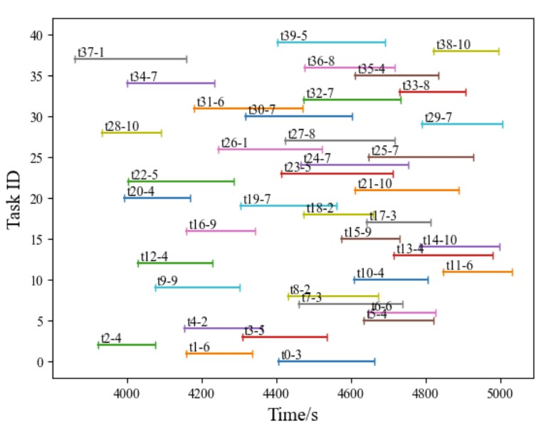
Figure 1. Normally distributed sample of possible observation tasks. (Chun, et al., 2023)
While exact solutions to the Agile Earth Observation Satellite Scheduling Problem (AEOSSP) exist, they remain computationally intractable for even a moderately large number of tasks (Lemaitre & Verfaillie, 2002). Approximately optimal greedy heuristics exists however they often fail to reach sufficient parody with the exact solution while remaining computationally expensive (Lemaitre & Verfaillie, 2002).
In order to construct a more optimal solver, AEOSSP can be reframed as a causally directed graph network with a time dimension and three spatial (rotation angle) dimensions. A graph network is a set of nodes (features of interest) connected via edges (relationships between features) which represent some arbitrarily abstract collection of information. A simple graph might be a friend group where the nodes represent people and the edge represent the relationship between any two pairs of people, i.e. Alice and Bob are friends while Bob and Charlie are enemies. In AEOSSP, nodes represent observation tasks and edges represent time (and consequently energy) constraints between each task. Figure 2 showcases a two-dimensional version of AEOSSP
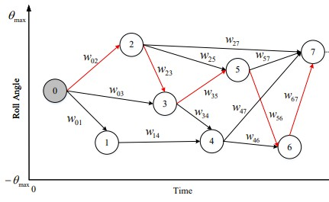
Figure 2. Simplified graph of AEOSSP with 1 degree of freedom. (Chun, et al., 2023)
For AEOSSP, it is valuable to understand how future rewards (completing tasks) can be achieved through choosing certain paths earlier as the most optimal total rewards may not be guaranteed if the maximal next reward is the only criteria (greedy algorithms). For example, a task with a large required observation time may provide a large reward, but it necessarily forces the satellite to miss many more short observation time tasks which in total provide a greater reward than the single large task. Therefore, it is natural to formulate AEOSSP as a graph problem for which numerous machine learning models can approximate an optimal solver.
While choosing a graph-based model is sufficient for most problems formulated as graphs, AEOSSP presents the additional challenge of data distribution representability and reward modeling. The state space of AEOSSP is combinatorically large and therefore it may require a computationally intractable amount of compute to generate enough training examples for the model to generalize outside of its training set. Furthermore, rating each training example against the optimal solution would require an exact solution which is also computationally expensive. Given these two constraints, it is necessary to construct a model able to train itself through a Reinforcement Learning (RL) framework
Reinforcement Learning is a new paradigm in machine learning championed by Google
DeepMind’s AlphaGo agent which achieved superhuman level play in the Chinese game of Go (Silver, Huang, & Maddison, 2016). Fundamentally, RL mimics the rewards-based mechanisms within the human brain to learn general solutions to complex tasks through self-taught evolution. Learning is typically split between two components of a single agent, the actor and the critic networks as seen in
.
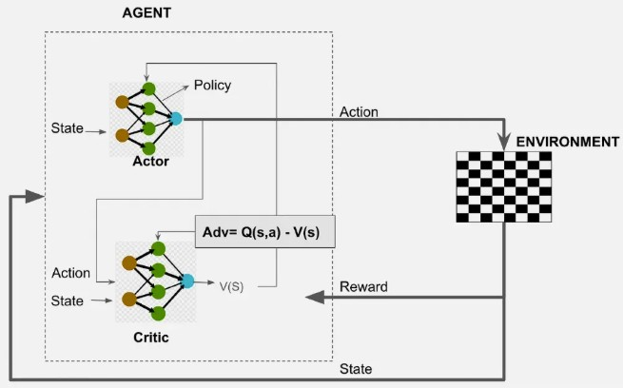
Figure 3. Simplified RL agent with reward system. (Chun, et al., 2023)
The actor takes actions within a state space that ideally maximizes an arbitrary value function
controlled by the critic. The critic then learns from the actor’s actions to update the value function to more accurately represent the state space’s rewards. In laymen’s terms, the critic computes the possible decisions and their consequences and the actor decides how to choose between the possible decisions for the best reward. Over many iterations, an RL agent near optimally generates its own training set by balancing exploration and exploitation as well as assigns rewards to the training set based on its own perceived value, solving the additional constraints placed on a graph-based optimal solver.

Objectives
This report aims to analyze graph-based Reinforcement Learning (RL) methods applied to the Agile Earth Observation Satellite Scheduling Problem (AEOSSP) and characterize their suitability as optimal solvers. The objectives are therefore to:
- Assess performance of a Graph Neural Network with RL model within AEOSSP constraints
- Compare model performance against traditional approximate solvers and heuristics
- Analyze the limitations and identify potential extensions of the assessed work

In the Activities and Results section, Objective 1 will help guide a focused examination of how a graph-based RL agent behaves under the specified constraints outlined in the Background using the metrics and scenarios reported in the literature. Objective 2 will then build on this by comparing the results against the traditional methods applied to AEOSSP on solution quality, computation time, and scalability. Finally, Objective 3 will address weaknesses of the proposed model and potential areas of improvement in future work.

Activities and Results
To formalize AEOSSP constraints, the model must:
- Scale efficiently to task sizes beyond the approximately 27 tasks limit of exact solvers
- Achieve accuracy surpassing traditional approximate solvers and heuristics
- Respect time and energy constraints of observable windows and available onboard propellent
- Generalize well beyond training set examples
- Remain computationally tractable for on-orbit satellites to compute

To address these constraints, the literature proposes a Graph Decision Neural Network (GDNN)
RL agent architecture (Chun, et al., 2023). GDNNs are a minor modification to the classical Graph Neural Network (GNN) found throughout the machine learning field (Scarselli, Gori, & Tsoi, 2009). A GNN’s basic principle is to share node information across connected edges to fully contextualize all the information in a graph, similar to how Convolutional Neural Networks (CNN) work but on an irregular grid (Bronstein, Bruna, & LeCu, 2017). Information is spread in “message passing” rounds where nodes aggregate information provided by their neighbors to add as a residual on the current stored information. Each round can be thought of as recontextualizing the information stored at each node based on the nodes connected to it. Information can therefore propagate through a graph over several rounds of message passing to result in a final contextualized state of the graph. In AEOSSP, this framework allows future tasks to inform prior tasks about their characteristics which theoretically enables the current task to understand the context several tasks in the future given only the next available tasks. Given the contextualized model, the GNN is modified to contain a final output layer to decide between the potential next available tasks (a GDNN) which is then used to update the graph to the next state.
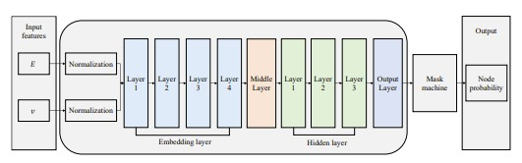
Figure 4. Graph Decision Neural Network model architecture. (Chun, et al., 2023)
The use of a graph-based method can identify the best path (subgraph) with accuracy comparable to CNNs (the most successful ML model formulated) (Bronstein, Bruna, & LeCu, 2017) as well as scale with tasks more efficiently, 𝒪(𝑛²), than exact solutions, 𝒪(𝑛!). A GDNN solves constraints 1, 2, 3 and 5 yet crucially lacks generalization beyond training sets. GNN models are inherently based on supervised learning which assumes a training set with accurate rewards (or labels) which quantify the accuracy of the model. As discussed in the Background, AEOSSP does not have any associated well-labeled training set to use. Furthermore, the possible combination of tasks and types of tasks is combinatorically large and therefore it is not guaranteed the model will perform well outside of the training set (poor real-world performance). Consequently, the literature includes the addition of an RL architecture to self-produce the training set required to train the GDNN, solving constraint 4.
The RL agent framework utilizes the GDNN as a primary model around which it optimizes. A single GDNN provides the primary structure (backbone) for both the actor and critic networks with separate final output layers for the actor and critic. The literature uses a Proximal Policy Optimization (PPO) objective to train both the actor and critic networks in tandem. Standard Policy Optimization (PO) maximizes the expected reward of a series of actions over a set horizon (number of tasks) with a weighting parameter favoring maximizing current rewards vs future rewards. PO’s architecture works well for problems where rewards change smoothly over the domain of interest and therefore the model weights change smoothly. This is not necessarily the case with AEOSSP where rewards can shift rapidly as the solution quality increases significantly during the initial and final training phases (stiff reward function). PPO modified the standard objective function by computing the ratio of the current achieved rewards and the previously achieved rewards. This ratio is then clipped via a hyperparameter weight to prevent large model weight updates. This has been shown to significantly stabilize training as well as increase model accuracy which is necessary for stiff-reward functions found in AEOSSP (Schulman, Wolski, & Dhariwal, 2017).
As a high-level overview, the actor GDNN encodes the list of tasks into a graph representation which is passed through the model to make a decision on the next task. The satellite then moves to perform that task (under the time and energy constraints encoded in the nodal information) which represents the updated graph state. This then repeats until the satellite reaches the final target time where the total rewards are accumulated based on the value assigned from the critic GDNN. The rewards are then used to update the actor and then critic weights to reflect the information learned through the training set and the cycle is repeated until the framework reaches the convergence criteria. The Average Scheduling Profit (ASP), the Average Scheduling Time (AST), and Percentage of Excessive Profit (PSP) are compared against other methods to determine the most optimal method.
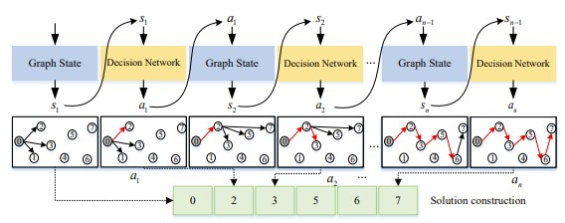
Figure 5. Actor GDNN constructing a solution subgraph. (Chun, et al., 2023)

The literature designs four heuristics as well as a GDNN with a Deep Quality Network (DQN) which represents a more standard RL framework approach compared to PPO (Mnih & Kavukcuoglu,
2015). The four heuristics are:
- Start time of observational Time Window Ascending (STWA)
- Profit of Task Descending (PTD)
- Ratio of Profit and Image time Descending (RPID)
- Conflict Degree of Task Descending (CDTD)

The goal of each heuristic is to outline a simple rule or set of rules to determine which tasks
should the satellite complete next.
STWA is perhaps the most natural implementation possible. Tasks are ordered based on their
start time and the completed based on their availability and constraints as soon as they are available, maximizing the number of tasks completed. STWA ignores all other aspect about each task such as reward, duration, or energy requirements which results in poor performance when tasks are of mixed rewards, mixed duration, or physically separated.
PTD is also a natural heuristic, yet distinct from STWA as it prioritizes the most rewarding tasks instead of completing the most tasks. The most rewarding task is completed first and then the satellite targets the next most rewarding task still available which is repeated for the entire solution set. Therefore, PTD solves any potential mixed reward issues, but necessarily drops the ability to utilize time effectively, resulting in non-optimal performance.
RPID leverages the benefit of both STWA and PTD through measuring the reward per time spent
on task, targeting the most time efficient rewards first. While theoretically more suitable, RPID still does not optimize for the physical or temporal separation of the tasks which can result in poor performance in most examples.
CDTD attempts to solve RPID’s separation problems by targeting the most clustered tasks first, aiming to reduce energy and time expenditure moving between tasks. This however neglects all the theoretical benefits of RPID for tasks temporally spaced and of varying rewards which does not provide a solid basis of a general heuristic.
As expected, the heuristics perform poorly against the machine learning based models as they necessarily ignore important aspects of AEOSSP as seen in Figure 6.
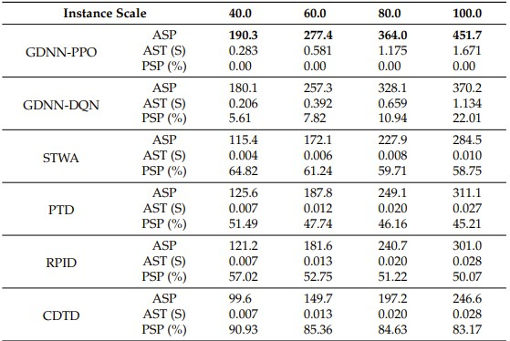
Figure 6. Comparison of GDNN-PPO against simple models. (Chun, et al., 2023)
Despite the poor performance, the heuristics provide valuable information about AEOSSP. More
specifically, the heuristics perform similarly (within tens of relative percent of each other) while optimizing for significantly different criteria. Therefore, it can be concluded that task availability, reward value, task duration, and spatial and temporal separation all remain important to AEOSSP and, consequently, all valid solvers must respect each of these aspects.
Additionally, the DQN notably only experienced a minor dip in evaluation compared to PPO until
task sizes grew large, suggesting that the DQN required greater representation capabilities (larger neural networks) than PPO for a similar level of performance.
The literature then expands to compare against more accurate methods in Figure 7: GRILS, Selfadaption Differential Evolution (SDE), and Self-adaptation Genetic Algorithm (SGA) (Peng, Song, He, & Yu, 2020), (Li, Chen, & Yao, 2017).
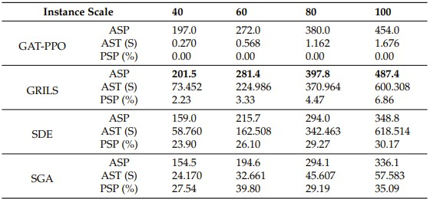
Figure 7. Comparison of GDNN-PPO against SOTA models (Chun, et al., 2023)
Notably, GDNN-PPO (referred to as GAT-PPO in Figure 7) falls behind the most optimal model,
GRILS, in the ASP metric which would violate the objective of the GDNN-PPO model except that GRILS scales poorly with task scale as seen in Figure 8 with AST scores rapidly increasing with task scale. Filtering for only scalable models, GDNN-PPO significantly out-performs its only competition, SGA, and therefore satisfies the constraints set above. Based off these results, the literature concludes that the GDNN-PPO proposed satisfies their original objective criteria and suggests that efforts to improve scheduling priority will be investigated.

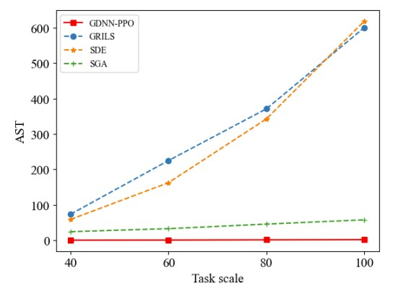
Figure 8. Solve time against task scale. (Chun, et al., 2023)
Based off the literature provided, there are a number of potential improvements to the modeling methods which may improve the performance of such a model.
The construction of the training set is done at a single task scale at a time with which the model is
trained on. This necessarily restricts the model to learning how to optimize over a set horizon rather than learning a generalized solution over an indefinite horizon, a distinction which the literature acknowledges through comparison of the GDNN-PPO model trained and tested at varying scales. Given the model’s ability to train and test on differing task scales, a natural improvement to the model would be the inclusion of a variety of task scales in the model’s environment. It follows that a scale-invariant GDNNPPO would necessarily improve the generalizability to a wide variety of task scales as expected in realworld deployment. Combining a variety of task scales could also be done gradually throughout the training procedure with the introduction of larger task scales only after the model has begun understanding smaller cases. This method could additionally promote stability in training which random shuffling of task sizes may erode.
The graph modeling of AEOSSP in the literature is done via a time-attitude adjacency graph where distances are computed via a time heuristic equation that only incorporates the roll angle while ignoring pitch and yaw angles. Furthermore, the edge connections are generated via a five-nearestneighbors computation performed in the time heuristic domain. While theoretically sufficient, the graph modeling approach is both simple and restrictive to the information naturally stored within each task. Incorporating all three angles via the transition angle equation already defined in the literature likely improves the model’s understanding of the true mechanics without sacrificing any time constraints which are validated later in the process. Furthermore, adding additional nodal information related to the constraints, such as slack time to the View Time Window (VTW) end when transitioning nodes, may aid the model’s ability to select subgraphs which prevent dead ends.
The RL framework in the literature lacks a proper description of the critic network, a crucial aspect of the RL architecture, and thus is assumed to an identical model structure to the actor network (GDNN). The actor and critic model are assumed to have independent encoding structures (embedding layers) which typically hurts alignment between the actor and critic, harming generalization. Utilizing a shared encoding structure between actor and critic with separate GNN layer blocks both unifies the learned representation of the agent as well as maintains the representability of the individual networks. Furthermore, adding regularization to the critic, such as a L2 loss or physics-informed losses, may provide increased stability or accuracy over training while maintaining or improving the generalizability of the model. Additionally, removing infeasible transitions between tasks creates sharp gradients during training which are not immediately visible compared to when infeasible transitions are utilized directly in the reward structure. Adding constraint-based losses with smooth gradients (PPO-Lagrangian) may improve training and generalizability to optimal strategies rather than pattern exploitation.

Conclusions
The Agile Earth Observation Satellite Scheduling Problem presents a difficult challenge that the rapidly growing space industry needs to tackle to fully utilize the increasing demand from a variety of customers. Traditionally methods and heuristics fall short in either solution quality or generation speed which limit the operational effectiveness of satellites. A GDNN-PPO approach proposed by the cited literature achieved their objective in producing high-quality solutions to AEOSSP while remaining computationally tractable yet still left open numerous avenues for improvement of the algorithm as well as expansion to more challenging versions of AEOSSP.
GDNN-PPO achieved an approximately 50% increase in model performance on average compared to basic heuristics and fell within 7% of the SOTA heuristics-based methods while maintaining near linear scaling on task size and remaining with a 2 second solve time. The 350x reduction in solve time compared to the SOTA methods represents a fundamental shift in the usage away from pure research to practical implementation. Furthermore, the success of the model proposed suggests similar classes of NP-Hard problems can approximately solved in real-time, a potentially revolutionary possibility.
Despite the tantalizing benefits, indirect limitations of GDNN-PPO hamper the overall benefit of the model. Modeling decisions discussed in the literature such as task scale-locked environments, neglected beneficial node and edge information, and lack of proper RL framework implementation suggest major improvements are still available.
Even with the current model, practical implementation remains feasible. Adoption into practical applications might involve a range of deployments from scheduled settings with human oversight to fully autonomous systems onboard satellites able to handle requests from a variety of users. Faster, more efficient, more productive Earth observation satellites have moved from a mathematically impossible
problem to an engineering implementation possibility.

References
Bronstein, M., Bruna, J., & LeCu, Y. (2017). Geometric Deep Learning: Going beyond Euclidean data.
IEEE.
Chun, J., Yang, W., Liu, X., Wu, G., He, L., & Xing, L. (2023). Deep Reinforcement Learning for the
Agile Earth Observation Satellite Scheduling Problem. Mathematics.
Lawler, E., Lenstra, J., & Rinnooy Kan, A. (1991). The Traveling Salesman Problem: A Guided Tour of
Combinatorial Optimization. Wiley.
Lemaitre, M., & Verfaillie, G. (2002). Selecting and Scheduling Observations of Agile Satellites.
Elsevier.
Li, G., Chen, C., & Yao, F. (2017). Hybrid Differential Evolution Optimisation for Earth Observation
Satellite Scheduling with Time-Dependent Earliness-Tardiness Penalties. Wiley Online Library.
Minnett, P., Alvera-Azcarate, A., & Chin, T. (2019). Half a century of satellite remote sensing of seasurface temperature. ScienceDirect.
Mnih, V., & Kavukcuoglu, K. (2015). Human-level control through deep reinforcement learning. Nature.
Peng, G., Song, G., He, Y., & Yu, J. (2020). Solving the Agile Earth Observation Satellite Scheduling
Problem with Time-Dependent Transition Times. IEEE.
Raup, B., Andreassen, L., Bolch, T., & Bevan, S. (2015). Remote Sensing of Glaciers. Boulder, Colorado:
John Wiley & Sons, Ltd.
Scarselli, F., Gori, M., & Tsoi, A. (2009). The Graph Neural Network Model. IEEE.
Schulman, J., Wolski, F., & Dhariwal, P. (2017). Proximal Policy Optimization Algorithms. ArXiv.
Shams, S., Boehnert, J., & Wilhelmi, O. (2025). Assessing the Impact of Conservation Practices on Post-
Wildfire Recovery of Evergreen and Conifer Forests Using Remote Sensing Data. MDPI Fire.
Silver, D., Huang, A., & Maddison, C. (2016). Mastering the game of Go with deep neural networks and
tree search. Nature.

