TTCN

Do Not modify any thing on hardcoded path on GPU server for testing you can create your work place and place the script and modify there

# TTCN-3 Eclipse Environment Setup
Give the password as known list on ttcn laptop
ssh-keygen -t rsa -b 4096 -f ~/.ssh/id_rsa -N ""
chmod 600 ~/.ssh/id_rsa.pub
chmod 700 ~/.ssh
ssh-copy-id hyconsoft_rnd@192.168.0.48
ssh hyconsoft_rnd@192.168.0.48
mkdir -p ~/.ssh
echo "ssh-rsa AAAAB3N... user@dell-Latitude-5400" >> ~/.ssh/authorized_keys
chmod 600 ~/.ssh/authorized_keys
chmod 700 ~/.ssh
git clone https://github.com/Hyconsoft-RND-Center/CSMS_TTCN_Scripts
for eclipse I have kept zip file inside download folder unzip that one and place above inside Workspace
This project directory contains the setup for running the TTCN-3 Eclipse environment, specifically tailored for the CSMS (Charging Station Management System) project under the Hycon framework. Below are the instructions to set up and run the environment.

## Prerequisites

- **Operating System**: Ubuntu 22.04.4 LTS (or compatible Linux distribution)
- **Hardware**: Compatible with Dell Latitude 5400 or similar hardware
- **Dependencies**:
- `unzip` utility for extracting the Eclipse archive
- GCC 11 (pre-installed or compatible with the provided TTCN-3 package)

## Directory Structure

- **eclipse_/**: Contains the extracted Eclipse environment
- **eclipse/**: Main Eclipse directory
- `artifacts.xml`: Eclipse artifacts configuration
- `configuration/`: Configuration files for Eclipse
- `dropins/`: Directory for additional Eclipse plugins
- `eclipse`: Eclipse executable
- `eclipse.ini`: Eclipse configuration file
- `features/`: Eclipse features directory
- `icon.xpm`: Eclipse icon
- `notice.html`: License and notice information
- `p2/`: Eclipse provisioning directory
- `plugins/`: Eclipse plugins directory
- `readme/`: Eclipse readme directory
- `ttcn3-11.0.0-linux64-gcc11-ubuntu_22.04.4_lts_foss`: TTCN-3 compiler and runtime
- `TITAN_Designer_and_Executor_plugin-11.0.0`: TITAN Designer and Executor plugin for TTCN-3
- `Workspace/`: Default Eclipse workspace directory

## Setup Instructions

1. **Extract the Eclipse Archive**:
- If the `eclipse_.zip` file is present, unzip it to create the `eclipse_` directory:
```bash
unzip eclipse_.zip
```

2. **Navigate to the Eclipse Directory**:
- Move into the `eclipse_/eclipse` directory:
```bash
cd eclipse_/eclipse
```

3. **Run Eclipse**:
- Execute the Eclipse binary to start the TTCN-3 environment:
```bash
sudo apt update
sudo apt install xutils-dev
./eclipse
```

4. **Workspace Configuration**:
- By default, Eclipse uses the `Workspace/` directory for projects. You can select or create a new workspace when prompted on startup.
dell@dell-Latitude-5400:~/Desktop/projects/hycon/git/CSMS_TTCN_Scripts/shell/src$ sudo apt install titan.runtime titan.dev titan.core titan.tpd titan.testports
[sudo] password for dell:
## Running TTCN-3 Projects

- The environment includes the **TITAN Designer and Executor plugin** (version 11.0.0) for TTCN-3 development.
- The **ttcn3-11.0.0-linux64-gcc11-ubuntu_22.04.4_lts_foss** package provides the TTCN-3 compiler and runtime.
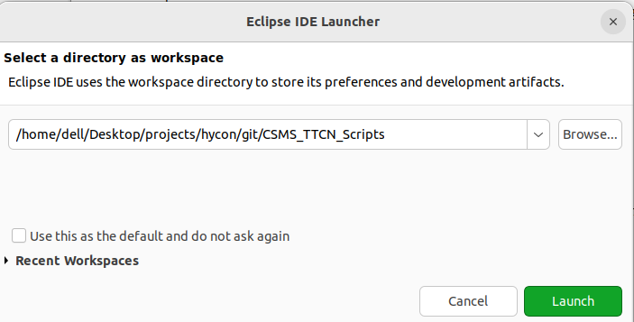
- Load your TTCN-3 project files into the Eclipse workspace and use the TITAN plugin to compile and execute TTCN-3 test cases.
Below is the screenshoot

click the up right most for view executing mode

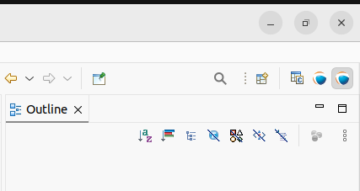

\

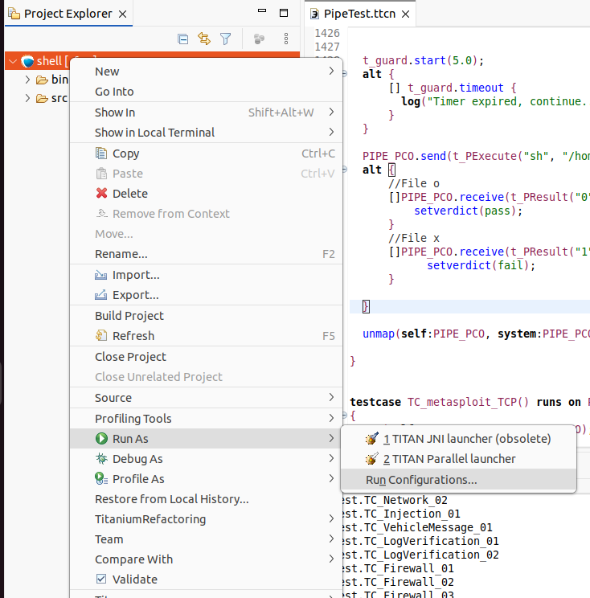

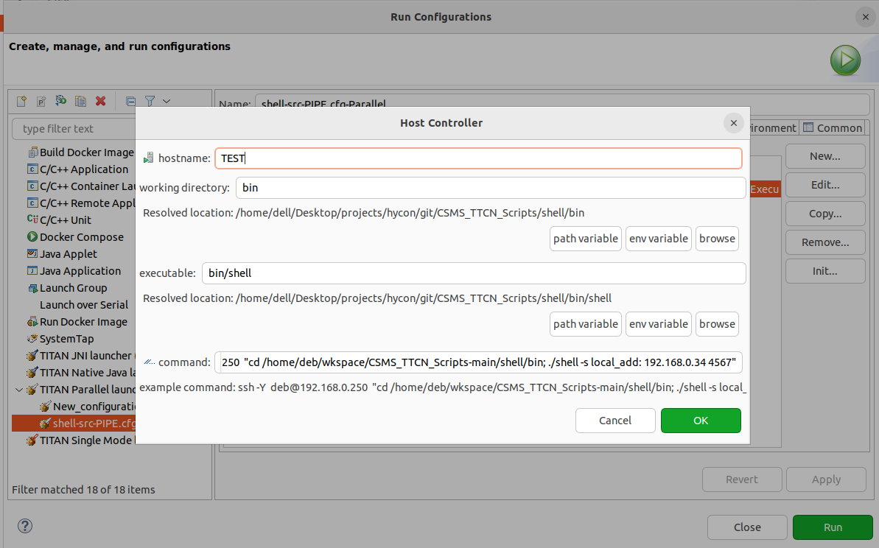

The above ip for gpu server and the ttcn laptop is below
ssh hyconsoft_rnd@192.168.0.48 "cd /home/hyconsoft_rnd/actevia/eclipse_/eclipse/Workspace/CSMS_TTCN_Scripts-main/shell/bin; ./shell -s 192.168.0.48 192.168.0.43 4567"
you just need to change proper ip
GPU SERVER IP : hyconsoft_rnd@192.168.0.48
TTCN system IP : 192.168.0.43
Write the executable name in our case is shell
./shell
Update the Project path on GPU server (repo path CSMS)
cd ~/actevia/eclipse_/eclipse/Workspace/CSMS_TTCN_Scripts-main/shell/bin

Last step
After fill above ip and name Press on run It will launch autoware ,csms project on the GPU server from the ttcn laptop
Script Uunderstanding and Build Procedure
Open the file in your setup path(i am using my local path only for example )
400:~/Desktop/projects/hycon/CSMS/ttcn/eclipse_/eclipse/Workspace/CSMS_TTCN_Scripts-main/shell/src$ gedit PipeTest.ttcn
Our CSMS code for CAN,LIN, FlexRay, UDP are present in PipeTest.ttcn
We are using python script for trigger the executable
Below path of GPU server for trgger autoware tool
below trigger from ttcn script from ttcn laptop
TTCN_Laptop → GPU Server (source code ,execuatble, python script)
both should be in same network

Search for control and write the order of execution
Below I have given one snippet

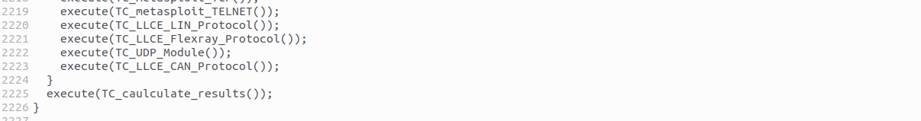

ROS2 environment setup

for change in environment for the ros like domaind id you need to change in the python script used in the above ttcn script
I will provide one example to modify the setup environment for ros for CSMS project
if you open any of the file example
cat /home/hyconsoft_rnd/actevia/eclipse_/eclipse/Workspace/CSMS_TTCN_Scripts-main/16_LLCE_Flexray_Protocol/autoware_start.py
you will see some setup line like below
there you can modify for ros and other script also
export DISPLAY=:1
export ROS_DOMAIN_ID=13
source /home/hyconsoft_rnd/autoware-1/install/setup.bash;ROS_DOMAIN_ID=13 ros2 launch autoware_launch planning_simulator.launch.xml map_path:=$HOME/autoware_map/sample-map-planning vehicle_model:=sample_vehicle sensor_model:=sample_sensor_kit
BUILD STEPS:

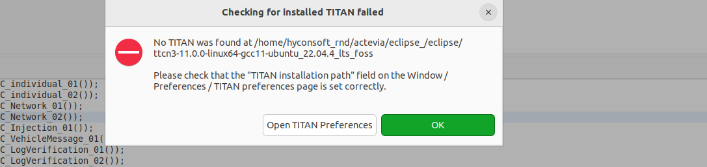
TROUBLESHOT
IF you are getting below error the we need to update library path in image 2

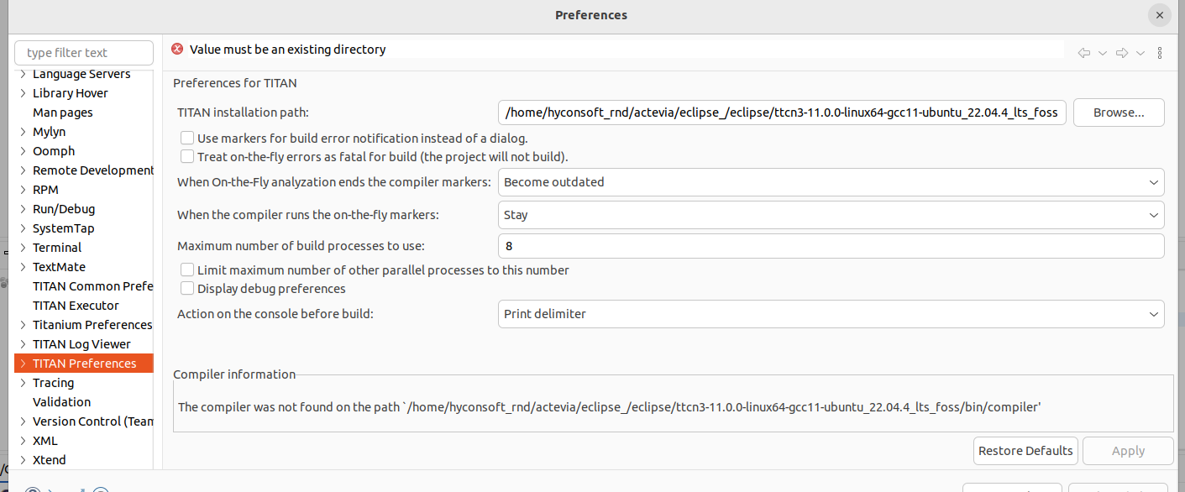
image 2
In the above click on browse and update library in my case path is (/home/dell/Desktop/projects/hycon/CSMS/ttcn/eclipse_/eclipse/ttcn3-11.0.0-linux64-gcc11-ubuntu_22.04.4_lts_foss)
then apply
apply & close

BUILD PROCEDURE right click on shell and click on Build project shell will generate

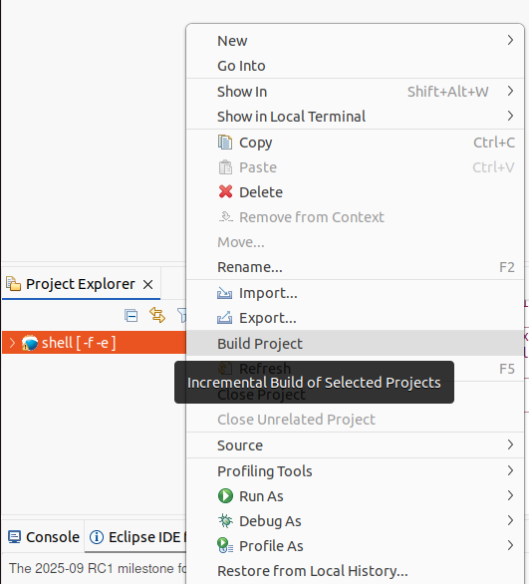
After build click RUN AS
Then press run configuration

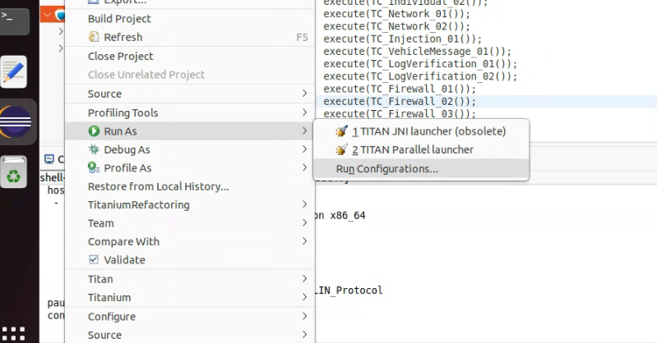
fill the ssh HC
ssh hyconsoft_rnd@192.168.0.48 "cd /home/hyconsoft_rnd/actevia/eclipse_/eclipse/Workspace/CSMS_TTCN_Scripts-main/shell/bin; ./shell -s 192.168.0.48 192.168.0.43 4567"

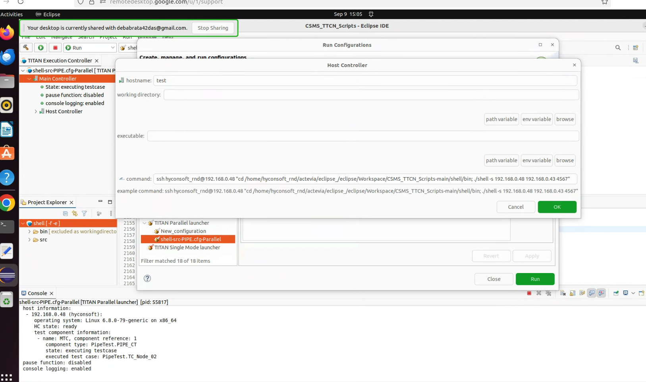

then press ok then press run it will trigger ttcn script for gpu server from ttcn laptop
Pass or fail result will show in below
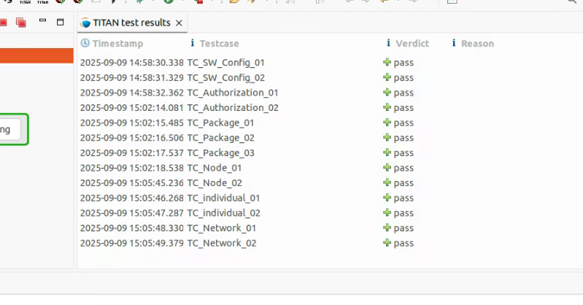
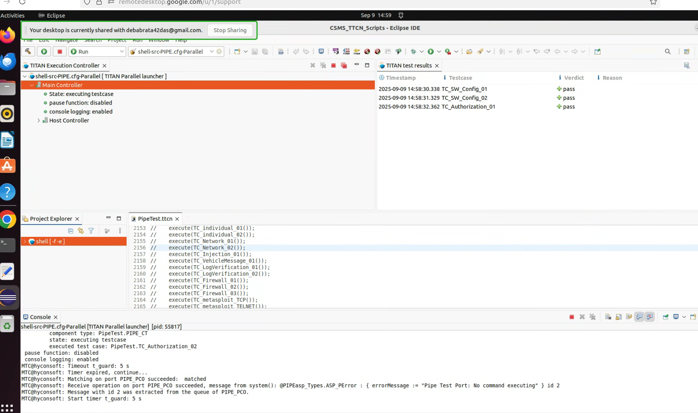

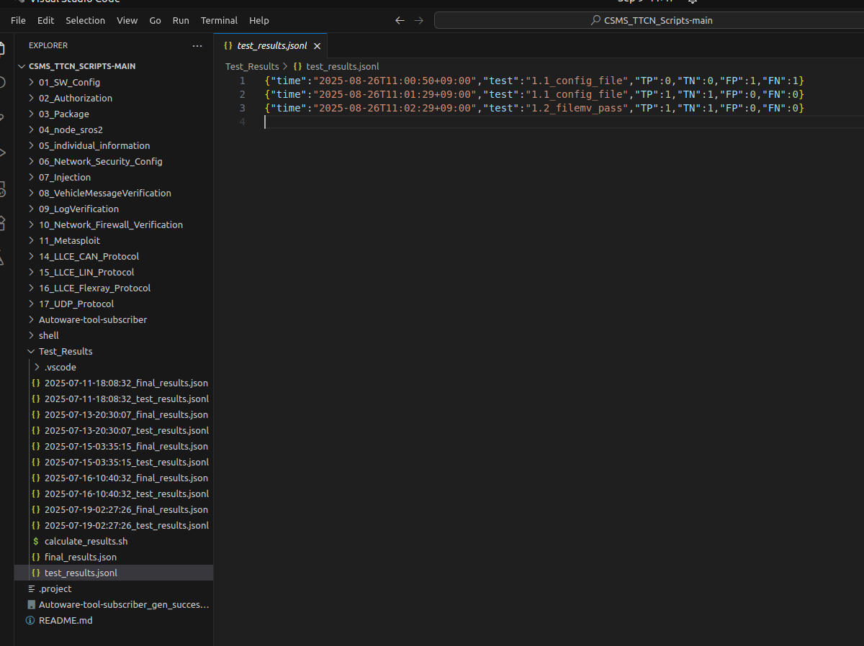
in the above image pass or fail log is visible

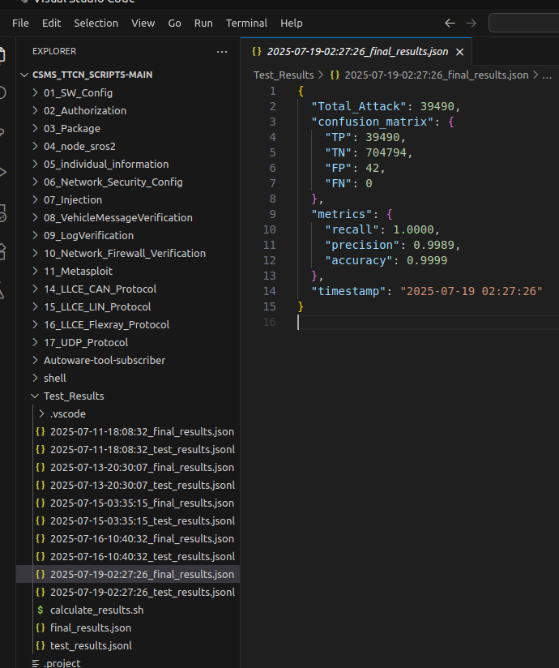
In the above image it will calculate total cases for TP,TN,FP,FN log stored

