Building Document for EB Tresos

⚠️ Important Note
- Follow this document only if changes are required in the bootloader.
- The bootloader is already configured in the path mentioned below.
- Do not change memory addresses or configurations unless absolutely necessary. Any incorrect modification may crash the NXP board program.
- This document is provided only for reference and to outline the setup we have done in this project.

Bootloader Application for Cortex-M7 Cores
- Prepare the bootloader application specific to Cortex-M7 cores.
- Use the given images and configurations exactly as shown.
- Follow the same memory addresses as provided.
- Do not modify any addresses – they are project-specific and pre-validated.
Step-1 Load Configuration
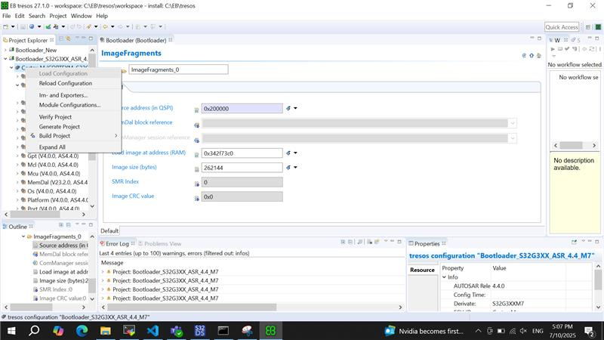

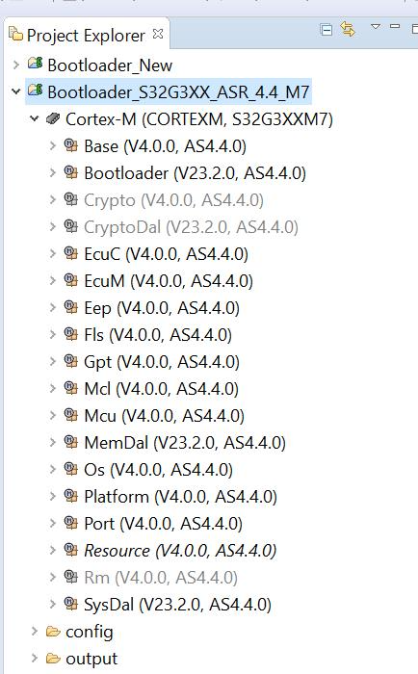

Double click on Bootloader and create below configurations
Boot Source click

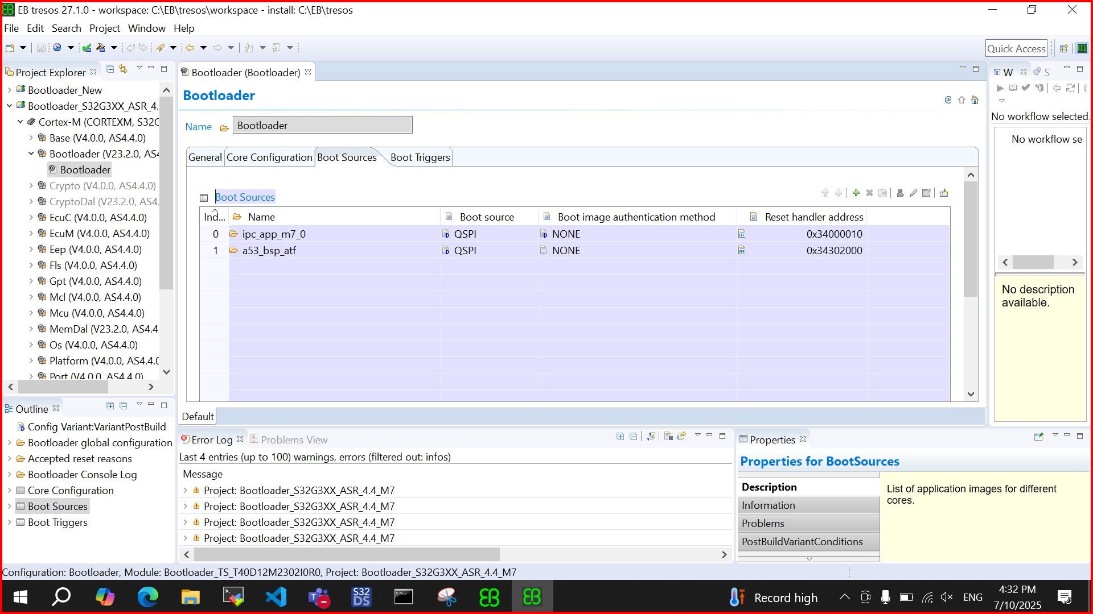
Core Configuration
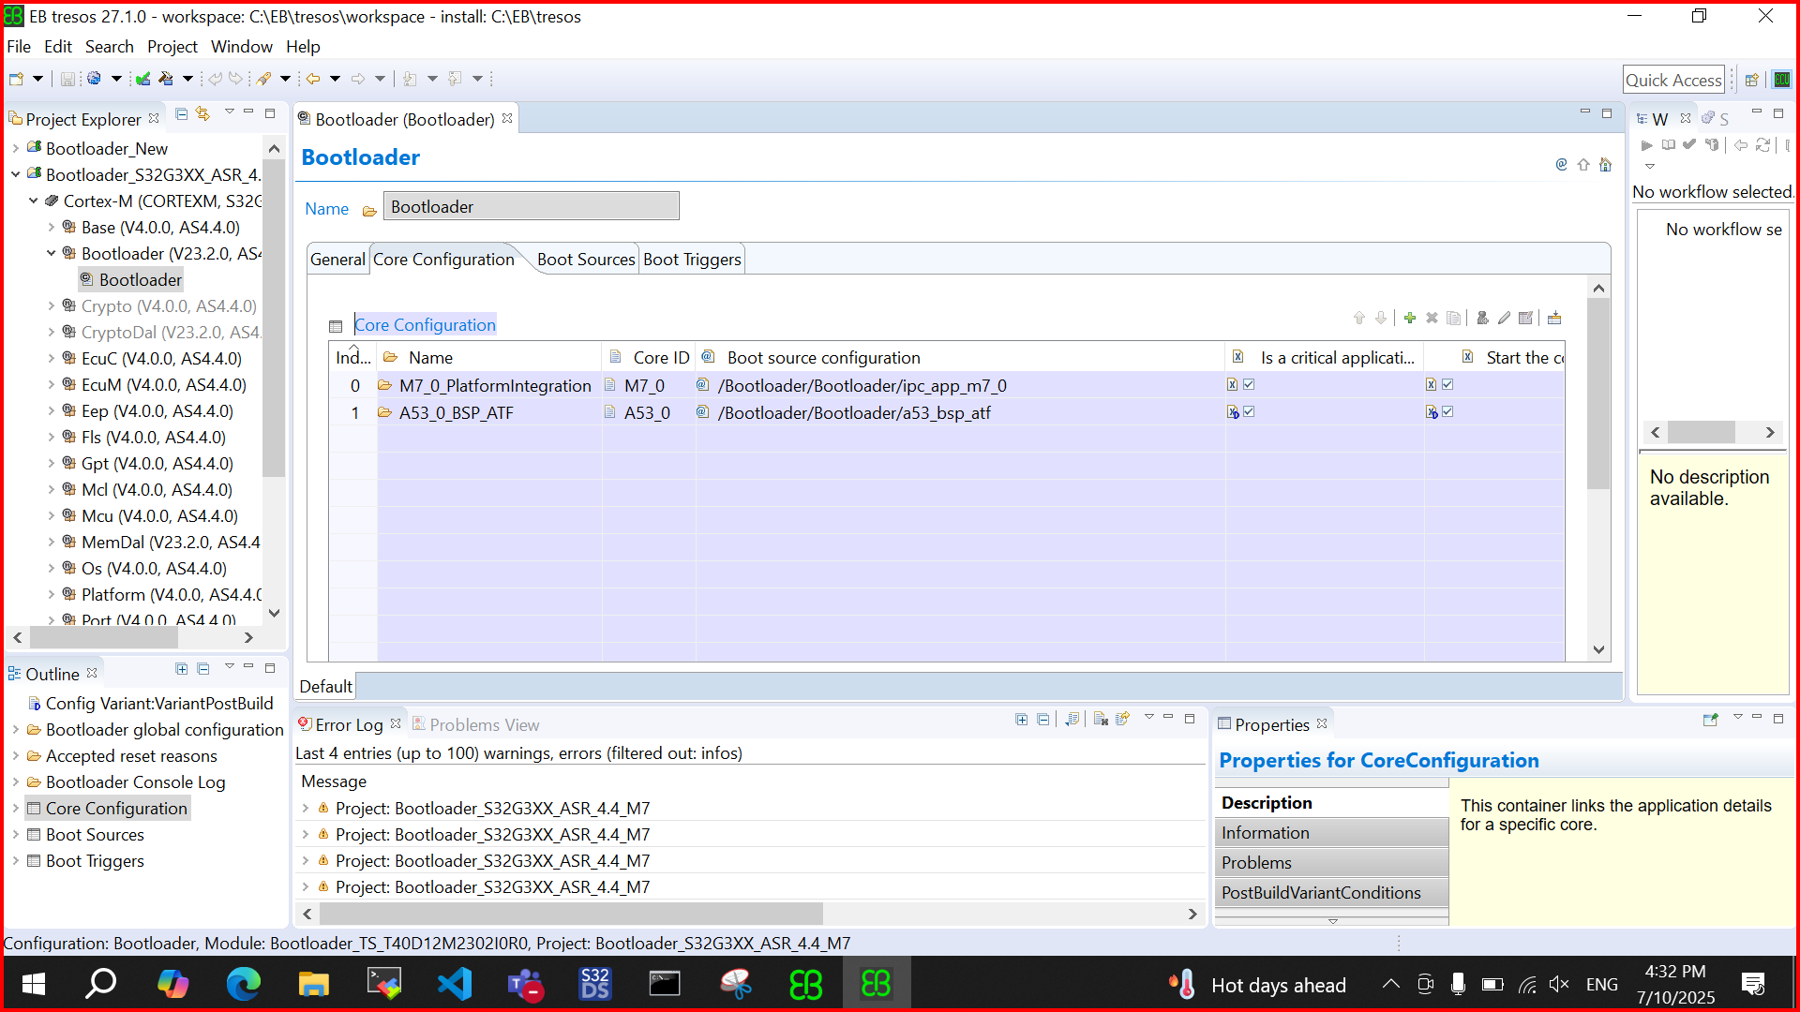

ImageFragment create
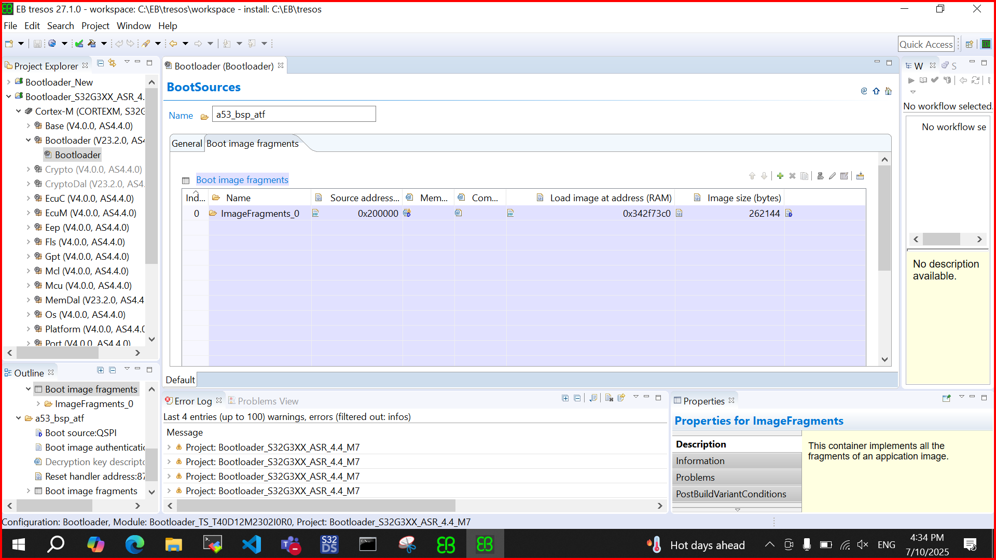
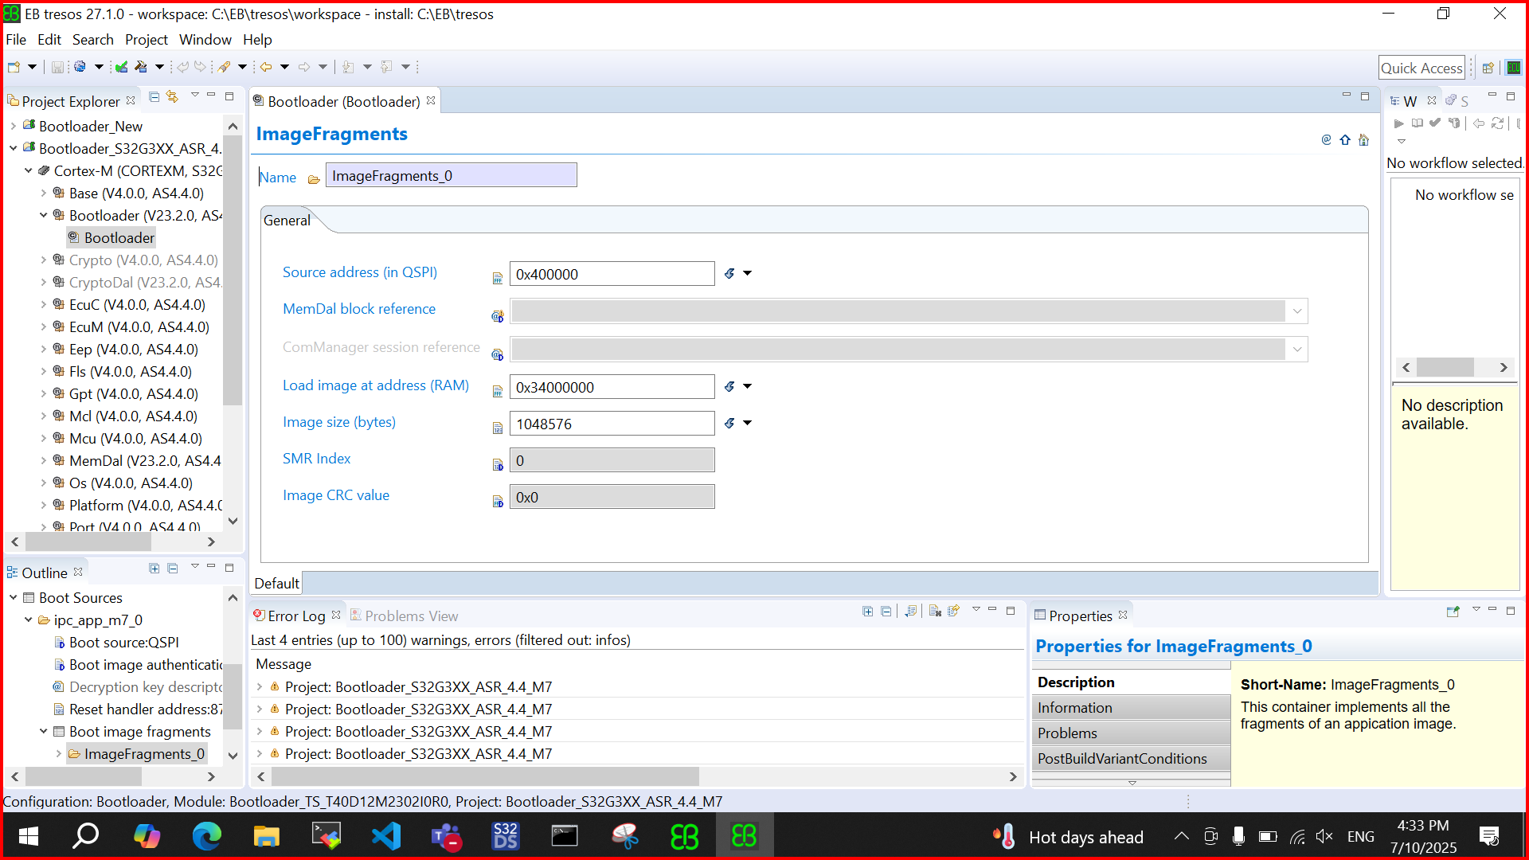

a53_bsp_atf double click and fill with below address
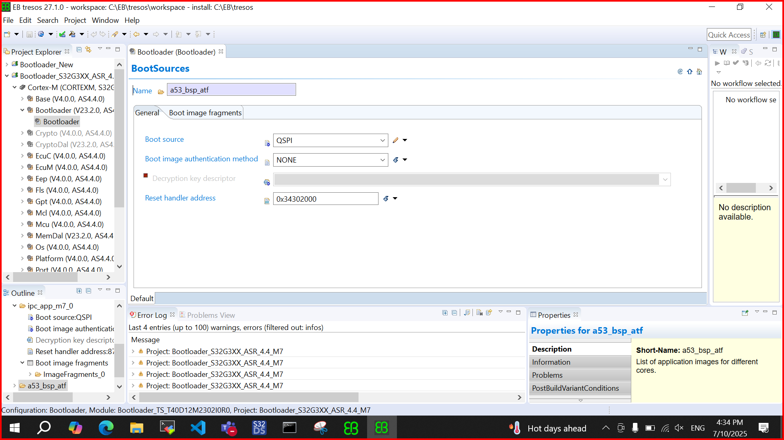

After all the setups Verify project and after verify generate it .

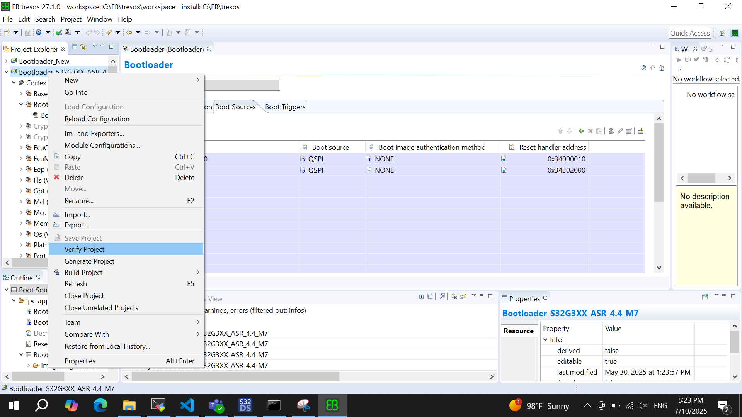

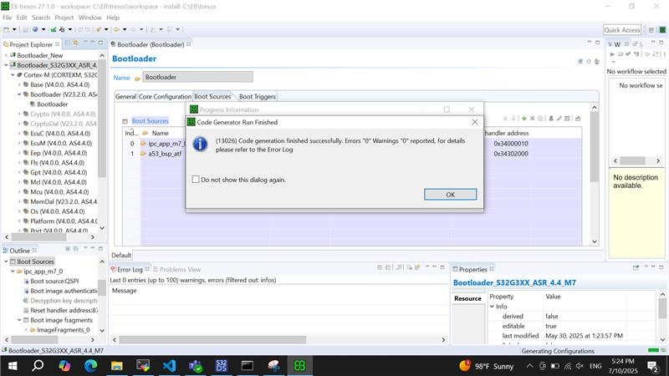

Build The Bootloader

