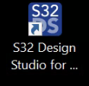
Building Document for NXP
step 1 : Lunch the S32 Design studio

Step 2 : Load below grey marked file

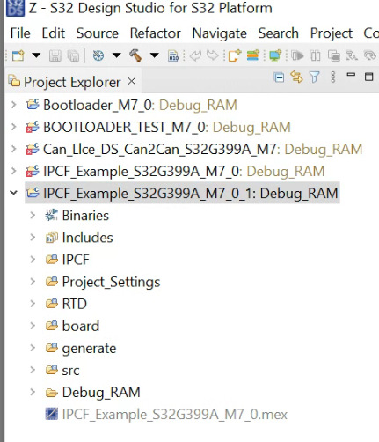

Step 3 : Build the code clicking below image

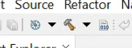
Step 4 : Generated binary file will be inside Debug_RAM folder

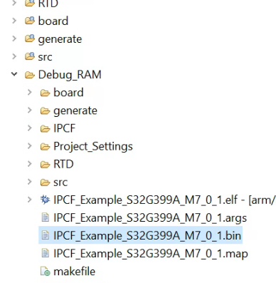
Step 5 : Generate S32G Boot Image Using S32DS IVT_TOOL

Click IVT like below image

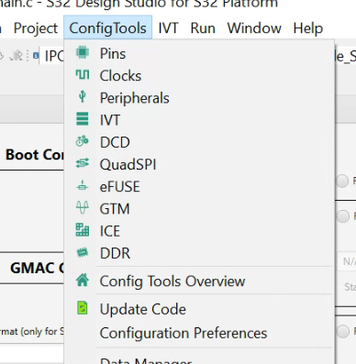

Step 6 : Configure all the blocks like below given image
BOOT Configuration : M7_0
Interface selection :
SPI Serial Flash
Configure QuadSPI parameters
paste this : C:\NXP\Integration_Reference_Examples_S32G3_2023_02\code\framework\realtime\swc\bootloader\platforms\S32G3XX\res\flash\S32G3XX_QuadSPI_133MHz_DDR_configuration.bin
Step 7 : DCD paste below path without any spaces
C:\NXP\Integration_Reference_Examples_S32G3_2023_02\code\framework\realtime\swc\bootloader\platforms\S32G3XX\res\flash\S32G3XX_QuadSPI_133MHz_DDR_configuration.bin
Step 8 : HSE paste below path
C:\NXP\HSE_FW_S32G2XX_0_2_51_0\hse\bin\rev2.1_s32g2xx_hse_fw_0.1.0_2.51.0_pb240404.bin.pink
addr :- 0x400 size :- 397664
HSE FW conf:-
0x61560
SysImage External Flash type : QSPI
Page size : 0x1000
Step 9 : Application Bootloader BOARD 1
C:\NXP\Integration_Reference_Examples_S32G3_2023_02\code\framework\realtime\swc\bootloader\platforms\S32G3XX\build\bin\Bootloader.bin

Start address : 0x77560 Size in bytes : 1049696

Step 10 : Application Boot Code image
Address : 0x34400000
Ram entry point
Address : 0x34500000
code length : 1049616
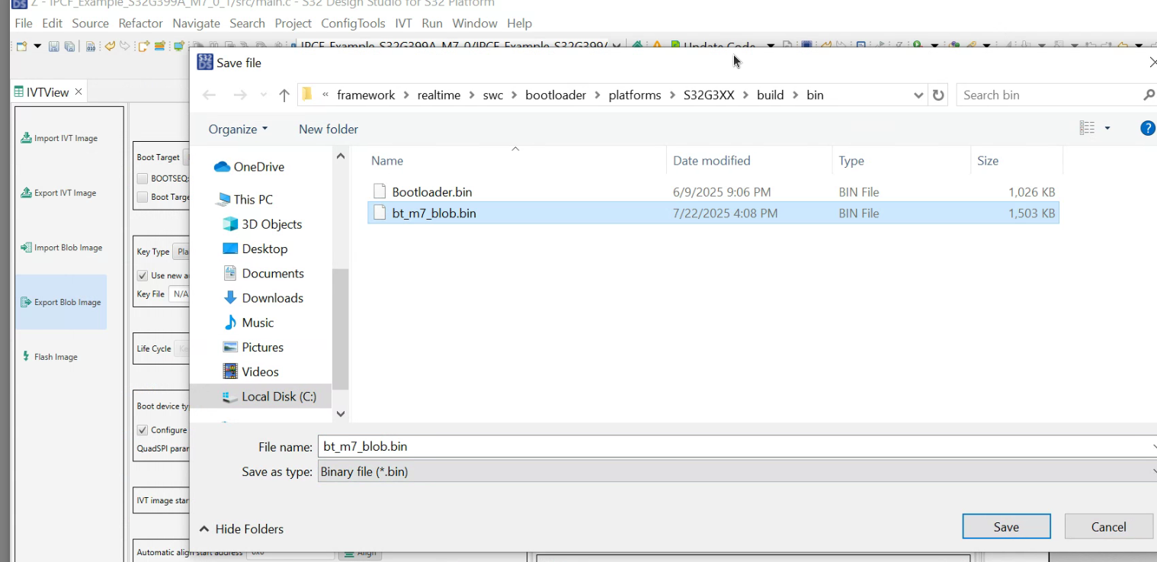
Click on export Blob Image

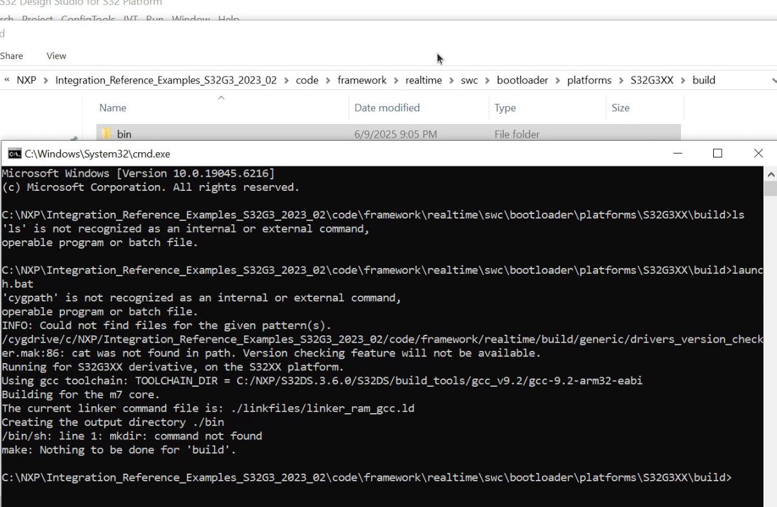
Final blob bin image generated path is C:\NXP\Integration_Reference_Examples_S32G3_2023_02\code\framework\realtime\swc\bootloader\platforms\S32G3XX\build\bin
If Bootloader.bin not found then build bootloader using following path
run script → launch.bat

